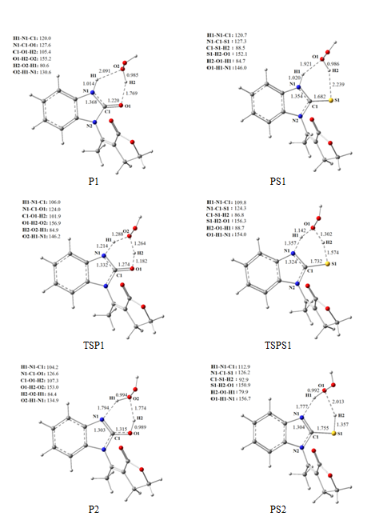

Figure S1. Optimized geometries involved in hydrogen peroxide assisted tautomerisation reactions.

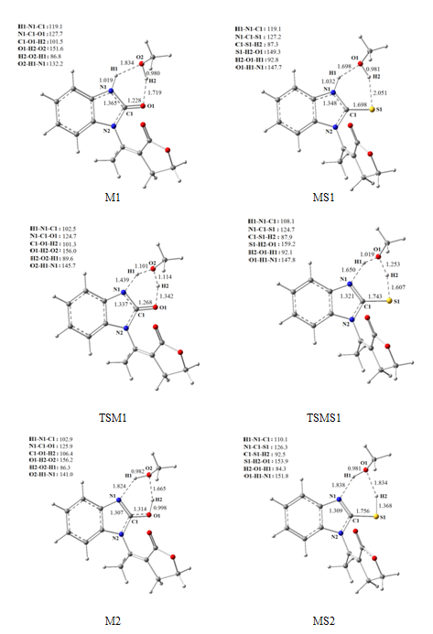

Figure S2. Optimized geometries involved in methanol assisted tautomerization reaction.

