Supplementary material
Figure 13
Longitudinal sonogram of the right kidney. A rounded (7.3mm long x 7.7mm thick), heterogeneously hypoechoic nodule was present in the caudal cortex of the right kidney (between callipers).

Figure 14
Right kidney, cat. Protruding from the kidney is an off-white multilobulated irregular mass which extends through the cortex on section. Bar = 1 cm.
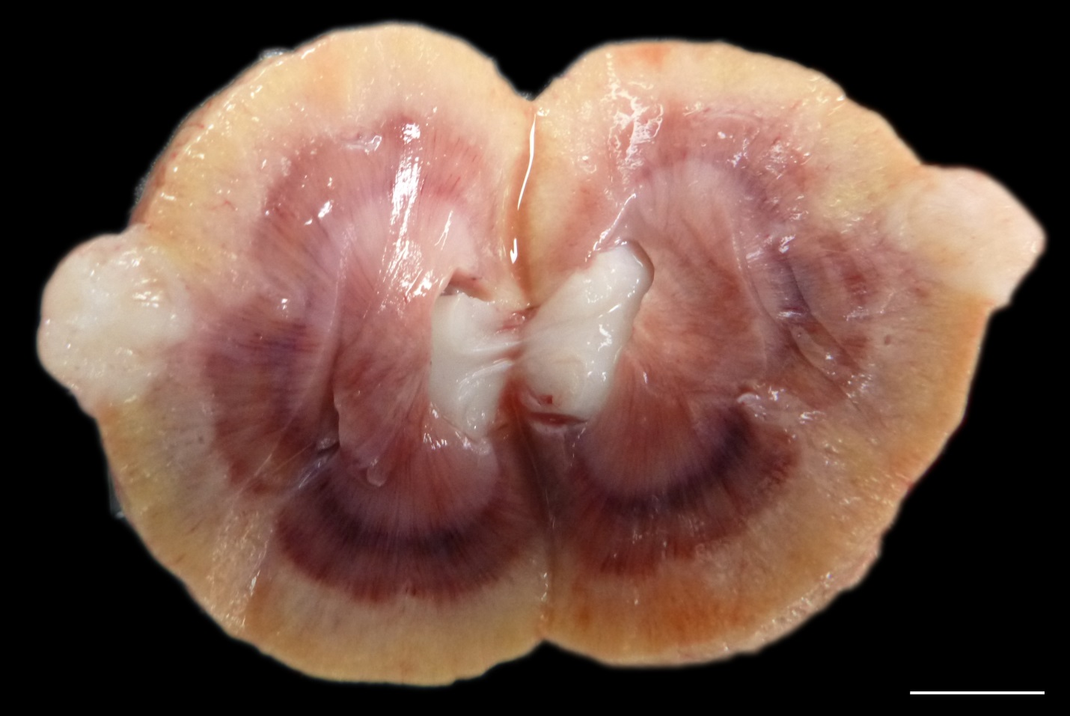

Figure 15
Left kidney, cat. Note the loss of reniform appearance, with blunting of the left cranial aspect by a smooth pale tan focus. Bar = 1 cm.
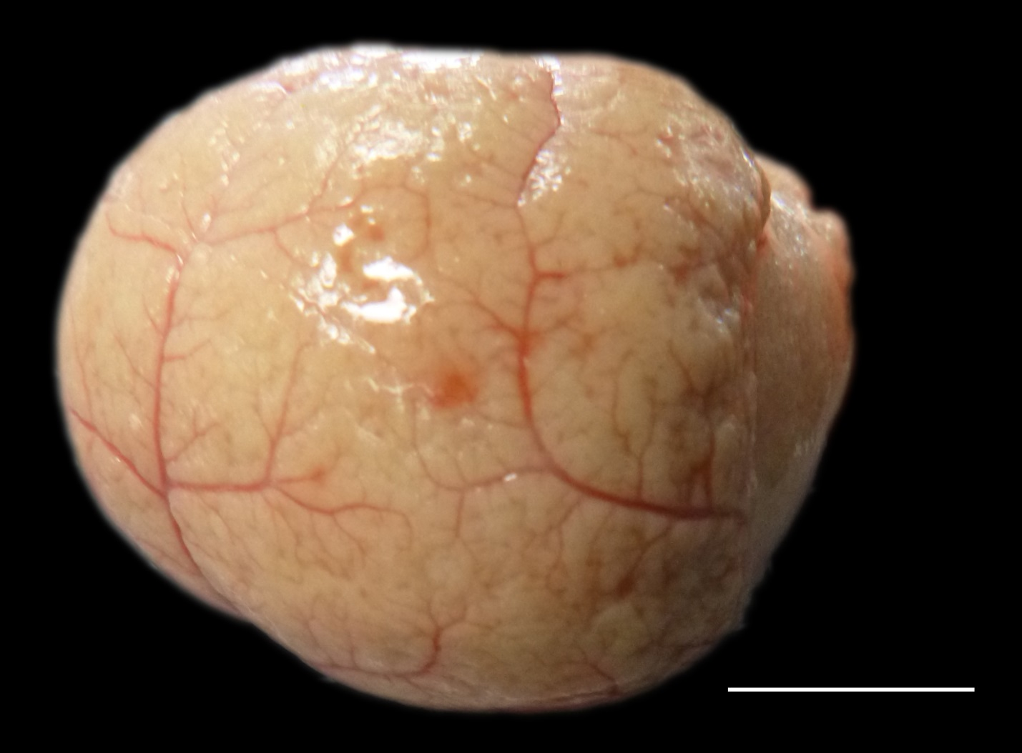

Figure 16
Liver, cat. Numerous pale tan firm nodules are peppered across the hepatic serosa.
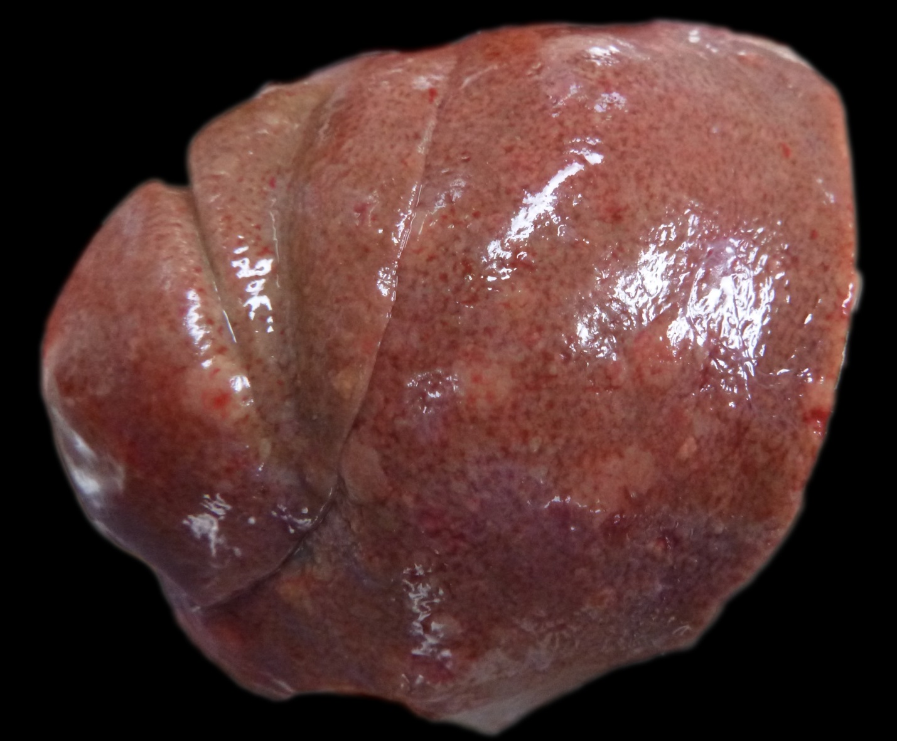

Figure 17
Renal mass, cat. Neoplastic cells demonstrate similar behavior to the colonic mass (Figure 7). Note the marked anisocytosis and anisokaryosis. 400X. HE.

Figure 18
Renal mass, cat. Neoplastic cells demonstrate diffuse marked nuclear and cytoplasmic labeling for S100. 400X. Peroxidase immunohistochemistry and HE.

Figure 19
Renal mass, cat. Neoplastic cells demonstrate diffuse marked cytoplasmic labeling for vimentin. 400X. Peroxidase immunohistochemistry and HE.

Figure 20
Renal mass, cat. Neoplastic cells demonstrate scattered faintly positive cytoplasmic labeling for c-kit. 400X. Peroxidase immunohistochemistry and HE.

Figure 21
Renal mass, cat. Neoplastic cells demonstrate diffuse marked cytoplasmic labeling for glial fibrillary acidic protein. 400X. Peroxidase immunohistochemistry and HE.

