Appendix 2
Survey

ELIGIBILITY QUESTIONS

How old are you?
_____ years
What is your sex?
⃝ | Male | ⃝ | Female

What is your current height?
_____ feet _____ inches
What is your current weight?
_____ lbs.
CALCULATE RESPONDENT’S BODY MASS INDEX (NOT SHOWN TO THE RESPONDENT)

Please answer the following questions:
RANDOMIZE ORDER
 | Yes | No | Don’t Know
In the past week, have you participated in exercise, sports, or physically active hobbies? | ⃝ | ⃝ | ⃝
In the past 12 months, have you used tobacco, such as cigarettes, cigars, pipe or snuff (smokeless tobacco)? | ⃝ | ⃝ | ⃝
Has your doctor or other health professional ever told you that you have high blood pressure? | ⃝ | ⃝ | ⃝
Has your doctor or other health professional ever told you that you have high cholesterol? | ⃝ | ⃝ | ⃝
(IF MALE) Has your doctor or other health professional ever told you that you have diabetes?  (IF FEMALE) Other than during pregnancy, has your doctor or other health professional ever told you that you have diabetes? | ⃝ | ⃝ | ⃝
In the past 5 years, has your doctor or other health professional told you that you have cancer (even if you do not have cancer now)? | ⃝ | ⃝ | ⃝
Has your doctor or other health professional ever told you that you have emphysema, severe asthma that cannot be controlled by medication, or chronic obstructive pulmonary disease (COPD) (a lung problem)? | ⃝ | ⃝ | ⃝
Has your doctor or other health professional ever told you that you have congestive heart failure? | ⃝ | ⃝ | ⃝
Has your doctor or other health professional ever told you that you have end-stage renal disease? | ⃝ | ⃝ | ⃝
On a typical day, do you eat at least 1 fruit or vegetable? | ⃝ | ⃝ | ⃝
Have you ever been screened for colorectal cancer? Some examples include a colonoscopy, flexible sigmoidoscopy, or fecal occult blood test (test to look for blood in your bowel movements or stool). | ⃝ | ⃝ | ⃝
FOR MALE RESPONDENTS  On a typical day, do you drink 3 or more alcoholic beverages? | ⃝ | ⃝ | ⃝
FOR FEMALE RESPONDENTS  On a typical day, do you drink 2 or more alcoholic beverages? | ⃝ | ⃝ | ⃝
FOR FEMALE RESPONDENTS  In the past 2 years, have you had a mammogram or been screened for breast cancer? | ⃝ | ⃝ | ⃝

FOR RESPONDENTS WHO ANSWERED “YES” TO EVER HAD CANCER
In the past 5 years, did you have non-melanoma skin cancer?
⃝ | Yes
⃝ | No
⃝ | Don’t Know

FOR RESPONDENTS WHO ANSWERED “YES” TO NON-MELANOMA SKIN CANCER
In the past 5 years, did you have any other type of cancer?
⃝ | Yes
⃝ | No
⃝ | Don’t Know

DETERMINE IF THE INDIVIDUAL IS ELIGIBLE FOR THE SURVEY:
Patient is eligible for the survey if s/he meets ALL of the following criteria:
- CONDITION #1: Age 45-70 years
- CONDITION #2: Responded NO or DON’T KNOW to each of the following: emphysema / severe asthma / chronic obstructive pulmonary disease, congestive heart failure, and end-stage renal disease.
- CONDITION #3: Responded either:
  - NO or DON’T KNOW to cancer
  - YES to cancer –AND– YES to non-melanoma skin cancer –AND– NO to other type of cancer
- CONDITION #4: At least ONE of the following: body mass index ≥25, YES to tobacco use, NO to mammogram, NO to screened for colorectal cancer, NO to participation in exercise/sports/physically active hobbies, YES to excess alcohol consumption, NO to fruit/vegetable consumption, YES to high blood pressure, YES to high cholesterol, YES to diabetes.
IF THE INDIVIDUAL IS INELIGIBLE FOR THE SURVEY:
We are sorry, but you are ineligible for this survey. This is because you may be very different from the patients who will receive the type of healthcare information developed in this study. Thank you for your time.
[TERMINATE SURVEY]

IF THE INDIVIDUAL IS ELIGIBLE FOR THE SURVEY, CONTINUE TO THE NEXT QUESTION:
[ADVANCE TO NEXT WEB PAGE]

DEFINITION OF PREVENTIVE CARE

Preventive care services are things that a person can do to live a longer and healthier life. They are often used to help lower a person’s risk of getting a disease. Some examples are:
- Cancer tests and screenings
- Eating a healthier diet and exercise
- Losing weight
- Lowering blood pressure, blood sugar, and cholesterol
- Quitting smoking
Depending on which preventive care services you choose, you may be able to lower your risk of cancer, diabetes, heart attack, heart disease, kidney disease, or stroke.
Even if you can’t lower your risk of a disease, your doctor may be able to find the disease early, when it is more treatable.
Some preventive care services are harder (or easier) than others. You may have to take a new medicine, undergo an uncomfortable test, or change your lifestyle (for example, eating less salt).
[ADVANCE TO NEXT WEB PAGE]

SCENARIO

MALE RESPONDENTS SHOULD SEE “MR. SMITH”, “MAN”, “HE”, “HIS”, AND “HIM”.
FEMALE RESPONDENTS SHOULD SEE “MRS. SMITH”, “WOMAN”, “SHE”, AND “HER”.
Please consider the following scenario:
Imagine that {Mr./Mrs.} Smith is a 55 year-old {man/woman} who has diabetes, is obese (weighs too much) and has high blood pressure and high cholesterol. {He/She} doesn’t take any medication. No one in {his/her} family has ever had cancer.

{Mr./Mrs.} Smith visits {his/her} doctor, who says, “You probably already know that I would like you to lose weight, lower your blood pressure and cholesterol, and do some other things. All of them are important. But, I understand that it’s probably not realistic for you to make all of these changes at once. So, I have prepared some information for us to talk about. It compares the choices that are available to you.”

The doctor explains that these recommendations were created just for {Mr./Mrs.} Smith, based on {his/her} medical issues, medications, past surgeries, lifestyle, and family history. Therefore, no other patient will receive the same information as {Mr./Mrs.} Smith.
Here is the information that the doctor gives {Mr./Mrs.} Smith:

RANDOMIZE EACH PARTICIPANT TO RECEIVE GRAPHIC A1, A2, B1, B2, C1, OR C2. (SEE GRAPHICS AT THE END OF THIS APPENDIX)

SHOW THE GRAPHIC

Then, {Mr./Mrs.} Smith and {his/her} doctor talk about {his/her} health care goals and concerns. The doctor learns whether {Mr./Mrs.} Smith is more interested in tests and procedures, taking new medicine, or changing {his/her} eating habits. Together, they choose which preventive care services make the most sense, and develop a plan to accomplish these goals.

[ADVANCE TO NEXT WEB PAGE]

COMPREHENSION

REPEAT THE GRAPHIC

Based on the information shown above, please answer the following questions:
MALE RESPONDENTS SHOULD SEE “MR. SMITH” AND “HIS”. FEMALE RESPONDENTS SHOULD SEE “MRS. SMITH” AND “HER”.

RESPONDENTS RECEIVING GRAPHIC A1, A2, B1, OR B2 SHOULD SEE “IMPROVE {MR./MRS.} SMITH’S HEALTH”. RESPONDENTS RECEIVING GRAPHIC C1 OR C2 SHOULD SEE “HELP {MR./MRS.} SMITH LIVE LONGER”.

Which of the following things is most likely to {improve {Mr./Mrs.} Smith’s health} {help {Mr./Mrs.} Smith live longer}? (Please select 1)
RANDOMIZE ORDER OF RESPONSES
⃝ Control {his/her} diabetes
⃝ Eat a healthier diet and exercise
⃝ Get a mammogram (for female respondents)
⃝ Lose weight
⃝ Lower blood pressure
⃝ Lower cholesterol
⃝ Screen for colorectal cancer
DISPLAY RESPONSES IN THE SAME ORDER AS PREVIOUS RANDOMIZATION THROUGHOUT THE SURVEY.
Which of the following things is least likely to {improve {Mr./Mrs.} Smith’s health} {help {Mr./Mrs.} Smith live longer}? (Please select 1)
⃝ Control {his/her} diabetes
⃝ Eat a healthier diet and exercise
⃝ Get a mammogram (for female respondents)
⃝ Lose weight
⃝ Lower blood pressure
⃝ Lower cholesterol
⃝ Screen for colorectal cancer

RISK PERCEPTIONS

Which is more likely to {improve {Mr./Mrs.} Smith’s health} {help {Mr./Mrs.} Smith live longer}, controlling {his/her} diabetes or eating a healthier diet and exercise?
Controlling {his/her} diabetes much more likely to {improve {his/her} health} {help {him/her} live longer} | ⃝ | ⃝ | ⃝ | ⃝ | ⃝ | ⃝ | ⃝ | Eating a healthier diet and exercise much more likely to {improve {his/her} health} {help {him/her} live longer}

RISK PERCEPTIONS

[REPEAT GRAPHIC AT TOP OF PAGE]
FOR RESPONDENTS RECEIVING GRAPHIC A1, B1, OR C1
{Mr./Mrs.} Smith’s doctor explains that the height of the bars is also specific to {him/her}. For example, the height of the “Lower Blood Pressure” bar is based on {his/her} most recent blood pressure, {his/her} age, and {his/her} other risk factors. If {Mr./Mrs.} Smith decides to lower {his/her} blood pressure, then as {he/she} makes progress, the bar will get shorter.

FOR RESPONDENTS RECEIVING GRAPHIC A2, B2, OR C2
{Mr./Mrs.} Smith’s doctor explains that the length of the bars is also specific to {him/her}. For example, the length of the “Lower Blood Pressure” bar is based on {his/her} most recent blood pressure, {his/her} age, and {his/her} other risk factors. If {Mr./Mrs.} Smith decides to lower {his/her} blood pressure, then as {he/she} makes progress, the bar will get shorter.

RESPONDENTS RECEIVING GRAPHIC A1, A2, B1, OR B2 SHOULD SEE “IMPROVE {MR./MRS.} SMITH’S HEALTH”. RESPONDENTS RECEIVING GRAPHIC C1 OR C2 SHOULD SEE “HELP {MR./MRS.} SMITH LIVE LONGER”.

In your opinion, which of the following things are likely to {improve {Mr./Mrs.} Smith’s health} / {help {Mr./Mrs.} Smith live longer}?
NOTE: DESPITE FORMATTING BELOW, WEB SURVEY USED THE SAME COLUMNAR DISTANCE BETWEEN RESPONSE CHOICES
 | Not at all likely |  |  |  |  |  | Extremely likely
Controlling {his/her} diabetes | ⃝ | ⃝ | ⃝ | ⃝ | ⃝ | ⃝ | ⃝
Eat a healthier diet and exercise | ⃝ | ⃝ | ⃝ | ⃝ | ⃝ | ⃝ | ⃝
Get a mammogram (for female respondents) | ⃝ | ⃝ | ⃝ | ⃝ | ⃝ | ⃝ | ⃝
Lose weight | ⃝ | ⃝ | ⃝ | ⃝ | ⃝ | ⃝ | ⃝
Lower blood pressure | ⃝ | ⃝ | ⃝ | ⃝ | ⃝ | ⃝ | ⃝
Lower cholesterol | ⃝ | ⃝ | ⃝ | ⃝ | ⃝ | ⃝ | ⃝
Screen for colorectal cancer | ⃝ | ⃝ | ⃝ | ⃝ | ⃝ | ⃝ | ⃝

[ADVANCE TO NEXT WEB PAGE]

SHARED DECISION-MAKING (MODIFIED SDM-Q-9 VALIDATED METRIC)

[DO NOT REPEAT GRAPHIC ON THIS PAGE]
For this section, please imagine a conversation between {Mr./Mrs.} Smith and {his/her} doctor about the information. In your opinion, do you agree or disagree with the following statements?
You can just look quickly at each item.

NOTE: DESPITE FORMATTING BELOW, WEB SURVEY USED THE SAME COLUMNAR DISTANCE BETWEEN RESPONSE CHOICES
 | Strongly Disagree |  |  |  |  |  | Strongly Agreee
{Mr./Mrs.} Smith’s doctor should make clear that a decision needs to be made about {his/her} preventive care | ⃝ | ⃝ | ⃝ | ⃝ | ⃝ | ⃝ | ⃝
{Mr./Mrs.} Smith’s doctor should ask exactly how {he/she} wants to be involved in making a decision about {his/her} preventive care | ⃝ | ⃝ | ⃝ | ⃝ | ⃝ | ⃝ | ⃝
{Mr.Mrs.} Smith’s doctor should tell {him/her} there are different options for {his/her} preventive care | ⃝ | ⃝ | ⃝ | ⃝ | ⃝ | ⃝ | ⃝
{Mr./Mrs.} Smith’s doctor should precisely explain the advantages and disadvantages of the preventive care options | ⃝ | ⃝ | ⃝ | ⃝ | ⃝ | ⃝ | ⃝
{Mr./Mrs.} Smith’s doctor should help {him/her} understand all the information | ⃝ | ⃝ | ⃝ | ⃝ | ⃝ | ⃝ | ⃝
{Mr./Mrs.} Smith’s doctor should ask which preventive care options {he/she} prefers | ⃝ | ⃝ | ⃝ | ⃝ | ⃝ | ⃝ | ⃝
{Mr./Mrs.} Smith and {his/her} doctor should thoroughly weigh the different preventive care options | ⃝ | ⃝ | ⃝ | ⃝ | ⃝ | ⃝ | ⃝
{Mr./Mrs.} Smith and {his/her} doctor should select preventive care options together | ⃝ | ⃝ | ⃝ | ⃝ | ⃝ | ⃝ | ⃝
{Mr./Mrs.} Smith and {his/her} doctor should reach an agreement on how to proceed | ⃝ | ⃝ | ⃝ | ⃝ | ⃝ | ⃝ | ⃝

PATIENT VIEWS ON INDIVIUDALIZED RECOMMENDATIONS

[DO NOT REPEAT GRAPHIC ON THIS PAGE]
Now, please imagine that your doctor gives similar information to YOU, based on your own health care needs. Your doctor tells you that the chart was created just for YOU, based on your medical issues, your medications, your past surgeries, your lifestyle, and whether certain diseases run in your family. Therefore, no other patient will receive the same chart.

Your doctor realizes that you probably can’t do everything at once. Instead, you and your doctor talk about your goals, interests, and changes you may be able to make in your life, while also maintaining your relationships with family and friends, work, and hobbies. Together, you and your doctor choose which preventive care services make the most sense, and develop a plan to accomplish your goals.

Please answer the following questions:

Would you be interested in talking about this information with your doctor, based on your own health care needs?
Not at all interested | ⃝ | ⃝ | ⃝ | ⃝ | ⃝ | ⃝ | ⃝ | Extremely interested

How helpful do you think talking about this information with your doctor would be in motivating you to improve your health?
Not at all helpful | ⃝ | ⃝ | ⃝ | ⃝ | ⃝ | ⃝ | ⃝ | Extremely helpful

Would you prefer a chart that shows the combined impact of doing everything? There would be a bar labeled “Do Everything.”
Strongly prefer chart without a “do everything” bar | ⃝ | ⃝ | ⃝ | ⃝ | ⃝ | ⃝ | ⃝ | Strongly prefer chart with a “do everything” bar

In your opinion, how do you think talking about this information with your doctor would change your interest in trying to do each of the following? Please just take your best guess.
 |  | Much less likely |  |  |  |  |  | Much more likely
(For current smokers)
QBEH4_1 | Quit smoking? | ⃝ | ⃝ | ⃝ | ⃝ | ⃝ | ⃝ | ⃝
(For respondents with calculated body mass index ≥25)
QBEH4_2 | Lose weight? | ⃝ | ⃝ | ⃝ | ⃝ | ⃝ | ⃝ | ⃝
(For respondents with current or past high blood pressure)
QBEH4_3 | Lower your blood pressure? | ⃝ | ⃝ | ⃝ | ⃝ | ⃝ | ⃝ | ⃝
(For respondents with current or past high cholesterol)
QBEH4_4 | Lower your cholesterol? | ⃝ | ⃝ | ⃝ | ⃝ | ⃝ | ⃝ | ⃝
(For respondents with current or past diabetes)
QBEH4_5 | Control your diabetes or blood sugar? | ⃝ | ⃝ | ⃝ | ⃝ | ⃝ | ⃝ | ⃝
(For all respondents)
QBEH4_6 | Eat a healthier diet? | ⃝ | ⃝ | ⃝ | ⃝ | ⃝ | ⃝ | ⃝
(For all respondents)
QBEH4_7 | Exercise? | ⃝ | ⃝ | ⃝ | ⃝ | ⃝ | ⃝ | ⃝
(For all respondents)
QBEH4_8 | Screen for colorectal cancer? | ⃝ | ⃝ | ⃝ | ⃝ | ⃝ | ⃝ | ⃝
(For female respondents)
QBEH4_9 | Get a mammogram? | ⃝ | ⃝ | ⃝ | ⃝ | ⃝ | ⃝ | ⃝
(For respondents consuming excess alcohol)
QBEH4_10 | Drink less alcohol? | ⃝ | ⃝ | ⃝ | ⃝ | ⃝ | ⃝ | ⃝
(For all respondents)
QBEH4_11 | Do everything? | ⃝ | ⃝ | ⃝ | ⃝ | ⃝ | ⃝ | ⃝
[ADVANCE TO NEXT WEB PAGE]
This is the same chart as you saw before. We are showing it again to help you answer the following questions.
[REPEAT GRAPHIC]

RESPONDENTS RECEIVING GRAPHIC A1, A2, B1, OR B2 SHOULD SEE “IMPROVE YOUR HEALTH”. RESPONDENTS RECEIVING GRAPHIC C1 OR C2 SHOULD SEE “HELP YOU LIVE LONGER”.
In your opinion, do you think it is useful to compare preventive care services based on their ability to {improve your health} / {help you live longer}?
Not at all useful | ⃝ | ⃝ | ⃝ | ⃝ | ⃝ | ⃝ | ⃝ | Extremely useful

RANDOMIZE ORDER OF NEXT 2 QUESTIONS
In your opinion, how easy is it to understand the chart?
Not at all easy | ⃝ | ⃝ | ⃝ | ⃝ | ⃝ | ⃝ | ⃝ | Extremely easy

In your opinion, how trustworthy is the chart as a way of presenting the information?
Not at all trustworthy | ⃝ | ⃝ | ⃝ | ⃝ | ⃝ | ⃝ | ⃝ | Extremely trustworthy

If you visited your doctor for a check-up, sometimes called a physical or health maintenance exam, would you want to see the chart and talk about it?
Definitely not | ⃝ | ⃝ | ⃝ | ⃝ | ⃝ | ⃝ | ⃝ | Definitely yes

If you visited your doctor for a routine office visit (something other than a check-up, such as a cough or fever), would you want to see the chart and talk about it?
Definitely not | ⃝ | ⃝ | ⃝ | ⃝ | ⃝ | ⃝ | ⃝ | Definitely yes

Would you be more likely to visit your doctor if you knew you were going to see the chart and talk about it?
Definitely not | ⃝ | ⃝ | ⃝ | ⃝ | ⃝ | ⃝ | ⃝ | Definitely yes

FOR RESPONDENTS RECEIVING GRAPHIC A1 OR A2 ONLY
In the chart, a preventive care service is “More Urgent” if it is more likely to help you live longer and “Less Urgent” if it is less likely to help you live longer. Do you think this is a reasonable way to compare preventive care services?
Not at all reasonable | ⃝ | ⃝ | ⃝ | ⃝ | ⃝ | ⃝ | ⃝ | Extremely reasonable

FOR RESPONDENTS RECEIVING GRAPHIC C1 OR C2 ONLY
In the chart, a preventive care service makes you “younger” if it can help you live longer. Do you think this is a reasonable way to compare preventive care services?
Not at all reasonable | ⃝ | ⃝ | ⃝ | ⃝ | ⃝ | ⃝ | ⃝ | Extremely reasonable

RANDOMIZE MALE RESPONDENTS TO RECEIVE ONE OF QUESTION 1 OR 3 BELOW
RANDOMIZE FEMALE RESPONDENTS TO RECEIVE ONE OF QUESTION 2 OR 3 BELOW
IF RESPONDENT RECEIVES QUESTION 3, THEN SHOW BOTH PARTS 3A AND 3B BELOW

FOR RESPONDENTS RECEIVING QUESTION 1
RESPONDENTS RECEIVING GRAPHIC A1, A2, B1, OR B2 SHOULD SEE “IMPROVE YOUR HEALTH”. RESPONDENTS RECEIVING GRAPHIC C1 OR C2 SHOULD SEE “HELP YOU LIVE LONGER”.
It is easy for doctors to know some things, like whether you weigh too much or have high blood pressure. But it is hard for doctors to know if you have cancer. In the chart above, your doctor’s best guess is that screening for colorectal cancer is less likely to {improve your health} / {help you live longer} than the other services.

But, if it turns out that you have cancer, then treating your cancer will become more important.

Based on this information, do you like the way the chart shows Screen for Colorectal Cancer?

Current way of showing  Screen for Colorectal Cancer  is very bad | ⃝ | ⃝ | ⃝ | ⃝ | ⃝ | ⃝ | ⃝ | Current way of showing  Screen for Colorectal Cancer  is very good

FOR RESPONDENTS RECEIVING QUESTION 2
RESPONDENTS RECEIVING GRAPHIC A1, A2, B1, OR B2 SHOULD SEE “IMPROVE YOUR HEALTH”. RESPONDENTS RECEIVING GRAPHIC C1 OR C2 SHOULD SEE “HELP YOU LIVE LONGER”.
It is easy for doctors to know some things, like whether you weigh too much or have high blood pressure. But it is hard for doctors to know if you have cancer. In the chart above, your doctor’s best guess is that getting a mammogram (screening for breast cancer) is less likely to {improve your health} / {help you live longer} than the other services.

But, if it turns out that you have cancer, then treating your cancer will become more important.

Based on this information, do you like the way the chart shows Get a Mammogram?

Current way of showing  Get a Mammogram is very bad | ⃝ | ⃝ | ⃝ | ⃝ | ⃝ | ⃝ | ⃝ | Current way of showing  Get a Mammogram is very good

FOR RESPONDENTS RECEIVING QUESTION 3
QUESTION 3A
Another way to compare preventive care services would be based on their ability to improve your quality of life. For example, your quality of life might be higher if it was easier for you to climb several flights of stairs, and your quality of life might be lower if you had back pain.

In your opinion, would you be more interested in a chart that compares preventive care services based on their ability to help you live longer or based on their ability to improve your quality of life?

Much more interested in  “Help you live longer” | ⃝ | ⃝ | ⃝ | ⃝ | ⃝ | ⃝ | ⃝ | Much more interested in  “Improve your quality of life”

QUESTION 3B
In your opinion, which type of chart would be more trustworthy, a chart that compares preventive care services based on their ability to help you live longer or based on their ability to improve your quality of life?

“Help you live longer”  is more trustworthy | ⃝ | ⃝ | ⃝ | ⃝ | ⃝ | ⃝ | ⃝ | “Improve your quality of life”  is more trustworthy

[ADVANCE TO NEXT WEB PAGE]

[DO NOT REPEAT GRAPHIC ON THIS PAGE]
In most years, do you visit your doctor for a check-up, sometimes called a physical or health maintenance exam? These are visits when you are feeling well, but still want to discuss your overall health.
⃝ | Yes
⃝ | No
⃝ | Don’t know

FOR RESPONDENTS WHO ANSWER “YES”
Do you think there would be enough time during your typical check-up to discuss the information in the chart with your doctor?
Not enough time at all | ⃝ | ⃝ | ⃝ | ⃝ | ⃝ | ⃝ | ⃝ | Plenty of time

FOR ALL RESPONDENTS
In the past 1 year, have you visited your doctor when you were not feeling well? For example, you may have had a fever, headache, or pain.
⃝ | Yes
⃝ | No
⃝ | Don’t know

FOR RESPONDENTS WHO ANSWER “YES”
Do you think there would be enough time during a visit when you are not feeling well, to discuss the information in the chart with your doctor?
Not enough time at all | ⃝ | ⃝ | ⃝ | ⃝ | ⃝ | ⃝ | ⃝ | Plenty of time

FOR ALL RESPONDENTS.
Would you consider discussing these recommendations with a nurse, who might have more time than your doctor?
Definitely not | ⃝ | ⃝ | ⃝ | ⃝ | ⃝ | ⃝ | ⃝ | Definitely yes

Would you like to see this information before your doctor’s visit, to have time to think about it?
Definitely not | ⃝ | ⃝ | ⃝ | ⃝ | ⃝ | ⃝ | ⃝ | Definitely yes

FOR RESPONDENTS WHO SELECT THE 4th, 5th, 6th, OR 7th DOTS FROM THE LEFT ABOVE
How would you most like to see this information before your doctor’s visit?
⃝ | Log onto a website before my doctor’s visit
⃝ | Arrive 30 minutes early to my doctor’s visit
⃝ | Arrive 15 minutes early to my doctor’s visit
⃝ | Receive the chart in the mail before my doctor’s visit
⃝ | Other (ALLOW SHORT [OPTIONAL] FREE-FORM TEXT TO DESCRIBE)
⃝ | Prefer not to answer

Thank you for completing this section!
[ADVANCE TO NEXT WEB PAGE]

THIS SECTION ONLY APPLIES TO PARTICIPANTS WHO RECEIVED GRAPHIC A1 OR A2

[REPEAT GRAPHIC AT TOP OF PAGE]

FOR PARTICIPANTS WHO RECEIVED GRAPHIC A1
Currently, the left side of the chart says “More Urgent” and “Less Urgent.” Which word do you prefer? (Please select 1)

FOR PARTICIPANTS WHO RECEIVED GRAPHIC A2
Currently, the bottom of the chart says “More Urgent” and “Less Urgent.” Which word do you
prefer? (Please select 1)

RANDOMIZE ALL CHOICES EXCEPT “Other (please specify)”
QFOR1_1 | ⃝ Important
QFOR1_2 | ⃝ Urgent
QFOR1_3 | ⃝ Helpful
QFOR1_4 | ⃝ Impactful
QFOR1_5 | ⃝ Useful
QFOR1_6 | ⃝ Other (please specify)

Thank you for completing this section!

For the next section, which is brief, we are going to show you different ways of presenting the information. This section should be relatively short because we just want you to look at different ways of presenting the information, and then rank the charts in order of your preference.

Which of these do you prefer?

RANKING: CAN ONLY CHOOSE EACH COLUMN ONCE
 | 1st Choice | 2nd Choice
Original chart  REPEAT ORIGINAL GRAPHIC (A, B, OR C) | ⃝ | ⃝
IF PARTICIPANT RECEIVED GRAPHIC A1, B1, OR C1  A chart that shows the bars horizontally (going left to right)  IF PARTICIPANT RECEIVED GRAPHIC A2, B2, OR C2  A chart that shows the bars vertically (going up and down)  IF PARTICIPANT RECEIVED GRAPHIC A1, THEN SHOW GRAPHIC A2  IF PARTICIPANT RECEIVED GRAPHIC A2, THEN SHOW GRAPHIC A1  IF PARTICIPANT RECEIVED GRAPHIC B1, THEN SHOW GRAPHIC B2  IF PARTICIPANT RECEIVED GRAPHIC B2, THEN SHOW GRAPHIC B1  IF PARTICIPANT RECEIVED GRAPHIC C1, THEN SHOW GRAPHIC C2  IF PARTICIPANT RECEIVED GRAPHIC C2, THEN SHOW GRAPHIC C1 | ⃝ | ⃝

[ADVANCE TO NEXT WEB PAGE]

Which of these do you prefer?

RANKING: CAN ONLY CHOOSE EACH COLUMN ONCE
 | 1st Choice | 2nd Choice | 3rd Choice
Original chart  REPEAT ORIGINAL GRAPHIC (A, B, OR C) | ⃝ | ⃝ | ⃝
Another possibility
SHOW ALTERNATE GRAPH FROM A1, B1 OR C1 (IF PARTICIPANT PREFERRED HORIZONTAL IN THE PREVIOUS QUESTION) OR A2, B2 OR C2 (IF PARTICIPANT PREFERRED VERTICAL IN THE PREVIOUS QUESTION) | ⃝ | ⃝ | ⃝
Another possibility
SHOW ALTERNATE GRAPH FROM A1, B1 OR C1 (IF PARTICIPANT PREFERRED HORIZONTAL IN THE PREVIOUS QUESTION) OR A2, B2 OR C2 (IF PARTICIPANT PREFERRED VERTICAL IN THE PREVIOUS QUESTION) | ⃝ | ⃝ | ⃝

Thank you! We are almost done.
[ADVANCE TO NEXT WEB PAGE]

It can be hard when your doctor asks you to make a lot of changes to improve your health. When answering the questions below, please think about how many changes you could make in your life in the next 4 weeks, while also maintaining your relationships with your family and friends, your work, and your hobbies.

In your opinion:

In the next 4 weeks, how likely would you be to do everything your doctor recommended…

NOTE: DESPITE FORMATTING BELOW, WEB SURVEY USED THE SAME COLUMNAR DISTANCE BETWEEN RESPONSE CHOICES
 | Not at all likely |  |  |  |  |  | Very likely
If your doctor recommended 1 preventive care service? | ⃝ | ⃝ | ⃝ | ⃝ | ⃝ | ⃝ | ⃝
If your doctor recommended 2 preventive care services? | ⃝ | ⃝ | ⃝ | ⃝ | ⃝ | ⃝ | ⃝
If your doctor recommended 3 preventive care services? | ⃝ | ⃝ | ⃝ | ⃝ | ⃝ | ⃝ | ⃝
If your doctor recommended 5 preventive care services? | ⃝ | ⃝ | ⃝ | ⃝ | ⃝ | ⃝ | ⃝
If your doctor recommended 8 preventive care services? | ⃝ | ⃝ | ⃝ | ⃝ | ⃝ | ⃝ | ⃝

Imagine that you visit your doctor today, and he or she recommends too many preventive care services (more than you feel able to do). In your opinion, which of the following would you be likely to do in the next 4 weeks?

RANDOMIZE ORDER OF QUESTIONS BELOW

NOTE: DESPITE FORMATTING BELOW, WEB SURVEY USED THE SAME COLUMNAR DISTANCE BETWEEN RESPONSE CHOICES
 | Not at all likely |  |  |  |  |  | Very likely
Do all the preventive care services | ⃝ | ⃝ | ⃝ | ⃝ | ⃝ | ⃝ | ⃝
Do none of the preventive care services | ⃝ | ⃝ | ⃝ | ⃝ | ⃝ | ⃝ | ⃝
Do cheaper preventive care services (which cost less money) | ⃝ | ⃝ | ⃝ | ⃝ | ⃝ | ⃝ | ⃝
Do expensive preventive care services (which cost more money) | ⃝ | ⃝ | ⃝ | ⃝ | ⃝ | ⃝ | ⃝
Do quick and easy preventive care services (like blood work or X-rays) | ⃝ | ⃝ | ⃝ | ⃝ | ⃝ | ⃝ | ⃝
Make lifestyle changes (like eating a healthier diet, losing weight, or quitting smoking) | ⃝ | ⃝ | ⃝ | ⃝ | ⃝ | ⃝ | ⃝
Take new medicines | ⃝ | ⃝ | ⃝ | ⃝ | ⃝ | ⃝ | ⃝
Read about the preventive care services on the internet | ⃝ | ⃝ | ⃝ | ⃝ | ⃝ | ⃝ | ⃝
Read about the preventive care services in a book or magazine | ⃝ | ⃝ | ⃝ | ⃝ | ⃝ | ⃝ | ⃝
Talk with family or friends | ⃝ | ⃝ | ⃝ | ⃝ | ⃝ | ⃝ | ⃝
Make another appointment to talk more with my doctor | ⃝ | ⃝ | ⃝ | ⃝ | ⃝ | ⃝ | ⃝

[ADVANCE TO NEXT WEB PAGE]

NUMERACY (SUBJECTIVE NUMERACY SCALE)

We are now going to ask you some questions about how comfortable you are with math and numbers. Please give the response that best matches how you feel.
 | Not good at all |  |  |  |  |  | Extremely good
How good are you at working with fractions? | ⃝ | ⃝ | ⃝ | ⃝ | ⃝ | ⃝ | ⃝
How good are you at working with percentages? | ⃝ | ⃝ | ⃝ | ⃝ | ⃝ | ⃝ | ⃝
How good are you at calculating a 15% tip? | ⃝ | ⃝ | ⃝ | ⃝ | ⃝ | ⃝ | ⃝
How good are you at figuring out how much a shirt will cost if it is 25% off? | ⃝ | ⃝ | ⃝ | ⃝ | ⃝ | ⃝ | ⃝

When reading the newspaper, how helpful do you find tables and graphs that are parts of a story?
Not at all helpful | ⃝ | ⃝ | ⃝ | ⃝ | ⃝ | ⃝ | ⃝ | Extremely helpful

When people tell you the chance of something happening, do you prefer that they use words (“it rarely happens”) or numbers (“there’s a 1% chance”)?
Always prefer words | ⃝ | ⃝ | ⃝ | ⃝ | ⃝ | ⃝ | ⃝ | Always prefer numbers

When you hear a weather forecast, do you prefer predictions using percentages (for example, “There will be a 20% chance of rain today”) or predictions using only words (for example, “there is a small chance of rain today”)?
Always prefer percentages | ⃝ | ⃝ | ⃝ | ⃝ | ⃝ | ⃝ | ⃝ | Always prefer words

How often do you find numerical information to be useful?
Never | ⃝ | ⃝ | ⃝ | ⃝ | ⃝ | ⃝ | ⃝ | Very often

[ADVANCE TO NEXT WEB PAGE]

GRAPHICAL LITERACY

Please consider the following scenario:
Imagine that your doctor says that you can reduce your risk of getting a stroke by taking a medicine. Your doctor helps you understand the benefits of the medicine by showing you the following graphs:
SHOW GRAPH “GRA-1 IMAGE” (SEE END OF THIS APPENDIX)

Based on the information shown above, please answer the following questions:
If 100 people do not take the medicine, approximately how many will get a stroke in the next 2 years?
__________ people

If 100 people take the medicine, approximately how many will get a stroke in the next 2 years?
__________ people

Compared to 100 people who do not take the medicine, approximately how many fewer people will get a stroke if they take the medicine?
__________ fewer people

[ADVANCE TO NEXT WEB PAGE]

Now, your doctor helps you understand the possible side effects of the medicine by showing you the following graphs:
SHOW GRAPH “GRA-2 IMAGE” (SEE END OF THIS APPENDIX)

Based on the information shown above, please answer the following questions:
Who is more likely to get severe bleeding, someone who takes the medicine or someone who does not?
⃝ | Someone who takes the medicine | ⃝ | Someone who does not take the medicine | ⃝ | Don’t Know

Who is more likely to get any kind of bleeding (mild or severe), someone who takes the medicine or someone who does not?
⃝ | Someone who takes the medicine | ⃝ | Someone who does not take the medicine | ⃝ | Don’t Know

Will taking the medicine increase or decrease your risk of bleeding?
⃝ | Increase your risk of bleeding | ⃝ | Decrease your risk of bleeding | ⃝ | Don’t Know

[ADVANCE TO NEXT WEB PAGE]

DEMOGRAPHICS

Are you Hispanic or Latino/a?
⃝ | Yes | ⃝ | No

What is your race? (Please select all that apply)
□ White or Caucasian
□ Black or African American
□ Native American, American Indian or Alaska Native
□ Asian or Asian-American
□ Pacific Islander or Native Hawaiian
□ Other (please specify)

What is your current marital status?
⃝ | Married or living with a civil/domestic partner
⃝ | Widowed
⃝ | Divorced
⃝ | Separated from your spouse or partner
⃝ | Never married or never in a civil/domestic partnership

What is the highest level of education you have completed?
⃝ | Less than high school
⃝ | Some high school, but no diploma
⃝ | High school (Diploma or GED)
⃝ | Trade school
⃝ | Some college, but no degree
⃝ | Associate’s degree (AA, AS, etc.)
⃝ | Bachelor’s degree (BA, BS, etc.)
⃝ | Master’s degree (MA, MS, MPH, etc.)
⃝ | Doctoral or Professional degree (PhD, MD, etc.)

What state do you live in?
[Drop-down of all 50 states and Washington, DC]

Is your annual household income from all sources:
⃝ | Less than $20,000
⃝ | $20,000 to $34,999
⃝ | $35,000 to $49,999
⃝ | $50,000 to $74,999
⃝ | $75,000 to $99,999
⃝ | $100,000 to $149,999
⃝ | $150,000 or more
⃝ | Prefer not to answer

IF AGE IS <= 64
Do you have health insurance?
⃝ | Yes
⃝ | No
⃝ | Don’t Know

IF “YES”
Is your health insurance a “high deductible health plan” (deductible of at least $1,200 for yourself or $2,400 for you and your family)
⃝ | Yes
⃝ | No
⃝ | Don’t Know

Please answer this last question about your personal health beliefs:
In your opinion, how likely are you to have a heart attack sometime in your lifetime?
Not at all likely | ⃝ | ⃝ | ⃝ | ⃝ | ⃝ | ⃝ | ⃝ | Extremely likely
[ADVANCE TO NEXT WEB PAGE]
In this survey, you read scenarios about the importance of doing various things to improve your health or to help you live longer. Please understand that all of our scenarios and recommendations were imaginary. Information that we told you in this study may not match the facts about the actual preventive care services.

If you would like to know more about the types of preventive care services you read about in this survey, please talk to your doctor.

We are now done with the survey. Thank you for your time.
[END OF SURVEY]

GRAPHICS SHOWN IN SURVEY

Graphic A1
Females | Males
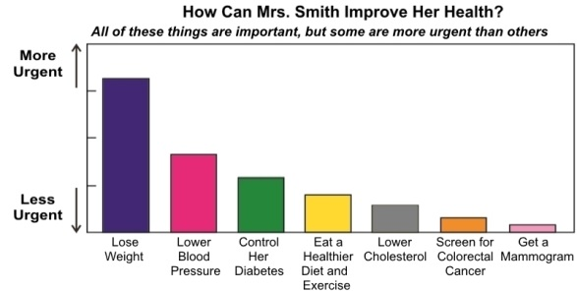 | 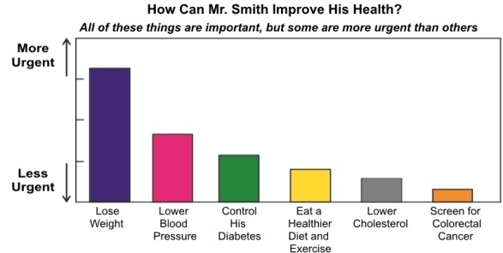

Graphic A2
Females | Males
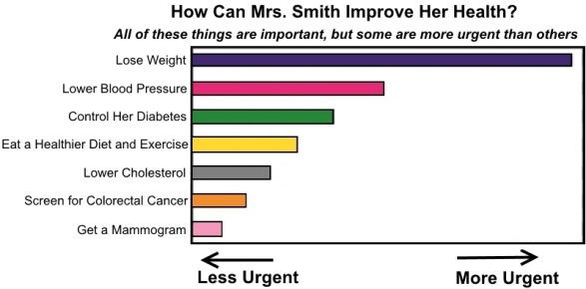 | 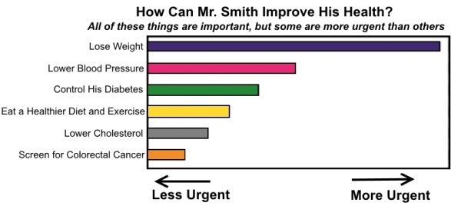

Graphic B1
Females | Males
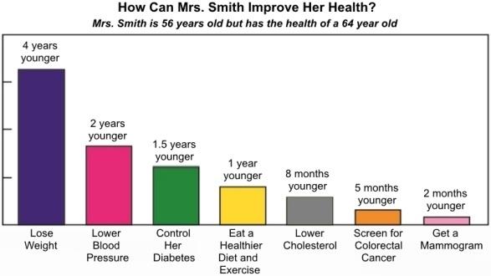 | 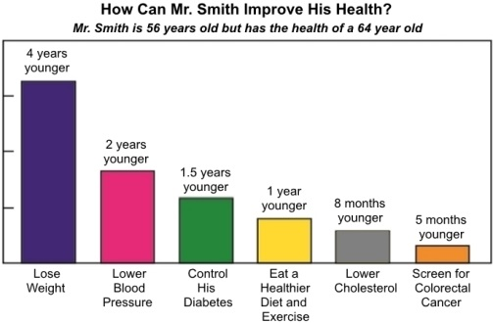

Graphic B2
Females | Males
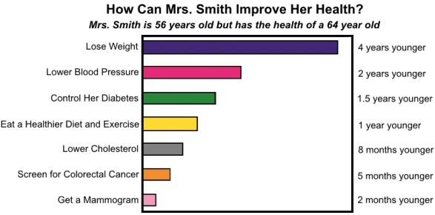 | 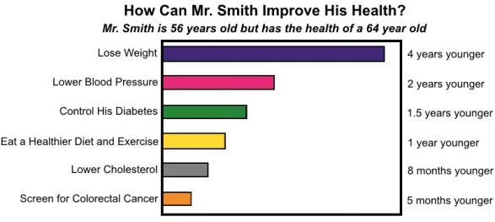

Graphic C1
Females | Males
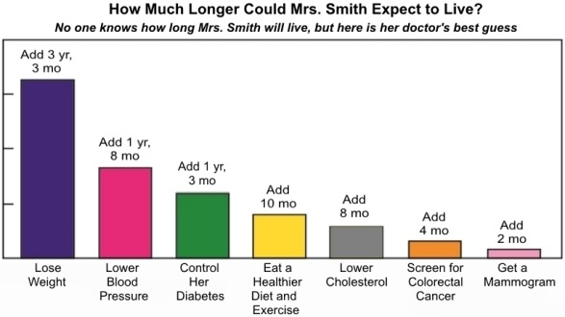 | 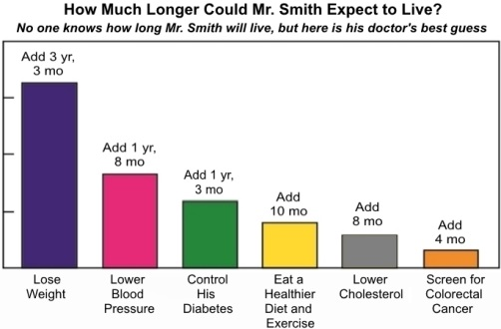

Graphic C2
Females | Males
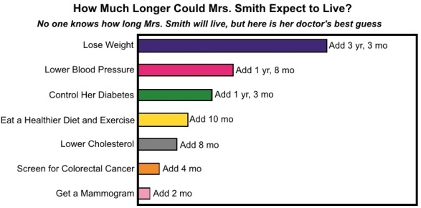 | 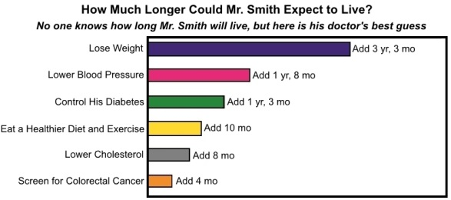

GRA-1 Image
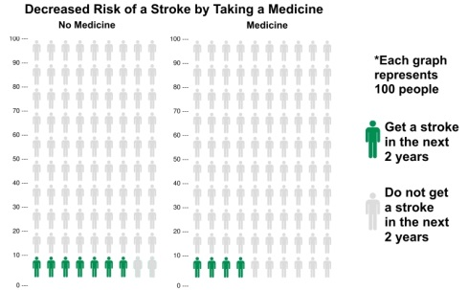

GRA-2 Image
