Institutional Policy Manual
Policy Title: Pharmacist Managed Dofetilide Ordering and Administration Policy
Policy Summary: It is the policy of Maine Medical Center (MMC) to order, dispense, administer, and monitor dofetilide (Tikosyn®) in a manner that promotes patient safety. This program requires active and coordinated participation of the following disciplines: electrophysiologists, pharmacists, nurses, and EKG technicians. Dofetilide is an anti-arrhythmic medication used for the conversion of atrial fibrillation or atrial flutter to normal sinus rhythm. Dofetilide prolongs the QTc of an electrocardiogram, possibly inducing Torsades de Pointes, a potentially fatal cardiac arrhythmia. Because of this risk, the manufacturer’s product labeling requires a mandatory minimum 3 day (6 doses) inpatient stay for initiation of dofetilide. All new, as well as some (see Appendix A) continuing patients receiving dofetilide are maintained on continuous cardiac monitoring during initiation. Transcutaneous pacing equipment must be available on the unit. MMC Department of Pharmacy dofetilide supply is to be used for all inpatients, according to the ‘Patients’ Own Medications, Practitioner Supplied Medications and Self-Administration’ Policy.
Policies:
I. New Dofetilide Patient or Chronic Dofetilide Patient Requiring Telemetry:
- Authorized Units where Dofetilide may be Initiated and Administered: CICU, R9, and R7.
- Authorized Providers: Dofetilide may be initiated to inpatients at MMC by attending Electrophysiologists of the Department of Cardiology at MMC only.
- Authorized Orders: MMC pharmacists, pursuant to this policy, enter the dofetilide orders. Dofetilide may only be ordered and administered as per this approved policy. Written orders, non-formulary orders, or orders entered by an unauthorized provider are not valid orders.
- Scheduling of Elective Admissions:
  - The authorized provider’s office will contact the Cardiology Clinical Pharmacy Specialist to coordinate admission. Every effort will be made to admit elective patients on weekdays, Monday through Wednesday, by 12:00, in order to obtain laboratory results and EKG’s in a timely manner for dose initiation and titration as necessary.
  - Patients will receive dofetilide and undergo monitoring according to Electrophysiologist, Pharmacy, Nursing, and EKG Technician Procedure statements below.

ELECTROPHYSIOLOGIST PROCEDURE:
- The authorized electrophysiologist or the MMC pharmacist will activate the ‘Dofetilide – NEW/CHRONIC PATIENT REQUIRING TELEMETRY Order Set’, which requests lab draws and 12-lead EKG monitoring. Advance Practice Providers may also initiate this order set, as requested by the authorized provider.
- MMC electrophysiologists calculate the baseline and each of the subsequent QTc measurements from the 12-lead EKGs obtained 2 hours after each administered dose. Electrophysiologists communicate the QTc value to the MMC pharmacist via CPOE documentation twice per day (approximately 08:00 from the 22:00 EKG from the prior night; and 13:00 from the 11:00 EKG); before the next dofetilide dose is due.
- Patients necessitating dose reduction late in therapy (5th or 6th dose) due to a prolonged QTc will continue to be monitored with 12 lead EKGs until the QTc falls within an acceptable range for a minimum of 2 additional doses (24 hours) after the dose reduction.

PHARMACY PROCEDURE:
- The MMC pharmacist contacts all elective patients the week prior to admission to review cost, insurance co-pays and to ensure no drug-drug interactions are present.
- The MMC pharmacist reviews and discusses the following information with the designated electrophysiologist: renal function, drug interactions, electrolyte supplementation, QTc timing and calculation, presence or absence of ventricular conduction abnormalities and other laboratory or clinical data as necessary. The MMC pharmacist manually calculates creatinine clearance to determine the correct dofetilide dose and enters the appropriate dose and interval into the electronic medical record system (see Appendix B).
- The MMC pharmacist performs and documents in the electronic medical record dofetilide medication counseling for each patient. Changes or recommendations to the dosing plan are documented in the electronic medical record for each dose. The MMC pharmacist co-monitors (in conjunction with an MMC electrophysiologist) all dofetilide doses and subsequent QTc measurements. All pharmacist-ordered dose adjustments (see Appendix B) are reviewed/confirmed with the authorized provider.
- The MMC pharmacist coordinates provision of outpatient dofetilide: once the final dose is determined, the outpatient prescription is sent to the patient’s preferred pharmacy. Inpatients receiving dofetilide beyond the initial 72 hours no longer require QTc monitoring. However, the MMC pharmacist, as well as the authorized provider must continue to review the patient profile for drug interactions; and monitor renal function for appropriateness of dosing for the duration of the time the patient receives dofetilide.

NURSING PROCEDURE:
- A 12-lead EKG will be obtained at baseline, and 2 hours after each dose of dofetilide to determine the QTc, for a minimum of 72 hours. Additional 12-lead EKG’s may be ordered for further monitoring as dictated by the MMC electrophysiologist.
- Nurses monitor potassium and magnesium lab values, and administer supplementation, per protocol.
- Nurses coordinate administration of each dofetilide dose after conferring with both MMC pharmacists and electrophysiologists. Nurses also coordinate with EKG technicians to ensure EKG’s are obtained 2 hours after each dofetilide dose, in the event a dose is administered early/late.
- Transport monitors must be used on all patients traveling for tests or procedures.

EKG TECHNICIAN PROCEDURE:
- The MMC pharmacist notifies EKG coordinators/technicians of each dofetilide admission, as well as when EKG orders will be modified within the electronic medical record.
- 12-lead EKG’s are ordered as ‘routine’ for 2 hours after each scheduled dose (11:00 and 22:00).
- EKG technicians should coordinate with nursing to ensure EKG’s are obtained 2 hours after each dose, in the event a dose is administered early/late.

II. Readmission of Patients Chronically Maintained on Dofetilide
(Patients on current outpatient dofetilide therapy, admitted under a non-authorized dofetilide provider):
- Authorized Units where Dofetilide may be Administered: Patients not meeting criteria listed in Appendix A may be admitted and receive dofetilide on any unit, as dictated by the admitting attending and the patient’s reason for admission. All patients maintained on outpatient dofetilide will be screened by an MMC pharmacist upon admission. The MMC pharmacist will review the criteria in Appendix A with the admitting attending; patients meeting any of the criteria listed in Appendix A will follow all procedures under ‘New Dofetilide Patient or Chronic Dofetilide Patient Requiring Telemetry above. The MMC pharmacist may recommend obtaining a Cardiology consult and will review chronically maintained dofetilide inpatients on other services/attendings with an MMC electrophysiologist as indicated.
- Authorized Order for Chronic Dofetilide Patients:
Any attending physician may enter a ‘Dofetilide per Pharmacy – CHRONIC Patient’ order, contained within the ‘Dofetilide – CHRONICALLY MAINTAINED PATIENT Order Set’. The MMC pharmacist will review the creatinine clearance, dofetilide dosing and drug interactions, and enter the dofetilide order into the electronic medical record, in consultation with the attending electrophysiologist or the cardiology attending on call.
- The MMC pharmacist will review compliance with Appendix A criteria, drug
interactions, electrolyte abnormalities, etc, for dofetilide throughout the patient’s
admission and will discuss appropriateness of continued therapy with providers as
necessary.
III. Interruptions in Chronic Dofetilide Therapy
- Per dofetilide prescribing information; patients requiring dofetilide re-initiation after therapy interruption (defined as 4 half-lives assuming normal renal function, or ~ 48 hours) are required to undergo the mandatory 3 day admission with telemetry monitoring as per policy statement I above.
- Patients under the care of an electrophysiologist and directed to briefly interrupt their dofetilide prior to undergoing an atrial fibrillation catheter ablation via pulmonary vein isolation may resume dofetilide at the discretion of the attending electrophysiologist without the mandated 3 day initiation as per policy statement I above.

Pharmacist Managed Dofetilide Ordering and Administration Policy
Criteria for Transfer to an Authorized Unit
Patients meeting any of the below will be admitted/transferred to an authorized unit in order to continue to receive dofetilide (R7, CICU, R9)
- Hemodynamic instability defined as: BP < 90 mm Hg; HR > 120 < 50 bpm
- Serum creatinine increase necessitating a dofetilide dosage change from current
- Necessary prescription of a NEW medication that may interfere with dofetilide metabolism/elimination
- Consecutive electrolyte disturbances of K ≤ 3.3 and/or Mg ≤ 1.4
- Expectation of prolonged NPO status

Pharmacist Managed Dofetilide Ordering and Administration Policy
Table 1. Calculation of Dofetilide Dose and Adjustment of Dose per QTc Measurements
Creatinine Clearance Calculation for Dose | Dose Per Creatinine Clearance
Males  CL_{cr} = (140-age) x ACTUAL body weight*  72 x SCr**  Females = CL_{cr} x 0.85  * Use adjusted BW if ACTUAL body weight is > 134  ** Use SCr = 1.0 for age > 70 if actual value is < 1.0 | CL_{cr} > 60 mL/min – 500 mcg q 12 hr  CL_{cr} 40-60 mL/min – 250 mcg q 12 hr  CL_{cr} < 40 mL/min – 125 mcg q 12 hr

Table 2. MMC Dofetilide Dose Adjustment Protocol
 | QTc Maximum Limits by Patient Category
 | No Conduction Abnormality | Conduction Abnormality Present | Implantable Cardioverter Defibrillator Present
Contraindicated if baseline QTc is: | > 440 | > 500 | Maximum QTc at electrophysiologists’ discretion
Decrease dose if QTc #1 is: | Increased by  > 15% from baseline  OR  > 500 | Increased by  > 15% from baseline  OR  > 550
Discontinue if QTc #2-5 are: | > 500 | > 550

Table 3. Dose Adjustment Algorithm
Initial Dose | Adjusted Dose
500 mcg q 12 hr | 250 mcg q 12 hr
250 mcg q 12 hr | 125 mcg q 12 hr
125 mcg q 12 hr | 125 mcg Daily

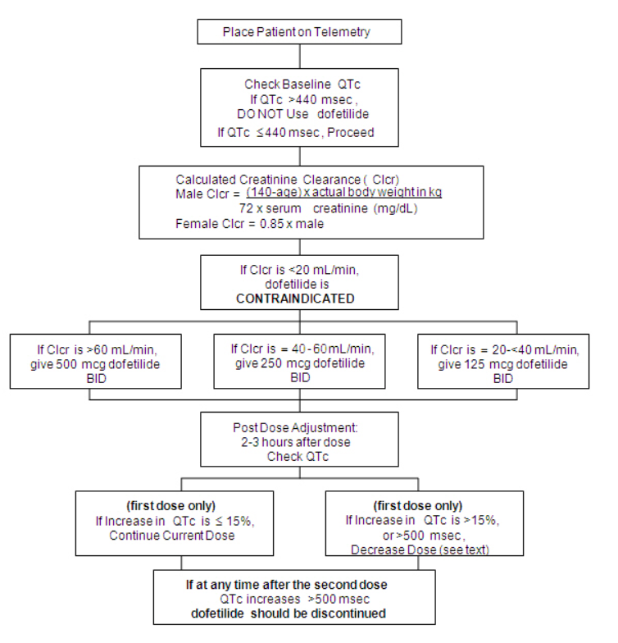
http://labeling.pfizer.com/ShowLabeling.aspx?id=639
Tikosyn Product Information, Pfizer Labs, Revised 10/2016

