Supporting Information
Fig. S1 TEM image of nanometer γ-Fe₂O₃ prepared by precipitation method. The bar length is 100 nm.
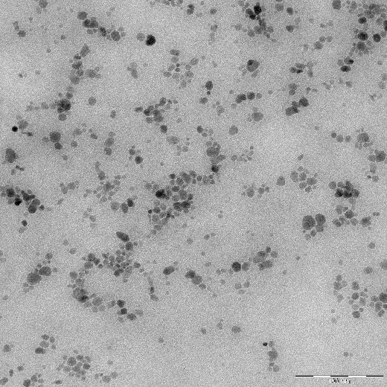

Fig. S2 The schematic of the concave meniscus-shaped capillary bridge between two equally sized particles with separation distance of $d$. The liquid bridge is defined by the blue curve. $Γ_{S,B}$ is the interfacial tension between bulk and secondary phases and $r$ is the particle radius. The three-phase contact angle $θ_{S,B}$ is calculated using the expanded Young–Dupré equation.
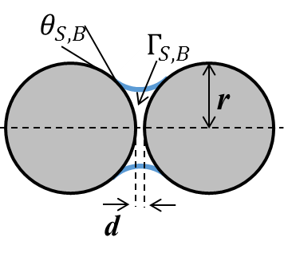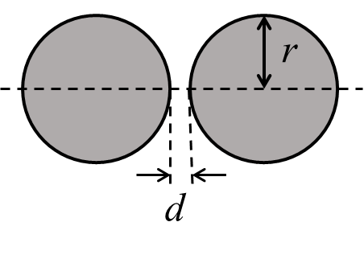

Fig. S3 Snapshots for MR suspensions with various volume fractions of CI particles with $ϱ=1$.
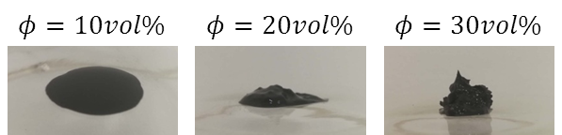

Fig. S4 Sedimentation ratio versus time for 20 vol% MRF. The sedimentation ratio is expressed as the height percentage of the particle-rich phase relative to the total fluid height.

