Supplemental Materials
Trait List
Below are characteristics that some people consider to be important qualities in a friend.

- Ambitious
- Generous
- Trustworthy
- Stable
- Active lifestyle
- Assertive
- Deals well with criticism

- Independent
- Reliable
- Affectionate
- Driven
- Good fun
- Exciting
- Broad-Minded
- Sporty and athletic
- Adventurous
- Supportive
- Sensitive
- Spontaneous

Profile Creation
In the prescreen survey that participants completed, they selected (a) three traits from the list of 19 traits that they considered most essential or desirable in an ideal friend (i.e., ideal traits), (b) three traits they considered least essential or desirable in an ideal friend (i.e., nonideal traits), and (c) three traits that best describe themselves (i.e., self-selected traits). The experimenter used the ideal and nonideal traits to create the ideal and nonideal “profiles” respectively (see Figure 1 in the main manuscript for an example). The three self-selected traits were simply part of the cover story; participants would later meet two partners at the experimental session (i.e., ostensibly other students) and would be told that their partners’ “profiles” contained these three self-selected traits.
In reality, these traits were selected by the experimenter. A day before each participant arrived for their study session, the first author created the ideal and nonideal profiles idiosyncratically for each participant. For the ideal profile, she selected two of the participant’s three ideal traits at random and placed them in two of the three slots on the profile. The remaining slot was a trait selected at random that the participant did not choose as most or least essential in an ideal friend. For example, if the participant chose “Reliable”, “Generous”, and “Stable” as her three most essential traits in an ideal friend, the three traits on the ideal profile might be “Broad-minded”, “Generous” and “Reliable”. The first author then repeated the procedure with nonideal traits for the nonideal profile.

Supplemental Table 1: Trait Frequencies
 | Prescreen |  |  | Profiles
Traits | Ideal | Nonideal |  | Ideal | Nonideal
ambitious | 12 | 29 |  | 18 | 31
generous | 14 | 1 |  | 17 | 22
trustworthy | 110 | 0 |  | 66 | 7
stable | 9 | 15 |  | 15 | 22
active lifestyle | 6 | 48 |  | 16 | 32
assertive | 0 | 55 |  | 5 | 39
deals well with criticism | 5 | 11 |  | 9 | 8
independent | 10 | 9 |  | 22 | 19
reliable | 60 | 0 |  | 46 | 8
affectionate | 13 | 19 |  | 19 | 21
driven | 11 | 8 |  | 23 | 9
good fun | 29 | 9 |  | 37 | 19
exciting | 10 | 7 |  | 23 | 15
broad-minded | 28 | 7 |  | 23 | 14
sporty and athletic | 2 | 88 |  | 3 | 47
adventurous | 24 | 10 |  | 24 | 14
supportive | 72 | 2 |  | 45 | 10
sensitive | 3 | 55 |  | 6 | 40
spontaneous | 2 | 47 |  | 6 | 46

Note. “Prescreen” columns indicate the frequency of traits selected by participants as “most essential” (ideal) and “least essential” (nonideal) in a potential friend on the prescreen survey. “Profile” columns indicate the frequency of traits that participants actually encountered on the ideal and nonideal profiles at the experimental session. After the study was completed, we were unable to locate one participant’s prescreen survey responses; thus, the total prescreen selections (420) are lower than the total profile selections (423). Profile frequencies can exceed the prescreen frequencies for a given trait because each trait was occasionally selected as one of the two random traits on the profile.

In-Person Confederate Script

PICTURE SET 1

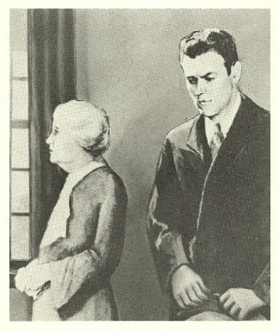
Picture 7
There’s a woman and a man in a room. Uh the woman seems to be older. She’s shorter than the man. Uh she looks a little worried or concerned. Her hair is tied up in like a little bun or an up-do. The man is stern looking and he looks worried as well. And he’s dressed in very proper clothes and he’s holding a hat.

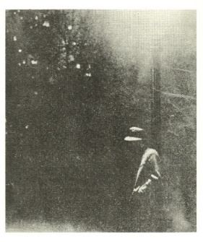
Picture 29
Ummm This looks more like a photograph also very dark. A man or a person of some sort is walking down a street and there is like a.. some… foliage behind him maybe? And then a fence? Umm this person is wearing a hat and a coat. His hands are in his pockets. And then there is a flair from the lighting.

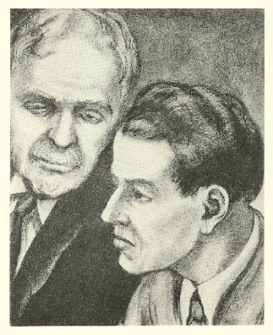
Picture 9
There are 2 men-- one older with white hair and a mustache, the other one younger with dark hair. Uhm, both of them are wearing suits. It looks as if they were sitting next to each other at an event and perhaps the older man was going to turn his head to say something to the younger man. Uhm, Again, they’re both in suits. (Pause) Uhm the younger man has kind of a prominent nose. Uhh..Yeah, that’s it.

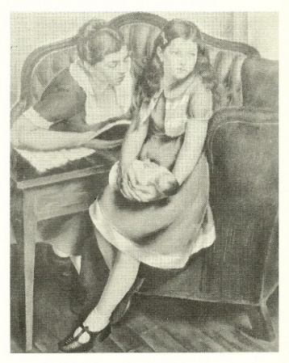
Picture 10
There is a woman and a girl sitting on a couch. The woman is looking at the girl. Uh she is wearing a dark shirt with a light collar, almost like a maid uniform. And the girl is dresses in a nice dress and um…shoes with a little platform. And she’s holding a doll.

PICTURE SET 2
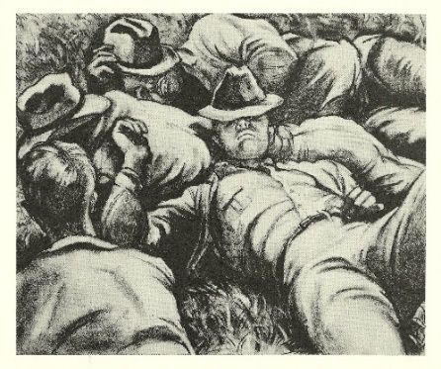
Picture 13

There’s a group of 4 men, 3 of them are laying down. One we can’t see his face, but the other three we can. Uhm three of them are wearing hats, it looks like they’re in a field. And it’s some sort of uniform. Maybe they were uhm..i don’t know (pause) farming. No, not farming. Like they were fighting in a war and they just laid down to take a rest. Uhm, yeah.

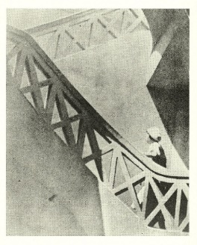
Picture 21

The picture is a black and white drawing of a person going up the stairs… these are big stairs…um the stairs are white. The stairs have big x’s on them…ornamental x’s…I cant tell if this person is a man or woman. It kind of looks like a young.. younger girl and she’s wearing a white hat.. I think a white dress

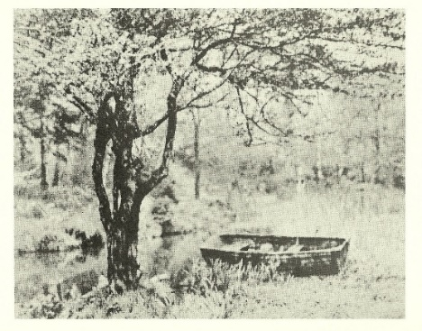
Picture 19

There’s like a boat.. But it’s like not in the water and there’s a uh tree. Or a lot of trees…. There are no people around…… And uh yeah the picture is pretty empty. There’s uh water, and a boat, and some trees…. And grass.

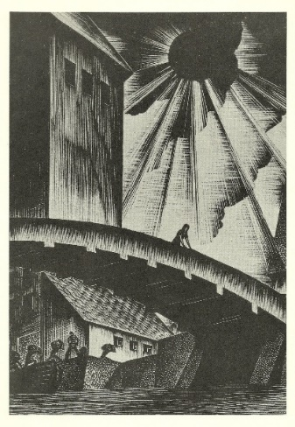
Picture 25
There’s a bridge and there’s a women standing on top of the bride. Water is running under it, there’s a boat. And then a bunch of men who are carrying things on their shoulders, so it’s probably a dock. They’re unloading stuff, carrying it to a building. There’s a huge building behind them all and then there’s a sun that looks like it’s being blacked out. Uhm probably a port and they’re unloading goods.
Online Chat Confederate Script
PICTURE SET 1
Picture 7
There’s a woman and a man in a room
the woman seems to be older…she’s shorter than the man
She looks a little worried or concerned
Her hair is tied up
in like a little bun
or an up do
The man is stern looking
he looks worried as well
And he’s dressed in very proper clothes
he’s holding a hat

Picture 29
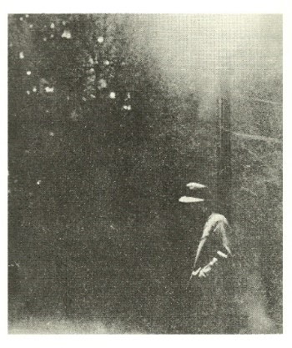
This looks more like a photograph
Very dark
A man or a person is walking down a street
and there is like a
foliage?
behind him maybe?
And then a fence?
He’s wearing a hat and a coat
His hands are in his pockets
And there’s a flare from the lighting.

Picture 9
There are 2 men
one older with white hair
and a mustache
the other one younger with dark hair
both of them are wearing suits
It looks as if they were sitting next to each other
at an event
and perhaps the older man was going to turn his head to say something
to the younger man
Again, they’re both in suits
Uhm the younger man has kind of a prominent nose
Yeah

Picture 10
There is a woman and a girl sitting on a couch
The woman is looking at the girl
She’s wearing a dark shirt with a light collar
almost like a maid uniform
The girl’s in a nice dress
And, uhm
shoes with a little platform
And she’s holding a doll

PICTURE SET 2
Picture 13

There’s a group of four men
three of them are laying down
One we can’t see his face, but the other three we can
three of them are wearing hats
it looks like they’re in a field
And it’s some sort of uniform
Maybe they were farming
idk
No, like they were fighting in a war
and they just laid down to take a rest
yeah

Picture 21
The picture is a black and white drawing of a person going up the stairs
these are big stairs
the stairs are white
They have big x’s on them
ornamental x’s
I cant tell if this person is a man or woman
It kind of looks like a younger girl and she’s wearing a white hat
I think a white dress

Picture 19
There’s a boat
But it’s like
not in the water
there’s a tree, or a lot of trees
there isn’t anyone around
Yeah…the picture is pretty empty
There’s water and a boat
some trees and grass

Picture 25

There’s a bridge and there’s a women standing on top of the bride
Water is running under it
there’s a boat
Bunch of men are carrying things on their shoulders
it’s probably a dock
They’re unloading stuff
Carrying it to a building
There’s a huge building behind them
there’s a sun that looks like it’s being blacked out
probably a port
they’re unloading goods

Post-Profile Partner Impression Questionnaire

Please use the rating scale below to indicate the extent to which you agree with the following statements. If you feel unsure about your answer to a specific question, just give it your best guess.

1 2 3 4 5 6 7 8 9
Strongly Disagree Neutral Strongly Agree

- I would be excited to get to know my interaction partner better
- I really like my interaction partner
- I would be interested in hanging out with my interaction partner
- I think my interaction partner is very much like my ideal friend
- The 3 characteristics chosen by my interaction partner are probably accurate in
describing him/her

Please recall the 3 characteristics (in no particular order) that your interaction partner said best described him/her (if you can’t remember the exact word, give a synonym or take your best guess).

____________________ _____________________ ____________________

INSTRUCTIONS: Any behavior can be described in many ways. For example, one person might describe a behavior as "writing a paper," while another person might describe the same behavior as "pushing keys on the keyboard." Yet another person might describe it as "expressing thoughts." This next task focuses on your personal preferences for how a number of different behaviors should be described.

In a moment, you will see several behaviors listed. After each behavior will be two different ways in which the behavior might be identified. For example:

Attending class
A. Sitting in a chair
B. Looking at a teacher

Your task is to imagine YOUR INTERACTION PARTNER engaging in each behavior, and choose the identification, A or B, that best describes the behavior of your partner. Please circle only one identification for each question. Remember, select the description that you personally believe is more appropriate in describing YOUR PARTNER for each behavior.

1. Imagine your partner… Making a list
Is your partner:
A. Getting organized
B. Writing things down

2. Imagine your partner… Reading
Is your partner:
A. Following lines of print
B. Gaining knowledge

3. Imagine your partner… Washing clothes
Is your partner:
A. Removing odors from clothes
B. Putting clothes into the machine

4. Imagine your partner… Picking an apple
Is your partner:
A. Getting something to eat
B. Pulling an apple off a branch

5. Imagine your partner… Measuring a room for carpeting
Is your partner:
A. Getting ready to remodel
B. Using a yard stick

6. Imagine your partner… Painting a room
Is your partner:
A. Applying brush strokes
B. Making the room look fresh

7. Imagine your partner… Paying the rent
Is your partner:
A. Maintaining a place to live
B. Writing a check

8. Imagine your partner… Locking a door
Is your partner:
A. Putting a key in the lock
B. Securing the house

9. Imagine your partner… Voting
Is your partner:
A. Influencing the election
B. Marking a ballot

10. Imagine your partner… Climbing a tree
Is your partner:
A. Getting a good view
B. Holding on to branches

11. Imagine your partner… Toothbrushing
Is your partner:
A. Preventing tooth decay
B. Moving a brush around in her mouth

12. Imagine your partner… Greeting someone
Is your partner:
A. Saying hello
B. Showing friendliness

13. Imagine your partner… Eating
Is your partner:

A. Getting nutrition
B. Chewing and swallowing

14. Imagine your partner… Traveling by car
Is your partner:
A. Following a map
B. Seeing countryside

15. Imagine your partner… Pushing a doorbell
Is your partner:
A. Moving a finger
B. Seeing if someone's home

Post-Interaction Partner Impression Questionnaire

Please use the rating scale below to indicate the extent to which you agree with the following statements. If you feel unsure about your answer to a specific question, just give it your best guess.

1 2 3 4 5 6 7 8 9
Strongly Disagree Neutral Strongly Agree

- I would be excited to get to know my interaction partner better
- I really like my interaction partner
- I would be interested in hanging out with my interaction partner
- I think my interaction partner is very much like my ideal friend
- The 3 characteristics chosen by my interaction partner are probably accurate in
describing him/her
INSTRUCTIONS: Any behavior can be described in many ways. For example, one person might describe a behavior as "writing a paper," while another person might describe the same behavior as "pushing keys on the keyboard." Yet another person might describe it as "expressing thoughts." This next task focuses on your personal preferences for how a number of different behaviors should be described.

In a moment, you will see several behaviors listed. After each behavior will be two different ways in which the behavior might be identified. For example:

Attending class
A. Sitting in a chair
B. Looking at a teacher

Your task is to imagine YOUR INTERACTION PARTNER engaging in each behavior, and choose the identification, A or B, that best describes the behavior of your partner. Please circle only one identification for each question. Remember, select the description that you personally believe is more appropriate in describing YOUR PARTNER for each behavior.

1. Imagine your partner… Making a list
Is your partner:
A. Getting organized
B. Writing things down

2. Imagine your partner… Reading
Is your partner:
A. Following lines of print
B. Gaining knowledge

3. Imagine your partner… Washing clothes
Is your partner:
A. Removing odors from clothes
B. Putting clothes into the machine

4. Imagine your partner… Picking an apple
Is your partner:
A. Getting something to eat
B. Pulling an apple off a branch

5. Imagine your partner… Measuring a room for carpeting
Is your partner:
A. Getting ready to remodel
B. Using a yard stick

6. Imagine your partner… Painting a room
Is your partner:
A. Applying brush strokes
B. Making the room look fresh

7. Imagine your partner… Paying the rent
Is your partner:
A. Maintaining a place to live
B. Writing a check

8. Imagine your partner… Locking a door
Is your partner:
A. Putting a key in the lock
B. Securing the house

9. Imagine your partner… Voting
Is your partner:
A. Influencing the election
B. Marking a ballot

10. Imagine your partner… Climbing a tree
Is your partner:
A. Getting a good view
B. Holding on to branches

11. Imagine your partner… Toothbrushing
Is your partner:
A. Preventing tooth decay
B. Moving a brush around in her mouth

12. Imagine your partner… Greeting someone
Is your partner:
A. Saying hello
B. Showing friendliness

13. Imagine your partner… Eating
Is your partner:
A. Getting nutrition
B. Chewing and swallowing

14. Imagine your partner… Traveling by car
Is your partner:
A. Following a map
B. Seeing countryside

15. Imagine your partner… Pushing a doorbell
Is your partner:
A. Moving a finger
B. Seeing if someone's home

Final Questionnaire*
*Measures have not been analyzed.
Below are characteristics that some people consider to be important qualities in a friend. Please rate the extent to which the following characteristics describe your ideal friend:
1 2 3 4 5 6 7 8 9
Not at all Extremely

- Ambitious
- Generous
- Trustworthy
- Stable
- Active lifestyle
- Assertive
- Deals well with criticism
- Independent
- Reliable
- Affectionate
- Driven
- Good fun
- Exciting
- Broad-Minded
- Sporty and athletic
- Adventurous
- Supportive
- Sensitive
- Spontaneous

We are interested in what you learned about the other participant during the interaction that you just had. For each of the characteristics listed below, indicate how much you learned about your partner during the interaction with respect to that characteristic.

1 2 3 4 5 6 7 8 9
“I learned nothing “I learned a great deal
about this characteristic” about this characteristic”

For example, if you learned nothing from the interaction about whether or not your partner is “adventurous”, then you would put a low number for #16.
However, if you learned a lot from the interaction about whether or not your partner is “adventurous”, you would put a high number for #16.

- Ambitious
- Generous
- Trustworthy
- Stable
- Active lifestyle
- Assertive
- Deals well with criticism
- Independent
- Reliable
- Affectionate
- Driven
- Good fun
- Exciting
- Broad-Minded
- Sporty and athletic
- Adventurous
- Supportive
- Sensitive
- Spontaneous

Order effects
Finally, we wanted to confirm that our key patterns observed in Figures 2 and 3 (in the main text) were not moderated by the order in which participants completed the two tasks (i.e., in-person vs. online interaction). For the in-person interaction, the three-way interaction of Ideal-Perceived Trait Match (ideal vs. non-ideal) × Assessment (post-profile vs. post-interaction) × Order (first vs. second) revealed a nonsignificant three-way interaction F(1,127)=1.04, p=.310, η_{G}²=.002, , η_{p}²=.008, 90% CI(.000, .052), and the key Ideal × Assessment interaction remained significant, F(1,127)=6.52, p=.012, η_{G}²=.010, η_{p}²=.049, 90% CI(.006, .121). For the online interaction, the same three-way interaction was also nonsignificant, F(1,128)=0.70, p=.404, η_{G}²=.001, η_{p}²=.005, 90% CI(.000, .045), and again the key Ideal × Assessment interaction remained significant, F(1,128)=11.92, p=.001, η_{G}²=.017, η_{p}²=.085, 90% CI(.023, .168). Thus, order did not qualify the key effects reported in the main text.

