Supplementary material
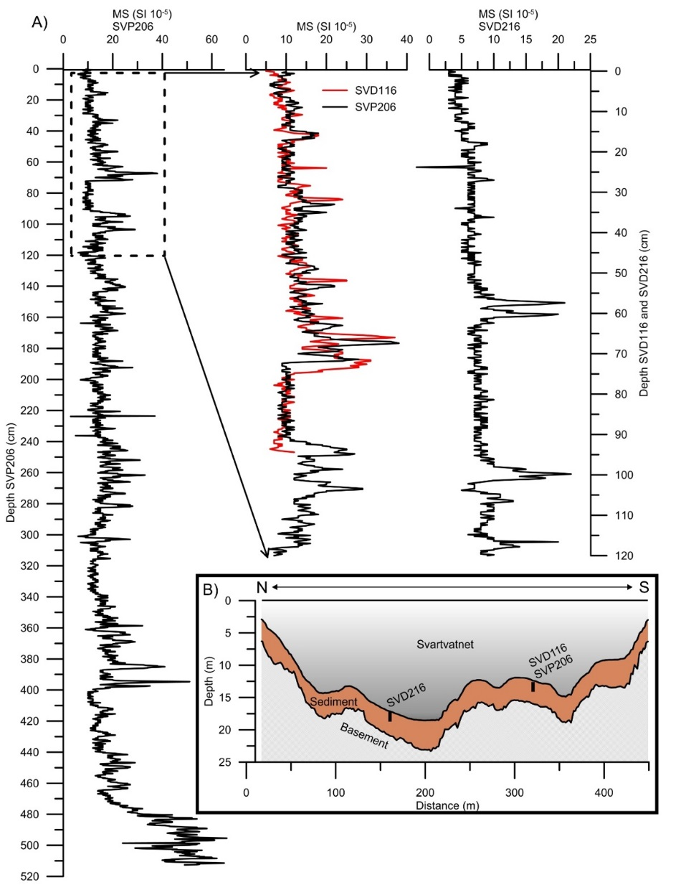
Fig. I: A) Results from the MS measurements of SVP206, SVD116 and SVD216. The results suggest that the piston core contains the topmost sediment of Svartvatnet. B) Cross-section of the north-south transect (N to S) from Fig. 2 showing the mapped draped sediment infill in Svartvatnet and the location of the cores.

