Supplementary material
a)
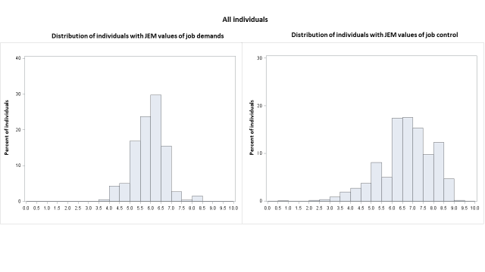b)
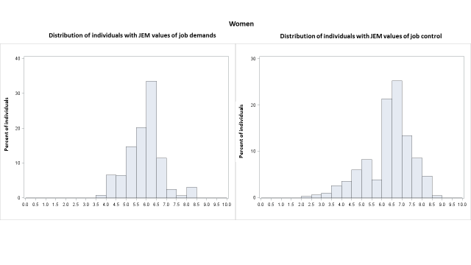c)
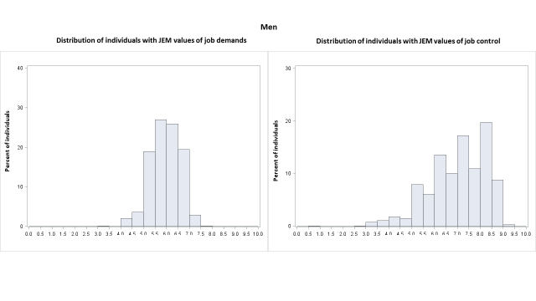

Supplementary figure 1. Histograms of the rates of individuals with different Job Exposure Matrix values (x-axis) for job demands and job control, respectively, among a) all individuals in paid work in 2001 in Sweden (n=2 194 694), b) women (n=1 082 490), and c) men (n=1 112 204)

Supplementary table 1. Questions used to construct the Job Exposure Matrix for psychosocial job demands and control in Sweden, from Fredlund et al., 2001.

Demands:
- Is it at times so stressful that you don’t have time to talk or even think about anything other than work?
- Do you sometimes have so much to do that you have to skip lunches, work overtime, or bring your work home?
- Does your work demand all your attention and concentration?
- To what degree of your working time do you have such difficult tasks that you need help?
Control:
- Are you partly able to determine yourself when different tasks are to be done (e.g. by choosing to work a little faster some days and a bit easier other days?)
- Do you have the possibility to determine your own pace at work?
- Are you able to take short breaks essentially any time to talk?
- Are you ever part of deciding your working arrangements (e.g. what shall be done, how it shall be done, or who shall work with you)?
- Does your work sometimes require you to repeat the same work task several times an hour?

Supplementary table 2. Adjusted¹ odds ratios² (OR) with 95% confidence intervals (CI) of long-term sickness absence (SA)/disability pension(DP) or unemployment as opposed to not, presented for all people in paid work in Sweden in 2001 (N=2 194 694), as well as for women (N=1 082 490) and men (N=1 112 204)
 | SA and/or DP >183 net days | Unemployed >183 days
 | Adjusted OR (95% CI) | Adjusted OR (95% CI)
All
Sex
Women | 2.89 (2.83-2.96) | 0.80 (0.78-0.81)
Men | Ref | Ref
Age group
25-34 years | 0.59 (0.57-0.61) | 0.86 (0.84-0.88)
35-44 years | Ref | Ref
45-54 years | 1.42 (1.40-1.45) | 0.97 (0.95-0.99)
Birth country
Sweden | Ref | Ref
Other Nordic country | 1.13 (1.09-1.18) | 1.28 (1.22-1.34)
Other EU25 | 1.20 (1.13-1.27) | 1.88 (1.77-2.00)
Rest of world | 1.38 (1.34-1.43) | 3.94 (3.84-4.05)
Type of living area
Large cities | Ref | Ref
Medium-sized towns | 1.13 (1.11-1.16) | 1.63 (1.59-1.66)
Small towns/rural | 1.26 (1.23-1.29) | 2.00 (1.95-2.04)
Educational level
University/college | 0.79 (0.77-0.81) | 0.50 (0.49-0.51)
High school | Ref | Ref
Elementary education | 1.26 (1.24-1.29) | 1.11 (1.09-1.14)
Family situation
Maried with children | Ref | Ref
Married without children | 1.27 (1.24-1.31) | 1.26 (1.22-1.20)
Single with children | 1.50 (1.46-1.53) | 2.01 (1.95-2.07)
Single without children | 1.41 (1.38-1.44) | 2.36 (2.32-2.41)
Women
Age group
25-34 years | 0.60 (0.58-0.62) | 0.91 (0.88-0.94)
35-44 year | Ref | Ref
45-54 years | 1.39 (1.36-1.42) | 0.85 (0.82-0.88)
Birth country
Sweden | Ref | Ref
Other Nordic country | 1.12 (1.07-1.17) | 1.26 (1.18-1.35)
Other EU25 | 1.15 (1.07-1.23) | 2.37 (2.20-2.57)
Rest of world | 1.24 (1.19-1.29) | 3.80 (3.65-3.95)
Type of living area
Large cities | Ref | Ref
Medium-sized towns | 1.16 (1.14-1.19) | 1.73 (1.67-1.79)
Small towns/rural | 1.29 (1.25-1.32) | 2.10 (2.03-2.18)
Educational level
University/college | 0.84 (0.81-0.86) | 0.48 (0.46-0.50)
High school | Ref | Ref
Elementary education | 1.28 (1.24-1.32) | 1.21 (1.16-1.25)
Family situation
Married with children | Ref | Ref
Married without children | 1.25 (1.22-1.29) | 1.26 (1.20-1.32)
Single with children | 1.50 (1.46-1.54) | 2.06 (1.99-2.13)
Single without children | 1.39 (1.36-1.43) | 2.22 (2.15-2.30)
Men
Age group
25-34 years | 0.56 (0.53-0.59) | 0.83 (0.81-0.86)
35-44 years | Ref | Ref
45-54 years | 1.56 (1.51-1.62) | 1.07 (1.04-1.10)
Birth country
Sweden | Ref | Ref
Other Nordic country⁴ | 1.18 (1.08-1.28) | 1.30 (1.23-1.38)
Other EU25 | 1.36 (1.22-1.53) | 1.46 (1.34-1.60)
Rest of world | 1.76 (-166-1.87) | 3.92 (3.79-4.06)
Type of living area
Large cities | Ref | Ref
Medium-sized towns | 1.04 (1.00-1.08) | 1.57 (1.52-1.61)
Small towns/rural | 1.16 (1.12-1.21) | 1.94 (1.88-2.00)
Educational level
University/college | 0.64 (0.61-0.68) | 0.50 (0.49-0.52)
High school | Ref | Ref
Elementary education | 1.19 (1.14-1.24) | 1.04 (1.01-1.07)
Family situation
Married with children | Ref | Ref
Married without children | 1.37 (1.29-1.45) | 1.28 (1.22-1.34)
Single with children | 1.49 (1.38-1.61) | 1.77 (1.67-1.87)
Single without children | 1.44 (1.39-1.49) | 2.46 (2.40-2.52)
¹Mutually adjusted for sex, age, birth country, education, type of living area, family situation, job demands/job control group.
²Using multinomial logistic regression, those with no long-term SA/DP or unemployment used as reference.

