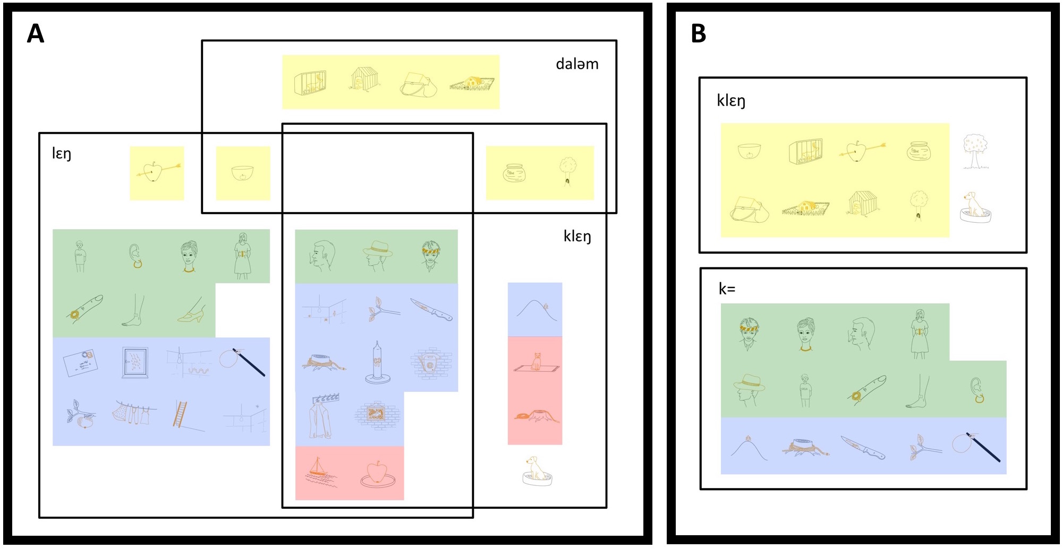
Figure 2A. Extension map of the use of klɛŋ, lɛŋ and daləm by the Jedek monolinguals. Figure 2B. Extension map of the use of klɛŋ and k= by the Jahai monolinguals. Yellow=containment scenes; green=body-part-as-Ground scenes; blue=attachment scenes; red=superjacent scenes. Lines indicate scenes labeled with a TRM by more than 33% of speakers.

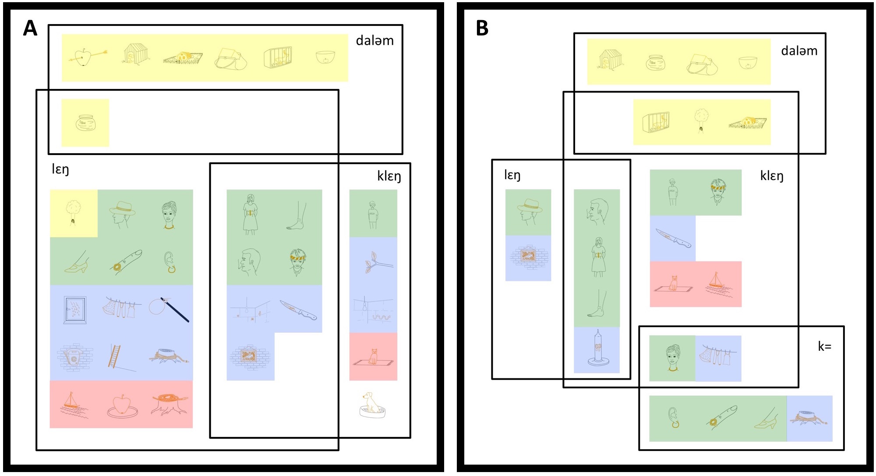
Figure 3A. Id-Jedek bilinguals’ use of klɛŋ, lɛŋ and daləm in Jedek.
Figure 3B. Id-Jedek bilinguals’ use of klɛŋ, lɛŋ, daləm and k= in Jahai. Yellow=containment scenes; green=body-part-as-Ground scenes; blue=attachment scenes; red=superjacent scenes. Lines indicate scenes labeled with a TRM by more than 33% of speakers.

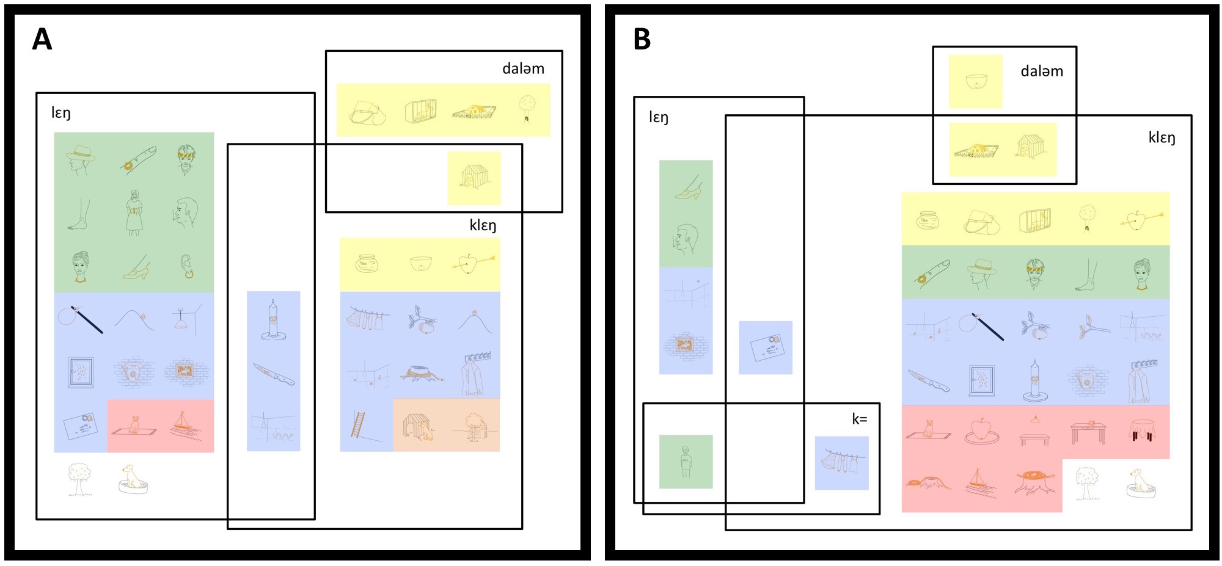
Figure 4A. Id-Jahai bilinguals’ use of klɛŋ, lɛŋ and daləm in Jedek.
Figure 4B. Id-Jahai bilinguals’ use of klɛŋ, lɛŋ, daləm and k= in Jahai. Yellow=containment scenes; green=body-part-as-Ground scenes; blue=attachment scenes; red=superjacent scenes; orange=adjacent scenes. Lines indicate scenes labeled with a TRM by more than 33% of speakers.

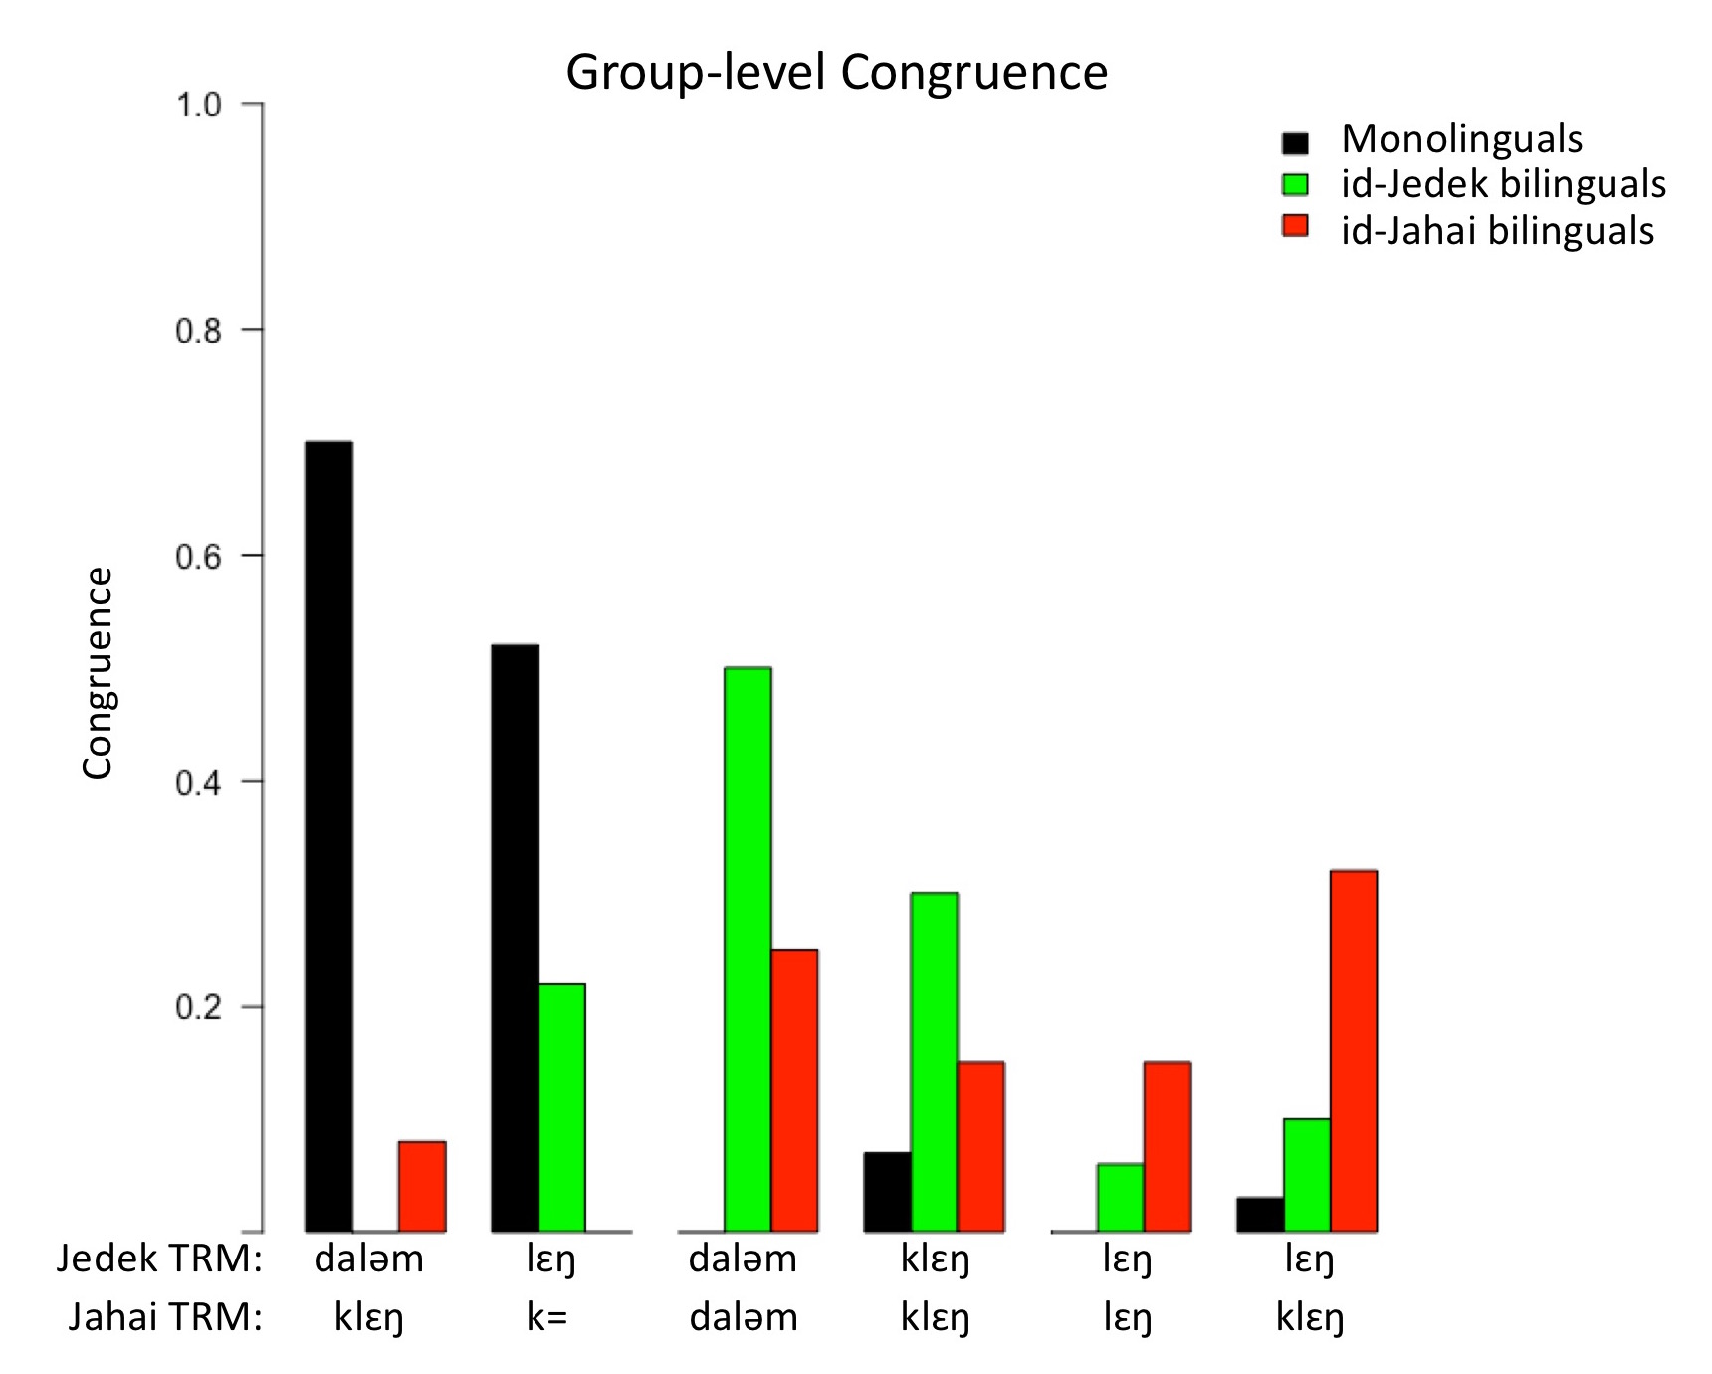
Figure 5. Group-level congruence of TRM pairs for the three groups.

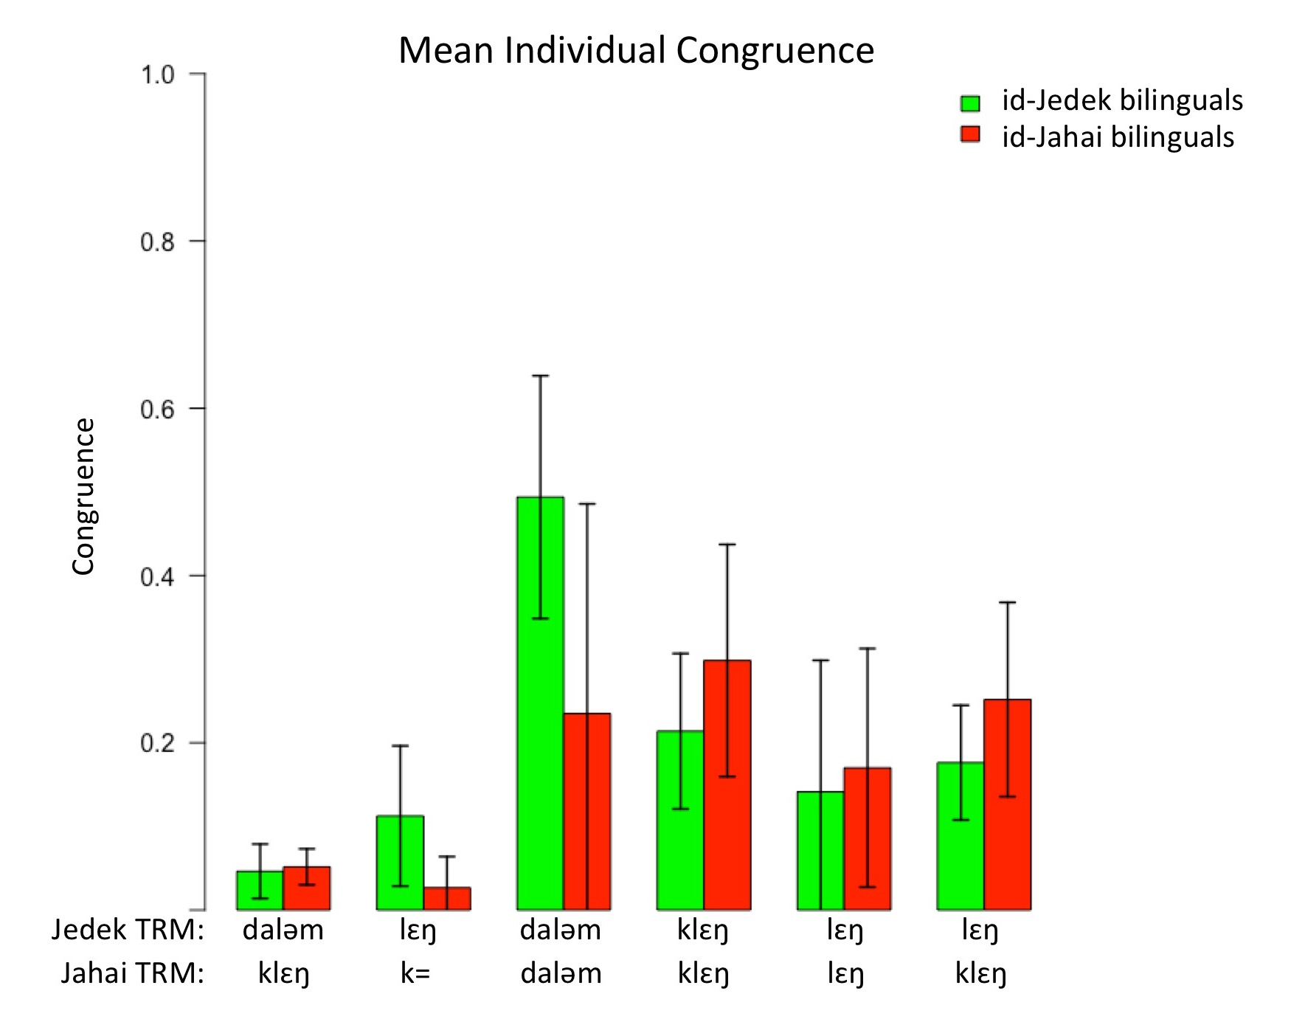
Figure 6. Mean individual congruence of TRM pairs for the two bilingual groups.

