**Supplementary Figure 1.** Flowchart Illustrating Literature Search and Exclusion Process (PRISMA Diagram)

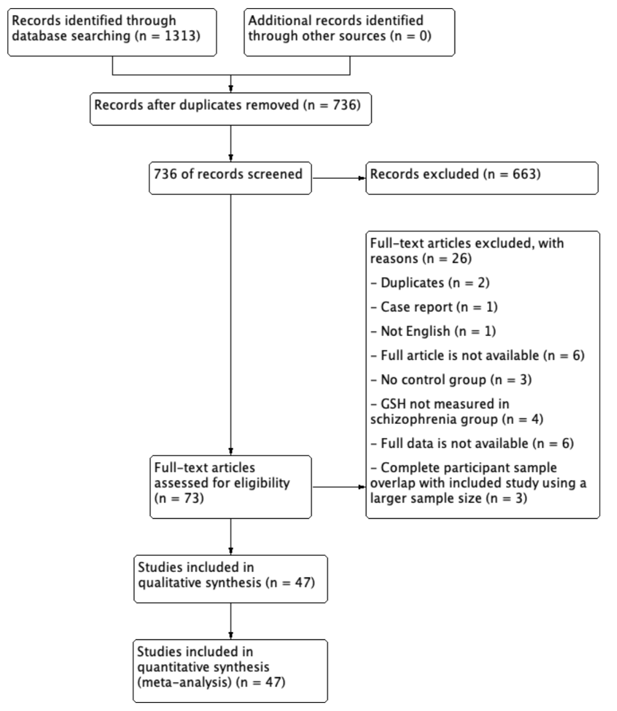

**Supplementary Figure 2.** Risk of Bias Summary of Included Studies

Each risk of bias is as follows: “selection of participants” was “high” for one study, which had no information about selection of participants; “confounding variables” was “high” for five studies, which did not match participants’ demographics; “confounding variables” was “unclear” for eight studies since they had insufficient information about participants’ demographics; “measurement of exposure” was high for nine studies, which did not diagnose with structured interview; “blinding of outcome assessments” and “incomplete outcome data” were considered “low”; "selective outcome reporting" was “unclear” for all studies since we could not obtain experimental protocols.





**Supplementary Figure 3.** The results of subgroup analyses.

(a) Whole blood GSH were lower in patients with SZ than in HCs (k=12, SMD=-1.15, CI=-1.77 to -0.52, *P*<0.001); (b) erythrocyte GSH showed trend to be lower in patients with SZ compared to HCs (k=5, SMD=-0.685, CI=-1.18 to -0.19, *P*=0.006); (c) plasma/serum GSH levels were lower in patients with SZ than in HCs (k=6, SMD=-1.23, CI=-1.90 to -0.57, *P*<0.001); (d) GSH levels in the ACC measured with 1H-MRS significantly decreased in patients with SZ compared to HCs ((k=10, SMD=-0.24, CI=-0.38 to 0.10, P=0.001); (e) Plasma/serum tGSH levels showed a trend-toward decrease in patients with SZ than in HCs (k=5, SMD=-0.56, CI=-1.12 to -0.002, P=0.049); (f) GSH levels were lower (n=7, SMD=-1.45, CI=-2.40 to -0.50, *P*=0.003) in unmedicated patients with SZ compared to HCs; (g) tGSH levels showed trend to be lower (n=5, SMD=-0.66, CI=-1.15 to -0.16, *P*=0.010) in unmedicated patients with SZ compared to HCs; (h) GSH levels were lower (k=17, SMD=-0.69, CI=-1.00 to -0.37, P<0.001) in medicated patients with SZ than HCs; (i) tGSH levels did not differ (n=5, SMD=-0.62, CI=-1.64 to 0.39, *P*=0.230) in medicated patients with SZ compared to those in HCs; (j) There was no difference in GSH levels between patients with FEP and HCs (k=11, SMD=-0.20, CI=-0.41 to 0.01, P=0.068).

1. **GSH levels in whole blood**

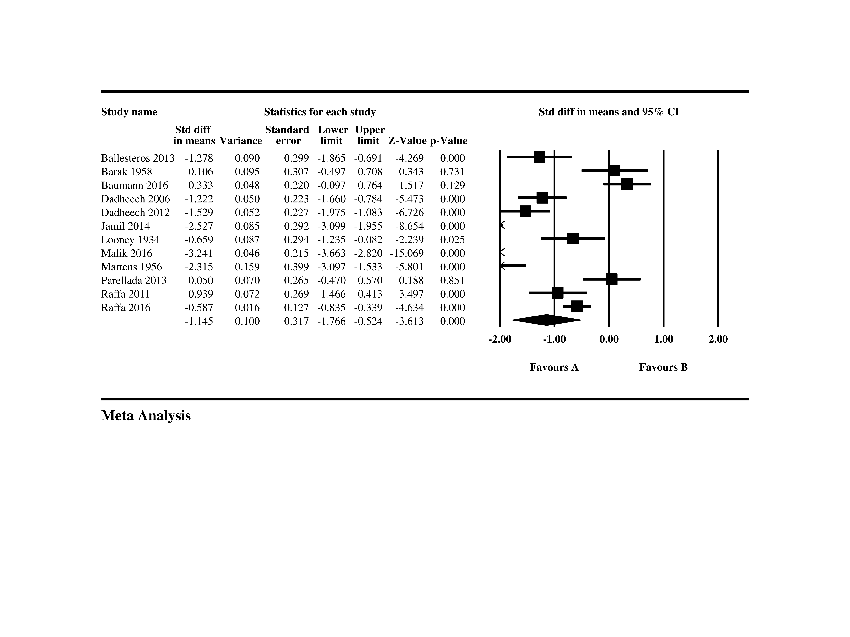

1. **GSH levels in erythrocyte**

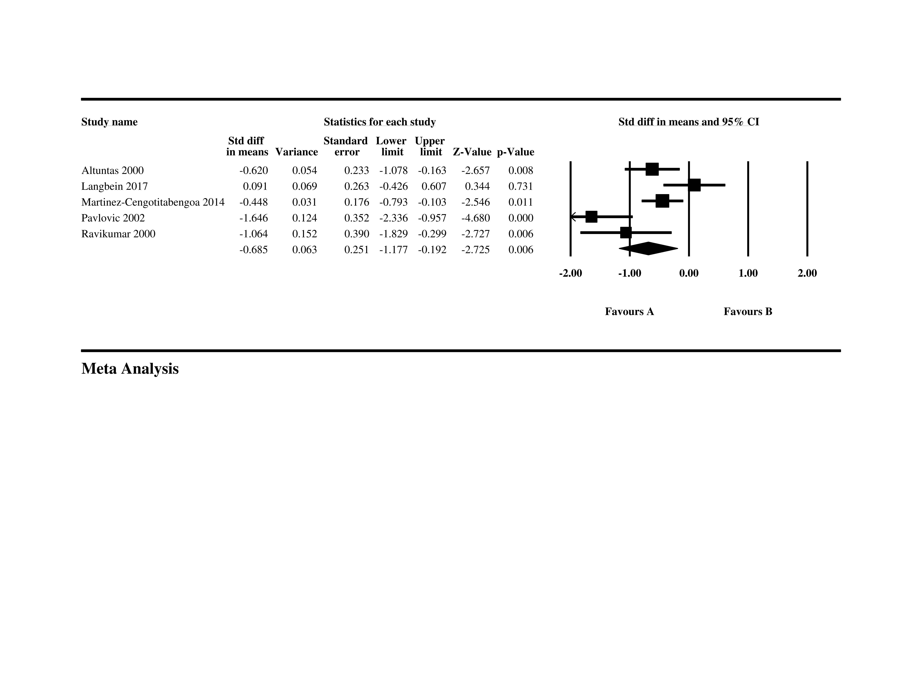

1. **GSH levels in plasma or serum**

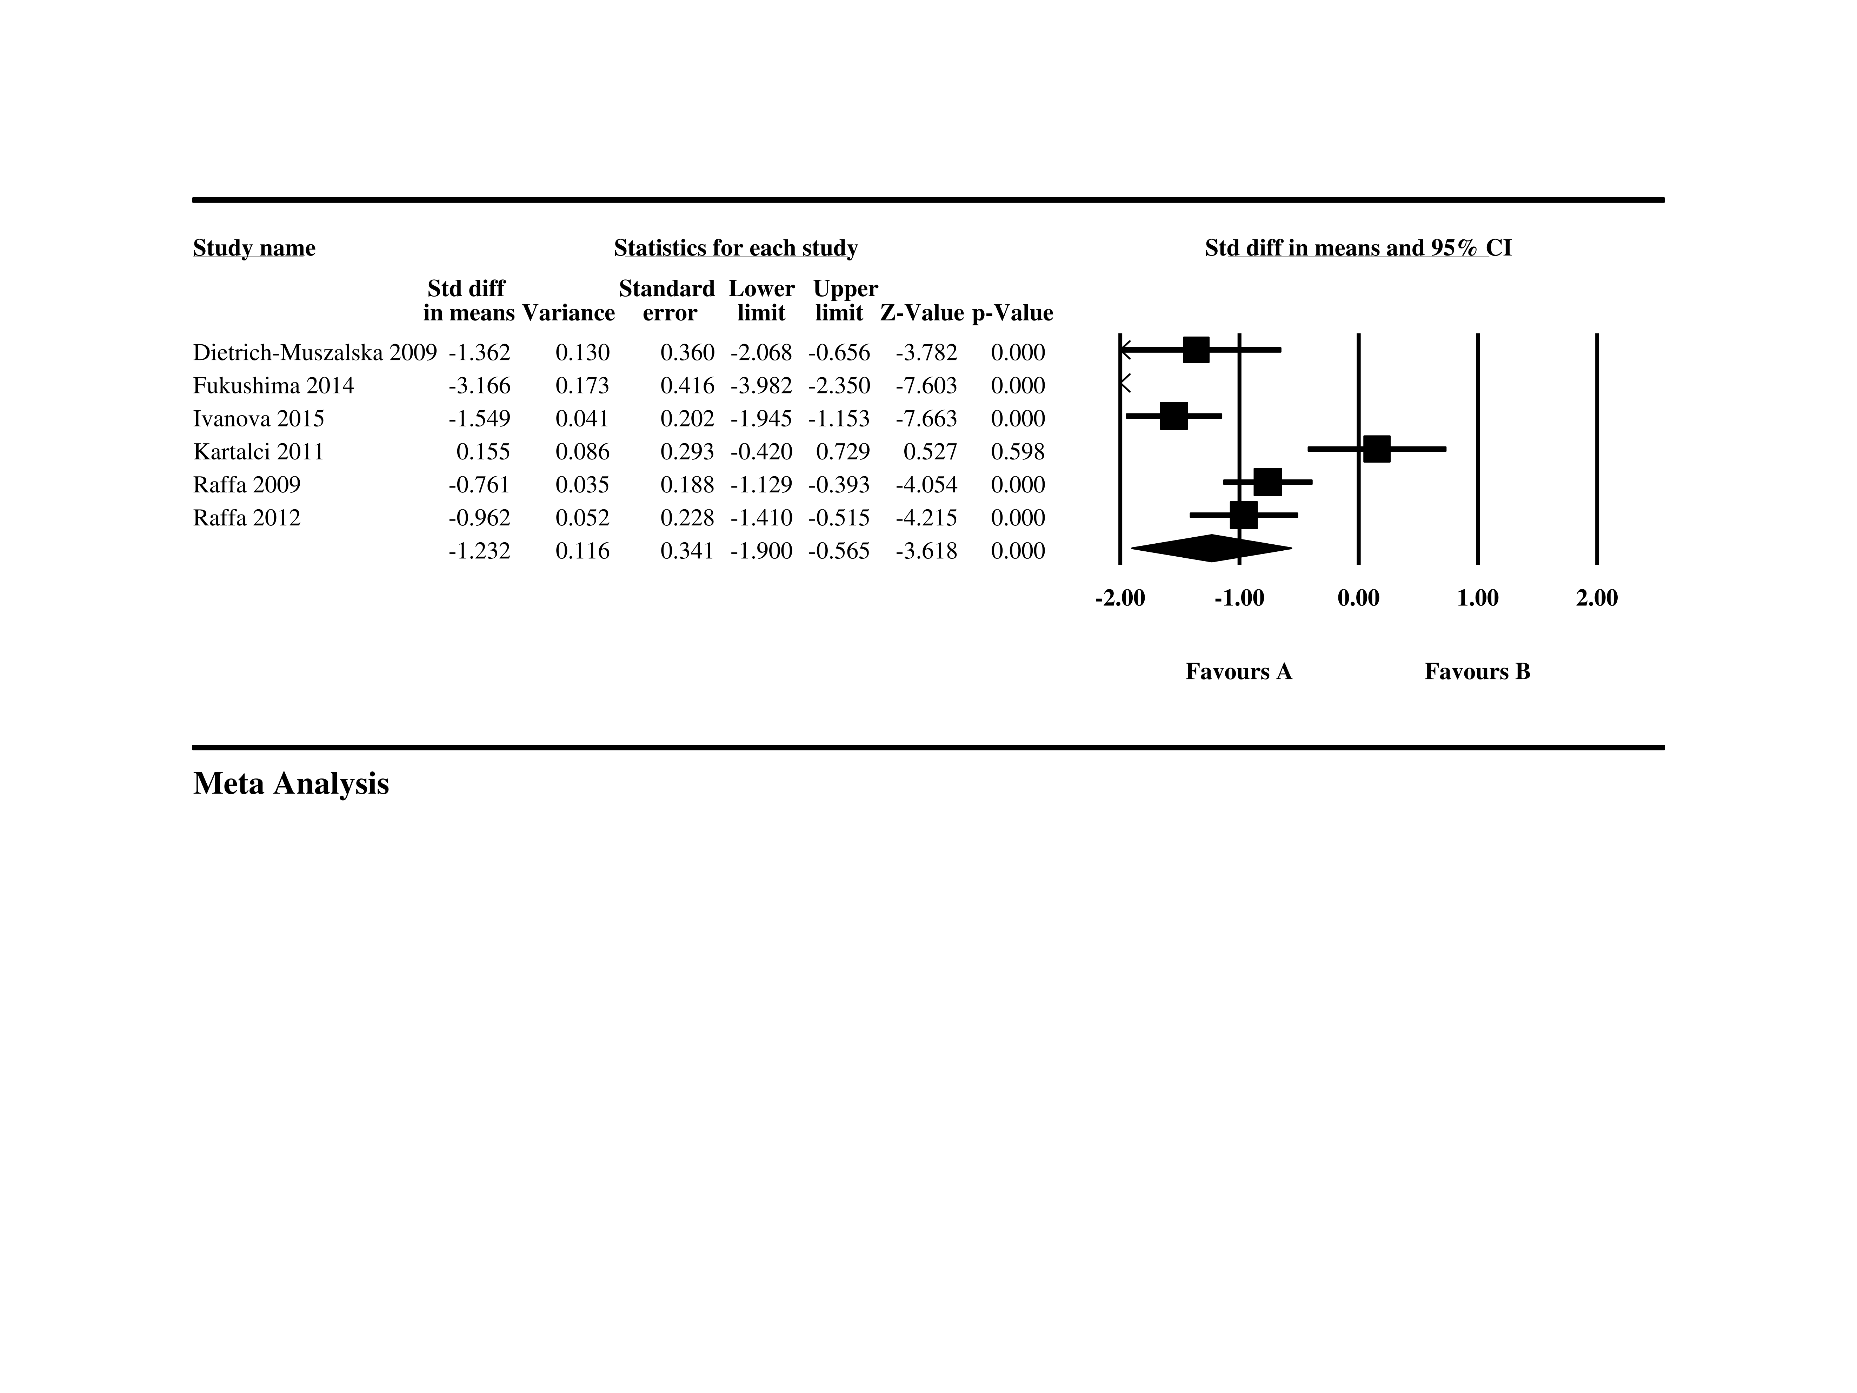

1. **GSH levels in the ACC with 1H-MRS**



1. **tGSH levels in plasma or serum**

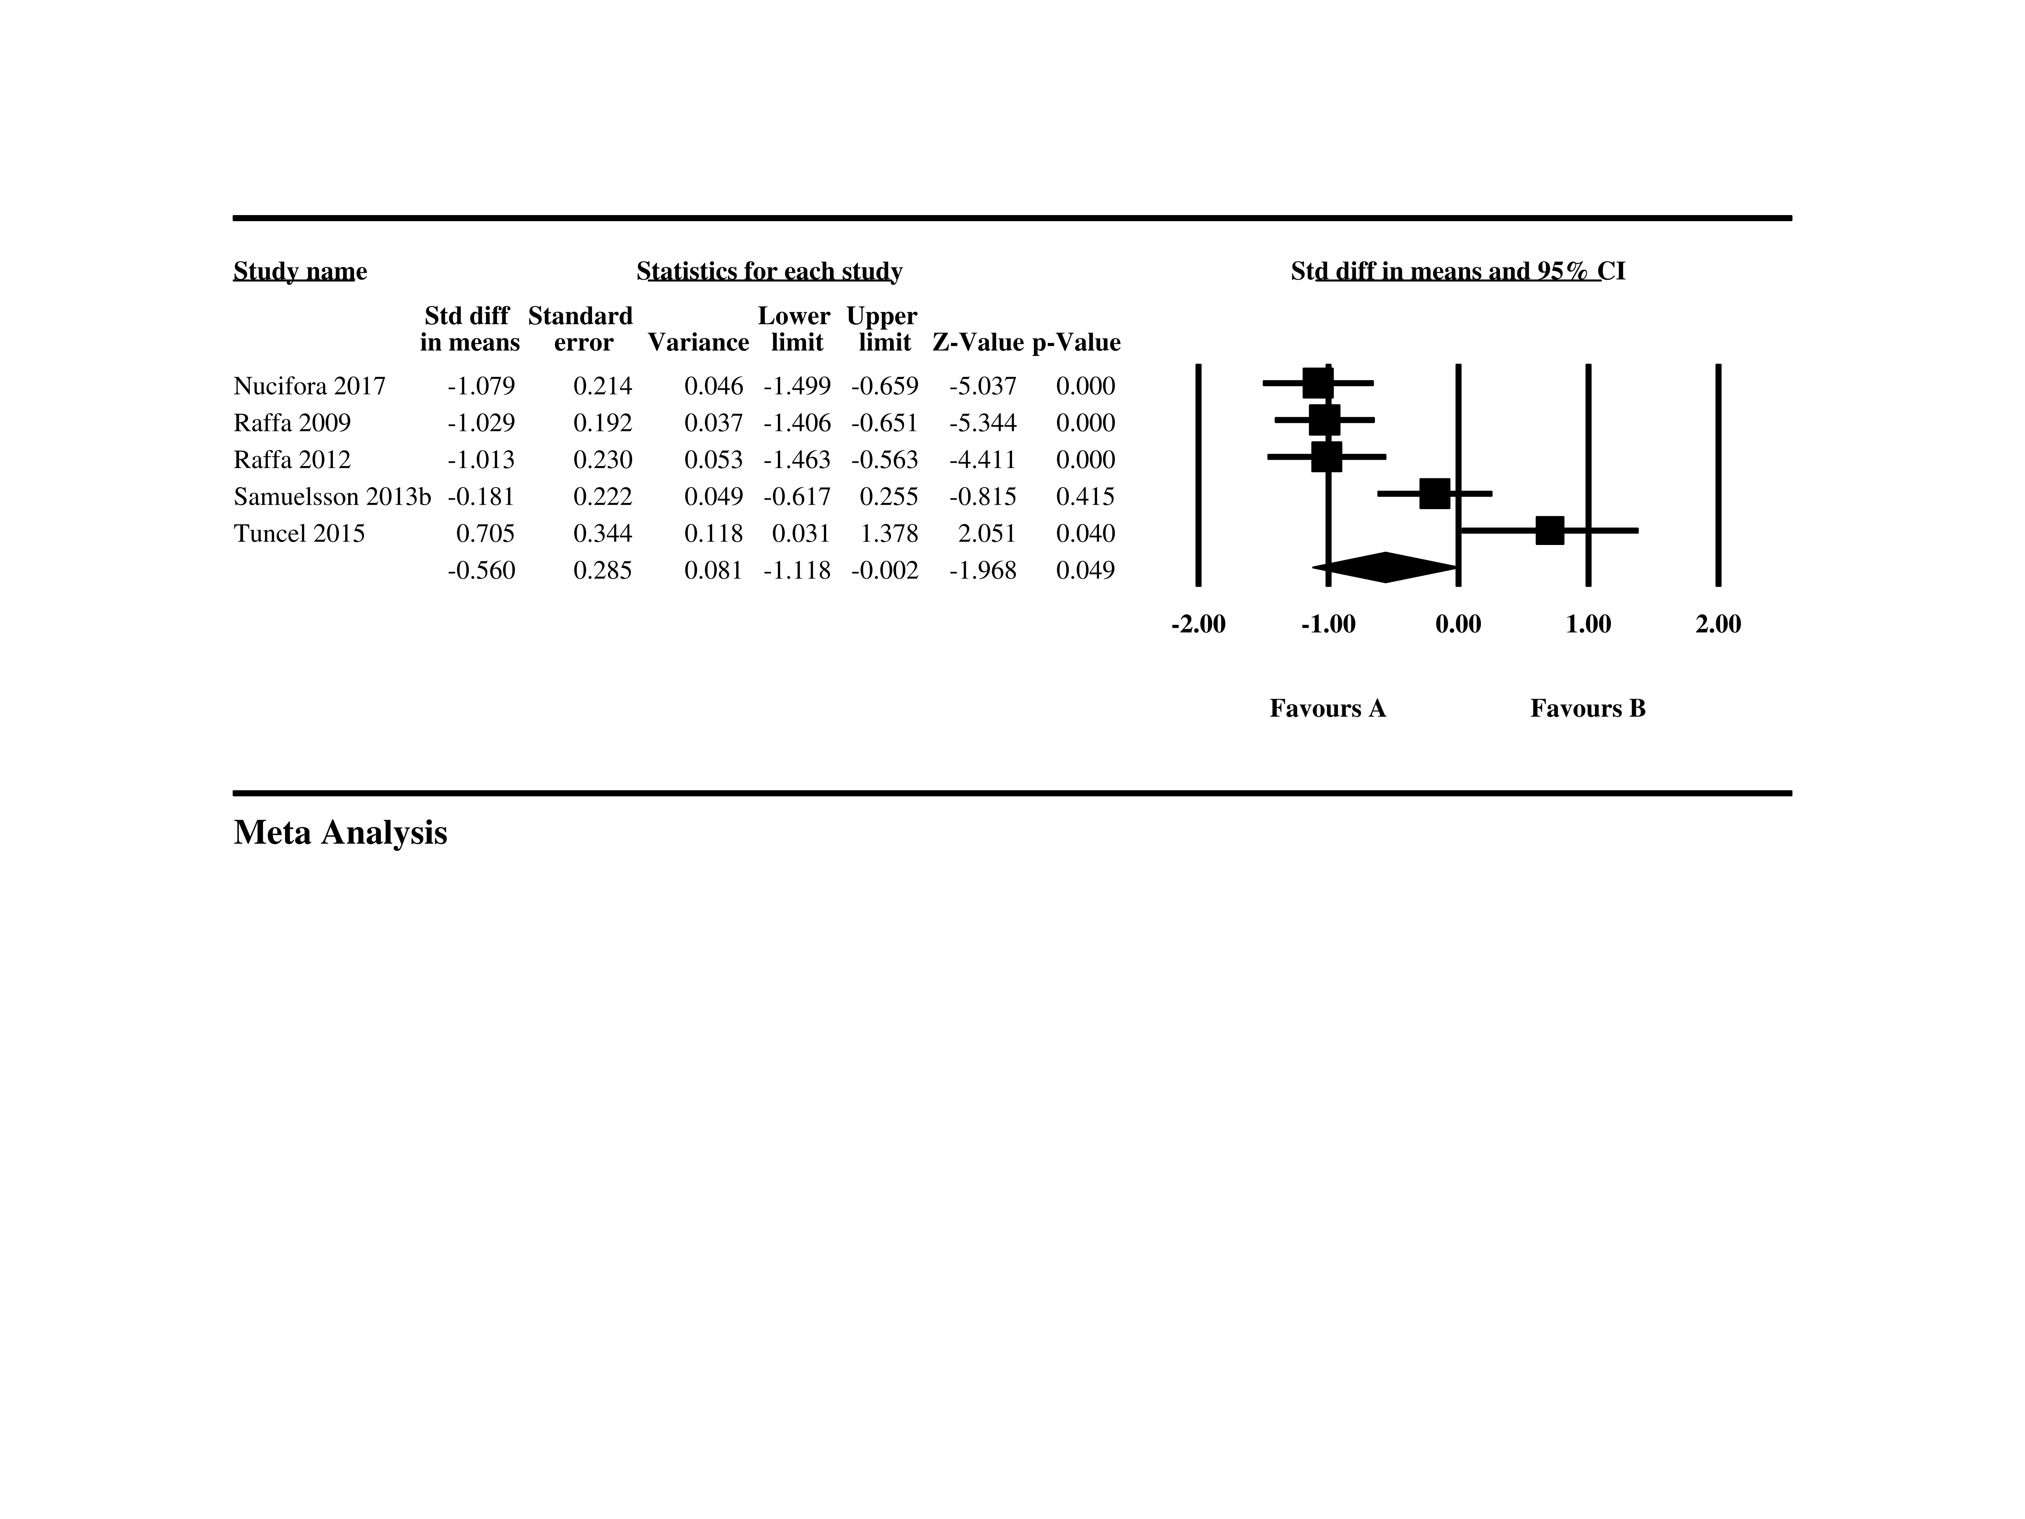

1. **GSH levels between unmedicated patients with SZ and HCs**



1. **tGSH levels between unmedicated patients with SZ and HCs**



1. **GSH levels between medicated patients with SZ and HCs**



1. **tGSH levels between medicated patients with SZ and HCs**



1. **GSH levels between patients with FEP and HCs**



**Abbreviations:** FEP, first-episode psychosis; HC, healthy control; 1H-MRS, proton magnetic resonance spectroscopy; CI: confidence interval; GSH, glutathione; tGSH, total GSH (GSH+GSSG); Std: standardized; SZ, schizophrenia.

**Supplementary Figure 4.** The results of meta-regressions.

(a) Higher patient’s age was associated with lower SMDs of GSH between patients with SZ and HCs (slope=-0.0304, CI=-0.0485 to -0.0123, P=0.0010), (b) a trend toward positive relationship was found between the SMDs of GSH and the proportion of medicated patients (slope=0.0078, CI=0.0013 to 0.0143, P=0.019);

**(a) meta-regression of patients’ age and SMDs of GSH levels**



**(a) meta-regression of the proportion of patients and SMDs of GSH levels**



**Supplementary Figure 5.** Funnel plot of metabolites and enzymes in GSH system in whole samples.

**(a) GSH**



**(b) GSSG**



**(c) tGSH**



1. **GPx**



1. **GR**



**Abbreviations:** GSH, glutathione; GSSG, GSH disulfide; tGSH, total GSH [GSH+GSSG]; GPx, GSH peroxidase; GR, GSH reductase; Std: standardized deviation