Extending REVEALS applicability to coastal lagoons, appendix A
The appendix aims to check that the dispersal and deposition function $g\left(x\right)$ used in REVEALS model for lakes and bogs is still valid for coastal lagoons. These dispersal and deposition function is derived by Gregory (1944) from the Sutton’s formula describing the decrease in density of a particle cloud emitted by an instantaneous point source due to turbulent diffusion (Sutton, 1932). Therefore, hereafter, the dispersal and deposition function will be derived for the case of an instantaneous and infinite line source, following Gregory (1944).
Let us define a tridimensional orthonormal frame $\left(O, \vec{i},\vec{j},\vec{k}\right)$ where an unidirectional wind is blowing parallel to $\left(Oi\right)$ with a constant velocity and where an instantaneous line source of infinite length called $L$, emitted $Q_{0}$ [grains cm⁻¹] at t=0 (Fig A1).
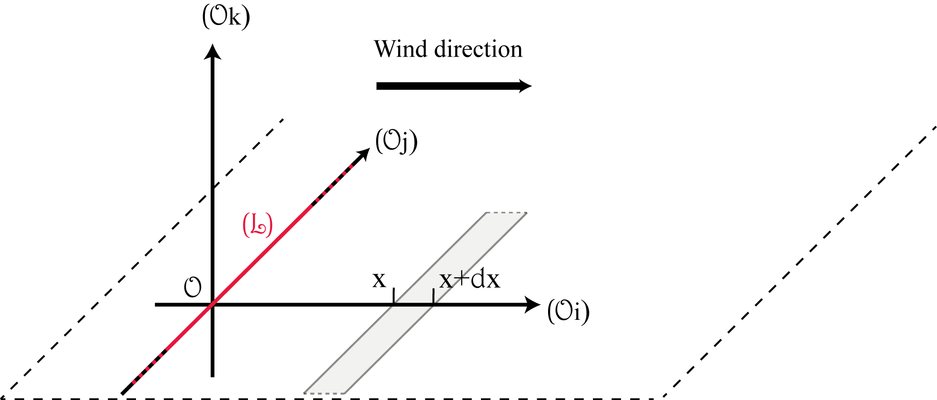
Figure A1: Orthonormal frame with the instantaneous and infinite line source of pollen (in red) and the strip of elementary cross section and infinite length at a distance x from the source (in grey).
An infinite and instantaneous line source is made of an infinite number of instantaneous point sources. Let us assume that the diffusion is not depending on the direction. Sutton demonstrates that the concentration of airborne particles emitted from an instantaneous point source situated at $\left(0, j^{'}, k^{'}\right)$ is:
$$χ_{point}\left(i,j,k,t\right)=\frac{Q_{0}}{π^{3/2}C^{3}{d\left(t\right)}^{3/2m}}\exp\left(-\frac{{\left(i-d\left(t\right)\right)}^{2}+{\left(j-j^{'}\right)}^{2}+{\left(k-k^{'}\right)}^{2}}{C^{2}{d\left(t\right)}^{m}}\right) \left(A1\right)$$
$C$ is the turbulent diffusion coefficient, m an empirical parameter depending on turbulence conditions and $d\left(t\right)$ is the distance between the center of the cloud and the source, it represents its translation due to wind.
An equivalent formula for an instantaneous and infinite line source at ground level can be deduced by integrating $\left(A1\right)$ with respect to $j$ and taking $k^{'}=0$:
$$χ_{line}\left(i,j,k,t\right)=\frac{Q_{0}}{π^{3/2}C^{3}{d\left(t\right)}^{3/2m}}\int_{-∞}^{+∞}{\exp\left(-\frac{{\left(i-d\left(t\right)\right)}^{2}+{\left(j-j^{'}\right)}^{2}+k^{2}}{C^{2}{d\left(t\right)}^{m}}\right)}dj$$
Thus,
$$χ_{line}\left(i,k,t\right)=\frac{Q_{0}}{πC^{2}{d\left(t\right)}^{m}}\exp\left(-\frac{{\left(i-d\left(t\right)\right)}^{2}+k^{2}}{C^{2}{d\left(t\right)}^{m}}\right) \left(A2\right)$$
Because the pollen source is at ground level, the diffusion is not possible downward. Thus, the pollen concentration is assumed to be two time higher:
$$χ_{line}\left(i,k,t\right)=\frac{2Q_{0}}{πC^{2}{d\left(t\right)}^{m}}\exp\left(-\frac{{\left(i-d\left(t\right)\right)}^{2}+k^{2}}{C^{2}{d\left(t\right)}^{m}}\right) (A2bis)$$

With $k≥0.$
The formula giving $χ_{line}\left(i,k,t\right)$, states that the overall cloud density is decreasing with time when it moves downwind because of turbulent diffusion. Nevertheless, following the same approach as Gregory (1944), the cloud density variation is assumed to be negligible for the short time during which it crosses an infinite strip of elementary cross section (Figure 2). This assumption is valid only if the diffusion speed is small compared to the translation speed of the cloud along the axis $\left(Oi\right)$ (the wind speed).
On the basis of this assumption, the amount of pollen grains deposited within the infinite strip of elementary cross section at the distance $x$ of a line source ($D_{strip}$) is assumed to be proportional to the total number of grains crossing the strip at ground level. Thus, the number of grains contained within a slice of elementary thickness cutting the cloud over its full length just above the ground level ($N_{line}$):
$$D_{strip}\left(x\right)=p×N_{line}(x)$$
Where $p$ is a deposition coefficient giving the proportion of grains flowing above the strip which are deposited.
For a given distance $x$, the cloud density is taken to be the density when its center cross $x$, that is to say $d\left(t\right)=x$ and $Q_{0}$ is changed in $Q\left(x\right)$ (the amount of grains remaining airborne) to take into account the grains already deposited between the source and $x$. Therefore, the number of particles contained within an elementary slice cutting the cloud horizontally at ground level $N_{line}(x)$ is obtained by integrating $χ_{line}\left(x,z\right)$ with respect to $i$ at $k=0$ between $\left]-∞,+∞\right[$:
$$N_{line}(x)=\frac{2Q(x)}{πC^{2}x^{m}}\int_{-∞}^{+∞}{\exp\left(-\frac{{\left(i-x\right)}^{2}}{C^{2}x^{m}}\right)di}$$
Thus,
$$N_{line}\left(x\right)=\frac{2Q\left(x\right)}{\sqrt{π}Cx^{m/2}} (A3)$$
And finally:
$$D_{strip}\left(x\right)=\frac{2pQ(x)}{\sqrt{π}Cx^{m/2}}$$
In the case of an instantaneous point source, Gregory (1944) demonstrates that the amount of pollen grains deposited in a ring of elementary cross section at a distance $x$ from the source is:
$$D_{ring}\left(x\right)=\frac{2pQ(x)}{\sqrt{π}Cx^{m/2}}$$
$D_{strip}$ and $D_{ring}$ are similar, however they don’t have the same physical dimension (grains.cm⁻¹ and grains). Indeed, the first one applies to an infinite line source which emitted, by definition, an infinite amount of grains and the second one applies to a point source which emitted a finite amount of grains. Nevertheless, the dispersal and deposition function $g\left(x\right)$used in REVEALS corresponds to the proportion of pollen initially emitted at the source and deposited at the distance $x$ (Sugita, 1993) and is thus dimensionless. Therefore, it is possible to write
$$g\left(x\right)=\frac{D_{ring}\left(x\right)}{Q_{0, ring}}=\frac{D_{strip}\left(x\right)}{Q_{0,strip}}$$
Quod erat demonstrandum

References
Gregory PH (1945) The dispersion of air-borne spores. Transactions of the British Mycological Society 28(1–2): 26–72.
Sutton OG (1932) A theory of eddy diffusion in the atmosphere. Proceedings of the Royal Society of London. Series A, Containing Papers of a Mathematical and Physical Character 135(826): 143–165.

