Rationale for age assumption of core top
Although wind can cause perturb the sediment-water interface in lakes and thus cause sediment mixing, wind-induced sediment resuspension at the lake bottom of Lake Lin is unlikely. According to Scheffer (1998), particles at the sediment-water interface will resuspend if wind-induced waves reach the bottom of the lake (when the wavelength of wind-induced waves exceeds twice the water depth). The wavelength is a function of fetch (the distance over which the waves have built up) and wind velocity. More detail of this equation can be found in Scheffer (1998). We found that the wavelength caused by NCEP/NCAR Reanalysis mean surface wind velocity at Lake Lin, which has a fetch of 33 m, is 0.004 m. This wavelength is less than twice the water depth (~1 m), and thus, wind induced mixing at the surface-water interface is unlikely. In fact, it is very unlikely for wind-induced waves to cause sediment mixing at Lin no matter how strong wind speed is because the fetch value at Lin is too small (Scheffer, 1998; Figure 2.7). Therefore, our assumption of the preservation of the core top is robust.
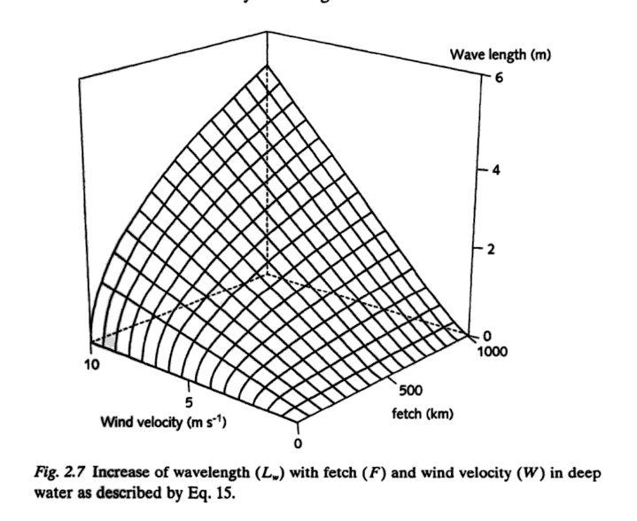(Scheffer, 1998)
Reference
Scheffer M (1998) Ecology of Shallow Lakes. Dordrecht: Kluwer Academic Publishers.

Supplementary figures
Figure A: Satellite image of Lake Lin (coring location denoted by orange marker; courtesy: ESRI).
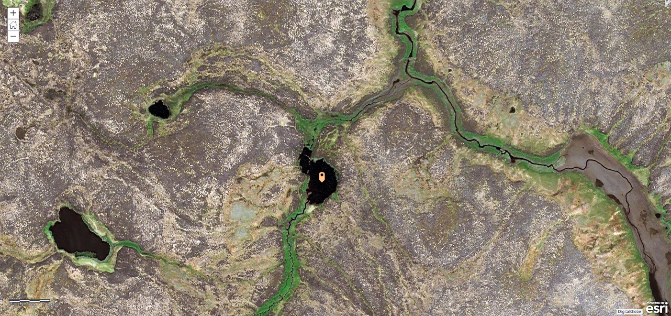

Figure B: Landscape characteristics and vegetation near the study site (within 5 km radius of Lake Lin). a) Local landscape of the study site. b) Vegetation in the AD 2015 burn scar. Dominant vegetation types are grasses and herbs. c) Vegetation in the AD 1972 “old” burn scar. Grasses and mosses are the most common vegetation types. d) Vegetation in the unburned area. Lichen is the dominant vegetation type. (Photo credit: Stash Wislocki and Homero Pena)
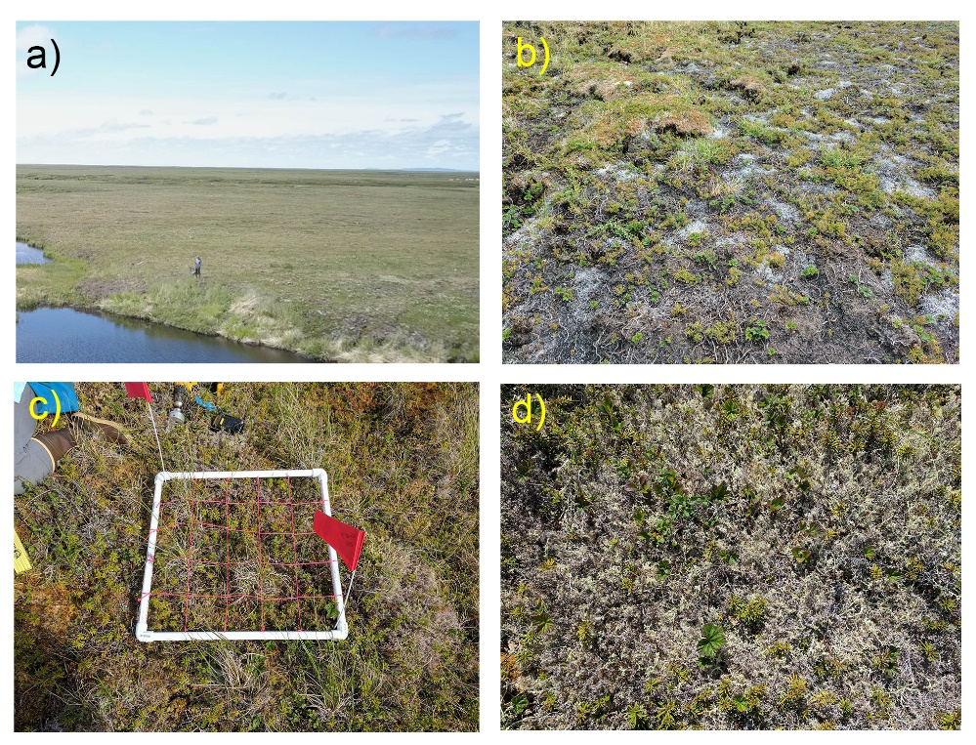
Figure C: NCEP/NCAR Reanalysis composite mean of surface wind in Alaska (AD 1948-2017; unit = m/s ; Kalney et al., 1996).

