Appendix 1. Cat Feeding Survey

Introduction We invite you to participate in this short web-based online survey about how you feed your cat. This is a research project being conducted by Dr. Tony Buffington, a clinical professor at the UC Davis School of Veterinary Medicine.
PARTICIPATION: Your participation in this survey is voluntary and the survey should take no more than 10 minutes. You may exit the survey at any time and all of your responses are anonymous. Please be at least 18 years old and the primary caregiver of at least one cat to fill out this survey. This cat must spend at least some time inside of your house. If you have multiple cats, please fill out this survey for ONLY the cat whose name begins closest to the BEGINNING of the alphabet.
BENEFITS: Your participation will help us learn more about how people feed their cats and you might learn about new ways to feed your cat. The results of this study may be published as part of our efforts to improve the health and welfare of cats.
RISKS: There are no foreseeable risks involved in participating in this study.
THANK YOU for taking the time to fill out this survey. If you have questions at any time about the study, please contact me at: drbuffington@ucdavis.edu
ELECTRONIC CONSENT: Please select your choice below. You may print a copy of this consent form for your records. Clicking on the “Agree” button indicates that
You have read the above information
You voluntarily agree to participate
You are 18 years of age or older
- Agree

A. Demographic information – tell us about your cat:
If you have more than one cat, please answer these questions for ONLY the cat whose name begins closest to the BEGINNING of the alphabet.

What is this cat's name?

Are you the primary caregiver of this cat?
Yes
No

What is the sex of this cat?
Male
Female

Is this cat spayed/neutered?
Yes
No

How many years have you owned this cat?
(Select from drop down menu)
▼ 0 ... 30

How old is this cat, in years? If you are unsure, please make your best guess.
(Select from drop down menu)
▼ 0 ... 30

Is this cat purebred?
Yes
No

Where did you obtain this cat?
Accidentally bred from my own cat
Deliberately bred from my own cat
From a pedigree breeder
From a friend, neighbor, non-pedigree breeder
Pet shop
Rescue shelter / charity
Stray / Feral / Found kitten / kitten turned up at house

What percentage of time does this cat spend INSIDE of your house (pick closest answer)?
None
25%
50%
75%
100%

On average, how many hours per day do you spend with this cat when you are able to observe his/her behavior? (Select from drop down menu)
▼ 0 ... 24

B. Tell us about yourself:

What is the gender you identify with? (you can choose more than one answer)
Male
Female
Transgender
Prefer to self-describe ________________________________________________
Decline to state

Which category includes your age?
18-24
25-34
35-44
45-54
55-64
65 or older
Decline to state

Which racial or ethnic category do you identify with? Please check all that apply.
White
Black or African American
American Indian or Alaska Native
Asian
Latino or Hispanic
Native Hawaiian or Pacific Islander
Other
Decline to state
C. Tell us about your household:

INCLUDING THIS CAT, how many TOTAL cats currently live in your household? (Select from dropdown menu)
▼ 1 ... 10

How many TOTAL dogs currently live in your household? (Select from dropdown menu)
▼ 0 ... 10

How many adults (aged 18 years or more), including you, live in the household? (Select from dropdown menu)
▼ 1 ... 10

How many children (aged 17 years or less) live in the household? (Select from dropdown menu)
▼ 0 ... 10

Please indicate which of these categories best describes your annual household income.
Less than $10,000
$10,000 - $19,999
$20,000 - $29,999
$30,000 - $39,999
$40,000 - $49,999
$50,000 - $59,999
$60,000 - $69,999
$70,000 - $79,999
$80,000 - $89,999
$90,000 - $99,999
$100,000 - $149,999
More than $150,000
Decline to state

Please indicate which of these best describes the highest level of education that any member of your household has achieved.
Less than high school
High school graduate
Some college
2 year degree
4 year degree
Professional degree
Doctorate
Decline to state

D. What do you feed your cat?
 | Only food fed | Half or more of daily diet | Less than half of daily diet | Only feed occasionally | Never feed
Commercial wet adult cat food (e.g. cans, pouches, foil packs).
Commercial wet kitten cat food (e.g. cans, pouches, foil packs).
Commercial dry adult food.
Commercial dry kitten food.
Uncooked/raw fresh food (e.g., fish, chicken).
Cooked fresh food (e.g., fish, chicken).
Other human foods.
Treats/snack foods for cats.
Other.

If you selected "Other" for the previous question, please tell us what other foods you feed your cat.

E. How do you feed your cat?
(note that the choices available on this question are dependent on your answer to the previous question)
 | Meals | Leave food out all the time | Only feed occasionally
Commercial wet adult cat food (e.g. cans, pouches, foil packs).
Commercial wet kitten cat food (e.g. cans, pouches, foil packs).
Commercial dry adult food.
Commercial dry kitten food.
Uncooked/raw fresh food (e.g., fish, chicken).
Cooked fresh food (e.g., fish, chicken).
Other human foods.
Treats/snack foods for cats.
Other.

Food puzzles are objects that can hold cat food and release bits of food when a cat interacts with it. Food puzzles may be mobile (rolled or pushed) or stationary, and can be used to provide either wet or dry food. They may be purchased or homemade. These are examples of common kinds of cat food puzzles.
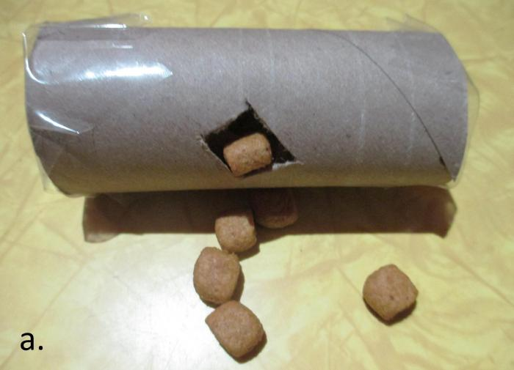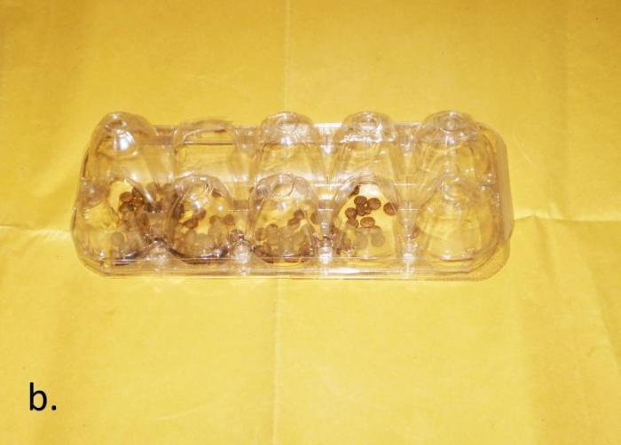
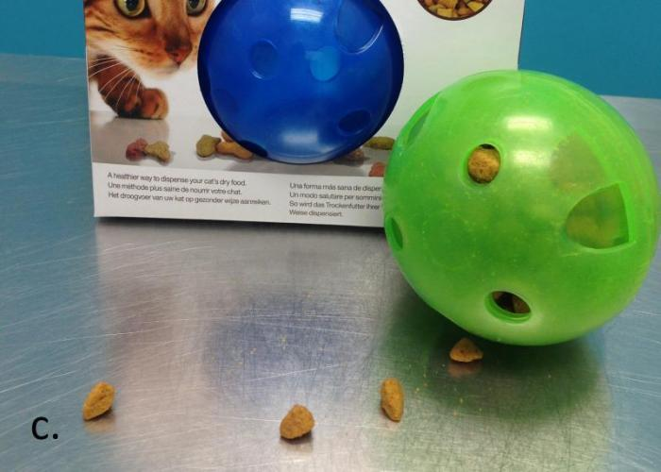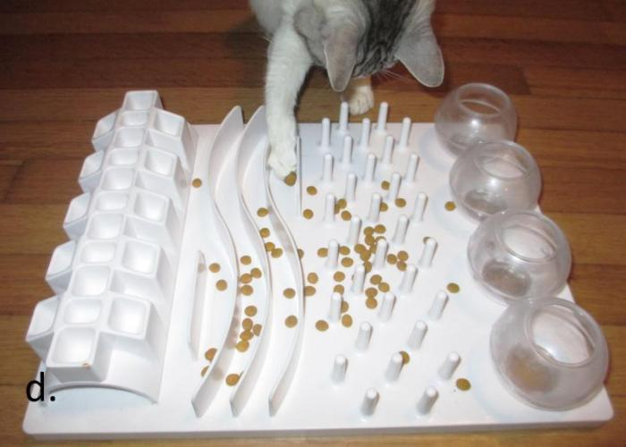
a. Homemade mobile
b. Homemade stationary
c. Purchased mobile
d. Purchased stationary
You will be asked some questions about the kind(s) of food puzzles you have in your house if you use food puzzles.
F. How much of your cat’s daily diet do you feed in:
 | Only food in diet | Half or more of daily diet | Less than half of daily diet | Only feed in occasionally | Never feed
A bowl or plate
A food puzzle

Do you use food puzzles in your home?
I do NOT use food puzzles in my home.
I use food puzzles in my home.
I tried food puzzles with my cat but no longer use them.
Skip To: Q48 If Do you use food puzzles in your home? = I do NOT use food puzzles in my home.
Skip To: Q44 If Do you use food puzzles in your home? = I tried food puzzles with my cat but no longer use them.

G. These are examples of common kinds of cat food puzzles.
a. Homemade mobile
b. Homemade stationary
c. Purchased mobile
d. Purchased stationary

Which kind(s) of food puzzles do you currently have in your home? (Please select all that apply):
Homemade mobile.
Homemade stationary.
Purchased mobile.
Purchased stationary.

Which kind of food puzzle does this cat use most often?
Homemade mobile.
Homemade stationary.
Purchased mobile.
Purchased stationary.

Do you do any of the following when you see this cat playing with her food puzzle? (Please select all that apply):
Give verbal praise.
Pet or stroke the cat.
Other (please explain in the text box below).
Have you done anything to attract your cat to a food puzzle? (Please check all that apply):
Showed the cat how to use it.
Put the cat’s favorite treat/food in it.
Nothing, cat used it without any need for attraction.
Changed to a new food to increase interest.
Started offering canned food and only put dry in puzzle(s).
Other (please explain in the text box below).

H. I started to use food puzzles to feed my cat(s) because (Please check all that apply):
My cat's pet sitter recommended them.
My cat's veterinarian recommended them.
My cat's veterinarian's technician recommended them.
I read about them on the internet or magazine.
A veterinary behaviorist recommended them.
A consultant or trainer recommended them.
I saw them in a pet store.
A friend recommended them.
Other (please describe): ________________________________________________

I. I provide my cats with (Please check all that apply):
Store bought food puzzles for dry food.
Store bought food puzzles for canned/wet food.
Homemade food puzzles for dry food.
Homemade food puzzles for canned/wet food.
Other (please list). ________________________________________________
I do not provide my cat with food puzzles.

J. If you do not use food puzzles for your cat (s), please indicate how much you agree or disagree with each statement.
I do not use food puzzles because:
 | Strongly agree | Somewhat agree | Neither agree nor disagree | Somewhat disagree | Strongly disagree
I don't think that my cat(s) will change their habits or behavior.
My cat is allowed outdoors.
We have dogs in our household.
I do not want toys/food on our floors.
I am worried about attracting bugs.
I have crawling infants or toddlers that I do not want to eat the cat food.
I am worried the puzzles will be a tripping hazard.
I can't afford them/financial constraints.
My cat is too lazy to use them.
My cat is too dumb to use them.
My cat hunts.
My cat is too old for this.
My cat is already too finicky to eat using a food bowl.
It is too much additional work for me.
I do not know how to use or choose food puzzles for my cats.
My cats fight if they have to share resources.
I have more than one cat with different weight goals.
I have more than one cat on different diets.
I have too many cats.
I don’t know how to use them.
Other (please list):

K. If you tried food puzzles with your cat but no longer use them, please tell us what kind of food puzzle(s) you tried.
These are examples of common kinds of cat food puzzles.
a. Homemade mobile
b. Homemade stationary
c. Purchased mobile
d. Purchased stationary

Which kind(s) of food puzzles did you try with your cat? (Please select all that apply):
Homemade mobile.
Homemade stationary.
Purchased mobile.
Purchased stationary.
Purchased food puzzles for dry food.
Purchased food puzzles for canned/wet food.
Homemade food puzzles for dry food.
Homemade food puzzles for canned/wet food.
Other (please list): ________________________________________________

Please indicate how much you agree or disagree with each statement.
I tried food puzzles with my cat but no longer use them because:
 | Strongly agree | Somewhat agree | Neither agree nor disagree | Somewhat disagree | Strongly disagree
The puzzles were underfoot/a tripping hazard.
The puzzles were messy
The puzzles were loud and disruptive.
The puzzles attracted bugs
My cats fought over them.
My cat never figured them out.
My cat is too lazy to use them.
My cat is too dumb to use them.
My cat hunts, so doesn’t need them.
My cat is too old for this.
My cat is too dumb to use them.
My cat is already too finicky to eat from anything but a bowl.
My cat now has health issues.
My cats are fed different diets.
I didn’t have time to put food in them regularly.
It was too much additional work for me.
I have too many cats.
I didn’t feel that my cat benefited from them.
Our dog(s) tried to use them.
I have toddlers/infants in the home that tried to play with them.
Other (please list):

Do you have any comments for us about this survey?

Thank you for completing the survey.
If you'd like to learn more about using food puzzles with cats, we recommend you visit the webpage, Food Puzzles for Cats:
www.foodpuzzlesforcats.com

