Supplementary Figure S1: Receiver Operating Characteristics curves for the prediction of severe hypoglycemia by different CGM-derived parameters

Supplementary Figure S2: Receiver Operating Characteristics curves for the prediction of the persistence of impaired awareness of hypoglycemia by different CGM-derived parameters

Supplementary Figure S1: Receiver Operating Characteristics curves for the prediction of severe hypoglycemia by different CGM-derived parameters
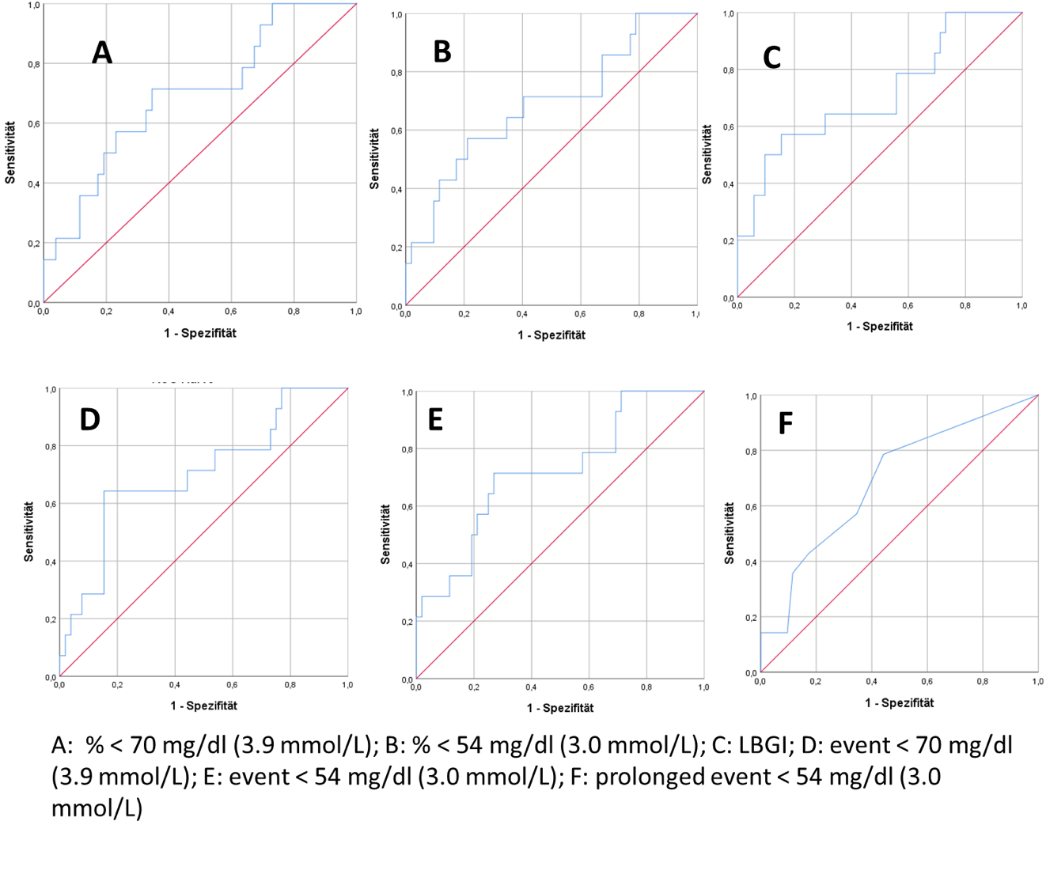
Supplementary Figure S2: Receiver Operating Characteristics curves for the prediction of the persistence of impaired awareness of hypoglycemia by different CGM-derived parameters
