- PROTOCOL USED
To obtain the equivalent doses (ED) from each sample, Single Aliquot Regeneration (SAR) protocol (Murray and Wintle, 2000) was followed. The protocol used is as follows:
Step | Treatment | Observed
 | Preheat at 220°C for 60 sec
 | Blue light stimulation at 125°C for 70 sec, cool to 50°C | Ln
 | Test Dose given (~10% of the natural)
 | Cut heat at 160°C, cool to 50°C
 | Blue light stimulation at 125°C for 70 sec, cool to 50°C | Tn
 | First Regeneration Beta Dose
 | Preheat at 220°C for 60 sec
 | Blue light stimulation at 125°C for 70 sec, cool to 50°C | Lx
 | Test Dose given (~10% of the natural)
 | Cut heat at 160°C, cool to 50°C
 | Blue light stimulation at 125°C for 70 sec, cool to 50°C | Tx
 | Second Regeneration Beta Dose
 | Go to Step number 7 and repeat the steps to get Lx/Tx for X=1,2,3 and for recuperation and recycling points.

Luminescence measurements were carried out on Freiberg Lexsyg Research/Smart TL-OSL reader with blue light emitting diode (LED) source (458 ± 10 nm) with maximum power of 100 mW/cm². The OSL signals were calculated by integrating counts in the initial 0.5 sec of the OSL decay curve.
The selection criteria of the discs was based on : (i) recycling ratio within 10% of unity, showing sensitivity changes remained within accepted value of 10% (Murray and Wintle, 2000) (ii) maximum test dose error to be less than10% and (iii) recuperation signal below 5% of the natural, showing accepted level of thermal transfer.
1.1 Preheat Plateau Test
Preheat is an important and necessary step to be taken before making OSL measurements. Preheating removes unstable OSL signal arising either from the shallow traps, contributing to the natural OSL during burial or from laboratory irradiation. Usually the preheat temperature in the range from 160°C to 300°C does not significantly hinder the equivalent dose of the sample (Murray and Olley, 1999; Murray and Wintle, 2000 and Roberts et al., 1999, Jaiswal et al., 2009). However, a preheat plateau test was carried out on MH 4. All the aliquots were first bleached and then given a dose of 3.4 Gy. The given dose was recovered at varying preheat temperatures starting from 200°C to 260°C using SAR protocol (mentioned in section 1). Five aliquots were used for each temperature. 220°C was chosen as the best preheat condition for the samples under current study (figure 1).
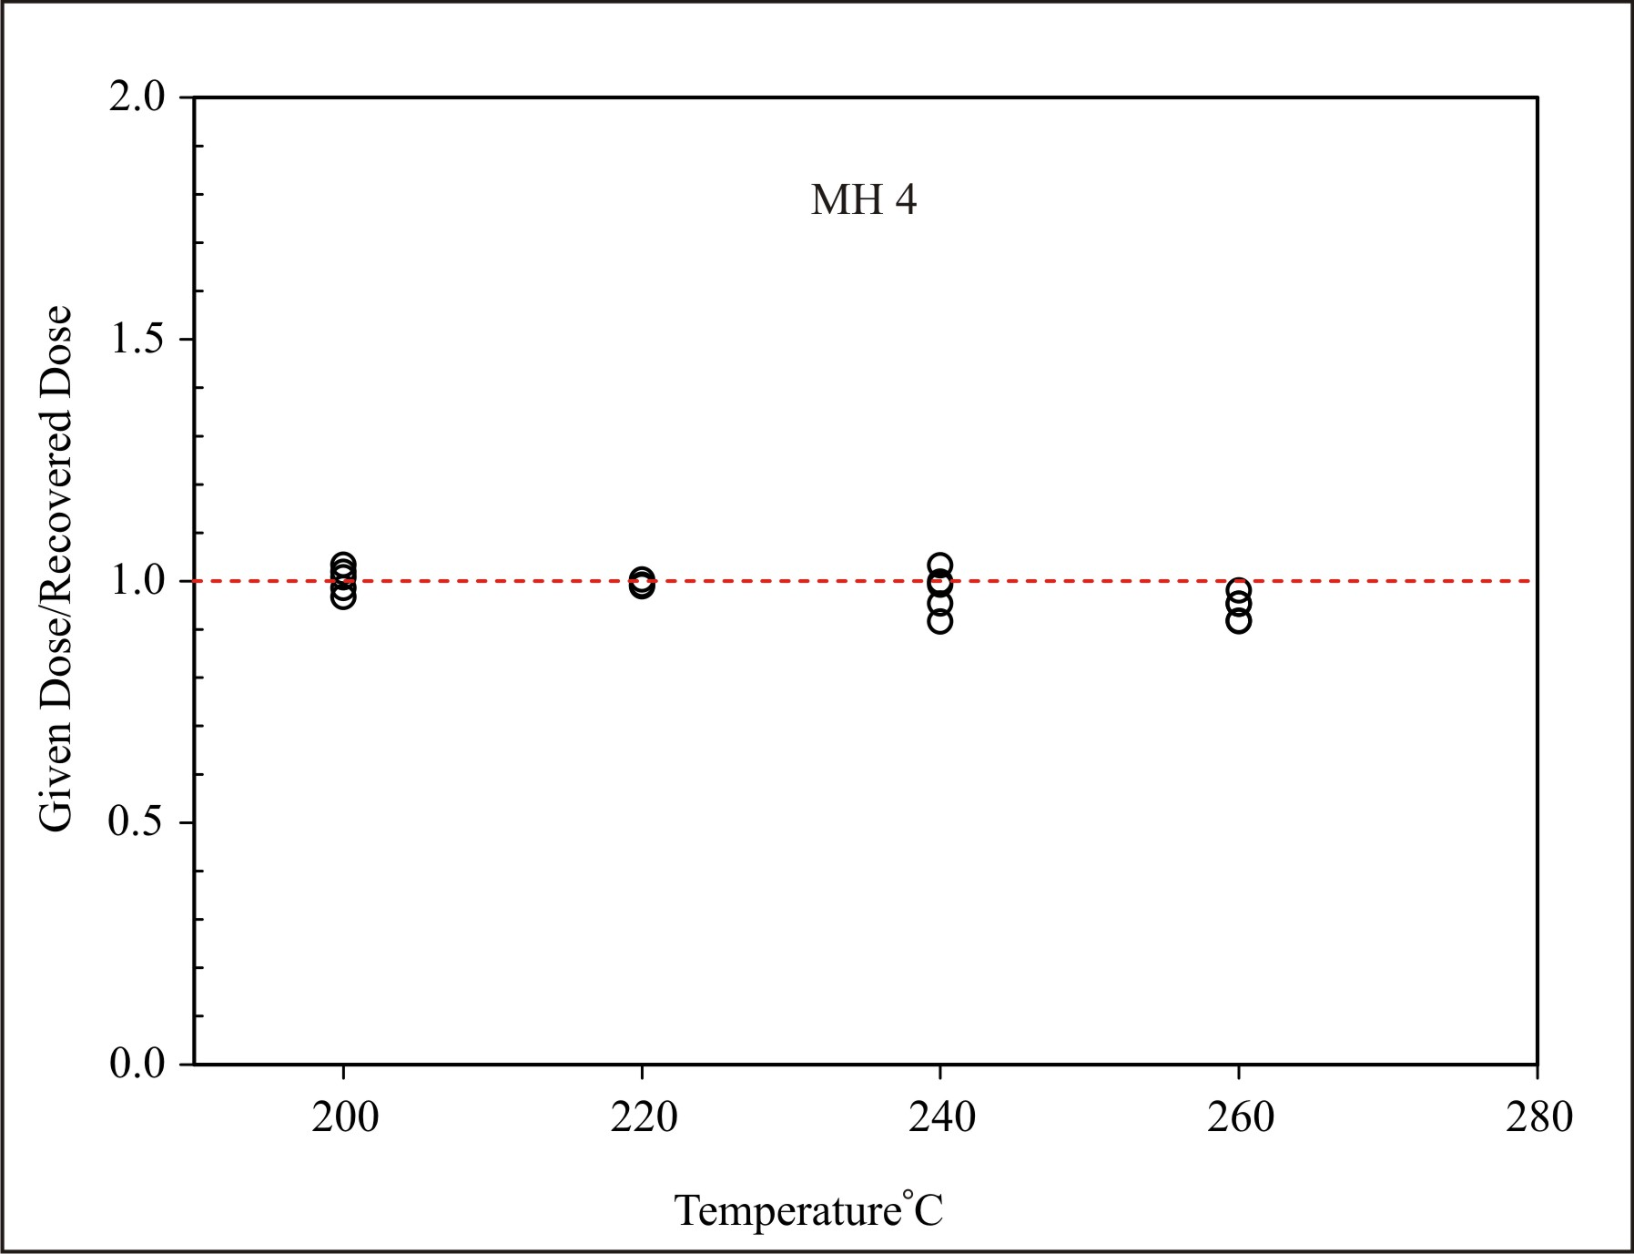
Figure 1: Preheat plateau test for MH 4, showing most effective recovery from preheat temperature of 220°C at 60 sec
1.2 Dose Recovery Test
Dose recovery test is important to judge the accuracy of SAR protocol used. Five aliquots of MH 4 were bleached and given 3.4 Gy of dose to observe the variation in the accuracy of the recovery. Good recovery within 5% was observed in all five discs using the SAR protocol mentioned (figure 2). Considering very young ages of the sample, linear fitting of growth curve was chosen for curve fitting.

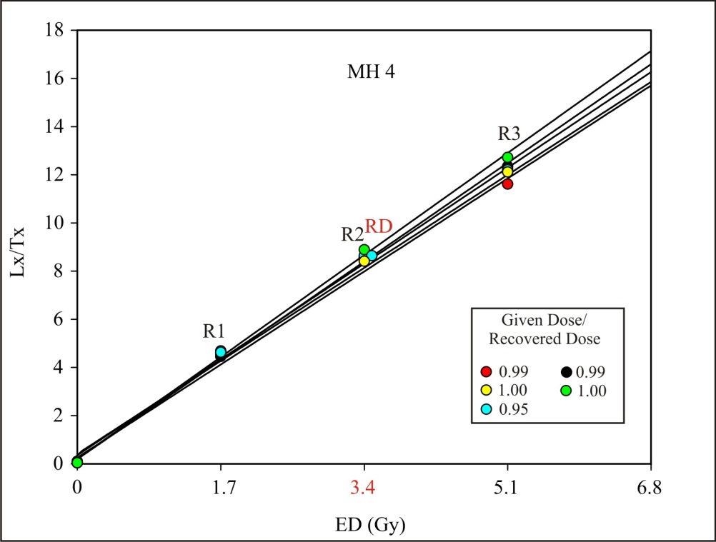
Figure 2: Dose recovery test on sample MH 4. Laboratory dose of 3.4 Gy (in red) were given and recovered from 5 bleached aliquots. (RD = Recovered dose), R1, R2, R3 are the regenerated laboratory doses shown in different colours for 5 different aliquots. The average ratio of the given doses/ recovered doses was 0.99±0.02.
REFERENCES
Jaiswal, M., Chen, Y., Kale, V. and Achyuthan, H., 2009. Residual luminescence in quartz from slack water deposits in Kaveri Basin, South India: a single aliquot approach. Geochronometria, 33(1), pp.1-8.
Murray, A.S. and Olley, J.M., 1999. Determining sedimentation rates using luminescence dating. Switzerland, GeoResearch Forum, Trans Tech Publications.
Murray, A.S. and Wintle, A.G., 2000. Luminescence dating of quartz using an improved single-aliquot regenerative-dose protocol. Radiation measurements, 32(1), pp.57-73.
Roberts, R.G., Galbraith, R.F., Olley, J.M., Yoshida, H. and Laslett, G.M., 1999. Optical dating of single and multiple grains of quartz from Jinmium rock shelter, northern Australia: Part II, results and implications. Archaeometry, 41(2), pp.365-395.

