Supporting Information
Supplementary figures: Urinary function and bother change by treatment types over time
Supplementary figure 1a: Urinary function over time for different treatment types
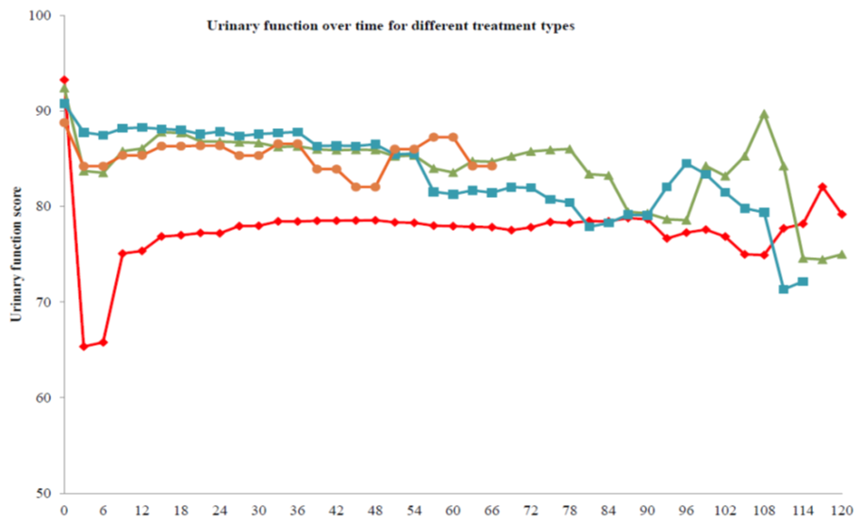
Months since treatment

Supplementary figure 1b: Urinary bother over time by different treatment types
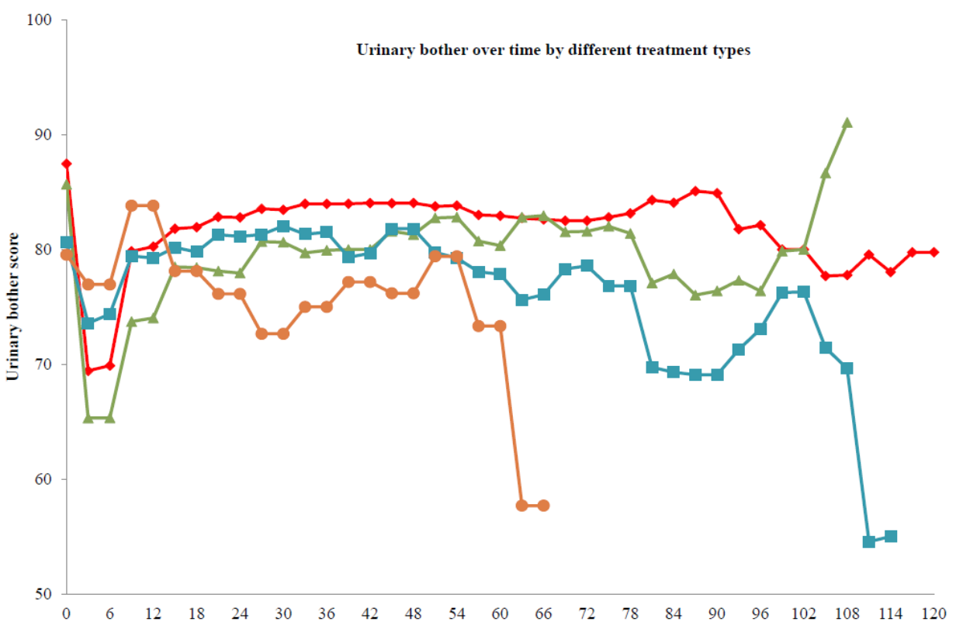
Months since treatment
RP, Radical prostatectomy; BT, Brachy; EBRT, External beam radiation therapy; WW, Watchful Waiting

Appendix S. Unit cost of CPT procedures
CPT | Procedure description | Unit cost ($)
00865 | Anesthesia for extraperitoneal procedures in lower abdomen, including urinary tract; radical prostatectomy (suprapubic, retropubic) | 73.33
00914 | Anesthesia for transurethral procedures (including urethrocystoscopy); transurethral resection of prostate | 52.38
00918 | Anesthesia for transurethral procedures (including urethrocystoscopy); with fragmentation, manipulation and/or removal of ureteral calculus | 52.38
50080 | Percutaneous nephrostolithotomy or pyelostolithotomy, with or without dilation, endoscopy, lithotripsy, stenting, or basket extraction; up to 2 cm | 3948.21
50660 | Ureterectomy, total, ectopic ureter, combination abdominal, vaginal and/or perineal approach | 3335.92
50684 | Injection procedure for ureterography or ureteropyelography through ureterostomy or indwelling ureteral catheter | 144.56
51050 | Cystolithotomy, cystotomy with removal of calculus, without vesical neck resection | 2242.44
51535 | Cystotomy for excision, incision, or repair of ureterocele | 2498.04
51600 | Injection procedure for cystography or voiding urethrocystography | 156.08
51700 | Bladder irrigation, simple, lavage and/or instillation | 207.75
51701 | Insertion of non-indwelling bladder catheter (eg, straight catheterization for residual urine) | 94.73
51702 | Insertion of temporary indwelling bladder catheter; simple (eg, Foley) | 108.35
51703 | Insertion of temporary indwelling bladder catheter; complicated (eg, altered anatomy, fractured catheter/balloon) | 192.91
51798 | Bladder ultrasound | 61.21
51840 | Anterior vesicourethropexy, or urethropexy (eg, Marshall-Marchetti-Krantz, Burch); simple | 566.92
52000 | Cystourethroscopy (separate procedure) | 648.15
52005 | Cystourethroscopy, with ureteral catheterization, with or without irrigation, instillation, or ureteropyelography, exclusive of radiologic service; | 2079.02
52204 | Cystourethroscopy, with biopsy | 2194.25
52214 | Cystourethroscopy, with fulguration (including cryosurgery or laser surgery) of trigone, bladder neck, prostatic fossa, urethra, or periurethral glands | 2334.62
52234 | Cystourethroscopy, with fulguration (including cryosurgery or laser surgery) and/or resection of; SMALL bladder tumor(s) (0.5 to 2.0 cm) | 2052.83
52250 | Cystourethroscopy with insertion of radioactive substance, with or without biopsy or fulguration | 2049.69
52260 | Cystourethroscopy, with dilation of bladder for interstitial cystitis; general or conduction (spinal) anesthesia | 1403.46
52276 | Cystourethroscopy with direct vision internal urethrotomy | 2069.59
52277 | Cystourethroscopy, with resection of external sphincter (sphincterotomy) | 2123.02
52281 | Cystourethroscopy, with calibration and/or dilation of urethral stricture or stenosis, with or without meatotomy, with or without injection procedure for cystography, male or female | 1473.64
52310 | Cystourethroscopy, with removal of foreign body, calculus, or ureteral stent from urethra or bladder (separate procedure); simple | 1431.74
52315 | Cystourethroscopy, with removal of foreign body, calculus, or ureteral stent from urethra or bladder (separate procedure); complicated | 2208.92
52320 | Cystourethroscopy (including ureteral catheterization); with removal of ureteral calculus | 2053.88
52332 | Cystourethroscopy, with insertion of indwelling ureteral stent (eg, Gibbons or double-J type) | 2243.49
52344 | Cystourethroscopy with ureteroscopy; with treatment of ureteral stricture (eg, balloon dilation, laser, electrocautery, and incision) | 2169.11
52351 | Cystourethroscopy, with ureteroscopy and/or pyeloscopy; diagnostic | 2111.50
52354 | Cystourethroscopy, with ureteroscopy and/or pyeloscopy; with biopsy and/or fulguration of lesion | 2178.54
52400 | Cystourethroscopy with incision, fulguration, or resection of congenital posterior urethral valves, or congenital obstructive hypertrophic mucosal folds | 2245.58
52450 | Transurethral incision of prostate | 2239.30
52601 | Transurethral electrosurgical resection of prostate, including control of postoperative bleeding, complete (vasectomy, meatotomy, cystourethroscopy, urethral calibration and/or dilation, and internal urethrotomy are included) | 7209.23
52612 | Transurethral resection of prostate; first stage of two-stage resection (partial resection) | 7209.23
52614 | Transurethral resection of prostate; second stage of two-stage resection (resection completed) | 7209.23
52620 | Transurethral resection; of residual obstructive tissue after 90 days postoperative | 6876.11
52630 | Transurethral resection; of regrowth of obstructive tissue longer than one year postoperative | 6876.11
53440 | Operation for correction of male urinary incontinence, with or without introduction of prosthesis | 8092.48
53442 | Removal of perineal prosthesis introduced for continence | 2923.99
53444 | Operation for correction of urinary incontinence with placement of inflatable urethral or bladder neck sphincter, cuff | 8020.20
53445 | Operation for correction of urinary incontinence with placement of inflatable urethral or bladder neck sphincter, including placement of pump and/or reservoir | 12603.87
53450 | Urethromeatoplasty, with mucosal advancement | 2609.72
53600 | Dilation of urethral stricture by passage of sound or urethral dilator, male; initial | 295.53
53601 | Dilation of urethral stricture by passage of sound or urethral dilator, male; subsequent | 147.87
53605 | Dilation of urethral stricture or vesical neck by passage of sound or urethral dilator, male, general or conduction (spinal) anesthesia | 1278.80
53670 | Catheterization, urethra; simple | 1585.78
53675 | Catheterization, urethra; complicated (may include difficult removal of balloon catheter) | 1585.78
53899 | Unlisted procedure, urinary system | 77.68
54060 | Destruction of lesion(s), penis (eg, condyloma, papilloma, molluscum contagiosum, herpetic vesicle), simple; surgical excision | 1670.19
74430 | Cystography, minimum of three views, radiological supervision and interpretation | 246.26
74450 | Urethrocystography, retrograde, radiological supervision and interpretation | 183.41
74455 | Urethrocystography, voiding, radiological supervision and interpretation | 253.60
99205 | Outpatient visit for a new patient | 157.13
99215 | Outpatient visit for an established patient | 109.99
99223 | Initial hospital care for a patient | 153.99
99235 | Observation or evaluation and management of a patient on hospital care | 140.37

