Web Appendix

Appendix W1: Supplemental Baseball Stadium Study

To complement the MLB data set for Study 1, we conducted a supplemental baseball stadium study, in partnership with a minor league baseball team, to (1) affirm that the dependent variable (attitudes toward the sponsorship) is representative of important customer-level brand performance metrics that contribute to brand equity (Simmons and Becker-Olsen 2006) and (2) examine brand efforts to improve brand evaluations through created visual congruence. The scope of this study is limited, in comparison with Study 1, yet it offers several advantages. For this supplemental study, we shared our Study 1 findings with the minor league baseball team and were directly involved in the creation of visually congruent sponsorship signage. In cooperation with the baseball club, we first surveyed fans to establish their baseline perceptions at the beginning of the season, then conducted a second fan survey at the end of the season.

Initial Fan Survey for Baseline Brand Evaluations
To establish baseline brand evaluations, before fans encountered any sponsorship signage, we surveyed them as they arrived at the stadium for the first home game of the minor league baseball season. Undergraduate research assistants approached fans at the ticket box office and stadium entrances and asked them to complete a single-page survey, for which they would be entered into a drawing for a $100 Amazon gift card. One hundred seventy-two fans completed the survey and evaluated three brand sponsors of the team: a local Toyota dealership, a local community credit union, and Levi’s. On the basis of our Study 1 findings, the Toyota dealership subsequently created sponsorship signage in the team colors, rather than its own brand colors. Each brand evaluation used a single, seven-point item, “How would you describe your attitude toward [brand name]?” (1 = “extremely negative,” and 7 = “extremely positive”). We particularly noted any differences in fans’ baseline evaluations of the local Toyota dealership compared with the other two brands. A repeated measures analysis of variance (ANOVA) shows that fans held a lower initial attitudes toward the Toyota dealership than the other brands (M_{Toyota} = 4.74, M_{Credit Union} = 5.47, M_{Levi’s} = 5.32; F(2, 342) = 15.54, p < .001), which are relevant for our interpretation of the sponsorship performance survey at the end of the season.

Subsequent Fan Survey for Assessing Sponsorship Performance
Methodology. We conducted the second survey during the last Saturday game of the season. Before fans arrived, we distributed more than 1,000 paper surveys in the cup holders of every other seat. Two hundred sixty-seven fans returned the completed survey and were entered into a drawing for a $100 Amazon gift card. Each survey had the stadium section number recorded on the bottom, so we could track where fans sat. The focal Toyota dealership’s visually congruent sponsorship signage was displayed on the top of the home and away teams’ dugouts at an angle that was easy to see for fans seated behind the dugouts but difficult for fans seated in other sections. All fans, regardless of where they sat, could easily view the sponsorship signage for Levi’s and the community credit union, which were prominently displayed above the outfield wall on a large lighting fixture.
Figure W1
Toyota Dealership’s Visually Congruent Sponsorship Signage Located on the Dugout
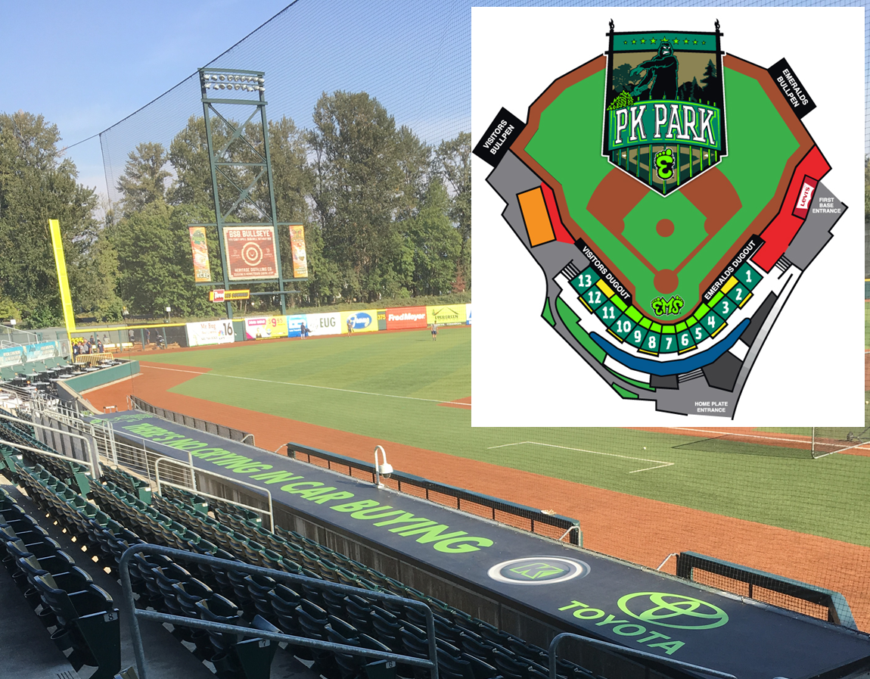

The survey included three, seven-point items to assess sponsorship performance. The first item was the attitude toward the sponsorship item from Study 1: “Use the scale below to indicate your opinion of each brand as a sponsor of the [team name]” (1 = “very negative,” 4 = “neutral,” 7 = “very positive”). With the second and third items, we used seven-point scales (1 = “not at all likely,” 4 = “somewhat likely,” 7 = “extremely likely”) to measure purchase intentions (“How likely are you to purchase each brand’s products or services in the future?”) and word of mouth (“How likely are you to recommend each brand to a friend or colleague?”). The attitudinal measure strongly correlated with the other two items (purchase intentions r = .60, p < .001; word of mouth r = .65, p < .001), in support of its appropriateness as a sponsorship performance metric. We averaged items as a composite score of sponsorship performance (α = .86).
Results. As noted, the created visual congruence in Toyota signage was most visible to fans seated behind the dugouts. Therefore, we assessed the Toyota dealership’s sponsorship performance with a mixed-repeated measure ANOVA with a between-subjects (seats in section behind dugouts vs. not) × within-subjects (Toyota dealership vs. credit union vs. Levi’s) design. The within-subjects contrasts suggested improvements based on seat location for the Toyota dealership but not for the other brands (section × brand F(1, 265) = 4.13, p < .05; M_{Toyota, behind dugouts} = 5.25, M_{Toyota, not behind dugouts} = 4.77, t(265) = 2.53, p < .05) (see Figure W1).
Figure W2
Sponsorship Performance by Brand and Location

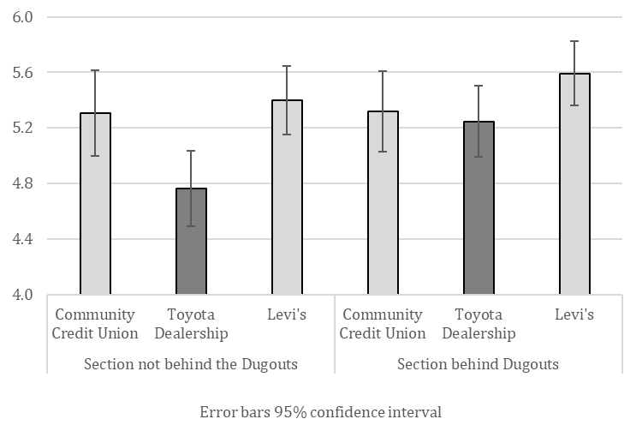

Discussion
When fans did not sit behind the Toyota dealership’s visually congruent signage, their evaluations of the Toyota dealership, relative to the other brands, exhibited the same pattern as we found from initial brand attitudes at the beginning of the season. However, these evaluations grew 10% more favorable when fans sat behind the Toyota dealership’s visually congruent signage than when they did not. That is, when fans could easily view all three sponsors’ signage, the Toyota dealership no longer suffered a significantly lower evaluation than the other brands.
These results in isolation do not provide strong evidence of the benefits of visual congruence, because they involve only three brands and too many potential unobserved factors. However, in combination with the results from Study 1’s extensive MLB stadium data set, the results suggest that the more positive outcomes for the Toyota dealership are due, at least partially, to its choice of visually congruent sponsorship signage.
Thus, this supplemental study complements Study 1 in two key ways. First, it validates attitudes toward the sponsorship as an indicator of sponsorship performance that correlates with other outcomes of managerial interest. Second, it accounts for initial brand preferences when assessing sponsorship performance. Furthermore, it demonstrates the ease with which managers can create visually congruent signage in their sponsorship displays.

Appendix W2: Tests of Color Blindness
We used Birch’s (1997) color blindness tests (see Figure W2), as has been used in several other studies that evaluate color perception abilities (e.g., Berry et al. 2002). Our criterion was strict, sensitive to detection, in that we scored respondents as color blind if they failed any of the tests.
Figure W2
Three Images Used to Test for Color Blindness

Web Appendix References
Berry, John W., John Widdup Berry, Ype H. Poortinga, Marshall H. Segall, and Pierre R. Dasen (2002). Cross-Cultural Psychology: Research and Applications. Cambridge: Cambridge University Press.
Birch, Jennifer (1997), “Efficiency of the Ishihara Test for Identifying Red-Green Colour Deficiency,” Ophthalmic and Physiological Optics, 17 (5), 403–408.
Simmons, Carolyn J. and Karen L. Becker-Olsen (2006), “Achieving Marketing Objectives Through Social Sponsorships,” Journal of Marketing, 70 (4), 154–69.

