Supplementary Information

Field Methods
Over three field seasons, the three-dimensional locations of stratigraphic boundaries, and archaeological features, were plotted onto georectified aerial photographs for GIS-based analysis of the number and type of activity traces preserved in the post-lake strata.
Traces of past human activity, including hearths, clusters of food-remains, patches of tool-making debris and isolated finds, like grindstones and shell tools, were located and documented during systematic inspection of 50 x 50m grid-squares superimposed on the georectified aerial photographs. Information was recorded about the content, and the context, of each archaeological feature or isolated find that remained at least partially embedded in sediment. Only a small proportion of the chipped stone artefacts found on the surface of the lunette are still encased in sediment, so discrete clusters of surface artefacts were included in the data base when their stratigraphic origin could be inferred using information about their distribution in relation to topographic features and sedimentary units, as well as the presence of refitting artefacts, and artefacts struck from the same block of raw material (Foley et al. 2017).
During the initial survey work, information was recorded about the type of heat retainer or baked sediment hearth encountered, and whether any food remains or tools are scattered in or around it (Stern 2015). It also included information about the types of stone artefacts encountered, including the raw materials from which they were made, and about the prey species and body parts represented in the patches of food remains. This was followed by more detailed studies of particular activity traces, with an initial focus on the chipped stone artefacts (Spry, 2014), grindstones (Fullagar et al., 2015a) and shell tools (Weston et al., 2017). Study of the chipped stone artefacts was designed to identify the stone working activities undertaken at specific locations and what these could reveal about changes in the way people moved around the landscape after the lakes had dried out (Spry, 2014).

OSL dating

Additional methodological information
OSL samples were opened and processed under dim red light conditions in the luminescence dating laboratory of the Max Planck Institute for Evolutionary Anthropology, Leipzig, Germany. The sediment from the innermost part of the tubes was used for dating, with the material from the ends of the tubes used to calculate in situ moisture content based on its raw and oven-dried masses. Quartz was extracted from the raw dateable sample using published methods (Fitzsimmons et al., 2014), following a protocol of digestion in hydrochloric acid to remove calcium carbonate, hydrogen peroxide to remove organic content, sieving to isolate the sand-sized (180-212 µm) size fraction, density separation in lithium heterotungstate at 2.62 and 2.68 g cm⁻³ and etching by hydrofluoric acid at 40% concentration for 60 minutes. The etched material was rinsed again with HCl and sieved to remove small flakes produced by the last procedure.
For each sample, 24 small (1 mm) aliquots and 6 single grain discs were prepared for equivalent dose (D_{e}) measurement, plus an additional 24 discs for preheat plateau testing of representative sample EVA1100 (Figure S1). Small aliquots of the clean quartz grains were prepared for measurement by mounting c. 100 grains each (Duller, 2008) onto the central 1 mm of 10 mm diameter stainless steel discs using silicone oil. Single grains were swept using a fine paintbrush onto 10 mm diameter anodised aluminium discs, each containing 10x10 grids of 300 μm diameter holes. Six single grain discs (600 grains) were measured for each sample.
D_{e} measurements on both single aliquots and single grains were undertaken using an automated Risø TL-DA-20 reader equipped with a single grain laser attachment. Clusters of blue light-emitting diodes (Bøtter-Jensen et al., 2000; 1999) provided light stimulation for single aliquot measurement. Single grain light stimulation was provided by green and infrared lasers emitting at 532 nm and 830 nm respectively (Bøtter-Jensen et al., 2000). The luminescence signal was detected by EMI 9235QA photomultiplier tubes with coated Hoya U-340 filters (Bøtter-Jensen, 1997). Irradiation was undertaken using calibrated ⁹⁰Sr/⁹⁰Y beta sources (Bøtter-Jensen et al., 2000). D_{e} was determined using the single aliquot regenerative dose (SAR) protocol of Murray and Wintle (2000; 2003). Preheat plateau tests were undertaken on small aliquots of sample EVA1100 using preheat temperatures between 180°C and 280°C. Since the preheat plateau extended to 260ºC (Figure S1), preheat and cutheat temperatures of 260°C and 220°C respectively were used in the measurement protocols. Depending on aliquot or single grain dose distribution, the central or minimum age models (CAM and MAM, respectively; Galbraith et al., 1999) were used to calculate sample D_{e}. For the majority of samples, both aliquots and single grains yielded broadly normal distributions (Figures S2, S3), so justifying application of the CAM. Generally the very youngest samples gave indication of incomplete bleaching of the OSL signal – a trait which may broadly characterise modern, unconsolidated sediments deposited rapidly and over short distances as is likely the case here based on strong resemblance between the modern sands and the immediately underlying units. For these samples (Table 2), where appropriate, the MAM was used to calculate D_{e}.
Sample dose rates were determined by in situ gamma spectrometry and laboratory beta counting. Attenuation of the dose rates was accounted for using published factors (Guérin et al., 2011). In-situ moisture content, which contributes to dose rate attenuation, was calculated by weighing the raw and oven-dried weight of material from the ends of the tubes and bulk sediment collected from around the sample points. The average of these two values was taken as the final value (Table S3). The cosmic ray component of the dose rates was determined from sample depths and uniform values for sediment density and site altitude, latitude and longitude, following Prescott and Hutton (1994). Although assuming constant depth may reduce the reliability of the dose rate calculations and therefore ages in these sediments with very low dose rates, we decided against modelling variability in cosmic ray dose rates through time (e.g. Burrough et al., 2007). We argue that the assumption of gradual accumulation of overburden is unrealistic in this dynamic environment.

Technical details of the results
Some variability was observed in the luminescence characteristics between sites. Generally, luminescence characteristics of the Lake Mungo samples are better than for those from Lake Durthong. In part this may be due to the fact that the Durthong sample set comprises a larger number of younger samples. Single aliquot samples from Lake Mungo generally yield overdispersion values below 22%, and below 37% for single grains (Table S1). The exceptions to these are the three youngest samples, EVA1103-EVA1105, for which higher proportions of scatter as defined by overdispersion values are observed, given higher precision in single grain measurements of very young samples at the limits of the technique. These three samples also yielded the lowest proportions of datable single grains for the Mungo dataset, which is also attributed to comparably low doses and correspondingly dim signals at the lower limits to the dating technique. The Lake Durthong dataset produced less satisfactory OSL characteristics (Table S1), including lower proportions of single aliquots and single grains passing quality control criteria for age analysis, and relatively high overdispersion values in most cases.
Table S1. Sample statistics from single aliquot and single grain OSL measurements at Lakes Mungo and Durthong. Thermal transfer is listed when the data were available.
Sample | Single aliquot |  |  |  | Single grain
 | D_{e} (Gy) | OD (%) | Aliquots accepted | Recycling ratio | D_{e} (Gy) | OD (%) | Grains accepted | Thermal transfer (%) | Recycling ratio
Lake Mungo
EVA1100 | 10.6 ± 0.5 | 20 | 24/24 | 0.97 ± 0.02 | 5.7 ± 0.2 | 34 | 121/600 | - | 0.98 ± 0.11
EVA1101 | 3.8 ± 0.2 | 22 | 24/24 | 0.97 ± 0.03 | 3.1 ± 0.1 | 37 | 244/600 | - | 0.99 ± 0.11
EVA1103 | 0.05 ± 0.00 | 80 | 22/24 | 0.89 ± 0.14 | 0.04 ± 0.01 | 28 | 55/600 | - | 0.98 ± 0.17
EVA1104 | 0.06 ± 0.01 | 92 | 23/24 | 0.17 ± 0.11 | 0.04 ± 0.00 | 49 | 59/600 | 7.4 | 0.96 ± 0.10
EVA1105 | 0.04 ± 0.00 | 70 | 23/24 | 0.90 ± 0.13 | 0.03 ± 0.02 | 49 | 65/600 | - | 0.99 ± 0.12
EVA1106 | 8.3 ± 0.3 | 15 | 24/24 | 1.00 ± 0.02 | 9.4 ± 0.4 | 36 | 160/600 | - | 1.00 ± 0.10
EVA1107 | 13.1 ± 0.4 | 12 | 24/24 | 0.98 ± 0.01 | 14.4 ± 0.4 | 26 | 230/600 | - | 1.00 ± 0.10
EVA1108 | 19.2 ± 0.9 | 20 | 24/24 | 0.97 ± 0.02 | 19.0 ± 0.6 | 29 | 231/600 | - | 0.99 ± 0.10
Lake Durthong
EVA1069 | - | - | - | - | 0.84 ± 0.16 | 91 | 63/600 | - | 0.97 ± 0.10
EVA1072 | - | - | - | - | 0.15 ± 0.01 | 15 | 45/600 | 6.5 | 0.97 ± 0.06
EVA1092 | 2.10 ± 0.60 | 93 | 12/24 | 0.99 ± 0.11 | 0.84 ± 0.13 | 36 | 8/600 | 0.1 | 1.00 ± 0.12
EVA1094 | 1.00 ± 0.03 | 0 | 20/24 | 1.01 ± 0.07 | 0.97 ± 0.04 | 0 | 17/600 | 7.7 | 0.94 ± 0.10
EVA1097 | 13.1 ± 7.5 | >90 | 19/24 | NDA | 1.80 ± 0.10 | 63 | 60/600 | 1.1 | 0.99 ± 0.01
EVA1099 | 16.5 ± 1.9 | 44 | 16/24 | NDA | 3.80 ± 0.21 | 0 | 88/600 | 1.3 | 1.00 ± 0.09

Substantial discrepancies between the single aliquot and single grain equivalent doses were observed in the Durthong samples. Aliquot D_{e} values yielded higher overdispersion values and were calculated using the CAM, resulting in much older ages than for the younger single grain D_{e}s, which were generally calculated using the MAM on the basis of likely incomplete bleaching of the very young signal. This is assumed on the basis of similarities between the reactivated sediments and lunette units immediately underlying them, which indicates rapid, short-distance transport; this assumption is supported by the observation of dose distributions skewed towards younger ages in some samples. It is interesting to note the prevalence of older D_{e} values in the calculated aliquots vs. single grains of given samples (Table S2); this is attributed to the homogenisation of older, incompletely bleached signals within aliquots. Single grain ages are preferred to the single aliquot values since incomplete bleaching is more reliably identified in single grains than in aliquots.
Table S2. Comparison between calculated D_{e} values for aliquots and single grains of given samples from Lake Mungo for which the MAM was ultimately used to calculate age. Uncertainties are omitted for simplicity of comparison.

Sample | Single grain |  | Single aliquot
 | CAM De (Gy) | MAM De (Gy) | CAM De (Gy) | MAM De (Gy)
EVA1103 | 0.037 | 0.035 | 0.072 | 0.050
EVA1104 | 0.036 | N/A | 0.112 | 0.060
EVA1105 | 0.036 | 0.030 | 0.069 | 0.037

Single grain CAM and MAM calculations for EVA1103 and EVA1105 yield much younger De values than the CAM values for aliquots of the same samples. The MAM of aliquots of sample EVA1105 is comparable with the MAM of its single grain equivalent.
Figure S1. Results of preheat plateau test undertaken on reactivated aeolian sample EVA1100.
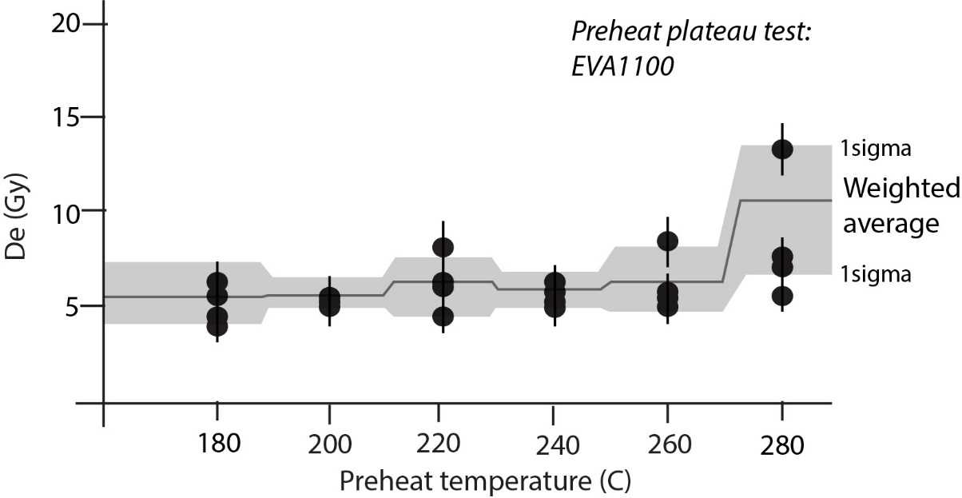

Figure S2. Radial plots for the single grain and single aliquot measurements on the samples from Lake Mungo. Single aliquot values are plotted as open triangle, and the corresponding D_{e} is given as a black line. Single grain results as closed circles and the corresponding D_{e} is shown as the horizontal shaded line.

Figure S3. Radial plots for the single grain and single aliquot measurements on the samples from Lake Durthong. Single aliquot values are plotted as open triangle, and the corresponding D_{e} is given as a black line. Single grain results as closed circles and the corresponding D_{e} is shown as the horizontal shaded line.
Figure S4. OSL signal decay curves from single grains of quartz from Lake Mungo. The uppermost sample, from modern sands, is dated to 0.06 ± 0.02 ka (c. 1950s); the lowermost sample is a Holocene aeolian reactivation, dated to 9.1 ± 0.5 ka. Both yield a clear signal of comparable brightness with respect to dose, with rapid signal decay.
Table S3. Water content values from both Lake Mungo and Durthong samples.
Sample code | Water content (%)
Lake Mungo
All samples | 5 ± 3
Lake Durthong
EVA1069 | 6 ± 3
EVA1072 | 4 ± 2
EVA1092 | 2 ± 2
EVA1094 | 3 ± 2
EVA1097 | 2 ± 2
EVA1099 | 3 ± 2

Figure S5. Dose distribution resulting from dose recovery test for sample EVA1069 (Lake Durthong). From an applied dose of 6.8 Gy (50s), a CAM dose of 6.82 ± 0.11 Gy (overdispersion 8%) was calculated, yielding a dose recovery ratio of 1.00 ± 0.02.

Legacy data bearing on the chronology of archaeological traces
Table S4. Unpublished radiocarbon dates from archaeological traces in the Willandra Lakes. Dates are calibrated using SH13 of Hogg et al. (2013); data points not used in comparative analyses in the main text due to lack of reliability are identifiable by italics.
Lake basin | Site | Description | Lab code | Feature | Sample type | Reference | ¹⁴C uncalibrated | ¹⁴C calibrated
Mungo | MLE5 | East of lake | SUA1737 | Fireplace | Charcoal | Clark (1987) | 700 ± 100 | 636 ± 130
Mungo | WOC | Walls of China, lunette | ANU666 | Fireplace | Charcoal | Clark (1987) | 740 ± 70 | 643 ± 95
Mungo | WOC | Walls of China, lunette | ANU663 | Fireplace | Charcoal | Clark (1987) | 950 ± 120 | 856 ± 208
Mungo-Leaghur interlakes | ML40 | In between lake basins | ANU4135 | Fireplace | Charcoal | Clark (1987) | 1490 ± 130 | 1339 ± 272
Mungo | MLB | Lake bed | ANU661 | Fireplace | Charcoal | Clark (1987) | 1610 ± 110 | 1498 ± 213
Mungo-Leaghur interlakes | ML40 | In between lake basins | ANU4136 | Fireplace | Charcoal | Clark (1987) | 1640 ± 80 | 1471 ± 152
Mungo | WOC | Walls of China, lunette | ANU664 | Fireplace | Charcoal | Clark (1987) | 2060 ± 170 | 1961 ± 401
Mungo | WOC-F80 | Walls of China, lunette | ANU2167A | Fireplace | Charcoal | Clark (1987) | 2670 ± 370 | 2758 ± 887
Garnpung-Leaghur | GL1 | In between lake basins | ANU701 | Fireplace | Charcoal | Johnston and Clark (1998) | 3560 ± 85 | 3786 ± 209
Mulurulu | ME3 | East of lake | ANU464B | Midden | Bone collagen | Johnston and Clark (1998) | 4020 ± 320 | 4468 ± 853
Mungo | WOC | Walls of China, lunette | ANU665 | Fireplace | Charcoal | Clark (1987) | 4020 ± 100 | 4440 ± 287
Mungo | WOC | Walls of China, lunette | ANU669 | Fireplace | Baked clay | Clark (1987) | 4260 ± 190 | 4781 ± 535
Mungo | WOC-F80 | Walls of China, lunette | ANU2167B | Fireplace | Charcoal | Clark (1987) | 4410 ± 360 | 4988 ± 907
Mulurulu | ME3 | East of lake | ANU464A | Midden | Bone calcite | Johnston and Clark (1998) | 7210 ± 100 | 7990 ± 206
Willandra Creek | WCW6 | West of creek | SUA870 | Fireplace | Charcoal | Clark (1987) | 8200 ± 95 | 9142 ± 284
Willandra Creek | WCW3 | West of creek | SUA871 | Fireplace | Charcoal | Clark (1987) | 9390 ± 120 | 10538 ± 293
Garnpung-Leaghur | GL13 | In between lake basins | ANU2165 | Fireplace | Charcoal | Johnston and Clark (1998) | 10250 ± 540 | 11778 ± 1362
Mungo |  |  | SANU27810 | Fireplace | Otolith | Clark (1987) | 11840 ± 45 | 13642 ± 106
Mulurulu | ME3, M11A midden 6 | Mulurulu East | ANU948 | Shell midden | Charcoal | Clark (1987) | 12800 ± 990 | 15531 ± 2595
Mungo | WOC | Walls of China, lunette | ANU684 | Fireplace | Charcoal | Clark (1987) | 12920 ± 550 | 15378 ± 1635
Garnpung | GL1 | Garnpung-Leaghur | ANU373 | Shell midden | Charcoal | Allen (1972) | 13920 ± 480 | 16803 ± 1304
Garnpung |  |  | OZB606 |  | Otolith | Bowler et al. (2012) | 14500 ± 600 | 17518 ± 1505
Arumpo | OA13 | Outer Arumpo lunette | ANU881 | Soil | Charcoal | Clark (1987) | 14630 ± 110 | 17757 ± 276
Garnpung |  | Lake Garnpung | OZB605 |  | Otolith | Bowler et al. (2012) | 14800 ± 370 | 17930 ± 875
Garnpung-Leaghur | GL13 | In between lake basins | ANU2166 | Fireplace | Charcoal | Johnston and Clark (1998) | 14750 ± 230 | 17918 ± 566
Garnpung |  | Lake Garnpung | OZB602 |  | Otolith | Bowler et al. (2012) | 14900 ± 130 | 18077 ± 331
Garnpung |  | Lake Garnpung | OZB607 |  | Otolith | Bowler et al. (2012) | 15050 ± 400 | 18237 ± 939
Mungo | WOC1 | Walls of China, lunette | ANU293 | Fireplace | Charcoal | Clark (1987) | 15140 ± 850 | 18425 ± 2172

Detailed results of archaeological survey and artefact analysis
Clusters of chipped stone artefacts are by far the most abundant trace of past human activity in the post-lake lunette sediments (63%), although hearths (~ 17%) and isolated finds (~ 20%), are also part of the record (Table S7). Most hearths consist of heat retainers, occasionally made from carbonate nodules but mostly from material collected from termite mounds. Two consist of a lens of disseminated charcoal, representing the final remnants of hearths eroded away in antiquity. Food remains and/or tools are rarely found in association with these hearths but a few chipped stone tools, highly fragmented terrestrial mammal bones and pieces of emu egg-shell were documented at two hearths (including one of the charcoal lenses). The isolated finds include one shell tool, two grindstones and some manuports, unworked blocks of sandstone, quartzite and nodules of silcrete that were carried to the lunette, which is naturally devoid of workable rocks. In view of the materials preserved, initial efforts to understand how people responded to the palaeoenvironmental changes associated with the avulsion of the Lachlan River have focused on the information that can be gleaned from the chipped stone artefacts, found in the post-lake aeolian sediments that accrued on the crest and lee of the Lake Mungo lunette. Analysis of these assemblages was designed to investigate whether the accumulation of fewer activity traces in the post-lake sediments was related in any way to increased mobility, given that water sources would have been smaller, more dispersed, and a greater proportion of them more ephemeral, than when the overflow system was operating.
Only 1% of the clusters of stone artefacts in these sediments preserve in situ artefacts; the rest are surface scatters made up either of artefacts struck from the same block of raw material (19%) or refitting sets of artefacts (80%). As such, they provide remarkable insights into episodes of stone-working activity that took place on the lunette, but to generate information about the technological system of which they were a part, they have been analysed and interpreted as an aggregated assemblage (Spry, 2014).
To investigate changes in the frequency and/or distance and/or duration of moves between residential campsites, and between campsites and activity loci, archaeologists try to identify the strategies people used to ensure that they had raw materials and/or tools, where and when they were needed (Kuhn 1995). Inferences about the strategy employed in any particular situation are usually based on information generated about the form in which particular raw materials of different origin and knapping quality were introduced to, and taken away from, different locations on the landscape, as well as the types of stone working techniques used and types of tools produced. This includes information about the way in which and the intensity with which cores were reduced, the types of tools produced, including the relative abundance of long use-life tools to those made, used and discarded on-site, and the strategies used to replace or rejuvenate them (eg. Bleed, 1986; Andrefesky, 1994; Kuhn, 1994; Nelson, 1991). Mobility can also been assessed using ratios that estimate the selective removal and transport of cortical material and cores between different locations on the landscape (eg. Douglass et al., 2008; Phillips et al., 2016), but the wide size range of the cobbles and boulders encountered at the silcrete outcrops in the Willandra Lakes region, as well as the presence of both cortical and non-cortical material, precludes their application to artefact assemblages in this area (Kurpiel, 2017).
We addressed the question about a change in mobility by comparing the chipped stone artefacts found in the post-lake aeolian sediments (Unit F) with those found in the underlying Last Glacial Maximum (LGM) age sediments (Unit E/Zanci; Table S8; Figure S7). The only sources of raw material in the Willandra Lakes region suitable for tool-making originate from numerous outcrops of silcrete located within 5-80 km of the central Mungo lunette and 2 of quartzite located 30-80km away; thin section, trace element and Pb-isotope analyses have been used to characterise the silcrete sources (Kurpiel 2017; Kurpiel et al. 2019). During both time periods, most of the material for making tools was obtained from the silcrete outcrops, but after the lake dried out, greater use was made of the higher-quality quartzite, suggesting that these localized and more distant sources of material were visited more often. Following final lake retreat, a smaller proportion of the cores carried onto the lunette were made from cobbles or slabs and a greater proportion were made from flakes or tools. This suggests that once the lakes dried out, raw material was more often carried around the landscape in the form of smaller, lighter and more prepared cores.
The post-lake stone clusters contain more elongate flakes than those dating to the LGM, indicating more systematic and efficient reduction of cores. A greater proportion of the flakes with edge modification are elongate with a thick cross-section, suggesting that tools with greater length of cutting edge/unit mass and with robust edges were more likely to be made and carried around after the lake dried out. Although the composition of the stone clusters indicates that some tools were made, used and discarded on the lunette during the post-lake period, the presence of small, backed artefacts points to the fact that people were also replacing these small, highly portable tools during visits to the lunette (Spry, 2014).
Taken together, these features of the Unit F chipped stone assemblage suggest that once the lakes dried out, people made greater use of raw material from relatively distant sources and placed greater emphasis on provisioning individuals with tools and highly portable cores than provisioning the landscape with raw material. In contrast, the LGM assemblages from the same part of the lunette suggest that provisioning the landscape with raw material was the predominant strategy employed at that time (Kurpiel, 2017).This suggests that people were more mobile after the lakes dried out, and that a change in stone technology was one of the ways in which they responded to the altered environmental conditions.

Figure S6. Google Earth image showing the locations on the Lake Mungo lunette where systematic archaeological surveys and geological mapping were undertaken, and their relationship to the Locality numbers and cross-section referred to in the text.

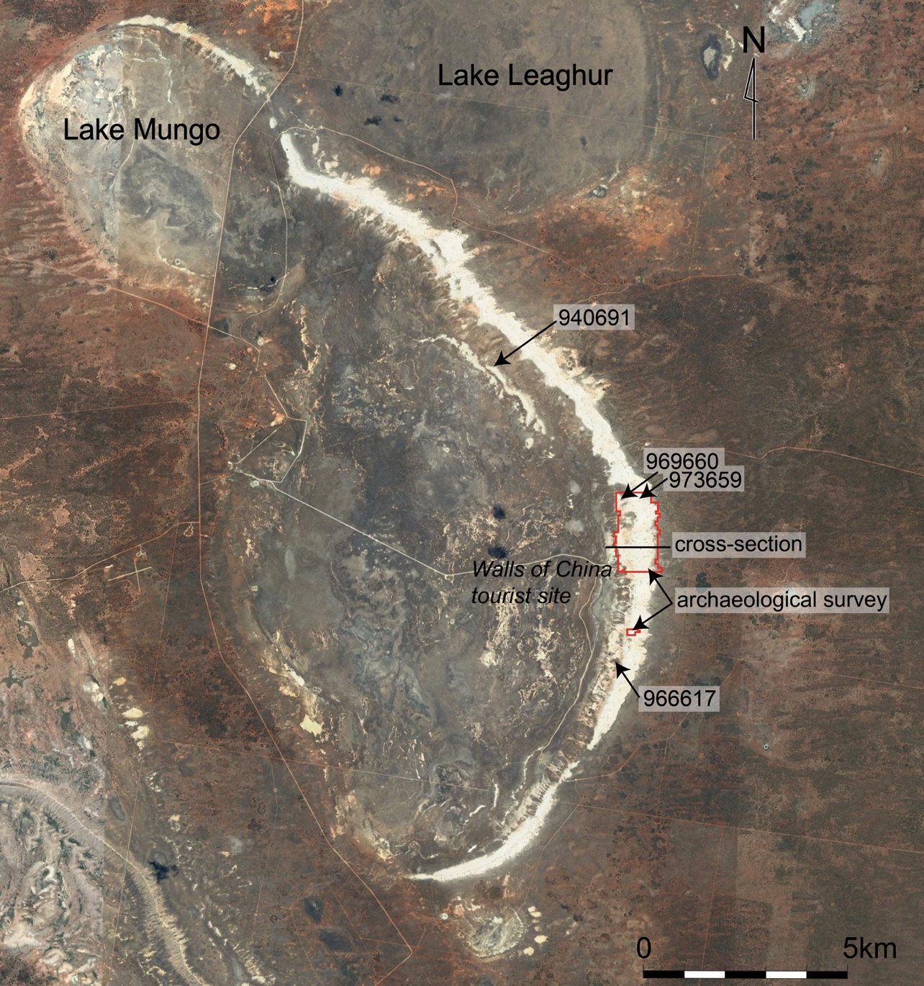
Figure S7. Refitting sets of stone artefacts found on the floor of the erosion basin at Locality 973659, in the central Mungo lunette. All originated from Unit F, the post-lake aeolian sediments. A. The outer shell of a cobble, which was flaked in multiple directions (MAP1262); B. A large flake used as a core (MAP1537); C. A microblade core from which several elongate flakes were struck (MAP1039).
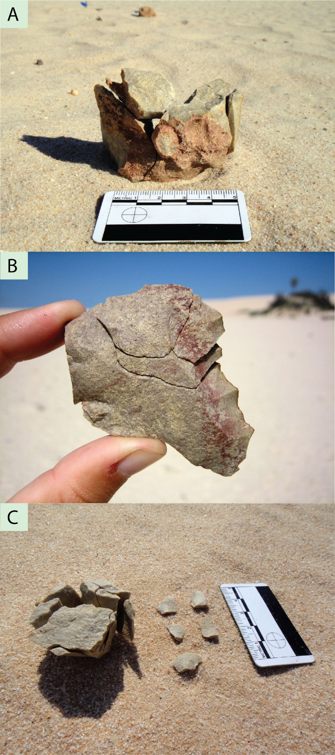

Table S5. Difference between the observed and expected number of archaeological features in the final lake-phase (Unit E/Zanci) and post-lake stratigraphic units (Units F, G) in the central Mungo lunette study area (Figures S6 and S7), based on the null hypothesis that activity traces are distributed homogenously through the stratigraphic sequence.

Stratigraphic unit | Conditions | Approx. age (ka) | Area  km ² | Observed sites | Expected sites | Difference
G – alluvial fan | locally more humid | 5 - 3.5 | 0.19 | 14 | 248 | - 234
F - aeolian | locally more arid | 14 - 8 | 0.21 | 106 | 272 | - 167
E – aeolian (Arumpo/Zanci) | lake oscillating/drying | 23 - 15 | 0.44 | 679 | 552 | + 126

Chi²: 1906, df: 9, p< 0.0001

Table S6. Percentage of sites, for all stratigraphic units in the central Mungo lunette study area, preserved in sediments representing different palaeoenvironmental conditions (N=1,456). For location of study area, see Figure S6.

Hydrologic conditions | % of sites
sustained lake full | 26
lake fluctuating | 65
lake dry, reworking of lunette sediments under locally arid conditions | 7
lake dry, reworking of lunette sediments under locally humid conditions | 1.5

Table S7. Relative abundance of the different types of activity traces preserved in the post-lake stratigraphic units in the central Mungo lunette.

Stratigraphic Unit | Total number  of cultural features | % of cultural features
 |  | Hearths | Isolated | Stone clusters
Unit G | 14 | 75% | 25%
Unit F | 106 | 10% | 20% | 70%

Table S8. Ratios and indices highlighting key technological differences between flaked stone artefact assemblages from units E (n=594) and F (n=700), which formed the basis of detailed technological study (Spry, 2014).

Ratio/index | Unit E | Unit F
Quartzite to silcrete | 1:25 | 1:7
Flake/tool core blanks to cobble/slab core blanks | 1:2 | 1:<1
Cortical material to non-cortical material | 1:2 | 1:3
Cores to flakes | 1:14 | 1:14
Flake elongation (flakes struck from cobbles/slabs) | 1.216 | 1.376
Flake elongation (flakes with edge modification) | 1.098 | 1.627
Cross-sectional shape (flakes with edge modification) | 2.734 | 2.626
Backed artefacts to scrapers | N/A (no backed artefacts) | 1:2

References cited in the Supplementary Information

Allen H (1972) Where the crow flies backwards: man and land in the Darling Basin. Australian National University.
Andrefsky W (1994) Raw material availability and the organization of technology. American Antiquity 59: 21–34.
Bleed P (1986) The optimal design of hunting weapons: maintainability or reliability. American Antiquity 51: 737–747.
Bøtter-Jensen L (1997) Luminescene techniques: instrumentation and methods. Radiation Measurements 27 (5/6): 749–768
Bøtter-Jensen L, Bulur E, Duller GAT and Murray AS (2000) Advances in luminescence instrument systems. Radiation Measurements 32: 523–528
Bøtter-Jensen L, Mejdahl V and Murray AS (1999) New light on OSL. Quaternary Science Reviews 18: 303–309
Bowler JM, Gillespie R, Johnston H, Boljkovac K (2012) Wind v water: Glacial maximum records from the Willandra Lakes, in: Haberle S., David B. (Eds.), Peopled landscapes: archaeological and biogeographic approaches to landscapes. The Australian National University, Canberra, pp. 271-296.
Clark PM (1987) Willandra Lakes World Heritage Area Archaeological Resource Study. A report to the New South Wales Department of Planning and the Western Lands Commission of NSW, Sydney.
Douglass MJ, Holdaway SJ, Fanning P and Shiner J (2008) An assessment and archaeological application of cortex measurement in lithic assemblages. American Antiquity 73: 513–526.
Duller G (2008) Single-grain optical dating of Quaternary sediments: why aliquot size matters in luminescence dating. Boreas 37: 589–612.
Foley E, Spry C and Stern N (2017) Establishing the integrity and stratigraphic origin of stone artefact scatters on the surface of the Lake Mungo lunette in south-eastern Australia. Journal of Archaeological Science: Reports 13: 547–557.
Fullagar R, Hayes E, Stephenson B, Field J, Matheson C, Stern N and Fitzsimmons KE (2015) Evidence for Pleistocene seed grinding at Lake Mungo, south-eastern Australia. Archaeology in Oceania 50 (S1): 3–19.
Hogg AG, Hua Q, Blackwell PG, Niu M, Buck CE, Guilderson TP, Heaton TJ, Palmer JG, Reimer PJ, Reimer RW, Turney CSM, Zimmerman SRH (2013) SHCal13 Southern Hemisphere calibration, 0–50,000 years cal BP. Radiocarbon 55(4), 1889–1903.
Johnston H, Clark P (1998). Willandra Lakes archaeological investigations 1968-98. Archaeology in Oceania 33, 105-119.
Kuhn SL (1994) A formal approach to the design and assembly of mobile toolkits. American Antiquity 59: 426–442.
Kuhn SL (1995) Mousterian Lithic Technology: An Ecological Perspective. New Jersey: Princeton University Press.
Kurpiel R (2017) Stone sources in the Willandra Lakes region, in south-eastern Australia: A study of source characterisation and raw material procurement. PhD Thesis, La Trobe University, Australia.
Nelson MC (1991) The study of technological organization. Archaeological Method and Theory 3: 57–100.
Phillipps RS and Holdaway SJ (2016) Estimating core number in assemblages: core movement and mobility during the Holocene of the Fayum, Egypt. Journal of Archaeological Method and Theory 23: 520–540.
Spry C (2014) Refitting a past: a comparison of late Pleistocene and Terminal Pleistocene/early Holocene stone tool technology at Lake Mungo, southwestern New South Wales, Australia. PhD Thesis, La Trobe University, Australia.
Stern N (2015) The archaeology of the Willandra: its empirical structure and narrative potential. In: McGrath A and Jebb MA (eds) Long History, Deep Time. Canberra: ANU Press, pp.221–240.
Weston E, Szabó K and Stern N (2017) Pleistocene shell tools from Lake Mungo lunette, Australia: identification and interpretation drawing on experimental archaeology. Quaternary International 427: 229–242.

