Appendix A: Conditions
Healthcare Threat

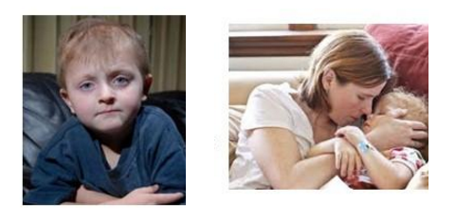

Five Year Old Cancer Patient Kyler van Nocker Dies After Being Denied Life-Prolonging Treatment by Insurance Company

Philadelphia, Pennsylvania – One of the worst abuses practiced by private insurance companies is the use of misleading reasons to deny claims for life-saving medical treatments. Not even children are exempt from such abuses, as was the case for Philadelphia native Kyler van Nocker. Indeed, van Nocker, then 5, suffered from neuroblastoma (a rare form of childhood cancer) and was denied access to a life-prolonging treatment. After one year in remission, the cancer returned, and Kyler was once again in need of treatment.

Although Kyler’s parents Paul and Maria had health insurance, their health insurer HealthAmerica refused to pay for a treatment that doctors believed could have saved his life (MIBG treatment). The Harrisburg-based insurance provider, a subsidiary of Coventry Healthcare, considered the drug “investigational/experimental,” arguing that they denied the treatment because it had yet to be approved by the FDA.

Yet earlier that same year, HealthAmerica approved a different experimental treatment which happened to be significantly cheaper than the one recommended by Kyler’s doctors. In fact, the child’s oncologist stated that the treatment that Health America refused to pay for is considered the standard of care in Europe and the United States.

This prompted Philadelphia Daily News columnist Ronnie Polaneczky to ask, “So why, pray tell, is HealthAmerica playing the ‘experimental therapy’ card in the case of the MIBG treatment Kyler now needs? Gee, money couldn’t have anything to do with the decision, could it?’

Unfortunately, Kyler died only three months away from his sixth birthday, with the family of the child left in heavy debt by out-of-pocket medical bills.

Water Pollution Condition

Two-year-old May Sustain Life-Long Health Consequences Due to Polluted Water Supply

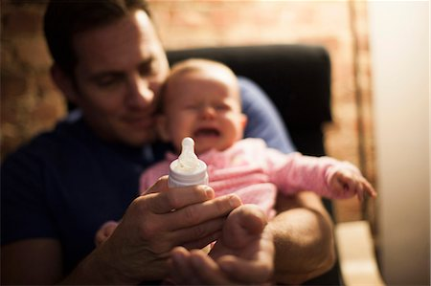
Springfield, Mississippi -- Adam Reed knew that something was wrong when his bubbly, energetic 2-year-old daughter, Josephine, suddenly became anxious and irritable all the time. Reed eventually took his daughter to the doctor for a blood test. His worries were soon confirmed when her blood tests revealed that she was suffering from severe heavy metal poisoning caused by drinking polluted Springfield water.

Springfield’s water pollution has been a growing issue in the past decade, and has resulted from toxic sewage spills and industrial waste into the town’s nearby river. The regulation of toxic pollution has remained lax in the United States. In fact, according to the EPA, 41 states have reported higher than acceptable levels of lead in drinking water in the last three fiscal years. "We just don’t know what’s going to happen to her," Reed said in an interview while consoling Josephine. "My daughter’s just a kid. She doesn’t know what’s going on, and we’re all scared for what comes next.”

Heavy metal poisoning has severe consequences for children younger than six, who can suffer from organ damage, slowed development, and behavioral problems later in life.
Despite these risks, the privatization of water systems are disserving local communities. Privatized systems are not only more expensive, but also cut corners, with these negligent practices resulting in the deterioration of existing infrastructures for the sake of short term profit.

Casey Dinges, the senior managing director of the American Society of Civil Engineers, has stated that the US needs to “seriously invest” in cleaner public water services. Those investments may include stringent regulations of water cleaning plants and additional grants to fund the EPA.
The long-term damage to children who are exposed to contaminated water is incredibly severe. Distraught with his daughter’s condition and the lack of a serious resolution to Springfield’s pollution problem, Reed has stated, “I want what’s best for my daughter, but I don’t think these private companies care.”

Air Pollution Condition
12-Year Old Dies of Asthma Attack Caused by Extreme Polluting in Evansville, Indiana
EVANSVILLE, Ind. — Evansville contains some of America’s largest coal-fired power plants. These plants pump out millions of pounds of toxic air pollution, levels that are comparable to Hong Kong. According to a Center for Public Integrity investigation, areas like Evansville contain an extreme concentration of super polluting coal plants.

This pollution has hit some families particularly hard. Local 12-year old Kavon Cooper suffered from intense asthma, which his mother described as “a constant battle.” He needed medicine to breathe if he stayed in Evansville too long. His asthma attacks were so severe that he would sometimes have to be hospitalized. Because of the severity of his asthma, Kavon stayed home with the windows closed as much as possible, often playing video games with the hopes of testing them for a living someday.

On April 18, 2015, Kavon collapsed and died at home, lying in the hallway by the bathroom right outside his bedroom. The cause of death was an acute asthma attack. At the time, Kavon’s family couldn’t understand what had happened. However, it’s no coincidence that toxic particle and sulfur dioxide levels jumped to extreme levels the morning Kavon died, according to the air monitor near the Cooper family home. Moreover, after learning about this spike in pollution, Kavon’s mother realized that his asthma was much better whenever he left Evansville. She also explained that that “there’s a lot of illness, a lot of sickness in this area.”

One extreme polluter near Kavon’s area, Gibson, is the fourth-largest coal plant in the United States, and released 2.9 million pounds of air pollutants in 2014. Much of their pollution contains sulfuric acid, a lung irritant which the EPA says contributes to the formation of fine, asthma-related particles. Worse yet, Evansville polluters have used settlements to install cheaper, less-effective environmental controls rather than address this dangerous pollution.

These extreme polluters and corner-cutting measures have put local communities in danger. Kavon’s brother, Kameron, tragically stated in Kavon’s obituary, "I just want my brother. We just want him back."

Financial Collapse Prime

Greed hurts: Causes of the Global Financial Crisis

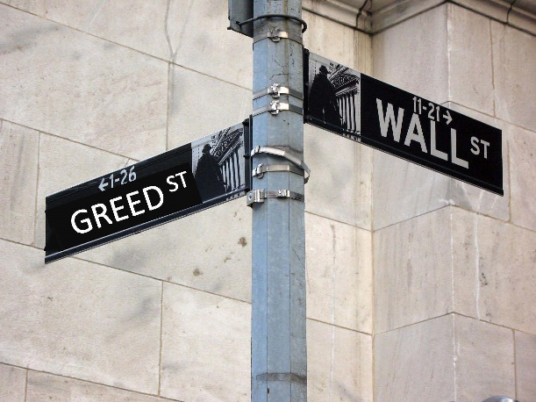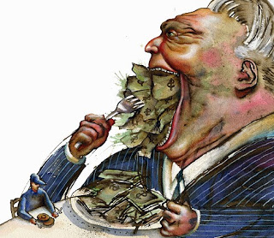

“Greed is good,” insisted Gordon Gekko in the 1987 film Wall Street. Many people would disagree, and recent events in the mortgage lending industry prove them right.

Predatory Lending
The banking scandals from 2008—the most dangerous crisis since the Great Depression of the 1930’s—provides a case in point. As with many financial crises, the problem can be traced back to greed. More specifically, the crisis can be linked to predatory lending practices by our nation’s richest banks. Lenders intentionally issued unfavorable mortgages to those with poor credit, and then saddled them with double digit interest rates after a low introductory rate. To make things worse, banks pressured credit rating agencies to give these shoddy loans AAA status, which increased the appeal of the loans. As long as people paid their mortgages, everyone profited. When the economy slowed down, many people lost their jobs and defaulted on their loans. This slowdown put the global economy into disarray.

The Government Bailout: Guess Who Paid for It?
Banks were fined billions of dollars for these illegal practices. But how did they pay for these fines? Some banks forgave loans already sold to other companies, whereas others denied government-backed modifications, claim documents were never received, and misapplied mortgage payments. Even worse, Bank of America told consumers with excellent credit to purposefully miss payments, to be “eligible” for government-backed programs. If banks were unable to turn consumers to in-house modifications (with higher interest rates and fees), they would foreclose. Ultimately, banks paid their fines by taking advantage of everyday Americans that were scraping by to make ends meet.

One Family’s Story
The Gonzales family of Ocala, Florida bought a modest home in 1998, with Bank of America servicing their loan. In 2008, the couple requested a government-backed modification, and a bank representative told the family to stop making regular mortgage payments to qualify. After sending the documents required, without any written proof, a bank representative approved the family and requested “trial payments” of $1,200. Yet, these payments were never applied, and the couple’s home was foreclosed upon the next year.

Nothing is Free
We can't fall for the line that the bailout was free of cost for the taxpayer. Instead, it created a monster: a continual shift of taxpayer dollars to the banks in the form of hidden subsidies. Far from representing a win for the public, the bailout enslaved us to the big banks more than ever before.

Control Condition

Recent research reveals mysteries of food allergies

Food allergies or food intolerances affect nearly everyone at some point. People often have an unpleasant reaction to something they ate and wonder if they have a food allergy. One out of three people either say that they have a food allergy or that they modify the family diet because a family member is suspected of having a food allergy. But only about 5% of children have clinically proven allergic reactions to foods. In teens and adults, food allergies occur in about 4% of the total population.

This difference between the clinically proven prevalence of food allergy and the public perception of the problem is in part due to reactions called “food intolerances” rather than food allergies. A food allergy, or hypersensitivity, is an abnormal response to a food that is triggered by the immune system. The immune system is not responsible for the symptoms of a food intolerance, even though these symptoms can resemble those of a food allergy. For example, being allergic to milk is different from not being able to digest it properly due to lactose intolerance. It is extremely important for people who have true food allergies to identify them and prevent allergic reactions to food because these reactions can cause devastating illness and, in some cases, be fatal.

Food allergies involve two features of the human immune response. One is the production of immunoglobulin E (IgE), a type of protein called an antibody that circulates through the blood. The other is the mast cell, a specific cell that occurs in all body tissues but is especially common in areas of the body that are typical sites of allergic reactions, including the nose and throat, lungs, skin, and gastrointestinal tract.

The ability of a given individual to form IgE against something as benign as food is an inherited predisposition. Generally, such people come from families in which allergies are common – not necessarily food allergies but perhaps hay fever, asthma, or hives. Someone with two allergic parents is more likely to develop food allergies than someone with one allergic parent.

ISIS Condition
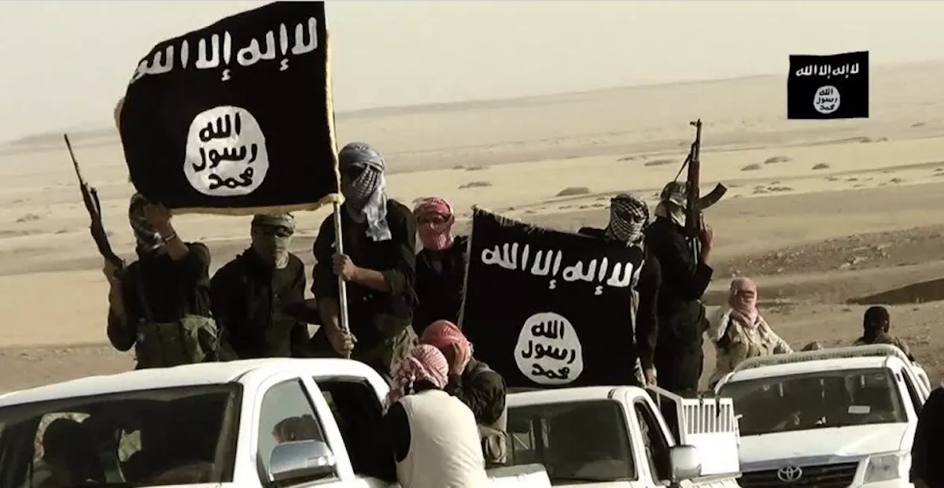

Isis: A Threat to the West

The rise of the Islamic State in Iraq and Syria (ISIS) has wreaked havoc around the world, with the loss of more than 1200 lives outside of Iraq and Syria in attacks linked to ISIS. From broadcasting the beheading of American journalists to coordinating multiple attacks on European soil, ISIS’ cruelty is second to none. ISIS also inspired the 2015 San Bernardino shooting in which a couple pledged allegiance to the leader of ISIS before murdering 14 and injuring 22 at a Department of Public Health Christmas party. ISIS furthermore inspired the Orlando terrorist attack that killed 49 Americans. Terrifyingly, more could be on the way.

According to information provided to Judicial Watch by a source identified as “a high-ranking Homeland security official,” ISIS jihadists have indeed remained in close quarters with the US. This includes ISIS militant Shaykh Mahmood Omar Khabir, who has lived in Mexico for over a year. According to this source, Khabir previously trained hundreds of Al Qaeda fighters in Pakistan, Afghanistan, and Yemen, and now provides training to thousands of jihadis at a base near Ciudad Juarez, which is located just across the border from El Paso, Texas. Khabir has bragged that he “could get in with a handful of men, and kill thousands of people in Texas or in Arizona in the space of a few hours.” The dangers of ISIS cannot be understated. ISIS represents an ominous threat to American security.

Appendix B: Political Attitudes Items, Experiment 1

Hawkish Attitudes
- Military spending is too high.
- The best way to ensure peace is through military strength.
- Using overwhelming military force is the best way to defeat terrorism around the world.
- A strong military is the most important ingredient to keeping America safe.
- Diplomatic solutions to terrorism are almost always preferable to the use of military force.
- Military force is not an effective way to combat terrorism.
- I am strongly in favor of going to war against enemies of the United States.
- If someone asked me to march in an anti-war rally, I would probably go.
- America needs a strong military in order to combat terrorist activity across the world.
- It is in our best interest that we improve our military power.
- America's military might needs to be substantially improved in order to defeat terrorism across the globe.
- Military spending is far too high in our country.

Social Liberal Attitudes
- I am happy that same-sex marriage is now legalized.
- Permits should be required for gun ownership.
- Homosexual relations are morally acceptable.
- Man evolved from other animals.
- Abortion should be legal in all circumstances.
- We should outlaw capital punishment.
- Taxes on the rich are too low.
- We should invest greater time and resources into renewable energy sources (e.g., wind and solar power).
- Carbon dioxide and other greenhouse gasses should be aggressively regulated by the EPA, and violators of the law should be severely punished.

Social Conservative
- I strongly support prayer in public schools.
- Immigrants today are a burden on our country because they take our jobs, housing and health care.
- The U.S. government already spends too much giving money to the poor.
- Taxes on the richest citizens should not be increased.
- Stricter environmental laws and regulations cost too many jobs and hurt the economy.
- There should be less gun control in this country, not more
- Individuals and businesses should not be forced to service people that could potentially conflict with their own religious principles.
- Business owners ought to have the freedom to operate their business that is consistent with their own religious principles.
- Abortion should be outlawed in all circumstances.
- Minorities who can't get ahead in this country are mostly responsible for their own condition.
- Government regulation of business usually does more harm than good.

Healthcare Items
- I would support aggressive regulation of health insurance companies.
- I believe that we should aggressively expand health care coverage for the poorest Americans.
- I would support regulation of privatized health insurance companies.
- Making healthcare attainable should be a priority for the government.
- Government does not have the obligation to provide healthcare for everybody.
- Healthcare companies should have some discretion in paying for experimental treatments.
- Most of the time, healthcare companies do right for their customers.
- I would support more careful monitoring of health insurance companies.
- It should be illegal for health insurance companies to refuse care to patients that have demonstrated need.
- Health insurance companies should be required to pay for all life-saving care.
- The government should have a minimal role in the healthcare industry.
- The government has a responsibility to provide healthcare for low-income individuals.
- People ought to be responsible for their own healthcare costs and needs.
- Government-run healthcare systems are inefficient and costly to tax-payers.
- I would support punishing the healthcare industry if their actions contributed to harming an individual.
- I would support fining health insurers millions of dollars if their actions contributed to harming their customers.
- Health insurers that illegally deny coverage to patients with need should lose their licenses to operate as insurers.
- I would imprison CEOs of health insurance companies that illegally denied coverage to a patient in need.

Appendix C: Political Attitudes Statements, Experiment 2

Hawkish Attitudes
- Military force is not an effective way to combat terrorism.
- Military spending is far too high in our country.
- A strong military is the most important ingredient to keeping America safe.
- America needs a strong military in order to combat terrorist activity across the world.

Social Liberalism
- I am happy that same-sex marriage is now legalized.
- Taxes on the rich are too low.
- Homosexual relations are morally acceptable.
- Abortion should be legal in all circumstances.
- Permits should be required for gun ownership.
- We should outlaw capital punishment.
- Man evolved from other animals.
- Religious expression does not belong in public schools.

Social Conservatism
- The U.S. government already spends too much giving money to the poor.
- Business owners ought to have the freedom to operate their business that is consistent with their own religious principles
- Taxes on the richest citizens should not be increased.
- Individuals and businesses should not be forced to service people that could potentially conflict with their own religious principles.
- I strongly support prayer in public schools.
- Government regulation of business usually does more harm than good.
- There should be less gun control in this country, not more.
- Abortion should be outlawed in all circumstances.

Healthcare Attitudes
- I believe that we should aggressively expand health care coverage for the poorest Americans.
- I would support regulation of privatized health insurance companies.
- The government should have a minimal role in the healthcare industry.
- People ought to be responsible for their own healthcare costs and needs.

Environmental Attitudes

- The federal government should aggressively carry out environmental protection regulations.
- The federal government has a responsibility to ensure companies are reducing their pollution levels.
- Federal funding of the Environmental Protection Agency should be our top priority, even if it means a reduction in funding for other areas.
- Private companies should be required, by federal law, to use cleaner energy solutions.
- I would support fining coal companies millions of dollars if their actions contributed to harming local communities
- I would support the aggressive federal regulation of coal companies.
- Private companies that cause extreme water pollution should be punished.
- Private companies that contribute to water pollution should be aggressively regulated by the federal government.
- The federal government does not have a right to oversee environmental matters.
- No additional tax dollars should go to the Environmental Protection Agency.
- Clean energy solutions are too costly for tax-payers.
- Private companies should be give more control to set and legally abide by their own environmental standards.
- The federal government should have a minimal role in regulating the coal industry.
- Coal companies are not obligated to reduce pollution.
- Private companies should not be aggressively regulated for the sake of preventing water pollution.
- Private companies should not be punished for causing water pollution.

Appendix D: Political Attitudes Statements, Experiment 3

Financial regulatory Attitudes

- The government has not gone far enough in regulating financial institutions, like banks.
- There are too many regulations on financial institutions in the United States.
- There is too much regulation on banks and financial institutions.
- I believe we needed higher levels of regulations of the financial services industry, such as banks, lending providers, and credit agencies.
- The federal regulation of financial institutions and markets harms economic growth.
- If the government does not regulate financial institutions and markets, the country is at risk of another financial crisis.
- There is no need to regulate the banking industry any further than it already has been.
- I would support much greater oversight of the largest banks in the nation.
- Strict regulations of the financial sector have gone far enough; there is no need for further regulation.
- I support a massive overhaul of the banking industry, to protect consumers from being unfairly treated.
- Contrary to what some might say, a powerful federal government is needed to protect the interests of the average man or woman.
- In the long run, federal regulations do more harm than good.
- We need to reduce, not strengthen, the power of the federal government.
- We need a strong federal government to protect the interests and welfare of the average consumer.

Hawkish Attitudes
- Military force is not an effective way to combat terrorism.
- Military spending is far too high in our country.
- A strong military is the most important ingredient to keeping America safe.
- America needs a strong military in order to combat terrorist activity across the world.
Social Liberalism
- I am happy that same-sex marriage is now legalized.
- Taxes on the rich are too low.
- Homosexual relations are morally acceptable.
- Abortion should be legal in all circumstances.
- Permits should be required for gun ownership.
- We should outlaw capital punishment.
- Man evolved from other animals.
- Religious expression does not belong in public schools.

Social Conservatism
- The U.S. government already spends too much giving money to the poor.
- Business owners ought to have the freedom to operate their business that is consistent with their own religious principles
- Taxes on the richest citizens should not be increased.
- Individuals and businesses should not be forced to service people that could potentially conflict with their own religious principles.
- I strongly support prayer in public schools.
- Government regulation of business usually does more harm than good.
- There should be less gun control in this country, not more.
- Abortion should be outlawed in all circumstances.

Healthcare Attitudes
- I believe that we should aggressively expand health care coverage for the poorest Americans.
- I would support regulation of privatized health insurance companies.
- The government should have a minimal role in the healthcare industry.
- People ought to be responsible for their own healthcare costs and needs.

Environmental Attitudes
- The federal government should aggressively carry out environmental protection regulations.
- Federal funding of the Environmental Protection Agency should be our top priority, even if it means a reduction in funding for other areas.
- Private companies should be required, by federal law, to use cleaner energy solutions.
- No additional tax dollars should go to the Environmental Protection Agency.
- Private companies should be give more control to set and legally abide by their own environmental standards.
- Private companies should not be aggressively regulated for the sake of preventing water pollution.

Appendix E: Preliminary Study, Design and Results

Overview of Experimental Design
Priming Manipulation: Participants were randomly assigned to one of five conditions, representing the identical manipulations described in Eadeh & Chang (2018). For convenience, I have attached the priming manipulations (Appendix A) to the bottom of this summary.
(1)Terrorist Threat
(2)Healthcare Threat
(3)Water Pollution Threat
(4)Corporate Misconduct Threat
(5)Control

Order: Participants either first completed the mood inventory, followed by a perceived threat index, or the perceived threat index followed by the mood inventory. None of our results were qualified by this independent measure, or the interaction with priming condition.

Dependent Measures

Perceived Threat Index (14 items, randomized)
- I feel threatened after reading this article.
- I am alarmed by the information I had read in the previous article.
- I feel unsafe after reading the assigned article.
- I believe the article I read is threatening for society at-large.
- I did not feel threatened by the article I had read.*
- I am not alarmed by the assigned article.*
- I believe the information I had read is not threatening for society.*
- I believe Americans are concerned about the information described in the article.
- I feel personally alarmed after reading the assigned article.
- This article made me feel a great deal of concern for fellow Americans.
- I think what happened in my assigned article could happen to me.
- This article discusses a threat that is potentially relevant to my own life.
- This article discusses a threat that is potentially relevant to my friends and/or people I know.
- This kind of threat could never be relevant to me.*
*reverse-scored
A. We first conducted unrotated principal components analysis on all 14 items. Analyses indicated the presence of one factor (Eigenvalue = 7.30, variance explained = 52.11%)
B. Self-Threat subindex (alpha = 0.91): 1, 2, 3, 5, 6, 9, 11, 12, 13, 14
C. Community-Threat index (alpha = 0.82) : 4, 7, 8, 10
D. Threat Average (14 items, alpha = 0.93)
Mood Inventory (35 total items, randomized)
Fear (afraid, scared, fearful; alpha = 0.92)†
Anger (angry, mad, irate, furious; alpha = 0.94)
Anxiety (anxious, nervous, worried; alpha = 0.88)
Disgust (disgusted, revulsion, repulsed, nauseated, sickened; alpha = 0.93)
†We pre-registered that we planned to include the item terrified into the mood inventory, but forgot to include this item in the mood inventory. This is the fault of the first author. However, reliability indices indicated that even a three-item measure produced excellent levels of internal consistency.

Table 1: Summary of Perceived Threat Indices by Experimental Condition

Measure of Interest | Control Condition, Experiment 1-3 | Terrorism Prime | Healthcare Prime, Experiment 1 | Water Pollution Prime, Experiment 2 | Corporate Misconduct Prime,  Experiment 3
Perceived Threat, Unrotated Principal Components Analysis (1 Factor, Unrotated, Eigenvalue = 7.30, variance explained = 52.11%) | -1.09_{a} | 0.08_{b} | 0.38_{b} | 0.48_{b} | 0.18_{b}
“Self Threat” Subindex (10 items, alpha = 0.91) | 3.41_{a} | 4.79_{b} | 5.30_{b} | 5.40_{b} | 5.00_{b}
“Social Threat” Subindex (4 items, alpha = 0.82) | 3.83_{a} | 5.63_{b} | 5.75_{b} | 5.89_{b} | 5.35_{b}
Perceived Threat, all items composite (alpha = 0.93) | 3.53_{a} | 5.03_{b} | 5.43_{b} | 5.54_{b} | 5.15_{b}

Table 2: Summary of Affective Indices by Experimental Condition

Measure of Interest | Control Condition, Experiment 1-3 | Terrorism Prime | Healthcare Prime, Experiment 1 | Water Pollution Prime, Experiment 2 | Corporate Misconduct Prime,  Experiment 3
Anger | 1.43_{a} | 2.90_{b} | 3.06_{b} | 3.45_{b} | 2.80_{b}
Disgust | 1.49_{a} | 2.77_{b} | 3.05_{b} | 3.18_{b} | 2.74_{b}
Fear | 1.35_{a} | 2.47_{b} | 2.31_{b} | 2.85_{b} | 2.08_{b}
Anxiety | 1.55_{a} | 2.55_{b} | 2.58_{b} | 2.86_{b} | 2.35_{b}

Appendix F: Tests of Moderated Mediation, Experiments 1 & 3
We performed moderated mediation analyses, by examining how participants’ political ideology affected the link between threat and political attitude change, both within and outside of changes in anger and fear/anxiety. Participants’ political ideology was operationalized by a 7-point self-reported political orientation scale (1 = Strongly Liberal, 7 = Strongly Conservative). All data were analyzed using mean-centered measures for anger, fear/anxiety, and political ideology, and were submitted to model 59 of Hayes’ (2013; 2018) PROCESS Macro for SPSS.
Before doing so, however, we probed for between-subjects differences on self-reported political ideology, between the experimental prime and control conditions. There was no evidence of these effects in Experiment 1, Ms = 3.69 (1.81) vs. 3.55 (1.74), F(1, 556) < 1, p > 0.25, and Experiment 3, Ms = 3.58 (1.79) vs. 3.75 (1.62), F(1, 223) < 1, p > 0.25. However, there was between-subjects differences on political ideology in Experiment 2, Ms = 3.21 (1.59) vs. 3.84 (1.74), F(1, 182) = 6.58, p = 0.01, partial η² = 0.04, such that participants assigned to the pollution threat were more likely to express lower ratings (i.e., more liberal) compared to participants assigned to the control condition. For these reasons, moderated mediation was only conducted in Experiments 1 and 3.
Experiment 1
Examination of the “a” path
We first examined whether political orientation of the target moderated the link between priming condition and affect. In the case of anger, there was evidence of a marginal condition*ideology interaction, b = -0.09 (se = 0.04), p = 0.05, 95 % CI [-0.17; 0.0001], indicating that self-described liberals (16th percentile) expressed somewhat higher levels of anger (b = 2.34) compared to moderates (50th percentile; SD; b = 2.17) and conservatives (84th Percentile; b = 2.00). With respect to fear, a similar pattern emerged, b = -0.07 (0.04), p = 0.08, 95% CI [-0.15; 0.01], such that liberals (b =1.06) expressed higher levels of fear compared to moderates (b = 0.91) and conservatives (b = 0.77).
Examination of “b” path
We next examined whether political orientation moderated the link between anger and fear/anxiety on support for healthcare attitudes. Analyses indicated the presence of an anger*ideology interaction, b = 0.05 (0.02), p = 0.04, 95% CI [0.01; 0.09], such that the link between anger and support for liberal healthcare attitudes was stronger for conservatives (16th percentile, b = 0.66), compared to moderates (50th percentile; b = 0.51) and liberals (b = 0.34). In contrast, the fear/anxiety*ideology interaction on healthcare attitudes did not reach statistical significance, b = -0.02 (0.02), p = 0.54, 95% CI [-0.06; 0.03]
Examination of “c” path
We next investigated whether political ideology moderated the link between priming condition and liberal healthcare attitudes. It did not, as the interaction between these variables did not reach conventional levels of statistical significance, b = -0.07 (0.06), p = 0.24, 95% CI [-0.18; 0.05]. We also conducted formal moderation analyses using model 1 of the PROCESS Macro, with priming condition serving as the independent variable, healthcare attitudes as the dependent variable, and political orientation as the moderating variable. These analyses were in-line with the above-mentioned analyses presented in Model 59, indicating no interaction between ideology and priming condition on healthcare attitudes, b = 0.01 (0.04), p = 0.89, 95% CI [-0.07; 0.08].

Experiment 3
Examination of the “a” path
We first examined whether political orientation of the target moderated the link between priming condition and affect. In the case of anger, there was no evidence for a condition*ideology interaction, b = -0.04 (se = 0.07), p = 0.55, 95 % CI [-0.19; 0.11]. With respect to fear, there was evidence of an interaction, b = -0.13 (0.06), p = 0.02, 95% CI [-0.25; -0.02], such that liberals (b =0.81) expressed higher levels of fear compared to moderates (b = 0.54) and conservatives (b = 0.28).
Examination of the “b” path
We next examined whether political orientation moderated the link between anger and fear/anxiety on support for healthcare attitudes. There was no evidence for an anger*ideology interaction on regulatory attitudes, b = 0.04 (0.04), p = 0.32, 95% CI [-0.04; 0.13], nor was there evidence of a fear*ideology interaction, b = 0.04 (0.06), p = 0.51, 95% CI [-0.08; 0.17]. Examination of the “c” path
We next investigated whether political ideology moderated the link between priming condition and liberal healthcare attitudes. It did not, as the interaction between these variables did not reach conventional levels of statistical significance, b = -0.10 (0.09), p = 0.31, 95% CI [-0.28; 0.09]. We also conducted moderation analyses using model 1 of the PROCESS Macro, with priming condition serving as the independent variable, regulatory attitudes as the dependent variable, and political orientation as the moderating variable. These analyses were in-line with the above-mentioned analyses presented in Model 59, indicating no interaction between ideology and priming condition on healthcare attitudes, b = 0.03 (0.07), p = 0.68, 95% CI [-0.11; 0.17].

