SUPPLEMENTARY INFORMATION

Table 1 Eron classification of skin and soft tissue infection (SSTI) according to the severity of local and systemic signs, and associated management[4]
Category | Clinical features
Class 1 | SSTI with no signs or symptoms of systemic toxicity or comorbidities
Class 2 | Either systemically unwell or systemically well but with comorbidity that may complicate or delay resolution
Class 3 | Toxic and unwell (fever, tachycardia, tachypnoea and/or hypotension)
Class 4 | Sepsis syndrome and life-threatening infection (e.g. necrotising fasciitis)

Table 2 Criteria for Systemic Inflammatory Response Syndrome[7]
Two or more of: | Temperature >38°C or <36°C
 | Heart rate >90/min
 | Respiratory rate >20/min or PaCO₂ <32mmHg (4.3 kPa)
 | White blood cell count >12 000/mm³ or <4000/mm³ or >10% immature bands

Table 3 Antibiotics prescribed as first regimen treatment for ABSSSI
First regimen antibiotics | Narrow spectrum: active against Staphylococci and Streptococci.  Broad spectrum: active against Staphylococci and Streptococci, Gram-negatives and anaerobes including toxin inhibitor
Teicoplanin | *Staphylococci and Streptococci
Clindamycin | Staphylococci and Streptococci and anti-toxin
Flucloxacillin | Staphylococci and Streptococci
Vancomycin | *Staphylococci and Streptococci
Clarithromycin | Staphylococci and Streptococci
Gentamicin | Gram-negative agent (part of broad-spectrum regimen)
Metronidazole | Anti-anaerobe agent (part of broad-spectrum regimen)
Linezolid | *Staphylococci and Streptococci
Benzylpenicillin | Streptococci only
Ceftriaxone | Staphylococci, Streptococci and Gram-negative cover (broad-spectrum)
Cefuroxime | Staphs, Streps and Gram-negative cover (broad-spectrum)
Daptomycin | *Staphylococci and Streptococci
Amoxicillin | Streptococci only
Co-trimoxazole | * Staphylococci, Streptococci and Gram-negative cover (broad-spectrum)
Moxifloxacin | Staphylococci, Streptococci and Gram-negative cover (broad-spectrum)
Rifampicin | * Staphylococci, Streptococci and anti-toxin
Amikacin | Gram-negative agent (part of broad-spectrum regimen)
Erythromycin | Staphylococci and Streptococci
Ciprofloxacin | Gram-negative agent (part of broad-spectrum regimen)
Piperacillin/tazobactam | Staphylococci and Streptococci and Gram-negative cover (broad-spectrum)
Doxycycline | *Staphylococci and Streptococci and Gram-negative cover (broad-spectrum)
Cefotaxime | Staphylococci, Streptococci and Gram-negative cover (broad-spectrum)
Co-amoxiclav | Staphylococci, Streptococci and Gram-negative cover (broad-spectrum)
* includes MRSA cover; beta-lactam antibiotics are shown in grey rows

Table 4 Reasons for change in antibiotics regimen
Reasons of choice of 1st therapy* | Number of patients | % (n=145)
Clinician choice | 45 | 31%
Allergy | 39 | 27%
Severity of infection | 29 | 20%
Previous treatment failure | 18 | 12%
IV no longer a requirement | 5 | 3%
Result of C&S | 3 | 2%
Unsuitable for oral therapy | 1 | 1%
Hospital/treatment policies and guidelines | 14 | 10%
Other | 8 | 6%
*Reasons based on clinician’s judgement, not mutually exclusive

Table 5 Distribution of patients receiving various first regimen antibiotics
Antibiotics used as part of first regimen | Number of patients* | % (n=145)
Teicoplanin | 47 | 32%
Clindamycin | 47 | 32%
Flucloxacillin | 26 | 18%
Vancomycin | 15 | 10%
Clarithromycin | 10 | 7%
Gentamicin | 8 | 6%
Metronidazole | 6 | 4%
Benzylpenicillin | 4 | 3%
Ceftriaxone | 4 | 3%
Cefuroxime | 4 | 3%
Other beta-lactam | 3 | 3%
Other non-beta-lactam | 18 | 3%
*Numbers are not mutually exclusive

Table 6 LOS of inpatients with SIRS classification according to ‘appropriateness’ of treatment
Median (IQR) LOS* | Appropriate | Over-treated
SIRS | 6.0 (4.0-13.0)  n=7 | 19.5 (14.8-38.5)  n=12
Resolved infection | 13.0 (9.5 - 22.3)  n=4 | 19.5 (16.0 - 33.5)  n=6
Resolving | 4.0 (3.0-5.0)  n=2 | 20.0 (7.8-35.3)  n=6
Non SIRS | 12.0 (10.8-14.8)  n=8 | 11.0 (4.0-19.0)  n=10
Resolved infection | 12.5 (9.5-16.0)  n=4 | 12.0 (7.5-20.5)  n=8
Resolving | 12.0 (11.0-12.0 )  n=3 | 4.0 (3.0-5.0)  n=2
*Infection not resolved for 2 patients receiving 'appropriate' treatment (1 SIRS, 1 non SIRS)

Figure 1 Management settings for patients diagnosed with ABSSSI

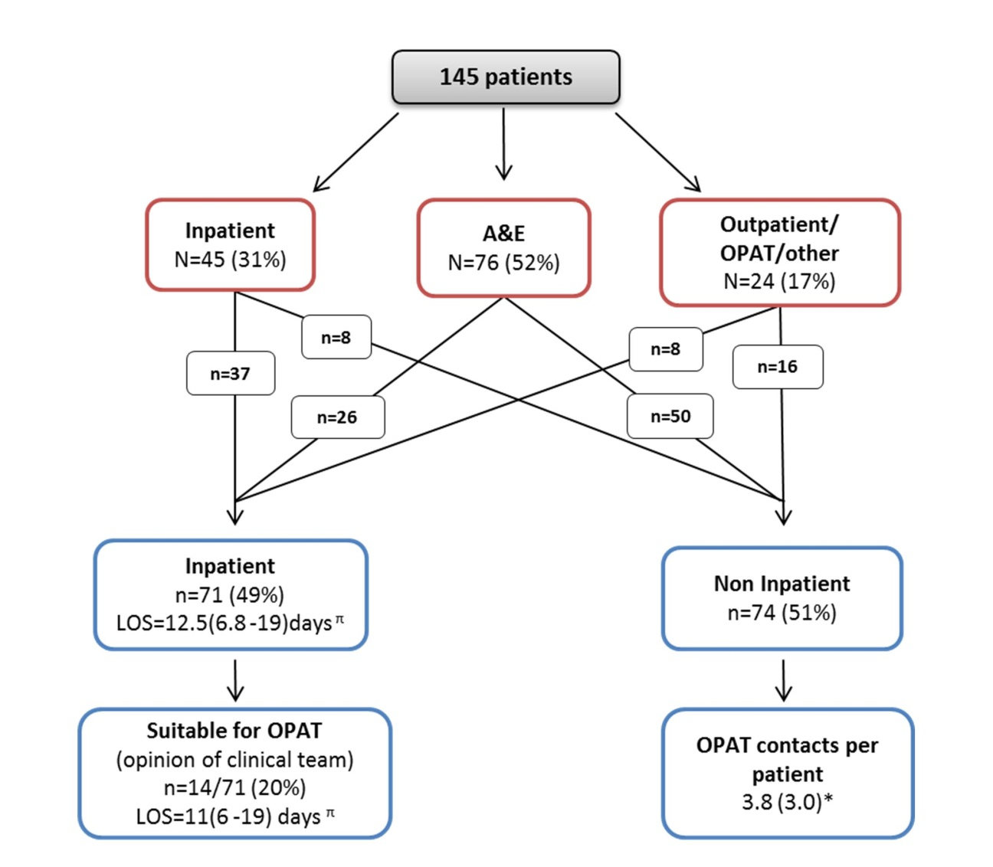
^{π}Result expressed as Median (interquartile range),*Results shown as Mean (SD). LOS is ABSSSI-related length of stay i.e. number of days until patient was deemed fit for discharge from under secondary care responsibility by the clinical team. Red boxes show patient management settings at the time of ABSSSI presentation and blue boxes represent management settings during treatment of ABSSSI.

