Paradoxical Effects of Power on Moral Thinking:
Why Power both Increases and Decreases Deontological and Utilitarian Moral Decisions

Online Supplemental Material

Online Supplemental Material
We present the results of two exploratory pilot studies, conducted prior to the confirmatory Studies 1 and 2. In addition, we present more detailed instructions for manipulations in Study 1 and an alternative analysis of the results of Study 2. We also provide a more detailed description of the Moral Orientations Scale (MOS) used in Studies 1 and 2 and both Pilot Studies, and present its items, its correlations (see Table S1, S3, S7) and its factor analysis (see Table S8).
Pilot Study 1
We conducted Pilot Study 1 prior to conducting Study 1 (in the main manuscript) as a first (non-preregistered) exploratory test of our hypotheses, and to estimate effect size. The results were highly similar to those of Study 1.
Method
Participants and Design. Three-hundred-and-sixty MTurkers (192 female, 168 male, 2 other, M_{age} = 36) participated for $0.50. The design was exactly the same as Study 1.
Materials. The materials were exactly the same as Study 1. Cronbach’s Alpha for the manipulation check was .96. Internal reliabilities of the MOS subscales were also good, with Cronbach’s alpha ranging between .69 and .88.
Results
See Table S2 for all means (and SDs). Results were highly similar as in Study 1, with the exception that we also found one additional effect on sentiment orientation. Specifically, as expected, participants expressed feeling more powerful in the high-power than in the low-power condition, t(317.63) = 26.44, p < .001, d = 2.75, CI₉₅ [2.46; 3.03]. Also as expected, compared to low-power participants, participants in the high-power condition scored higher on the integration, t(355.66) = 2.71, p = .007, d = 0.28, CI₉₅ [0.08; 0.49], deliberation, t(360) = 6.22, p < .001, d = 0.65, CI₉₅ [0.44; 0.87] and rule orientations, t(360) = 3.40, p = .001, d = 0.36, CI₉₅ [0.15; 0.57]. Unexpectedly, high-power participants also scored lower on sentiment orientation than low-power participants, t(360) = -1.99, p = .047, d = -0.20, CI₉₅ [-0.42; -0.003]. Given the lack of theoretical support and weak significance of the latter finding, we interpreted this as a chance finding. The null results for this test in Study 1 (main manuscript) confirmed this interpretation.
Study 1
Method
Power manipulation. We used the Dubois, Rucker, and Galinsky (2010) imagined hierarchical role manipulation of power. Participants imagined holding a high-power manager or low-power employee role in a company and wrote what that would be like. Specifically, they were asked to imagine what it would be like to either “work as a manager, have a lot of responsibility, and oversee the work of your employees” (manager role) or “work as an employee, have little to no responsibility, and just do what you are told to do” (employee role).
Pilot Study 2
We conducted Pilot Study 2 prior to conducting Study 2 (in the main manuscript) as a first (non-preregistered) test of our hypotheses and to estimate effect size. The results were highly similar to those of Study 2.
Method
Participants and Design. Three-hundred-and-two MTurkers (149 female, 153 male, M_{age} = 36) participated for $0.70. The design was exactly the same as in Study 2, except that participants were instructed to only participate if they were employed (as our IV focused on feelings of power at work). As this restriction introduces the possibility that some people may dishonestly claim to be employed, in Study 2 in the manuscript, we instead allowed everyone to participate, but removed participants who reported they were unemployed after data collection.
Materials. All materials were exactly the same as in Study 2. Internal reliabilities of the MOS subscales were good, with Cronbach’s alpha ranging between .76 and .91.
Results. Results were highly similar as in Study 2, with the exceptions that the effect of deliberation orientation on the utilitarian parameter was only marginal, the effect of rule orientation on the deontology parameter was not significant, and sense of power unexpectedly predicted higher sentiment orientation. However, these minor fluctuations did not affect the pattern of indirect effects, which came out very similar to Study 2. We present all bivariate correlations in Table S3. Sense of power did not significantly correlate with either the utilitarian or the deontological parameter. However, sense of power did positively correlate with the integration, deliberation, and rule moral orientations (though not sentiment orientation). In turn, the integration, deliberation, and rule orientations correlated with the utilitarian parameter, and integration orientation also correlated with the deontological parameter.
We tested for multiple mediation with 10.000 sample bootstrapped samples using Process for SPSS (Hayes, 2013). Figure S1 depicts the mediation model for the utilitarian parameter. Sense of power predicted higher scores on the integration, deliberation, and rule orientations, but not sentiment orientation (see Table S4). In turn, integration orientation significantly predicted, and deliberation orientation marginally predicted, the utilitarian parameter in a positive direction. Conversely, rule and sentiment orientations predicted reductions in the utilitarian parameter (see Table S5). Note that this pattern replicates past work (Conway, Velasquez, & Love, 2017). Analyses of indirect effects indicated that integration orientation significantly mediated the effect of sense of power on the utilitarian parameter, as did the deliberation and rule, but not sentiment orientations (see Table S6).
Figure S2 depicts the mediation model for the deontological process dissociation parameter. Integration orientation increased and deliberation orientation reduced the deontology parameter. Neither rule nor sentiment orientation significantly predicted the deontology parameter (see Table S5). Note that again, this pattern replicates past work (Conway et al., 2017). Indirect effect analyses indicated that sense of power indirectly influenced the deontological factor through integration and deliberation orientation, but not through rule or sentiment orientation (see Table S6).
Study 2 (Main Manuscript)
In Study 2, we removed unemployed participants from the final sample, because our independent variable measured feelings of power at work. Therefore, these items did not meaningfully tap into any construct for these participants, providing a clear rationale for deletion. Nonetheless, to ensure readers have access to complete information, we present results for all participants Study 2 below.
Results. Overall, the results of Study 2 remain highly similar to the analysis reported in the main manuscript when assessing the full sample. The most important differences are that the indirect effect of sense of power through integration orientation on the deontological and utilitarian PD parameters no longer reached significance anymore, whereas the indirect effect of sense of power on the deontological PD parameter through rule orientation was now significant. Specifically, consistent with pre-registered predictions, sense of power did not correlate with either the utilitarian or deontological parameters. However, sense of power correlated significantly with the deliberation and rule orientations (though not integration or sentiment orientation, see Table S3). In turn, all four moral orientations correlated significantly (either positively or negatively, as predicted) with the utilitarian parameter. Moreover, integration orientation significantly correlated, and deliberation orientation marginally correlated, with the deontology parameter.
Figure S3 shows the mediation model for the utilitarian parameter. Replicating Pilot Study 2, and consistent with preregistered hypotheses (http://aspredicted.org/blind.php/?x=h5k84d), sense of power predicted higher deliberation and rule orientations. However, sense of power did not significantly predict integration or sentiment orientation directly (see Table S4). In turn, integration and deliberation orientation predicted significant increases in the utilitarian parameter, whereas rule and sentiment orientations predicted significant decreases in the utilitarian parameter (see Table S5). Turning to indirect effects, the effect of sense of power on the utilitarian PD parameter was significantly mediated through the deliberation and rule orientations, but not through integration or sentiment orientation (see Table 4).
Figure S4 depicts the mediation model for the deontology parameter. Consistent with preregistered hypotheses, and replicating Pilot Study 2, integration orientation predicted increases in the deontology parameter, whereas the deliberation and rule orientations predicted decreases in the deontology parameter (see Table S5). Contrary to Pilot Study 2, sentiment orientation did not significantly predict the deontology parameter. Turning to indirect effects, the effect of sense of power on the deontology parameter was mediated through deliberation and rule orientation, but not through integration and sentiment orientation (see Table S6). Although the mediation patterns reported here deviate slightly from the patterns reported in the manuscript in terms of the significance levels of integration and rule orientations, readers will note that the sets of findings are otherwise quite close. We contend that the sample excluding non-working participants reflects a more accurate picture of these relationships, given that participants were asked to consider power at work specifically.
Finally, we present additional information regarding the analyses reported for Study 2 in the main manuscript. We present bivariate correlations between all variables in Study 2 in Table S7. The effects of power on the moral orientations in the mediation model can be found in Table S4, effects of moral orientations on the deontological and utilitarian PD parameter can be found in Table S5, and indirect effects of power through moral orientation on the deontological and utilitarian PD parameter can be found in Table S6.

Moral Orientation Scale
Table S8 shows a factor analysis of the moral orientation scale.
Instructions: Please indicate how much you agree or disagree with the following statements. There is no right or wrong answer; we are simply interested in your personal opinion.
Response scale: 1 = Strongly disagree – 7 = Strongly agree

Integration Orientation
When I think of people getting hurt it makes me upset.
It upsets me when people do something unethical.
Other people's pain is very real to me.
I tend to feel strong emotions when someone behaves unethically.
Unethical behavior does not bother me. (Reversed)
I tend to get upset when I see someone cheating.
I cringe when I see someone get injured.

Deliberation Orientation
When thinking of ethical problems, I try to develop practical, workable alternatives.
When people disagree over ethical matters, I strive for workable compromises.
When people disagree over ethical matters I strive for some points of agreement.
Ethical decisions are best made on a case by case basis.
When thinking through ethical problems, I try to make reasonable distinctions and clarifications.
It is of value to societies to be responsive and adapt to new conditions as the world changes.
When faced with an ethical dilemma people should focus on results.

Rule Orientation
A person's actions should be described in terms of being good or bad.
When faced with an ethical dilemma people should focus on rules.
A person's actions should be described in terms of being right or wrong.
Ethical decisions are best made by following a predefined set of rules.
Societies should follow stable traditions and maintain a distinctive identity.
It upsets me when I see someone doing something that is impure.
Uttering a falsehood is wrong because it wouldn't be right for anyone to lie.

Sentiment Orientation
When making ethical decisions, I trust my heart to be my guide.
I tend to follow my heart rather than my head when faced with an ethical dilemma.
In matters of morality, heart is more important than your head.
To do the right thing you must follow your heart.
Empathy is more important than logic when faced with an ethical dilemma.
Without emotion, it would be very hard to make the right decision when faced with an ethical dilemma.
I admire people who experience emotion when considering ethical dilemmas.

Table S1
Correlations Between Moral Orientations in Pilot Study 1 and Study 1
Measure | 1 | 2 | 3 | 4
1. Integration Orientation | — | .521*** | .587*** | .346***
2. Deliberation Orientation | .585*** | — | .479*** | .175**
3. Rule Orientation | .552*** | .497*** | — | .288***
4. Sentiment Orientation | .285*** | .199*** | .190*** | —
Note. Values above the diagonal are from Pilot Study 1, values below from Study 1.
*p < .05, **p < .01, ***p < .001

Table S2
Descriptive Statistics for the Manipulation Check and Moral Orientations in the High and Low Power Condition in Pilot Study 1.
Variable | High Power | Low Power | ΔM | 95% CI ΔM
Manipulation Check: Powerful | 6.05 (0.96) | 2.58 (1.49) | 3.47 | 3.21, 3.73
Integration Orientation | 5.57 (0.99) | 5.27 (1.17) | 0.31 | 0.08, 0.53
Deliberation Orientation | 5.56 (0.84) | 5.00 (1.00) | 0.61 | 0.42, 0.81
Rule Orientation | 5.61 (0.87) | 4.77 (0.96) | 0.35 | 0.15, 0.55
Sentiment Orientation | 3.91 (1.34) | 4.18 (1.25) | -0.27 | -0.003, 0.54

Table S3
Correlations Between Sense of Power (SoP), Moral Orientations, and the Deontological and Utilitarian PD Parameters in Pilot Study 2 and Study 2 full sample.
Measure | 1 | 2 | 3 | 4 | 5 | 6 | 7
1. SoP | — | .140* | .159** | .188** | .094 | -.031 | -.047
2. Integration | .064 | — | .368*** | .403*** | .421*** | .122* | .189*
3. Deliberation | .159*** | .305*** | — | .150** | .269*** | .121* | -.053
4. Rule | .108** | .349*** | .075† | — | .359*** | -.119* | -.017
5. Sentiment | .013 | .358*** | .203*** | .310*** | — | -.086 | -.010
6. Utilitarian PD Parameter | -.038 | .144*** | .111** | -.140** | -.123** | — | .110
7. Deontological PD Parameter | .054 | .278*** | -.071† | .033 | .058 | .110** | —
Note. Values above the diagonal are from Pilot Study 2, values below from Main Study 2, full sample.
†p < .10, *p < .05, **p < .01, ***p < .001

Table S4
Regressing Each Moral Orientation Subscale on Sense of Power, Pilot Study 2, Main Study 2 full sample, and Main Study 2.
 | Pilot Study 2 |  |  |  | Main Study 2, full sample |  |  |  | Main Study 2
Predicted variable | b | SE | p |  | b | SE | p |  | b | SE | p
Integration | 0.128 | 0.052 | .015 |  | 0.054 | 0.034 | .118 |  | 0.075 | 0.037 | .045
Deliberation | 0.114 | 0.041 | .006 |  | 0.106 | 0.027 | <.001 |  | 0.111 | 0.029 | <.001
Rule | 0.162 | 0.049 | <.001 |  | 0.097 | 0.036 | .008 |  | 0.086 | 0.040 | .030
Sentiment | 0.100 | 0.061 | .102 |  | 0.013 | 0.039 | .749 |  | 0.037 | 0.043 | .388

Table S5
Regressing the Utilitarian and Deontology PD Parameters on the Moral Orientation Subscales, Pilot Study 2, Study 2 full sample, and Study 2.
 | Utilitarian PD Parameter |  |  |  | Deontology PD Parameter
Variable | b | SE | p |  | b | SE | p
 | Pilot Study 2
Integration | 0.195 | 0.062 | .002 |  | 0.281 | 0.062 | <.001
Deliberation | 0.129 | 0.071 | .071 |  | -0.149 | 0.072 | .039
Rule | -0.159 | 0.062 | .012 |  | -0.086 | 0.062 | .164
Sentiment | -0.113 | 0.051 | .026 |  | -0.054 | 0.051 | .286
 | Main Study 2, full sample
Integration | 0.230 | 0.043 | <.001 |  | 0.348 | 0.043 | <.001
Deliberation | 0.112 | 0.050 | .026 |  | -0.223 | 0.050 | <.001
Rule | -0.154 | 0.038 | <.001 |  | -0.076 | 0.038 | .048
Sentiment | -0.145 | 0.036 | <.001 |  | -0.008 | 0.036 | .825
 | Main Study 2
Integration | 0.221 | 0.046 | <.001 |  | 0.337 | 0.045 | <.001
Deliberation | 0.125 | 0.054 | .021 |  | -0.226 | 0.054 | <.001
Rule | -0.174 | 0.041 | <.001 |  | -0.071 | 0.041 | .084
Sentiment | -0.143 | 0.038 | <.001 |  | -0.012 | 0.038 | .748

Table S6
Indirect Effects of Sense of Power on the Utilitarian and Deontological PD Parameter Mediated through the Moral Orientation Subscales, Pilot Study 2, Main Study 2 full sample, and Main Study 2.
 | Utilitarian PD Parameter |  |  |  | Deontology PD Parameter
Variable | ab | SE | 95% CI_{ab} |  | ab | SE | 95% CI_{ab}
 | Pilot Study 2
Integration | 0.025 | 0.014 | 0.004, 0.062 |  | 0.036 | 0.019 | 0.005, 0.082
Deliberation | 0.015 | 0.010 | 0.001, 0.043 |  | -0.017 | 0.011 | -0.045, -0.002
Rule | -0.026 | 0.012 | -0.056, -0.008 |  | -0.014 | 0.011 | -0.041, 0.003
Sentiment | -0.011 | 0.010 | -0.040, 0.001 |  | -0.005 | 0.007 | -0.026, 0.002
 | Main Study 2, full sample
Integration | 0.012 | 0.009 | -0.002, 0.034 |  | 0.019 | 0.013 | -0.005, 0.045
Deliberation | 0.012 | 0.006 | 0.002, 0.027 |  | -0.024 | 0.009 | -0.045, -0.009
Rule | -0.015 | 0.007 | -0.034, -0.003 |  | -0.007 | 0.005 | -0.022, -0.001
Sentiment | -0.002 | 0.007 | -0.017, 0.011 |  | -0.0001 | 0.002 | -0.005, 0.003
 | Main Study 2
Integration | 0.017 | 0.010 | 0.001, 0.041 |  | 0.025 | 0.014 | 0.0001, 0.053
Deliberation | 0.014 | 0.007 | 0.003, 0.031 |  | -0.025 | 0.010 | -0.049, -0.009
Rule | -0.015 | 0.009 | -0.037, -0.001 |  | -0.006 | 0.005 | -0.020, 0.0002
Sentiment | -0.005 | 0.008 | -0.024, 0.008 |  | -0.001 | 0.002 | -0.009, 0.003
Note. Confidence intervals are bias corrected confidence intervals obtained via 10,000 bootstrapping samples, as recommended by Hayes (2013).

Table S7
Correlations Between Sense of Power (SoP), Moral Orientations and Deontological and Utilitarian PD Parameters in Main Study 2
Measure | 1 | 2 | 3 | 4 | 5 | 6 | 7
1. SoP | — | .087* | .094* | .163*** | .037 | -.038 | .068
2. Integration |  | — | .348 | .333*** | .358*** | .132** | .265***
3. Rule |  |  | — | .093* | .336*** | -.166*** | .029
4. Deliberation |  |  |  | — | .217*** | .117** | -.067
5. Sentiment |  |  |  |  | — | -.134** | .048
6. Utilitarian PD Parameter |  |  |  |  |  | — | .103*
7. Deontological PD Parameter |  |  |  |  |  |  | —
Note. *p < .05, **p < .01, ***p < .001

Table S8. Principle Component Structure Matrix Loadings of Each Moral Orientation Item on each Oblimin Rotated Factor, Study 1.
Four Factor Scale Item | Factor 1 | Factor 2 | Factor 3 | Factor 4
Integration Orientation
1. […] when I would think of people getting hurt it would make me upset. | 0.740 | 0.130 | 0.005 | 0.075
2. […] it would upset me when people do something unethical. | 0.698 | 0.130 | 0.246 | 0.034
3. […] other people’s pain would be very real to me. | 0.666 | 0.202 | -0.132 | 0.150
4. […] I would tend to feel strong emotions when someone would behave unethically. | 0.654 | -0.043 | 0.112 | 0.235
5. […] unethical behavior would not bother me.* | 0.643 | 0.027 | 0.016 | -0.295
6. […] I would tend to get upset when I see someone cheating. | 0.636 | 0.180 | 0.206 | 0.029
7. […] I would cringe when I would see someone get injured. | 0.607 | 0.134 | -0.038 | 0.016
Deliberation Orientation
1. […] when thinking of ethical problems, I would try to develop practical, workable alternatives. | 0.017 | 0.835 | 0.029 | -0.025
2. […] when people would disagree over ethical matters, I would strive for workable compromises. | -0.005 | 0.816 | -0.033 | 0.084
3. […] when people disagree over ethical matters I would strive for some points of agreement. | 0.094 | 0.773 | -0.075 | 0.107
4. […] I would make ethical decisions best on a case by case basis. | 0.020 | 0.648 | -0.039 | 0.102
5. […] when thinking through ethical problems, I would try to make reasonable distinctions and clarifications. | 0.260 | 0.635 | 0.046 | -0.111
6. […] I would find it valuable if the company/team is responsive and adapts to new conditions as the world changes. | 0.248 | 0.572 | -0.012 | -0.089
7. […] when faced with an ethical dilemma I would focus on results. | -0.317 | 0.465 | 0.370 | -0.038
Rule Orientation
1. […] I would judge the actions of members of the company primarily in terms of being good or bad. | -0.058 | -0.097 | 0.715 | 0.285
2. […] when faced with an ethical dilemma I would focus on rules. | 0.043 | 0.045 | 0.693 | -0.254
3. […] I would judge the actions of members of the company primarily in terms of being right or wrong. | 0.036 | 0.019 | 0.687 | 0.211
4. […] I would make ethical decisions best by following a predefined set of rules. | 0.115 | -0.007 | 0.642 | -0.191
5. […] I would follow stable traditions and maintain a distinctive identity. | 0.127 | 0.205 | 0.489 | -0.026
6. […] it would upset me when I would see someone in the company doing something that is impure. | 0.552 | -0.061 | 0.442 | 0.079
7. […] I would find it wrong for anyone to utter a falsehood because it wouldn’t be right for anyone in the company to lie. | 0.365 | 0.141 | 0.396 | 0.096
Sentiment Orientation
1. [...] when making ethical decisions, I would trust my heart to be my guide. | -0.041 | -0.002 | 0.066 | 0.863
2. [...] I would tend to follow my heart rather than my head when faced with an ethical dilemma. | -0.060 | -0.032 | 0.035 | 0.859
3. [...] I would think that in matters of morality, heart is more important than your head. | 0.015 | 0.035 | -0.019 | 0.839
4. [...] I would think that to do the right thing you must follow your heart. | 0.008 | 0.002 | 0.005 | 0.836
5. [...] I would think that empathy is more important than logic when faced with an ethical dilemma. | 0.001 | 0.040 | -0.044 | 0.761
6. [...] I would think that without emotion, it would be very hard to make the right decision when faced with an ethical dilemma. | 0.089 | 0.086 | 0.016 | 0.668
7. [...] I would admire people who experience emotion when considering ethical dilemmas. | 0.376 | 0.050 | -0.042 | 0.486
Note. Sentences always started with either “As a manager” or “As an employee”, depending on condition.
* = As this item loaded negatively, it was reverse coded for analyses.

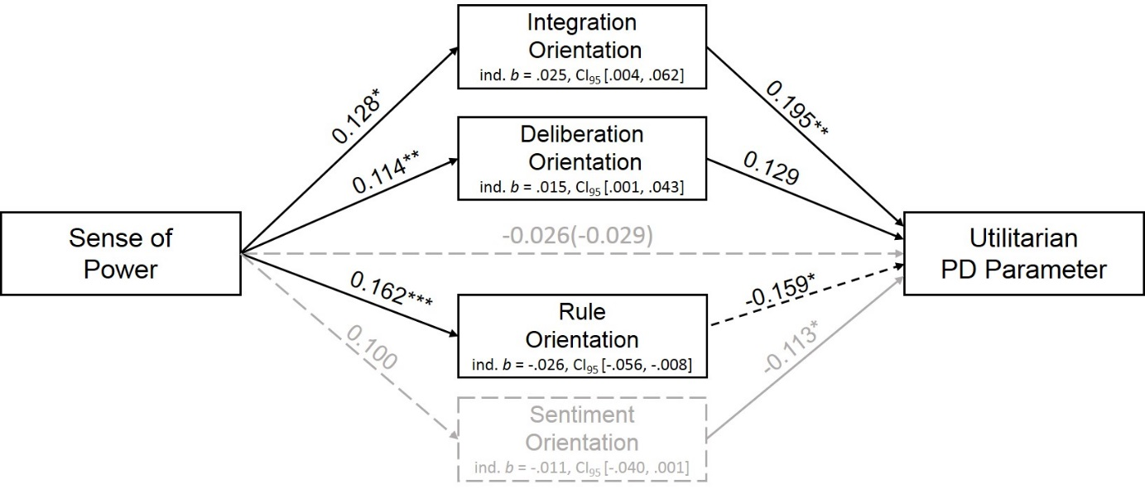
Figure S1. Sense of power predicting the utilitarian PD parameter, mediated through the integration, deliberation, rule, and sentiment orientations in Pilot Study 2. Bold lines indicate significant effects, dotted lines indicate non-significant effects. Significant indirect effects in black, non-significant in grey.

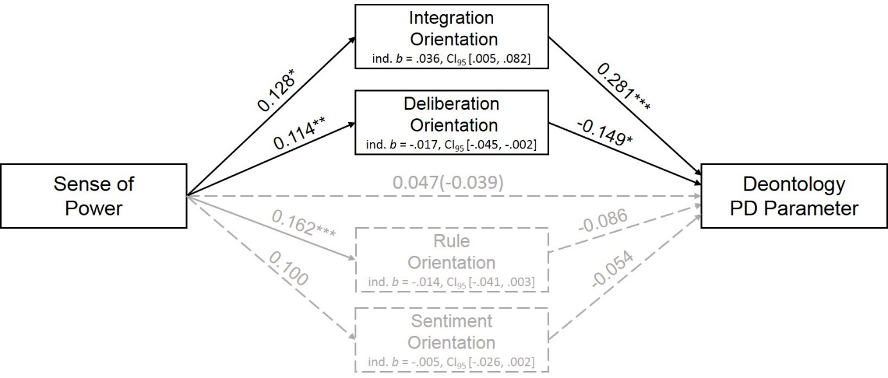
Figure S2. Sense of power predicting the deontology PD parameter, mediated through the integration, deliberation, rule, and sentiment orientations in Pilot Study 2. Bold lines indicate significant effects, dotted lines indicate non-significant effects. Significant indirect effects in black, non-significant in grey.

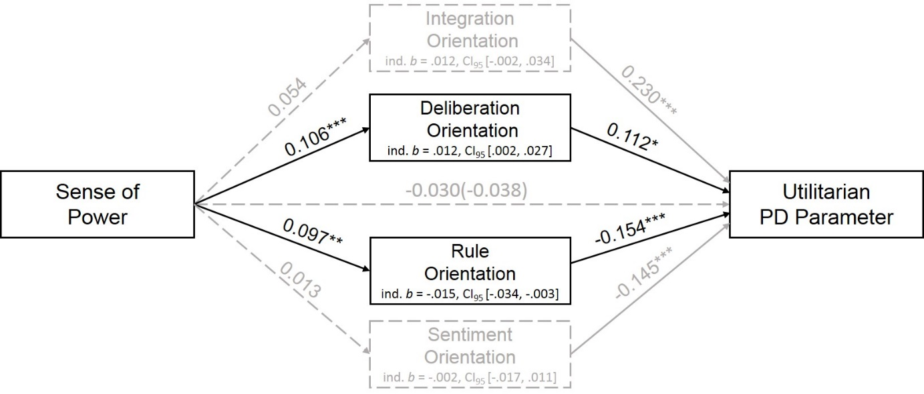
Figure S3. Sense of power predicting the utilitarian PD parameter, mediated through the integration, deliberation, rule, and sentiment orientations in the Study 2 full sample. Bold lines indicate significant effects, dotted lines indicate non-significant effects. Significant indirect effects in black, non-significant in grey.

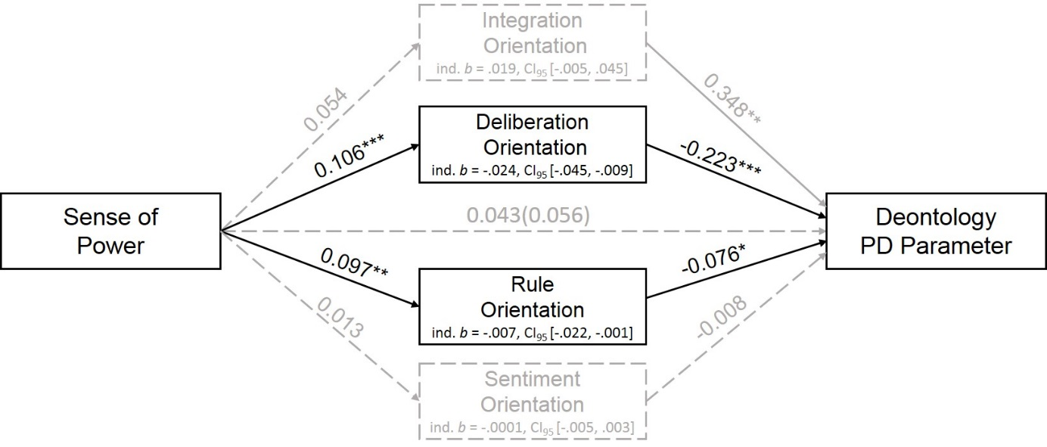
Figure S4. Sense of power predicting the deontology PD parameter, mediated through the integration, deliberation, rule, and sentiment orientations in the Study 2 full sample. Bold lines indicate significant effects, dotted lines indicate non-significant effects. Significant indirect effects in black, non-significant in grey.

