Appendix

Appendix A: Replication of Somer-Topcu (2015)

In Table A1, we replicate the main empirical model that Somer-Topcu (2015) adopts to examine the individual-level mechanism. This is an important step as recovering the same results Somer-Topcu presents in her research using our own data can help us rule out the possibility that differences to her conclusions are merely artifacts of the data. Clearly, this replication reveals very similar results to Somer-Topcu’s original findings. In particular, the effect of the Actual Distance between the respondent’s ideal position and the focal party’s position on one’s perceived distance is virtually 1. Moreover, the coefficient on the interaction-term between Actual Distance and Party Ambiguity is negative and statistically significant.
To better interpret the interaction effect and demonstrate how Party Ambiguity affects voters’ perception, we further calculate and plot the marginal effect of Actual Distance for different values of Party Ambiguity using the estimated results in Table A1. As Figure A1 demonstrates, when a party possesses a very concrete policy platform, say the ambiguity score is 0, respondents seem to have a pretty accurate perception about the ideological distance between themselves and the party — the marginal effect is about 1, suggesting that respondents can perfectly transform the actual distance into the perceived distance using a 1:1 ratio. On the contrary, when another party adopts the broad-appeal strategy and is very ambiguous about its own policy intentions, say the ambiguity is 0.27, the accuracy of respondents’ perception of the ideological distance between themselves and the ambiguous party significantly drops — now the marginal effect is about 0.8, suggesting that respondents significantly underestimate the true distance and tend to perceive a shorter distance to the ambiguous party than it actually is.

Table A1: Replication of the Individual-Level Model by Somer-Topcu (2015)

 | DV: Perceived Distance
Actual Distance | 1.012**
 | (0.036)
Ambiguity | 2.771
 | (4.651)
Distance * Ambiguity | -0.827**
 | (0.180)
Partisan Voter | -0.769**
 | (0.058)
Education | 0.018
 | (0.015)
Single Issue Party | 0.167
 | (0.551)
Government Party | 0.161
 | (0.223)
Vote Share | -0.004
 | (0.003)
2nd Wave | -0.116
 | (0.082)
Constant | 0.073
 | (1.029)
Rand. Effect – Party | -15.637
 | (297.902)
Rand. Effect – Party Wave | -17.42*
 | (7.326)
Rand. Effect – Residual | 0.398**
 | (0.009)
Observations | 6867
Log Likelihood | -12477.9
Standard errors in parentheses
,

Figure A1: The Marginal Effect of Actual Distance conditional on Party Ambiguity
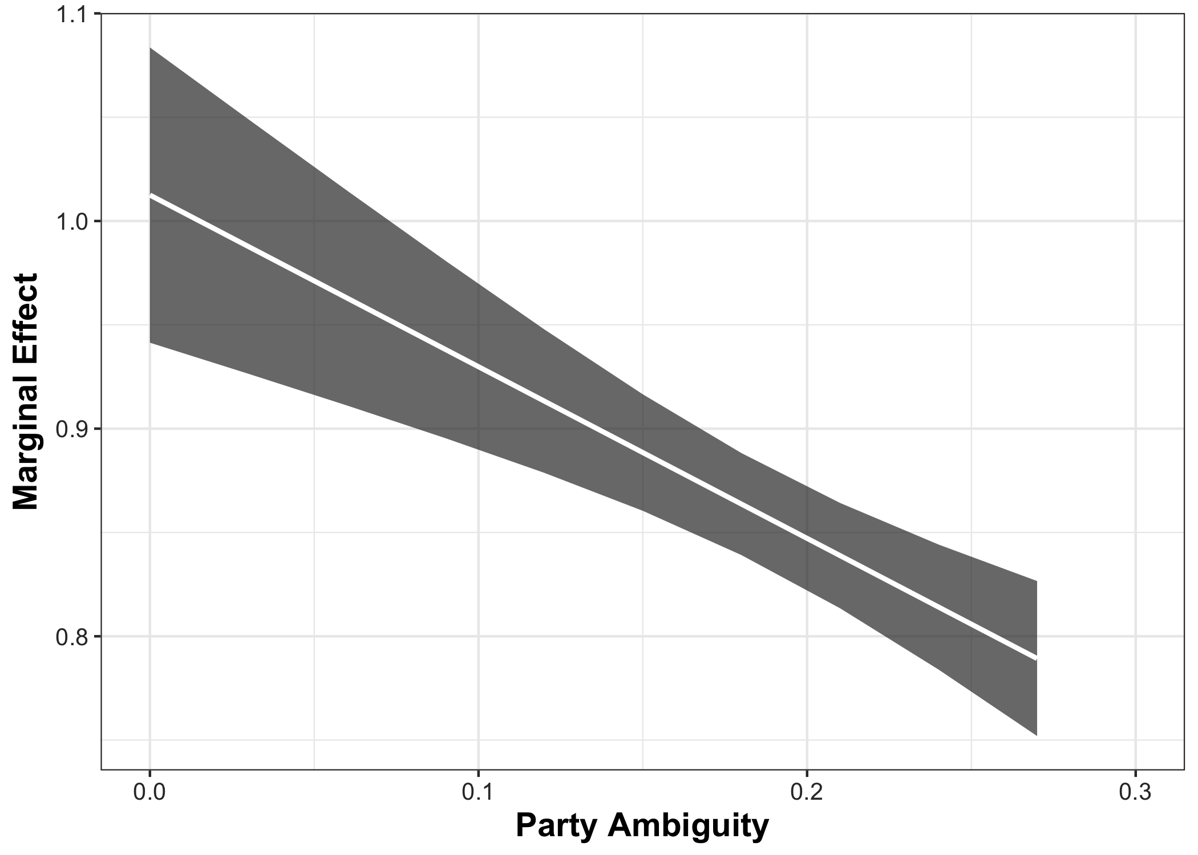
Note: White lines in the plot show point estimates, and gray areas indicate the 95% confidence interval.

Appendix B: Robustness Check using Ambiguity Score as a Continuous Variable
In Table A2, we replicate our main models presented in Table 2 by treating party ambiguity as a continuous variable. Similar to what we did in the main text, we further simulate and plot the marginal effect of Actual Distance for different values of Party Ambiguity and Perceived Party Cohesion in order to help readers better interpret the estimated results. Specifically, we present the marginal effect of Actual Distance by setting Party Ambiguity at its 5th percentile and 95th percentile values and Perceived Unity to range from its minimum to maximum values. We then present in the left panel of Figure A2 the situation where a party has a concrete policy stance (i.e., the value of ambiguity is set to its 5th percentile value), while in the right panel the situation where a party takes the broad-appeal strategy (i.e., the value of ambiguity is set to its 95th percentile value). The white lines in the figure indicate the point estimates of the marginal effect, and the gray areas represent the 95% confidence intervals.
It is clear that the results are similar to the main models in which we treat ambiguity as a dummy variable. When the party is being very ambiguous about its policies (i.e., the right panel), the discounting effect of this “broad-appeal" strategy only works when the party is perceived to be highly unified. Assume now this ambiguous party is perceived to be internally cohesive at the unity score of 10, the marginal effect of Actual Distance on Perceived Distance is about 0.7. This means when the Actual Distance is 1, respondents tend to underestimate it and only perceive a distance of 0.7 from oneself to the party. On the contrary, if the party is perceived to be internally divided, say at the unity score 2, the marginal effect significantly increases to about 0.9. This suggests that when the Actual Distance is 1, respondents tend to perceive a 0.9 distance, almost at a 1:1 ratio. In other words, when perceived unity increases, the discounting effect of being ambiguous on perceived distance significantly grows. Yet, when a party is very concrete about its policy stance (i.e., the left panel of Figure A2), respondents seem to know well about the party and have a clear sense of what the actual distance between themselves and the party is, regardless of whether the party is internally unified or not.

Table A2: Replicating Table 2 by Treating Ambiguity as a Continuous Variable
 | Model 1 | Model 2
Actual Distance | 1.060** | 1.047**
 | (0.082) | (0.081)
Ambiguity | 4.997** | 3.022
 | (1.516) | (4.715)
Distance * Ambiguity | -0.588 | -0.530
 | (0.408) | (0.405)
Perceived Party Unity | 0.064 | 0.068
 | (0.053) | (0.053)
Distance * Unity | -0.002 | -0.004
 | (0.014) | (0.014)
Ambiguity * Unity | -0.504* | -0.383
 | (0.244) | (0.242)
Distance * Ambiguity * Unity | -0.057 | -0.073
 | (0.070) | (0.069)
Partisan Supporter |  | -0.724**
 |  | (0.058)
Education |  | 0.020
 |  | (0.015)
Single Issue Party |  | -0.064
 |  | (0.556)
Government Party |  | 0.170
 |  | (0.225)
Vote Share |  | 0.000
 |  | (0.003)
2nd Wave |  | -0.116
 |  | (0.083)
Constant | -0.276 | 0.027
 | (0.337) | (1.043)
Random Effect – Party | -3.037** | -20.508
 | (0.866) | (10.78)
Random Effect – Party Wave | -3.104** | -21.592**
 | (0.873) | (7.517)
Random Effect – Residual | 0.405** | 0.393**
 | (0.009) | (0.009)
Observations | 6867 | 6867
Log Likelihood | -12530 | -12446
Standard errors in parentheses
, ,

Figure A2: The Marginal Effect of Actual Distance conditional on Party Ambiguity and Perceived Party Unity
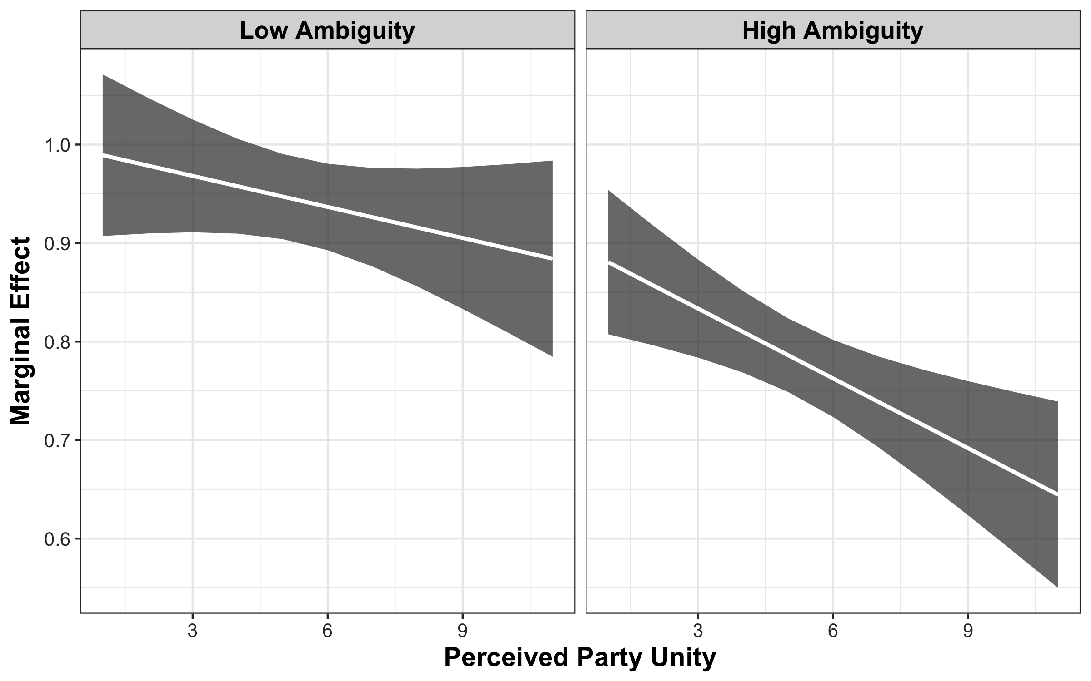 Note: The white lines in the plot show the point estimates, and the gray areas indicate the 95% confidence interval.

Appendix C: Robustness Check Adding Respondent Fixed Effects
In Table A3, we examine the robustness of our main model (i.e., Model 2) presented in Table 2 by adding the fixed effects at the respondent level. Doing so essentially absorbs all respondent-specific effects that are constant between the two waves in our sample. Since some respondents change their education level or party support between waves, we are able to estimate effects for these variables nevertheless. However, by adding several thousand respondent fixed effects, we lose a significant amount of efficiency.
Irrespective of these econometric considerations, we find that the results are very similar to results presented in Table 2. Figure A3 further indicates that the conclusions drawn from the model in the main text are robust to including respondent-specific fixed effects. We are, thus, confident to suggest that our conclusions are robust to time-invariant effects that we cannot directly control for.

Table A3: Replicating Table 2 while Adding Respondent Fixed Effects
 | Model 1
Actual Distance | 0.962**
 | (0.036)
Ambiguous Party | 0.453*
 | (0.160)
Distance * Ambiguous Party | -0.078
 | (0.052)
Perceived Party Unity | 0.000
 | (0.020)
Distance * Unity | -0.009
 | (0.006)
Ambiguous Party * Unity | -0.034
 | (0.024)
Distance * Ambiguous Party * Unity | -0.010
 | (0.008)
Partisan Supporter | -0.774**
 | (0.052)
Education | 0.017
 | (0.058)
Single Issue Party | 0.076
 | (0.062)
Government Party | 0.142**
 | (0.050)
Vote Share | 0.001
 | (0.002)
2nd Wave | -0.067
 | (0.045)
Respondent Fixed-Effects | Yes
Random Effect – Party | 0.000
 | (0.000)
Random Effect – Party Wave | 0.000
 | (0.000)
Random Effect – Residual | 1.226**
 | (0.010)
Observations | 6867
Log Likelihood | -11145
Standard errors in parentheses
, ,

Figure A3: The Marginal Effect of Actual Distance conditional on Party Ambiguity and Perceived Party Unity with Respondent Fixed Effects
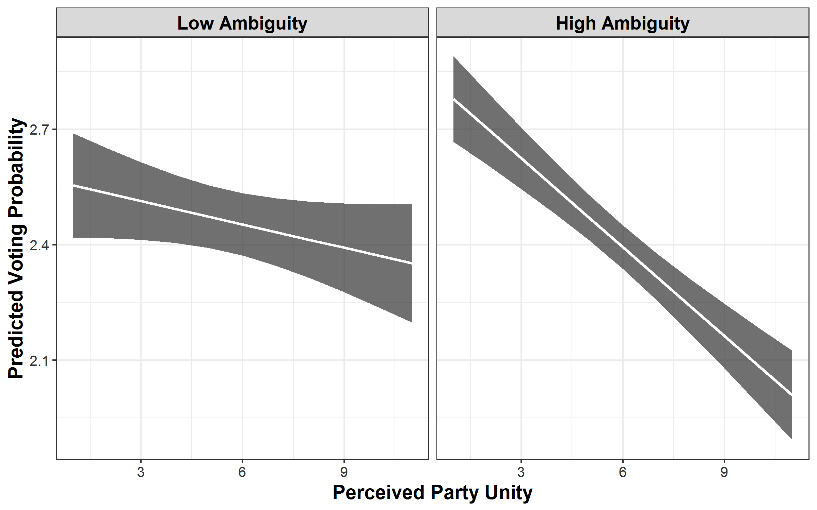 Note: The white lines in the plot show the point estimates, and the gray areas indicate the 95% confidence interval.

References
Adams, James, Lawrence Ezrow, and Zeynep Somer-Topcu. 2014. “Do Voters Respond to Party Manifestos or to a Wider Information Environment? An Analysis of Mass-Elite Linkages on European Integration.” American Journal of Political Science 58, no. 4: 967–78. https://doi.org/10.1111/ajps.12115.
Adams, James, Lawrence Ezrow, and Zeynep Somer-Topcu. 2011. “Is Anybody Listening? Evidence That Voters Do Not Respond to European Parties’ Policy Statements During Elections.” American Journal of Political Science 55, no. 2 (2011): 370–82. https://doi.org/10.1111/j.1540-5907.2010.00489.x.
Aldrich, John H, Gregory S Schober, Sandra Ley, und Marco Fernandez. „Incognizance and Perceptual Deviation: Individual and Institutional Sources of Variation in Citizens’ Perceptions of Party Placements on the Left–Right Scale“. Political Behavior, Forthcoming.
Alesina, Alberto, und Alex Cukierman. „The Politics of Ambiguity“. Quarterly Journal of Political Science 105, Nr. 4 (1990): 829–850.
Alesina, Alberto F., und Richard T. Holden. „Ambiguity and Extremism in Elections“. National Bureau of Economic Research, Working Paper, 2008.
APSA, American Political Science Association. „Toward a More Responsible Two-Party System“. American Political Science Review 44, Nr. Supplement (1950): v-99.
Argones, Enriqueta, und Zvika Neeman. „Strategic Ambituity in Electoral Competition“. Journal of Theoretical Politics 112, Nr. 2 (2000): 183–205.
Argones, E. and A. Postlewaite. 2002. “Ambiguity in Election Games.” Review of Economic Design 7(3):233–255.
Association, American Political Science. Toward a More Responsible Two-Party System: A Report. New York: Rinehart, 1950.
Bergholt, Drago, und Päivi Lujala. „Climate-related natural disasters, economic growth, and armed civil conflict“. Journal of Peace Research 49, Nr. 1 (2012): 147–162.
Blom, Annelies G, Christina Gathmann, und Ulrich Krieger. „Setting up an online panel representative of the general population: The German Internet Panel“. Field methods 27, Nr. 4 (2015): 391–408.
Blom, SFB 884 `Political Economy of Reforms’ Universität Mannheim, Annelies G.; Bossert, Dayana; Funke, Frederik; Gebhard, Franziska; Holthausen, Annette; Krieger. „German Internet Panel, Wave 2 (November 2012)“, 2016. http://dx.doi.org/10.4232/1.12608.
Blom, SFB 884 `Political Economy of Reforms’ Universität Mannheim, Annelies G.; Bossert, Dayana; Gebhard, Franziska; Funke, Frederik; Holthausen, Annette; Krieger. „German Internet Panel, Wave 7 - Core Study (September 2013)“, 2016. http://dx.doi.org/10.4232/1.12613.
Blom, Ulrich; SFB 884 `Political Economy of Reforms’ Universität Mannheim, Annelies G.; Bossert, Dayana; Funke, Frederik; Gebhard, Franziska; Holthausen, Annette; Krieger. „German Internet Panel, Wave 1 - Core Study (September 2012)“, 2016. http://dx.doi.org/10.4232/1.12607.
Blom, Ulrich; SFB 884 „German Internet Panel, Wave 8 (November 2013)“, 2016. http://dx.doi.org/10.4232/1.12614.
Börnsen, Wenke. „Die 100-Prozent-Blackbox“, 2017. www.tagesschau.de/inland/schulz-wahl-spd-105.html.
Bräuninger, Thomas, und Nathalie Giger. „Strategic Ambiguity of Party Positions in Multi-Party Competition“. Political Science Research and Methods, Forthcoming.
Budge, Ian. „A new spatial theory of party competition: Uncertainty, ideology and policy equilibria viewed comparatively and temporally“. British Journal of Political Science 24, Nr. 4 (1994): 443–467.
Callander, Steven, und Catherine H Wilson. „Context-Dependent Voting and Political Ambiguity“. Journal of Public Economics 92, Nr. 3 (2008): 565–581.
Caspari, Lisa. „König der Umfragen“, 2017. http://www.zeit.de/politik/deutschland/2017-02/martin-schulz-spd-cdu-umfragen.
Ceron, Andrea. "Bounded oligarchy: How and when factions constrain leaders in party position-taking." Electoral Studies 31.4 (2012): 689-701.
Cross, William P., und André Blais. Politics at the Centre: the Selection and Removal of Party Leaders in the Anglo Parliamentary Democracies. Oxford: Oxford University Press, 2012.
Dahlberg, Stefan. „Political Parties and Perceptual Agreement: The Influence of Party Related Factors on Voters’ Perceptions in Proportional Electoral Systems“. Electoral Studies 28, Nr. 2 (2009): 270–278.
Downs, A. An Economic Theory of Democracy. New York: Harper, 1957.
Enelow, James, and Melvin J. Hinich. "A new approach to voter uncertainty in the Downsian spatial model." American journal of political science (1981): 483-493.
Fortunato, David, und Randolph T Stevenson. „Perceptions of partisan ideologies: The effect of coalition participation“. American Journal of Political Science 57, Nr. 2 (2013): 459–477.
Glazer, A. „The Straetgy of Candidate Ambiguity“. The American Political Science Review 84, Nr. 1 (1990): 237–41.
Gill J. (2005) An entropy measure of uncertainty in vote choice. Electoral Studies 24(3):
371–392.
Greene, Zachary David, und Matthias Haber. „The Consequences of Appearing Divided: An Analysis of Party Evaluations and Vote Choice“. Electoral Studies 37 (2015): 15–27.
Hersh, Eitan D, und Brian F Schaffner. „Targeted Campaign Appeals and the Value of Ambiguity“. The Journal of Politics 75, Nr. 2 (2013): 520–534.
Hickmann, Christoph. „Alle lieben Schulz - noch“, 2. März 2017.
Jensen, T. 2009. “Projection Effects and Strategic Ambiguity in Electoral Competition.” Public Choice 141:213–232.
Kamann, Matthias. „Petry hat gegen Höcke schlechte Karten“, 15. März 2017.
Kedar, Orit. „When moderate voters prefer extreme parties: Policy balancing in parliamentary elections“. American Political Science Review 99, Nr. 2 (2005): 185–199.
King, Gary, Michael Tomz, und Jason Wittenberg. „Making the Most of Statistical Analyses: Improving Interpretation and Presentation“. American journal of political science 44, Nr. 2 (2000): 347–361.
Klüver, Heike, und Iñaki Sagarzazu. „Setting the agenda or responding to voters? Political parties, voters and issue attention“. West European Politics 39, Nr. 2 (2016): 380–398.
Laver, Michael. „Policy and the dynamics of political competition“. American Political Science Review 99, Nr. 2 (2005): 263–281.
Lehrer, Roni, Sebastian Juhl, and Thomas Gschwend. Forthcoming “The Wisdom of Crowds Design for Sensitive Survey Questions”. Electoral Studies. https://doi.org/10.1016/j.electstud.2018.09.012.
Lupu, Noam. „Party Brands and Partisanship: Theory with Evidence from a Survey Experiment in Argentina“. American Journal of Political Science 57, Nr. 1 (2013): 49–64.
Mair, Peter. „The Challenge to Party Government“. West European Politics 31, Nr. 1–2 (2008): 211–234.
Martin, L. W., und G. Vanberg. „Coalition Government and Political Communication“. Political Research Quarterly 61 (2008): 502–16.
Martin, Lanny W, und Georg Vanberg. Parliaments and coalitions: The role of legislative institutions in multiparty governance. Oxford University Press, 2011.
McFadden, Daniel. „Conditional Logit Analysis of Qualitative Choice Behavior“. In Frontiers in Econometrics, herausgegeben von P. Zarembka. Wiley, New York., 1973.
Meirowitz, Adam. „Informatoinal Party Primaries and Strategic Ambiguity“. Journal of Theoretical Politics 17, Nr. 1 (2005): 107–36.
Merrill, Samuel, Bernard Grofman, und James Adams. „Assimilation and contrast effects in voter projections of party locations: Evidence from Norway, France, and the USA“. European Journal of Political Research 40, Nr. 2 (2001): 199–221.
Page, Benjamin I. „The Theory of Political Ambiguity.“ American Political Science Review 70, Nr. 03 (1976): 742–752.
Polke-Majewski. „Alternative für Deutschland. Nur ein Machtkampf“, 2017. http://www.zeit.de/politik/deutschland/2017-02/alternative-fuer-deutschland-bjoern-hoecke-ausschluss-partei-machtkampf.
Rovny, Jan. "Who emphasizes and who blurs? Party strategies in multidimensional competition." European Union Politics 13.2 (2012): 269-292.
Sagarzazu, Iñaki, und Heike Klüver. „Coalition Governments and Party Competition: Political Communication Strategies of Coalition Parties“. Political Science Research and Methods 5, Nr. 2 (2017): 333–49.
Shepsle, Kenneth A. „The Strategy of Ambiguity: Uncertainty and Electoral Competition“. The American Political Science Review 66, Nr. 2 (1972): 555–568.
Somer-Topcu, Zeynep. „Everything to Everyone: The Electoral Consequences of the Broad-Appeal Strategy in Europe“. American Journal of Political Science 59, Nr. 4 (2015): 841–854.
Somer-Topcu, Zeynep. „Timely decisions: The effects of past national elections on party policy change“. The Journal of Politics 71, Nr. 1 (2009): 238–248.
Spoon, Jae-Jae, und Heike Klüver. „Does Anybody Notice? How Policy Positions of Coalition Parties are Perceived by Voters“. European Journal of Political Research 56, Nr. 1 (2017): 115–32.
Teorell, Jan. „A Deliberative Defence of Intra-Party Democracy“. Party politics 5, Nr. 3 (1999): 363–382.
Tomz, Michael, und Robert Van Houwelling. „The Electoral Implications of Candidate Ambiguity“. American Political Science Review 103, Nr. 1 (2009): 83–98.
Van der Eijk, Cees. „Measuring Agreement in Ordered Rating Scales“. Quality & Quantity 35, Nr. 3 (2001): 325–341.
Wittman, Donald A. „Parties as utility maximizers“. American Political Science Review 67, Nr. 2 (1973): 490–498.

