The Self-Perception Connection: Why Consumers Devalue Unattractive Produce
Lauren Grewal, Jillian Hmurovic, Cait Lamberton, and Rebecca Walker Reczek

Web Appendix

WEB APPENDIX A: COLOR VERSION OF STUDY STIMULI 2
WEB APPENDIX B: SELF-PERCEPTION SCALE USED IN STUDIES 1, 2, 3, AND 4B 3
WEB APPENDIX C: STUDY 1 ALTERNATIVE EXPLANATION ITEMS 5
WEB APPENDIX D: STUDY 2 “WHO I AM” TASK AND MANIPULATION 6
WEB APPENDIX E: STUDY 2, 4A, AND 4B MANIPULATION PRE-TEST RESULTS 8
WEB APPENDIX F: STUDY 3 SELF-ESTEEM PRIMING TASK 11
WEB APPENDIX G: STUDY 4A PICTURES AND SURVEY 12
WEB APPENDIX H: STUDY 4A POTENTIAL REVENUE IMPLICATIONS 14
WEB APPENDIX I: STUDY 4B SELF-AFFIRMATION ITEMS 17

WEB APPENDIX A: COLOR VERSION OF STUDY STIMULI

Study | Attractive or Control Stimuli | Unattractive Stimuli
1 | 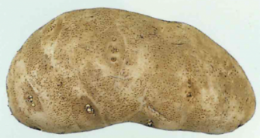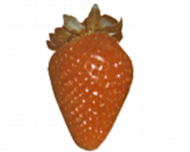 | 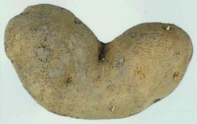  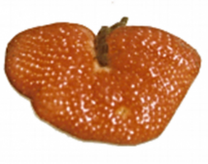
2 |  | 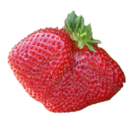
3 | 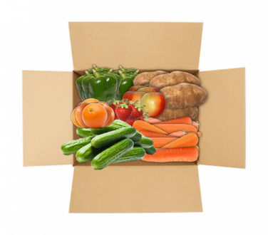 | 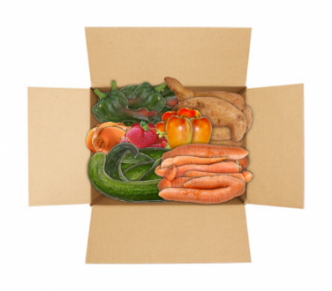
4A and 4B Manipulation | “Pick Ugly Produce” | “You are Fantastic! Pick Ugly Produce”
4B Choice Stimuli | 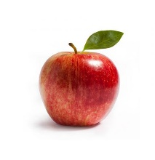

WEB APPENDIX B: SELF-PERCEPTION SCALE USED IN STUDIES 1, 2, 3, AND 4B

Our scale was built considering the established prior research on self-perceptions. Looking at self-perception research in marketing and psychology, the empirical standard across papers appears to be researchers creating their own measurements of self-perceptions that are tailored to the context they are studying (e.g., Allen 1982; Chaiken and Baldwin 1982; Chattaraman and Lennon 2008; John and Robins 1994; Ostlund 1974; Park and Roedder John 2010; Rao and Sieben 1992; Ryu and Feick 2007; Sela, Berger, and Kim 2017; Smith, Summers, and Reczek 2016). None of these papers used previously established measures of self-perceptions, specifically because the context for self-inferences were created to match the context being studied.
Considering the standard set from prior research, we chose items that represent self-inferences relevant to a food-oriented consumption setting (e.g., “healthy”) along with more general self-perceptions that represent the consumer as a whole that were not as specifically tailored to the context (e.g., important). Incorporating this mixture of items gave us a more nuanced, holistic view of consumer’s positive and negative self-perceptions.

Self-Perception Scale and Instructions:

Now we'd like you to use your imagination as vividly as you possibly can.
Your job is to fully imagine eating this food.
Take a minute to look at the food.
Imagine the experience of eating the food - what you would experience as you
look at the food,
feel it in your mouth,
taste its flavors,
and swallow it.
Eating different foods can make people feel many different ways.
Keeping your imagined eating experience in mind, please indicate how much you can imagine feeling the following after eating the pictured food.

[1 = Not at All, 7 = Very Much]

- Healthy*
- Pleased*
- Proud*
- Embarrassed
- Conflicted
- Disgusting
- Bad
- Good*
- Attractive*
- Ugly
- Worthless
- Important*
- Valuable*
- Immoral
- Physically ill
- Honest*

* Items were reverse-coded so that higher index score indicated more negative self-perceptions.

WEB APPENDIX C: STUDY 1 ALTERNATIVE EXPLANATION ITEMS

Items and Product Used to Rule out Priming and Halo Effects:

[1 = Strongly Disagree, 7 = Strongly Agree]

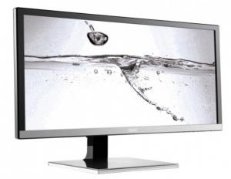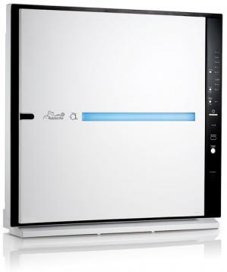

- This product looks aesthetically appealing.
- This product has an attractive design.
- I like this product.

Safety Concerns:

[1 = Strongly Disagree, 7 = Strongly Agree]

- The pictured produce is not safe.
- The pictured produce is dangerous.
- The pictured produce will make me sick.
- The pictured produce is harmful to me.

Produce Abnormality:

[1 = Strongly Disagree, 7 = Strongly Agree]

- The pictured produce is abnormal.
- The pictured produce is improper.
- The pictured produce is wrong.
- The pictured produce is tainted.

WEB APPENDIX D: STUDY 2 “WHO I AM” TASK AND MANIPULATION

Instructions for the "Who I Am" Task:

In this task, you will complete several personality scales.

Please answer honestly and truthfully.

We will use the responses on this task a little bit later in the session, when we will give you some information about your ability to match product choices to your own personality.

[1 = Strongly Disagree, 5 = Strongly Agree]

- I really enjoy talking to people.
- I sometimes fail to assert myself as much as I should.
- I usually seem to be in a hurry.
- I often feel as if I'm bursting with energy.
- The idea of relying on thought to make my way to the top appeals to me.
- I find contradicting others stimulating.
- I resist the attempts of others to influence me.
- I am someone who can always be trusted.
- It makes me feel better to have my time planned out in the next 1–2 months.
- I shy away from crowds of people.
- When I do things, I do them vigorously.
- I don't consider myself especially "light-hearted."
- I prefer complex to simple problems.
- I usually end up deliberating about issues even when they do not affect me personally.
- I consider advice from others to be an intrusion.
- It makes me angry when another person is held up as a role model for me to follow.
- I often struggle to make decisions.
- I usually prefer to do things alone.
- I am dominant, forceful, and assertive.
- I laugh easily.
- I prefer to think about small, daily projects over long-term ones.
- I really enjoy a task that involves coming up with new solutions to problems.
- It irritates me when someone points out things which are obvious to me.
- I become frustrated when I am unable to make free and independent decisions.
- I would prefer to tell the truth to someone, even if it hurts their feelings.
- I don't like to settle for less than the best.
- I set goals months in advance for what I want to achieve with my time.
Shopping Task Instructions: *

On the pages that follow, you will make product choices in a variety of different product categories.

From each assortment you see, choose the ONE item in each set that BEST reflects who you are as a person.

*Participants saw 10 different product assortments, viewing one assortment of 4 products per page. The randomized pages/product categories were for: water bottles, notebooks, muffins, lamps, rugs, ornaments, bread, cake, air purifiers, wood styles

Shopping Task Feedback:

You have completed the shopping task.

Please wait a moment...our algorithm is comparing your product selections and response latencies to the results of your answers on the "Who I Am" personality test you completed prior to the product choices.

This study is part of a larger project related to market segmentation and consumer profiles. Because some of our prior participants have expressed interest in seeing their personal profile results, we have started providing all participants with a brief results summary (below).

Diagnostic Value Condition:

RESULTS SUMMARY: Based on your self-assessment responses and product selections, the algorithm indicates that you tend to consistently choose items that accurately reflect who you are.
This means that you tend to select products that strongly match who you are as a person.

Non-diagnostic Value Condition:

RESULTS SUMMARY: Based on your self-assessment responses and product selections, the algorithm indicates that you do not tend to consistently choose items that accurately reflect who you are.

This means that you tend to select products that don’t strongly match who you are as a person.

WEB APPENDIX E: STUDY 2, 4A, AND 4B MANIPULATION PRE-TEST RESULTS

Study 2 Diagnosticity Manipulation Pre-Test

Amazon Mechanical Turk workers (n = 152, M_{age} = 34, 43% female) completed this survey for nominal payment. Participants were randomly assigned in a 3 (control, diagnostic, non-diagnostic) between-subjects design. Participants completed the “Who I Am” task from Study 2 in both the diagnostic and non-diagnostic conditions, but not in the control condition. Afterwards, participants answered scales in a randomized order. The scales they answered included a self-affirmation scale (operationalized as a feeling that one’s core personal values have been reinforced; Steele 1988; Steele and Liu 1983; α = .89; items in Web Appendix I), the psychological reactance scale subscales (emotional response to restricted choice (α = .82), reactance to compliance (α = .87), resisting influence from others (α = .71), and reactance towards advice and recommendations (α = .70); Hong and Faedda 1996), and a manipulation check regarding how diagnostic participants believed their choices to be (α = .82; four-item scale, listed below).
To test the effectiveness of our manipulation, we regressed the belief that choices were self-diagnostic on a variable representing the diagnostic condition (control and non-diagnostic= -1, diagnostic = 1), and a variable representing the non-diagnostic condition (control and diagnostic= -1, non-diagnostic = 1). We found that our diagnostic manipulation increased participants’ belief that their choices were self-diagnostic (b = .40, t = 3.48, p < .001), whereas our non-diagnostic manipulation made participants believe their choices were significantly less diagnostic (b = -.46, t = -3.94, p < .001).
Importantly, not only did we find that our manipulation moved perceived diagnostic value of choices, we additionally found that neither our manipulation did not appear to have acted as a self-affirmation (both p’s > .12), nor did it influence any of the subscales regarding felt psychological reactance (all p’s > .15).

Diagnostic Manipulation Check Questions:
Please indicate how much you agree or disagree with each of the following statements.

[1 = Strongly Disagree, 7 = Strongly Agree]
- I tend to choose products that reflect who I am.
- My product choices imply something about my tastes.
- The algorithm indicated that my product choices accurately reflect me.
- My product choices match who I am.

Study 4A and 4B Self-Esteem Manipulation Pre-Test

Amazon Mechanical Turk workers (n = 99; M_{age} = 33 years, 41% women) completed this survey for nominal payment. Participants were randomly assigned in a 2 (control, positive self-esteem) between-subjects design. Participants either saw the self-esteem advertisement or the control advertisement that was shown in the experiment in-the-field (Study 4A) and the controlled replication study (Study 4B). Afterwards, participants answered the State Self-esteem Scale (α = .89; Heatherton and Polivy 1991), which is comprised of three subscales: appearance self-esteem (α = .94), social self-esteem (α = .82), and performance self-esteem (α = .78).
To test the effectiveness of our manipulation, we regressed state self-esteem on our self-esteem manipulation (control = 0, self-esteem = 1). Participants exposed to the self-esteem advertisement reported significantly greater overall state self-esteem than those exposed to the control advertisement (b = .31, t = 2.24, p = .027). Looking at the specific subscales, the self-manipulation successfully increased appearance-self-esteem (b = .38, t = 2.34, p = .021) and performance self-esteem (b = .29, t = 2.55, p = .012), but not social self-esteem (b = .24, t = 1.11, p = .272). These results provide good face validity, as there is no social aspect to the self-esteem manipulation we used.

WEB APPENDIX F: STUDY 3 SELF-ESTEEM PRIMING TASK

Control Condition Writing Prompt:
Please take about 1-2 minutes (the page will not let you advance for 1 minute) to write about what a typical morning is like for you during the week (i.e., not the weekend).

Please provide as much detail as possible.

Self-Esteem Boosting Condition Writing Prompt:
Please take about 1-2 minutes (the page will not let you advance for 1 minute) to write about a time in the past couple of months when you accomplished something that made you feel proud of yourself. This could be a time when you succeeded at a difficult challenge, met a personal goal, or accomplished something important.

Please provide as much detail as possible. What did you accomplish? Why was this a moment of pride? How exactly did you feel in this moment?

WEB APPENDIX G: STUDY 4A PICTURES AND SURVEY

Examples of In-store Signage:
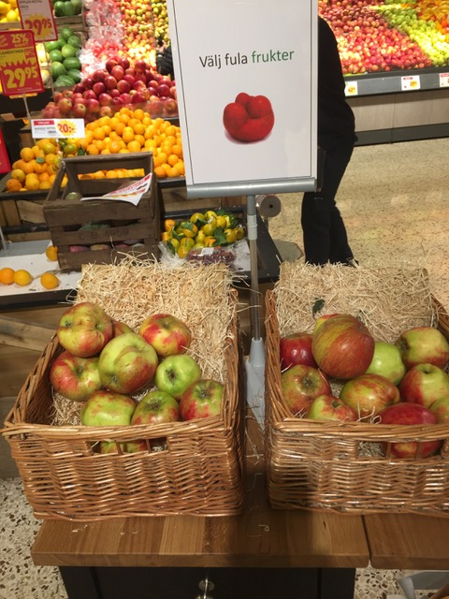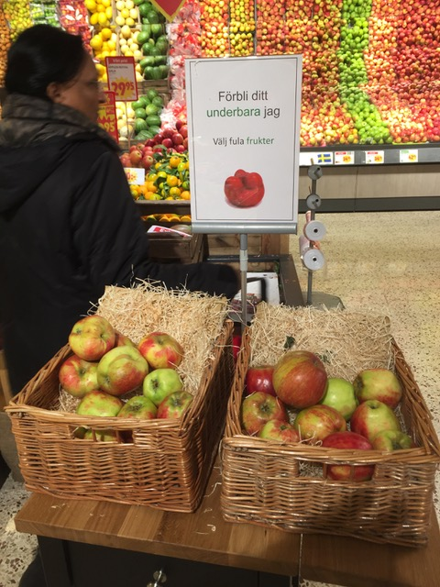
Control Condition Self-Esteem Boosting Condition

Example of Shoppers Completing Survey:
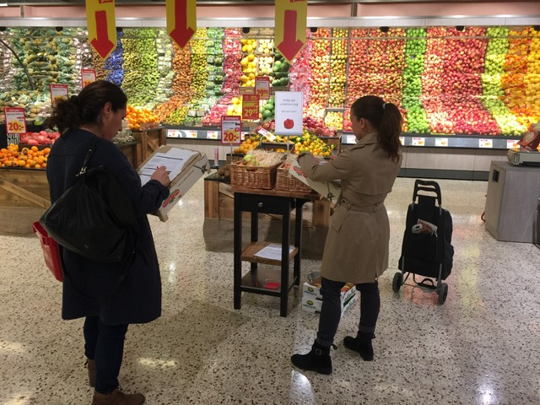

English Translation of Experiment in-the-Field Survey:
About You
 | Strongly Disagree |  |  |  |  |  | Strongly Agree
 | 1 | 2 | 3 | 4 | 5 | 6 | 7
Right now, I feel good about myself.
Right now, I feel valuable as a person.
Right now, I feel important.
Right now, I feel wonderful.
Right now, I feel attractive.

 | Strongly Disagree |  |  |  |  |  | Strongly Agree
 | 1 | 2 | 3 | 4 | 5 | 6 | 7
I am a “foodie.”
I am interested in the food I eat.
I am knowledgeable about food.

About the Display
 | Not at All |  |  |  |  |  | Very
 | 1 | 2 | 3 | 4 | 5 | 6 | 7
How noticeable was this display?

 | None at all |  |  |  |  |  | A lot
 | 1 | 2 | 3 | 4 | 5 | 6 | 7
How much attention did you pay to this display?

About Your Shopping
 | Strongly Disagree |  |  |  |  |  | Strongly Agree
 | 1 | 2 | 3 | 4 | 5 | 6 | 7
I like fresh produce.
I like apples.
I buy apples often.
I frequently shop at this store.

What is your age? _________years old
What is your gender? (circle one) Male Female Other
Are you shopping today exclusively for someone else (e.g., parent, friend, grandparent)? (circle one) Yes No

WEB APPENDIX H: STUDY 4A POTENTIAL REVENUE IMPLICATIONS

Equations and Assumptions
We conducted back-of-the envelope calculations to estimate the potential profitability of our simple in-store messaging. We separately estimated the revenue generated by shoppers’ observed choices when exposed to the control ad and when exposed to the self-esteem boosting ad. Each was calculated as the sum of revenue generated from the attractive produce and the unattractive produce:
$${Revenue}_{control}={Revenue}_{control,att}+{Revenue}_{control, unatt}$$
$${Revenue}_{boost}={Revenue}_{boost,att}+{Revenue}_{boost, unatt}$$
For each condition, the revenue for attractive produce was given by the equation:
$${Revenue}_{condition,att}=\left({FullPricePerLB}_{att} ×{ WeightLB}_{att}\right)×{Quantity}_{condition, att}$$
Because it is a relatively common strategy for retail managers to selectively discount unattractive produce (e.g., our store manager survey suggests discounts are often about 50%), the equation to estimate revenue for unattractive produce for each condition additionally included a discount factor to account for retailers’ promotional price reductions:
$${Revenue}_{condition,unatt}=\left({FullPricePerLB}_{unatt} ×{ WeightLB}_{unatt}×\left(1-{Discount}_{unatt}\right)\right)×{Quantity}_{condition, unatt}$$
To isolate the potential revenue implications of the observed choice boost, all elements of the equations were held constant across both conditions, with the exception of quantity chosen. In our estimates, the full price per pound of apples ($FullPricePerLB$) reflected the retailer’s actual price ($2.53), and the weight per apple ($WeightLB$) was assumed to be .33 lbs.
Because each shopper’s produce choice resulted in the receipt of two apples, each condition’s calculation of quantity was computed as two times the number of shoppers selecting the respective produce type (attractive or unattractive):
$${Quantity}_{condition,att}=2×{NShoppers}_{condition,att}$$
$${Quantity}_{condition,unatt}=2×{NShoppers}_{condition,unatt}$$
After separately estimating the revenue generated by shoppers’ observed choices when exposed to the control ad and when exposed to the self-esteem boosting ad, we compared these values to calculate the percent difference in revenue generated by the different ad messages:
$$\% Difference in Revenue=\left(\frac{{Revenue}_{boost}-{Revenue}_{control}}{{Revenue}_{boost}}\right)×100$$
We repeated this calculation, assuming different levels of discounting for unattractive produce, at a 50% and 30% discount, which is currently consistent with both retail manager norms and intuitions.
Results: Revenue Benefit of Self-Perceptions Boost
Our results show a consistent pattern of revenue benefit for the retailer. The self-esteem boosting ad generated more revenue than the control ad (see Table below, reproduced from paper). Assuming this retailer was offering a 30% discount on unattractive produce, the revenue from the self-esteem boosting ad was 12.6% higher than that of the control condition, despite the discount. If the retailer offered a 50% discount on unattractive produce, the self-esteem boosting ad still generated 6.5% more revenue than the control ad. However, had the retailer offered no discount on unattractive produce, the self-esteem boosting ad messaging would have generated 19.4% more revenue than the control messaging. Thus, the estimated retail revenue generated by the self-esteem boosting in-store advertisement was higher than when displaying the control ad, regardless of whether the unattractive produce is half- or equivalently-priced to the attractive produce.
Table W1: Potential Revenue Implications of the Experiment in Retail Context (Study 4A)
Retailer Promotion  (on Unattractive Produce) | % Difference in Revenue  (Boosting vs. Control) | Revenue Impact of Self-Esteem Boosting Ad:
No Discount | + 19.44% | ↑
30% Discount | + 12.58% | ↑
50% Discount | + 6.48% | ↑

WEB APPENDIX I: STUDY 4B SELF-AFFIRMATION ITEMS

Self-Affirmation Questions:

Please select the appropriate answer for each item, depending on whether you
strongly agree, agree, neither agree nor disagree, disagree, or strongly disagree with it.

[1 = Strongly Disagree, 5 = Strongly Agree]

- I feel as though my values have been affirmed.
- The task I engaged in affirmed the things that are most important to me in life.
- I feel more confident in my own value system than I did before completing this task.
- This task encouraged me to reflect on what's most personally relevant to me in life.

Prior to analyses, we converted all pricing and weight measurements from the metric system to the imperial system (i.e., US dollars and pounds)

