Appendix 1: Plots for Residential Instability, Ethnic Concentration, and Dependency
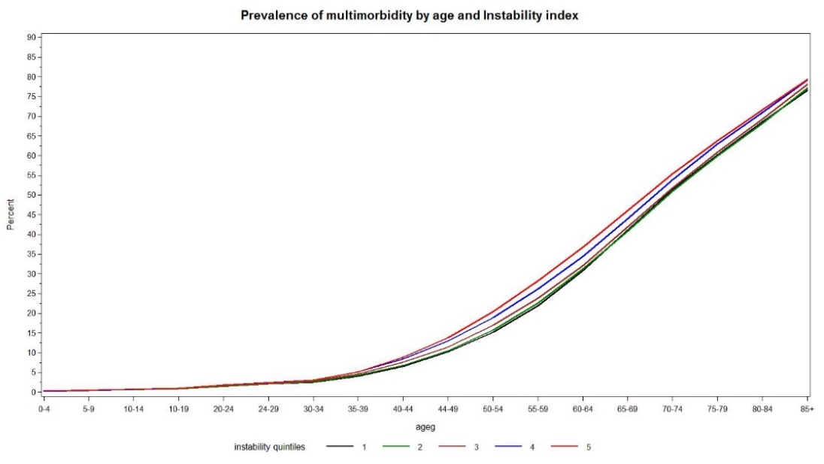
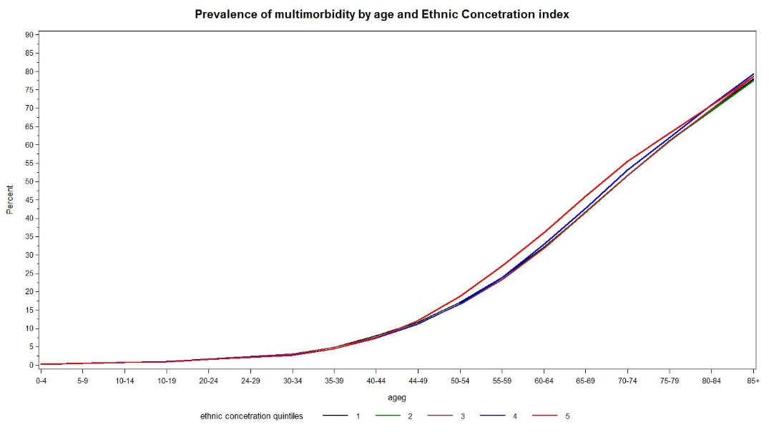
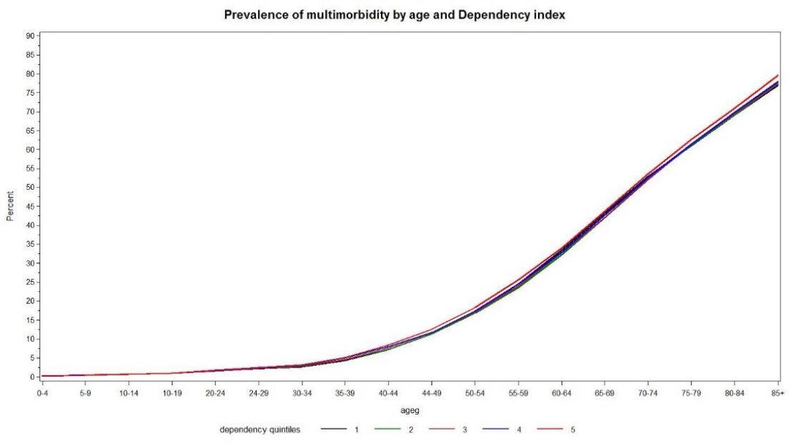
Appendix 2: List of Diagnosis Codes for Defining the 18 Selected Conditions
Condition | ICD 9 / OHIP | ICD 10
Alzheimer Disease | 290, 294.1, 331 | F00-F03, F05.1, G30, G31.1
Arthritis - Rheumatoid arthritis (excl. osteoarthritis) | 714 | M05-M06
Asthma | 493 | J45
Cancer | 140-239 | C00-C26, C30-C44, C45-C97
Chronic Obstructive Pulmonary Disease (COPD) | 491, 492, 496 | J41, J43, J44
Congestive Heart Failure (CHF) | 428 | I50, I50.1, I50.9
Crohn’s and Colitis | 555, 556 | K50, K51
Depression | 311, 300, 296 | F32, F33, F412, F480
Diabetes | 250 | E08 - E13
Epilepsy | 345 | G40, G41
Human Immunodeficiency Virus (HIV) | 042, 043, 044 | B20-B24
Hypertension | 401, 402, 403, 404, 405 | I10, I11, I12, I13, I15
Multiple Sclerosis (MS) | 340 | G35
Myasthenia Gravis (MG) | 358 | G700, G701, G702
Myocardial Infarction (MI) | 410 | I21, I22
Parkinson (PD) | 332 | G20, G21, G22
Schizophrenia | 295, 298 | F20, F21, F23.1, F25
Stroke or Transient Ischemic Attack (TIA) | 430, 431, 432, 434, 436 | G45.0-G45.3, G45.8-G45.9, H34.1, I60, I61, I63, I634

Adapted sources: (Antoniou et al., 2011; Pefoyo, et al., 2015; Tonelli et al., ‎2015)

