|  |  |  |  |  |  |  |
| --- | --- | --- | --- | --- | --- | --- |
| Variable | French (Total: 60) | | Iranian (Total: 86) | | P-valueadj | OR (CI 95%) |
| Number (%)  Mean ± SD  Median (IQR25-75) | MD (%) | Number (%)  Mean ± SD  Median (IQR25-75) | MD (%) |
| Sex (female%) | 43 (71.7) | 0 (0) | 67 (77.9) | 0 (0) | 0.452 | 0.364 (0.064-2.066) |
| RP | 60 (100) | 0 (0) | 82 (95.3) | 0 (0) | 0.270 | 1.049 (1.001-1.099) |
| Esophageal Symptoms | 48 (80) | 0 (0) | 60 (69.8) | 0 (0) | 0.435 | 0.577 (0.264-1.261) |
| Gastric Symptoms | 5 (8.3) | 0 (0) | 13 (15.1) | 0 (0) | 0.452 | 1.959 (0.659-5.821) |
| Intestinal Symptoms | 11 (18.3) | 0 (0) | 22 (25.6) | 0 (0) | 0.487 | 1.531 (0.679-3.455) |
| Joint Synovitis | 13 (21.7) | 0 (0) | 5 (6) | 2 (2.3) | **0.026** | 0.229 (0.077-0.682) |
| Muscle Weakness | 2 (3.3) | 0 (0) | 6 (7.1) | 2 (2.3) | 0.487 | 2.231 (0.434-11.454) |
| Telangiectasia | 6 (37.5) | 44 (73.3) | 36 (42.4) | 1 (1.2) | 0.865 | 1.224 (0.408-3.678) |
| Calcinosis | 0 (0) | 50 (83.3) | 2 (2.4) | 1 (1.2) | 0.843 | - |
| Palpitation | 12 (20) | 0 (0) | 15 (17.9) | 2 (2.3) | 0.865 | 0.870 (0.374-2.022) |
| Systemic HTN | 4 (6.7) | 0 (0) | 6 (7.4) | 5 (5.8) | 0.865 | 1.120 (0.302-4.158) |
| Renal Crisis | 1 (1.7) | 0 (0) | 1 (1.2) | 0 (0) | 0.865 | 0.694 (0.043-11.319) |
| Serum Creatinine (mg/dl) | 0.74 ± 0.17 | 48 (80) | 0.86 ± 0.39 | 4 (4.7) | 0.487 | - |
| Conduction Block | 5 (8.6) | 2 (3.3) | 16 (28.1) | 29 (33.7) | **0.029** | 4.137 (1.399-12.227) |
| Arrhythmia | 1 (14.3) | 53 (88.3) | 2 (3.5) | 29 (33.7) | 0.452 | 0.218 (0.017-2.778) |
| LVEF (%) | 62.64 ± 5.62 | 21 (35) | 56.92 ± 3.85 | 9 (10.5) | **<0.001** | - |
| ePAP  (mmHg) | 29.31 ± 12.52 | 21 (35) | 25.04 ± 7.20 | 13 (15.1) | 0.084 | - |
| Pericardial Effusion | 2 (5.4) | 23 (38.3) | 2 (3.4) | 28 (32.6) | 0.843 | 0.625 (0.084-4.641) |
| Lung Fibrosis | 22 (37.9) | 2 (3.3) | 28 (32.6) | 15 (17.4) | 0.865 | 1.066 (0.522-2.173) |
| Restrictive Defect | 18 (34.6) | 8 (13.3) | 60 (87) | 17 (19.8) | **<0.001** | 12.593 (5.099-31.098) |
| FVC  (% predicted) | 98 (71-114) | 25 (41.7) | 79 (65.5-92) | 16 (18.6) | **0.021** | - |

**Supplementary data 1.** Clinical and laboratory data of Iranian and French patients with disease duration lower than 5 years

P-valueadj: adjusted by Benjamini and Hochberg method and significant values were bold. RP: Raynaud’s phenomenon, HTN: arterial hypertension, ANA: anti-nuclear antibody, LVEF: left ventricular ejection fraction, ePAP: estimated pulmonary arterial pressure, FVC: forced vital capacity, F: female, M: male, SD: standard deviation, IQR: interquartile range (25-75), MD: missing data number

|  |  |  |  |  |  |  |
| --- | --- | --- | --- | --- | --- | --- |
| Variable | French (Total: 111) | | Iranian (Total: 114) | | P-valueadj | OR (CI 95%) |
| Number (%)  Mean ± SD  Median (IQR25-75) | MD (%) | Number (%)  Mean ± SD  Median (IQR25-75) | MD (%) |
| Sex (female%) | 99 (89.2) | 0 (0) | 101 (88.6) | 0 (0) | 0.920 | 1.052 (0.389-2.850) |
| RP | 111 (100) | 0 (0) | 110 (96.5) | 0 (0) | 0.120 | - |
| Esophageal Symptoms | 90 (81.1) | 0 (0) | 86 (75.4) | 0 (0) | 0.492 | 0.717 (0.379-1.357) |
| Gastric Symptoms | 22 (19.8) | 0 (0) | 31 (27.2) | 0 (0) | 0.368 | 1.511 (0.810-2.817) |
| Intestinal Symptoms | 18 (16.2) | 0 (0) | 29 (25.4) | 0 (0) | 0.186 | 1.763 (0.913-3.402) |
| Joint Synovitis | 22 (19.8) | 0 (0) | 7 (6.2) | 1 (0.9) | **0.007** | 0.267 (0.109-0.654) |
| Muscle Weakness | 3 (2.7) | 0 (0) | 5 (4.5) | 3 (2.6) | 0.618 | 1.698 (0.396-7.284) |
| Telangiectasia | 17 (63) | 84 (75.7) | 64 (56.6) | 1 (0.9) | 0.637 | 0.768 (0.323-1.825) |
| Calcinosis | 1 (5) | 91 (82) | 12 (10.6) | 1 (0.9) | 0.609 | 2.257 (0.277-18.399) |
| Palpitation | 13 (11.7) | 0 (0) | 34 (30.1) | 1 (0.9) | **0.004** | 3.244 (1.604-6.563) |
| Systemic HTN | 11 (9.9) | 0 (0) | 15 (13.5) | 3 (2.6) | 0.606 | 1.420 (0.621-3.247) |
| Renal Crisis | 1 (0.9) | 0 (0) | 2 (1.8) | 0 (0) | 0.637 | 1.964 (0.176-21.976) |
| Serum Creatinine (mg/dl) | 0.84 ± 0.21 | 90 (81.1) | 0.92 ± 0.82 | 5 (4.4) | 0.688 | - |
| Conduction Block | 7 (7) | 11 (9.9) | 22 (29.3) | 39 (34.2) | **<0.001** | 5.515 (2.209-13.769) |
| Arrhythmia | 0 (0) | 102 (91.9) | 3 (4.1) | 40 (35.1) | 0.647 | 1.042 (0.995-1.092) |
| LVEF (%) | 63.19 ± 3.92 | 52 (46.8) | 55.38 ± 5.10 | 10 (8.8) | **<0.001** | - |
| ePAP  (mmHg) | 33.44 ± 14.04 | 57 (51.4) | 29.83 ± 10.95 | 14 (12.3) | 0.184 | - |
| Pericardial Effusion | 7 (13.2) | 58 (52.3) | 2 (2.9) | 44 (38.6) | 0.087 | 0.193 (0.038-0.972) |
| Lung Fibrosis | 31 (29) | 4 (3.6) | 32 (36.8) | 27 (23.7) | 0.434 | 1.426 (0.780-2.608) |
| Restrictive Defect | 23 (26.7) | 25 (22.5) | 67 (73.6) | 23 (20.2) | **<0.001** | 7.647 (3.923-14.904) |
| FVC  (% predicted) | 102 (87-117) | 62 (55.9) | 71.5 (56-85.25) | 16 (14) | **<0.001** | - |

**Supplementary data 2.** Clinical and laboratory data of Iranian and French patients with disease duration equal and higher than 5 years

P-valueadj: adjusted by Benjamini and Hochberg method and significant values were bold. RP: Raynaud’s phenomenon, HTN: arterial hypertension, ANA: anti-nuclear antibody, LVEF: left ventricular ejection fraction, ePAP: estimated pulmonary arterial pressure, FVC: forced vital capacity, F: female, M: male, SD: standard deviation, IQR: interquartile range (25-75), MD: missing data number

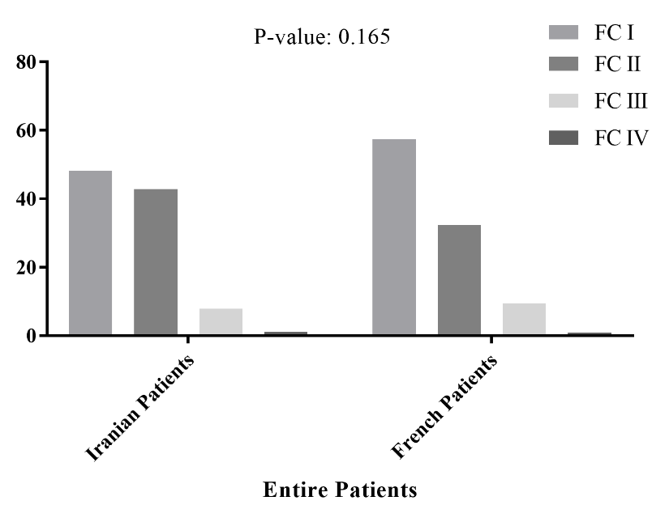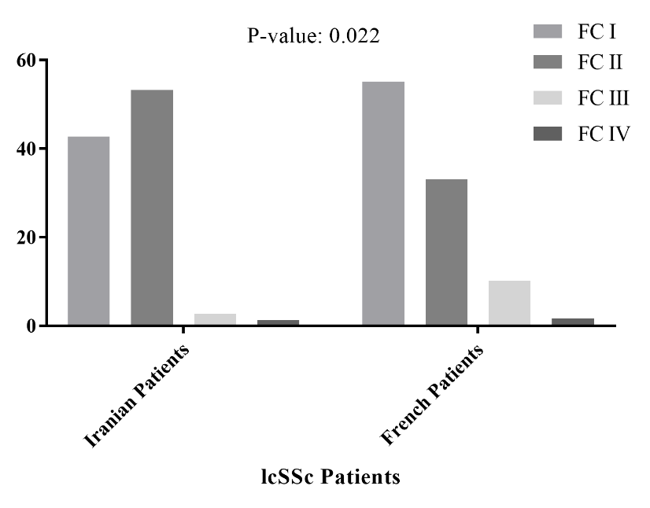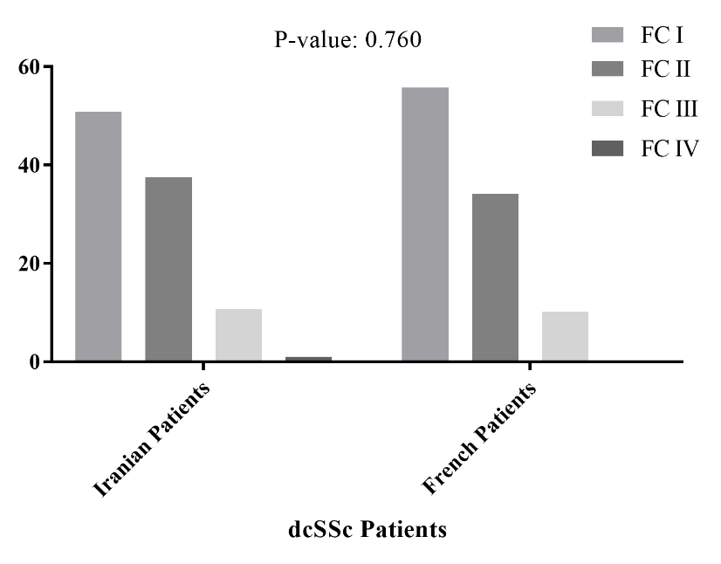

**Supplementary data 3**. The comparison of NYHA functional classes frequencies between Iranian and French population among entire, lcSSc and dcSSc patients.

NYHA: New York Heart Association; FC: functional class; lcSSc: limited cutaneous systemic sclerosis; dcSSc; diffuse cutaneous systemic sclerosis

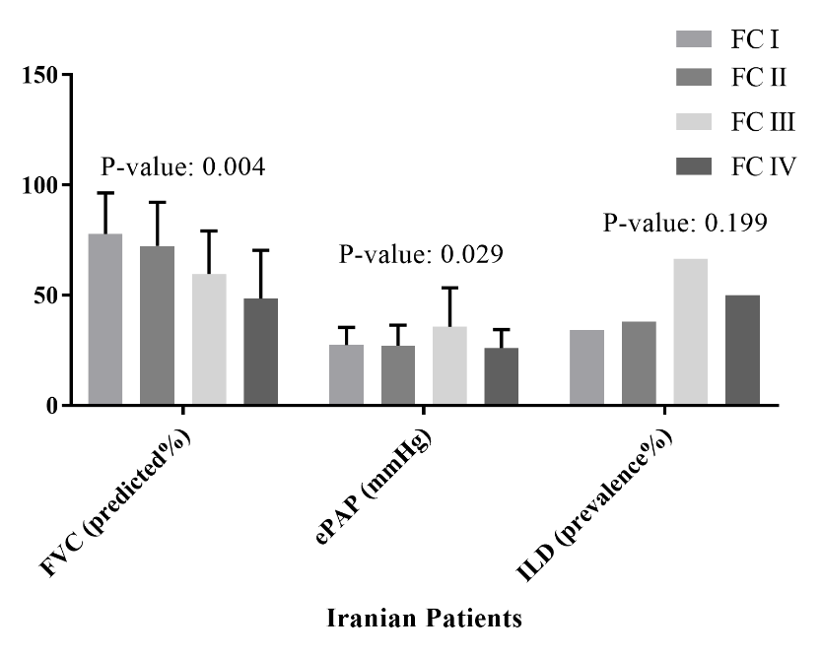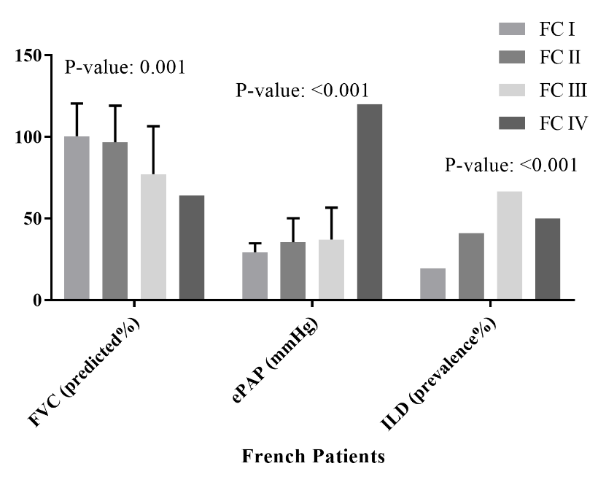

**Supplementary data 4.** The FVC, ePAP and lung fibrosis prevalence in different NYHA functional classes of Iranian and French population

NYHA: New York Heart Association; FVC: forced vital capacity, ePAP: estimated pulmonary arterial pressure, ILD: interstitial lung disease

|  |  |  |
| --- | --- | --- |
| Medication | Iranian Patients (N: 200)  Number (Percentage) | French patients (N: 268)  Number (Percentage) |
| Immunosuppressive agent | | |
| Cyclophosphamide | 40 (20.0) | 0 (0.0) |
| Mycophenolate mofetil | 76 (38.0) | 7 (2.5) |
| Azathioprine | 44 (22.0) | 11 (4.2) |
| Methotrexate | 34 (17.0) | 43 (16.0) |
| Rituximab | 6 (3.0) | 21 (7.8) |
| None | 0 (0.0) | 133 (49.6) |
| Vasoactive agents* | | |
| CCB | 164 (82.0) | 202 (84.5) |
| PDE-5 inhibitor | 40 (20.0) | 16 (6.7) |
| Endothelin receptor antagonist | 11 (5.5) | 13 (5.5) |
| Prostacyclin analog | 6 (3.0) | 9 (3.8) |
| ACEI/ARB | 45 (22.5) | 31 (12.9) |

**Supplementary data 5.** The comparison of treatment regimen between Iranian and French patients at the time of the study

CCB: calcium channel blocker; PDE: phosphodiesterase, ACEI: angiotensin-converting enzyme inhibitor, ARB: angiotensin II receptor blocker

*Percentage of missing data was in the range of 10.8-13.8 in French population.