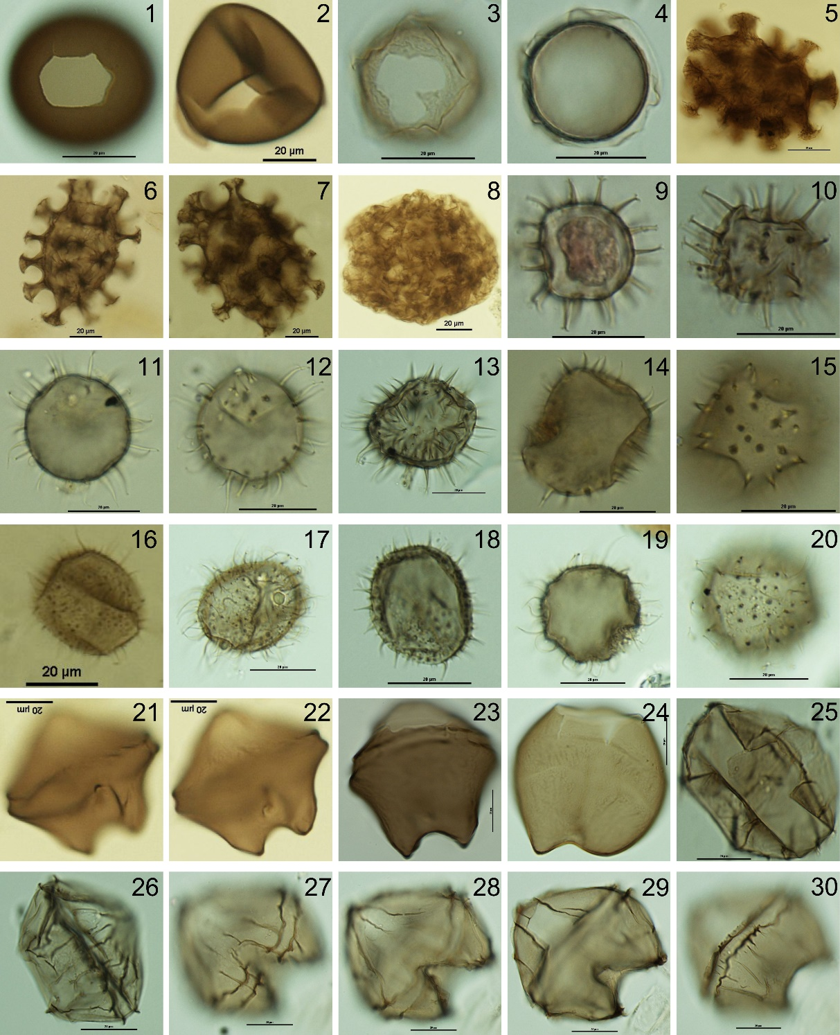
Supplementary Plate 1. Protoperidiniaceae cysts: 1-2. Brigantedinium spp. 3-4. Cyst of Protoperidinium americanum. Polykrikaceae cysts: 5-7. Cyst of Polykrikos schwartzii. 8. Cyst of Polykrikos kofoidii. Protoperidiniaceae cysts: 9-10. Echinidinium aculeatum. 11-13. Echinidinium granulatum 14-15. Echinidinium transparantum. 16-20. Cyst of Protoperidinium monospinum. 21-23. Lejeunecysta oliva. 24. Lejeunecysta sabrina. 25-30. Lejeunecysta paratenella. The scale bars are all 20 µm.
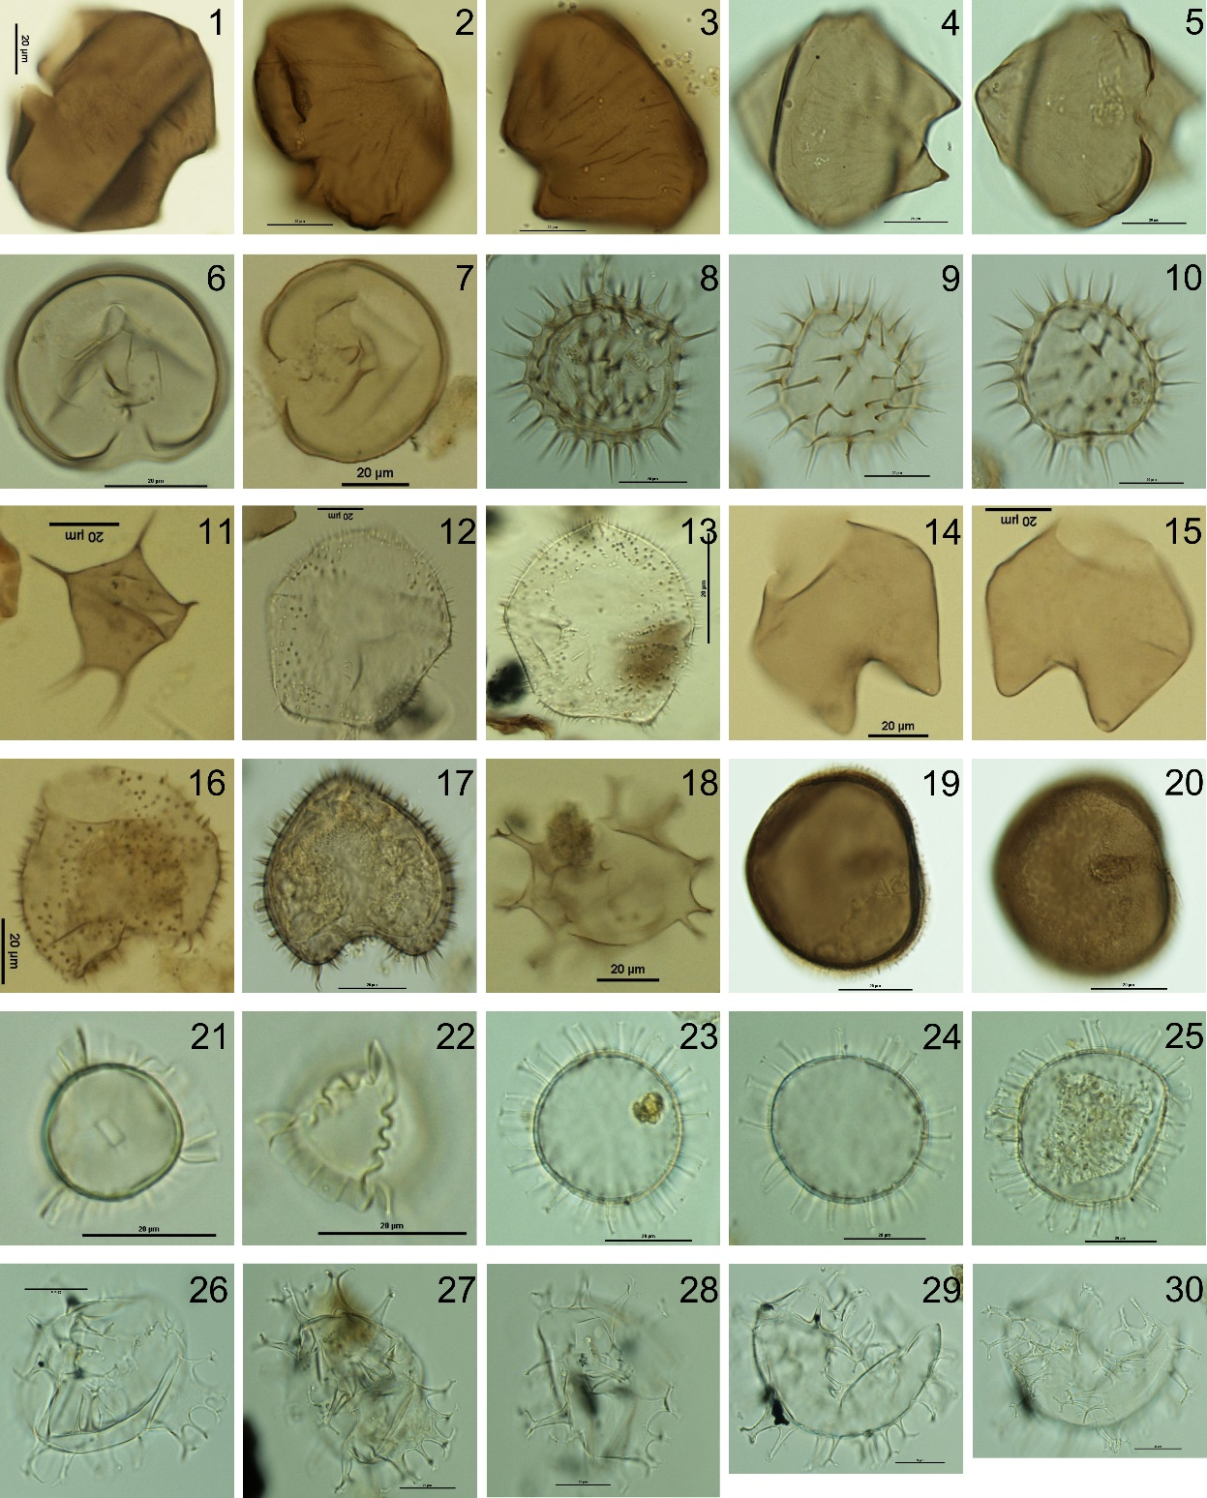
Supplementary Plate 2. Protoperidiniaceae cysts: 1-5. Quinquecuspis concreta. 6-7. Selenopemphix nephroides. 8-10. Selenopemphix quanta. 11. Stelladinium robustum. 12-13. Trinovantedinium applanatum. 14-15. Votadinium calvum. 16-17. Votadinium spinosum. 18. Xandarodinium xanthum. 19-20. Dubridinium spp. Gonyaulacaceae cysts: 21-22. Impagidinium strialatum. 23-25. Operculodinium centrocarpum. 26-28. Spiniferites mirabilis. 29-30. Spiniferites hypercanthus. The scale bars are all 20 µm.
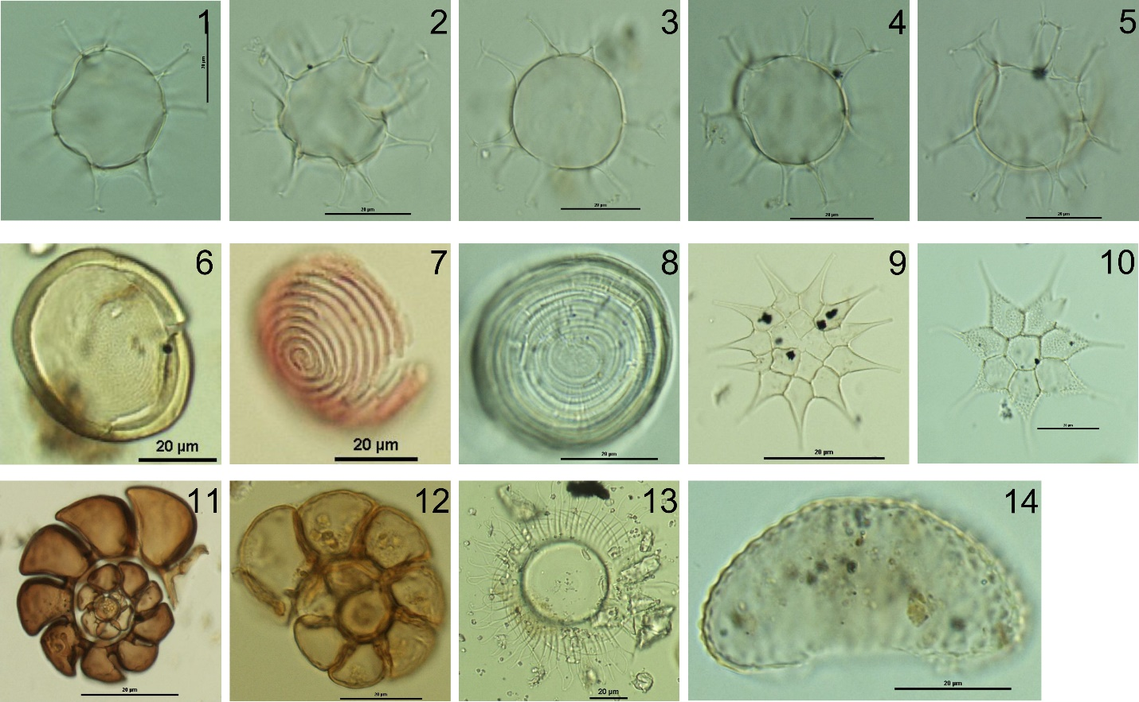
Supplementary Plate 3. Gonyaulacaceae cysts: 1-5. Spiniferites ramosus. 6-8. Concentricystes. 9-10. Pediastrum sp. 11-12. Foraminiferal organic linings. 13. Radiosperma cf. R. corbiferum. 14. Cosmarium spp. The scale bars are all 20 µm.

