Supplementary Materials

Participant Demographics
Study 1. Participants’ sexual orientation were as follows: 219 Straight/Heterosexual; 19 Not Listed/Other; 9 Bisexual/Pansexual; 6 Gay/Lesbian; and 6 Asexual. One hundred and seventy-eight people identified as White/European-American, 18 as Asian American/East Asian/South Asian, 15 as black/African-American, 13 as Latinx/Hispanic, one as Native Hawaiian/Native American/Alaska Native, and 14 as multi-racial/other.
Study 2. Participants’ sexual orientation were: 105 Straight/Heterosexual; 8 Not listed/Other; 7 Bisexual/Pansexual; 3 Gay/Lesbian; and 2 Asexual. Eighty-four people identified as White/European-American, eight as Asian American/East Asian/South Asian, eight as black/African-American, eight as Latinx/Hispanic, two as Native Hawaiian/Native American/Alaska Native, and 7 as multi-racial/other.
Study 3. Participants’ sexual orientation were: 151 Straight/Heterosexual; 14 bisexual/pansexual; 4 Gay/Lesbian; 2 Not listed/Other; and 1 Asexual. One hundred and twenty-seven people identified as White/European-American, 14 as Asian American/East Asian/South Asian, 11 as Latinx/Hispanic, 10 as black/African-American, two as Native Hawaiian/Native American/Alaska Native, and eight as multi-racial/other.
Study 4. Participants’ sexual orientation were: 154 Straight/Heterosexual; 6 bisexual/pansexual; 6 Asexual; 5 Gay/Lesbian; and 1 Not listed/Other. One-hundred and thirty-six people identified as White/European-American, 12 as black/African-American, nine as Asian American/East Asian/South Asian/Pacific Islander, 8 as Latinx/Hispanic, 1 as Native Hawaiian/American Indian/Alaska Native, and six as multi-racial/other.
Tables

Table S1.
Correlations Among All Study 1 Variables.
Variable | 1. | 2. | 3. | 4. | 5. | 6. | 7. | 8. | 9. | 10. | 11. | 12. | 13. | 14. | 15.
- Gender | --
- Sex. Orient | .17** | --
- Education | .01 | .05 | --
- Race / Eth. | .01 | -.03 | -.05 | --
- Age | -.14* | .15* | .01 | .26*** | --
- Religiosity | -.09 | .03 | -.01 | -.04 | .11† | --
- Political ID | .02 | .07 | -.22*** | .08 | .01 | .33*** | --
- Openness | -.01 | -.06 | -.05 | -.08 | -.09 | -.08 | -.13* | --
- SDO | .17** | .04 | -.10 | .07 | -.04 | .12† | .40*** | -.32*** | --
- Trans. Media | -.08 | -.05 | .01 | .04 | .06 | .09 | -.09 | .11 | -.08 | --
- Trans. Contact | -.11† | -.30*** | -.07 | -.12† | -.13 | -.08 | -.04 | .08 | -.05 | .14* | --
- Essentialism (General). | .19** | -.03 | -.10 | <.01 | -.17* | .05 | .21*** | -.06 | .30*** | -.14* | .03 | --
- Gender Essentialism | .20** | .17** | -.16* | .11† | .08 | .11† | .41** | -.09 | .35*** | -.07 | -.22*** | .46*** | --
- Trans. Rights | -.18** | -.18** | .13* | -.04 | -.12† | -.34*** | -.54*** | .24*** | -.51*** | .07 | .18** | -.30*** | -.61*** | --
- Women's Rights | -.17** | -.15* | .09 | .03 | -.10 | -.39*** | -.51*** | .26*** | -.56*** | -.01 | .10 | -.23*** | -.52*** | .73*** | --
Note. Ess. = Essentialism, †p ≤ .10, *p ≤ .05, **p ≤ .01, ***p ≤ .001
Table S2.

Descriptive Statistics and Correlations Among Study 2 Variables.
Variable | 1. | 2. | 3. | M | SD
1. Gender Essentialism | -- |  |  | 3.77 | 0.97
2. Support for Transgender Rights | -.60*** | -- |  | 3.44 | 1.16
3. Support for Women’s Rights | -.48*** | .68*** | -- | 3.48 | 0.84
†p ≤ .10, *p ≤ .05, **p ≤ .01, ***p ≤ .001

Table S3.

Descriptive Statistics and Correlations Among Study 3 Variables.
Variable | 1. | 2. | 3. | M | SD
1. Gender Essentialism | -- |  |  | 3.79 | 1.06
2. Support for Transgender Rights | -.60*** | -- |  | 3.41 | 1.20
3. Support for Women’s Rights | -.55*** | .76*** | -- | 3.50 | 0.99
†p ≤ .10, *p ≤ .05, **p ≤ .01, ***p ≤ .001

Table S4.

Descriptive Statistics and Correlations Among Study 4 Variables.
Variable | 1. | 2. | 3. |  | 4. | 5. | M | SD
1. Gender Essentialism | -- |  |  |  |  |  | 3.95 | 0.94
2. Transgender Prejudice | .43*** | -- |  |  |  |  | 3.72 | 1.70
3. Modern Sexism | .34*** | .46*** | -- |  |  |  | 3.27 | 1.49
4. Support for Transgender Rights | -.46*** | -.74*** | -.56*** |  | -- |  | 3.27 | 1.11
5. Support for Women’s Rights | -.43*** | -.48*** | -.58*** |  | .70*** | -- | 3.42 | 0.89
†p ≤ .10, *p ≤ .05, **p ≤ .01, ***p ≤ .001

Additional Mediation Results

Reverse Mediation Model Results
For each of the mediation models tested and reported in the main text, we provide below tests of the reverse causal model (lay theory exposure → rights → gender essentialism) to address questions about the directionality of the observed effects.
Women’s rights. Study 2 found support for the reverse causal model (lay theory exposure → women’s rights → gender essentialism) for participants in both the gender, b = -.28, SE = .16, 95% CI [-0.62, 0.01], and control, b = .17, SE = .15, 95% CI [-0.10, 0.48] conditions. However, Study 3 did not find support for the reverse causal model (lay theory exposure → policy support → gender essentialism), b = -.03, SE = 10, 95% CI [-0.22, 0.17].
Transgender rights. Support for the reverse causal model (lay theory exposure → transgender rights → gender essentialism) was not found. Specifically, Study 2 found no support for the reverse causal model (lay theory exposure → transgender rights → gender essentialism) for participants in either the gender, b = -.28, SE = .16, 95% CI [-0.62, 0.01], or control, b = .17, SE = .15, 95% CI [-0.10, 0.48] conditions. Additionally, the reverse causal model (lay theory exposure → policy support → gender essentialism) was not supported in Study 3, b = -.03, SE = 10, 95% CI [-0.22, 0.17].

Study Materials
Openness to New Experiences. (adapted from Costa & McCrae, 1982). I see myself as open to new experiences. (1= strongly disagree to 7 = strongly agree).

Social Dominance Orientation. (Pratto, Sidanius, Stallworth, & Malle, 1994). There are many kinds of groups in the world: men and women, ethnic and religious groups, nationalities, political factions. How much do you support or oppose the ideas about groups in general? *Indicates reverse coded item. (1 = extremely oppose to 10 = extremely favor).

- Group equality should be our ideal.*
- Superior groups should dominate inferior groups.
- We should not push for group equality.
- In setting priorities, we must consider all groups.*

Essentialism Index. (Bastian & Haslam, 2006). Please indicate to what extent you agree or disagree with the following statements. *Indicates reverse coded item. (1 = strongly disagree to 6 = strongly agree).

- The kind of person someone is can be largely attributed to their genetic inheritance.
- Very few traits that people exhibit can be traced back to their biology.*
- I think that genetic predispositions have little influence on the kind of person someone is.
- Whether someone is one kind of person or another is determined by their biological make-up.
- There are different types of people and with enough scientific knowledge; these different ‘types’ can be traced back to genetic causes.
- A person’s attributes are something that can’t be attributed to their biology.*
- With enough scientific knowledge, the basic qualities that a person has could be traced back to, and explained by, their biological make-up.
- A person’s traits are never determined by their genes.*
- The kind of person someone is, is clearly defined; they either are a certain kind of person or they are not.
- People can behave in ways that seem ambiguous, but the central aspects of their character are clear-cut.
- A person’s basic qualities exist in varying degrees, and are never easily categorized.*
- Everyone is either a certain type of person or they are not.
- A person's basic character is never easily defined.*
- A person either has a certain attribute or they do not.
- No matter what qualities a person has, those qualities are always indefinite and difficult to define.*
- People can have many attributes and are never completely defined by any particular one.*
- When getting to know a person it is possible to get a picture of the kind of person they are very quickly.

Gender Essentialism. (Coleman & Hong, 2008). Please indicate to what extent you agree or disagree with the following statements. *Indicates reverse coded item. (1 = strongly disagree to 6 = strongly agree).

- The properties of gender are constructed totally for economic, political, and social reasons.*
- The innate properties of a person's gender determine what the person is like.
- Gender is not set in stone and can be changed.*
- If social situations change, the characteristics we attribute to gender categories will change as well.*
- When men and women differ in some way, it is likely that the difference is due to biological factors.
- Gender is a result of "nurture" more than "nature".*
- A person's gender has more to do with a person's social environment than with an individual's disposition.*
- To a large extent, a person's gender biologically determines his or her abilities and traits.
- Gender is more directly linked to biology than to the way a person is socialized.*
- People's displays of gender behaviors are based more on biological factors than on the social climate.*

Support for Transgender Rights. (adapted from Davidson, 2014). Indicate on a scale below the degree to which you would support the following measures. Transgender is a term used to describe people whose gender identity differs from the sex the doctor marked on their birth certificate. *Indicates reverse coded item. (1 = not at all likely to 5 = very likely).

- How likely would you be to support a law that would allow individuals to change the gender on their driver’s licenses/passports?
- How likely would you be to support a decision to allow transgender individuals to serve in the military?
- How likely would you be to support a bill guaranteeing employment non-discrimination towards transgender individuals?
- How likely would you be to support a law requiring health insurance companies to cover gender transition related expenses (e.g., hormone therapy)?
- How likely would you be to support a bill allowing individuals to use the restroom that matches their gender identity rather than their birth-assigned sex?
- How likely would you be to support a bill that allows non-sports related private organizations (e.g., private clubs) to restrict membership based upon birth-assigned sex rather than gender identity?*

Exposure to News and Popular Media about Transgender-Related Issues. In the past month, how much exposure have you had to media concerning transgender individuals, rights, and issues? (1 = no exposure, 7 = a lot of exposure).

Contact with Transgender People. How many transgender individuals do you know personally? _____________________

Support for Women’s Rights. Indicate on a scale below the degree to which you would support the following measures. *Indicates reverse coded item. (1 = not at all likely to 5 = very likely).

- How likely would you be to support a policy that would raise the minimum wage for female employees?
- How likely would you be to support a law allowing women to serve in ground units that engage in close combat?
- How likely would you be to support an exemption for religious affiliated institutions to a federal rule that requires employers to cover birth control?*
- How likely would you be to support a bill guaranteeing paid maternity leave for new mothers in the U.S.?
- How likely would you be to support a law that declared abortion illegal at the federal level?*
- How likely would you be to support a policy allowing gender-based affirmative action to influence hiring decisions in the workplace?

Transgender Prejudice. (Nagoshi, Adams, Terrell, Hill, Brzuzy, & Nagoshi, 2008). Please indicate the degree to which you agree or disagree with each statement using the scale below. *Indicates reverse coded item. (1 = completely disagree to 7 = completely agree).

- I don’t like it when someone is flirting with me, and I can’t tell if they are a man or a woman.
- I think there is something wrong with a person who says that they are neither a man nor a woman.
- I avoid people on the street whose gender is unclear to me.
- When I meet someone, it is important for me to be able to identify them as a man or a woman.

Modern Sexism Scale. (Swim, Aikin, Hall, & Hunter, 1995). Below are a series of statements concerning men and women and their relationships in contemporary society. Please indicate the degree to which you agree or disagree with each statement using the scale below.*Indicates reverse coded item. (1 = strongly disagree to 7 = strongly agree).

- Discrimination against women is no longer a problem in the United States.
- Women often miss out on good jobs due to sexual discrimination.
- It is rare to see women treated in a sexist manner on television.
- On average, people in our society treat husbands and wives equally.
- Society has reached the point where women and men have equal opportunities for achievement.
- It is easy to understand the anger of women’s groups in America.*
- It is easy to understand why women’s groups are still concerned about societal limitations of women’s opportunities.*
- Over the past few years, the government and news media have been showing more concern about the treatment of women than is warranted by women’s actual experiences.*

Demographics

- How would you describe your political party affiliation?
(1=strong Democrat; 7=strong Republican)
- How would you describe your religious beliefs?
(1 = not at all religious; 7 = very religious)
- How would you describe your gender?
  - Woman
  - Man
  - Transgender
  - Not listed (specify) ___________________
- How would you describe your sexual orientation? (select all that apply)
  - Asexual
  - Bisexual/Pansexual
  - Queer
  - Straight/Heterosexual
  - Not listed (specify) ___________________
- What is the highest level of education you have completed?
  - Some high school
  - High school graduate
  - Some college
  - Trade/technical/vocational training
  - College graduate
  - Some postgraduate work
  - Postgraduate degree
  - Other (specify) ___________________
- What is your age? ________________________
- What is your race/ethnicity? (select all that apply)
  - African American, Black, African, Caribbean
  - East Asian (e.g. Chinese, Korean)
  - South Asian (e.g. Indian, Pakistani)
  - Southeast Asian (e.g. Vietnamese, Cambodian)
  - European American, White, Caucasian
  - Hispanic American, Latino(a), Chicano(a)
  - Pacific Islander (e.g. Micronesian, Melanesian)
  - Native Hawaiian, American Indian or Alaskan Native
  - Other (specify) ___________________
- How many years have you lived in the United States? _____________________
- What is your current zip code? ______________________

Study 2 Manipulations

Pro-Essentialism Gender Article. (Brescoll & LaFrance, 2006).
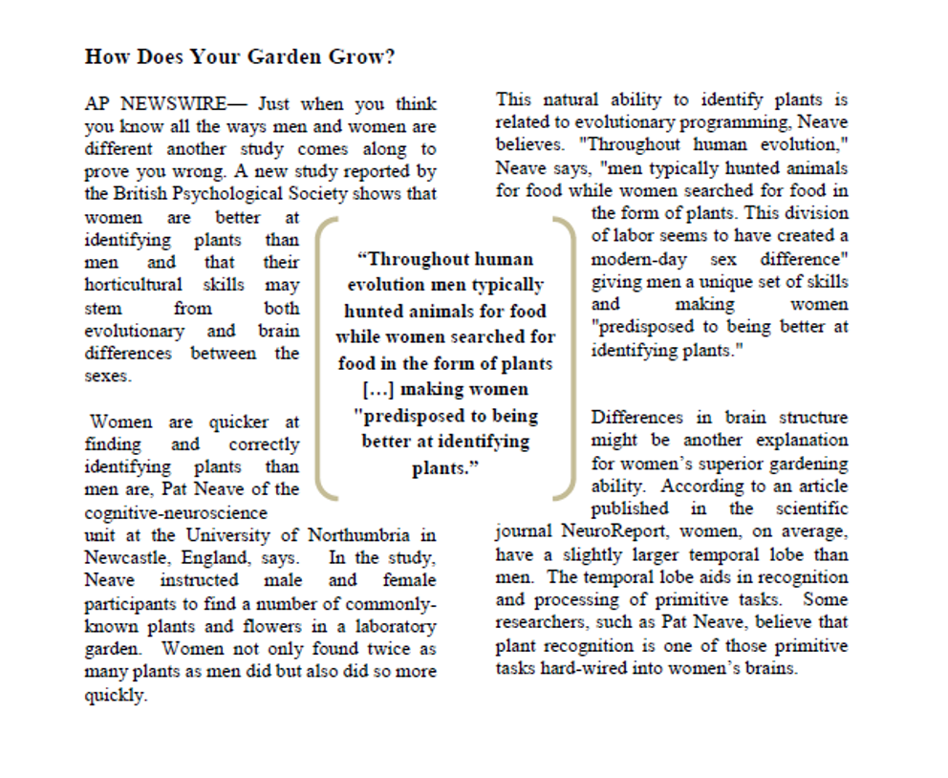

Anti-Essentialism Gender Article. (Brescoll & LaFrance, 2006).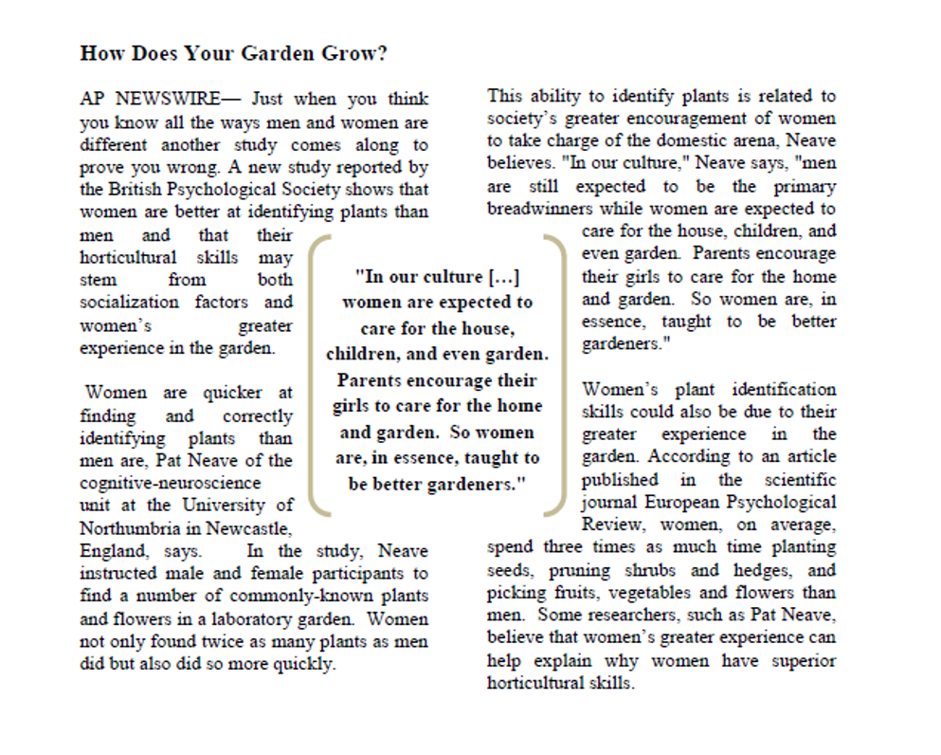

Pro-Essentialist Sleep Patterns Condition.

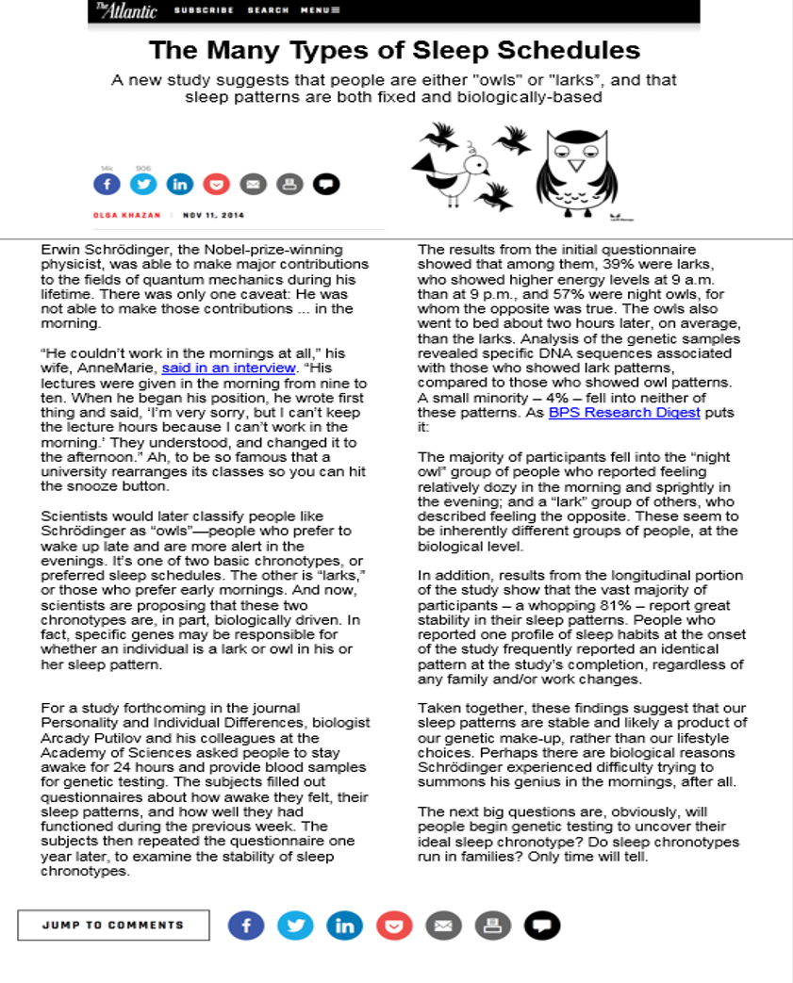

Anti-Essentialist Sleep Patterns Condition.

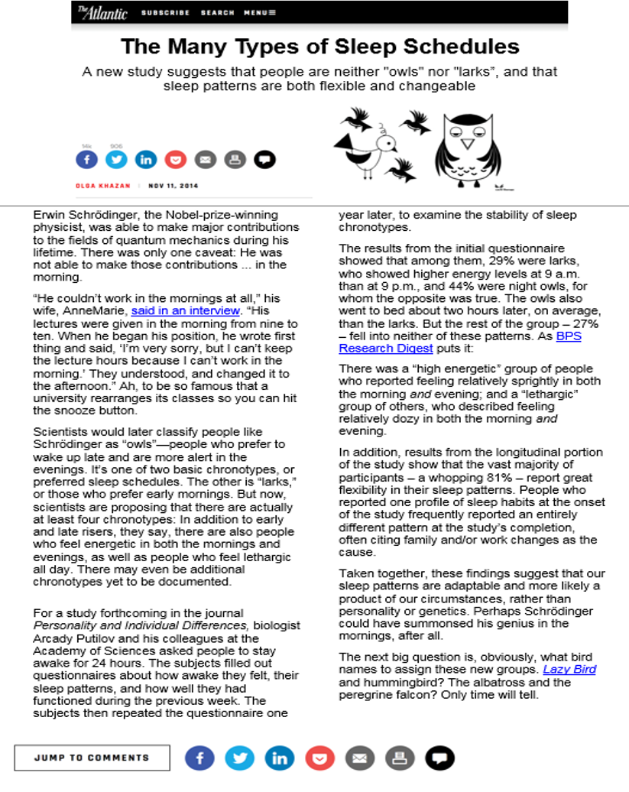

Study 3 and 4 Manipulations

Environment Condition (Control).

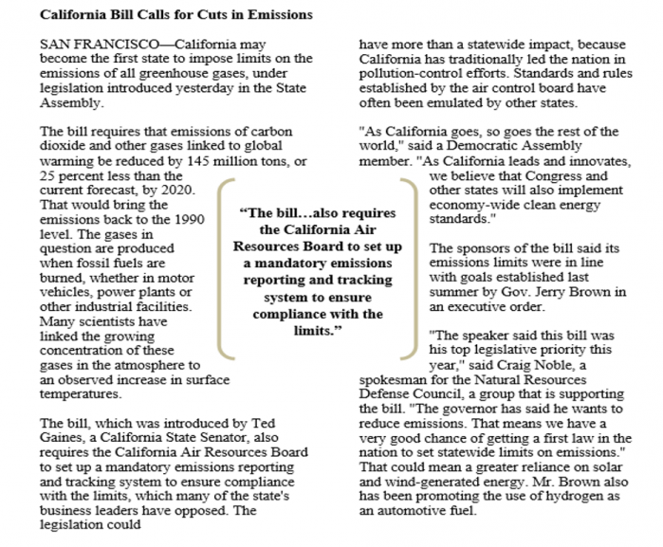

Pro-Essentialist Gender Condition.
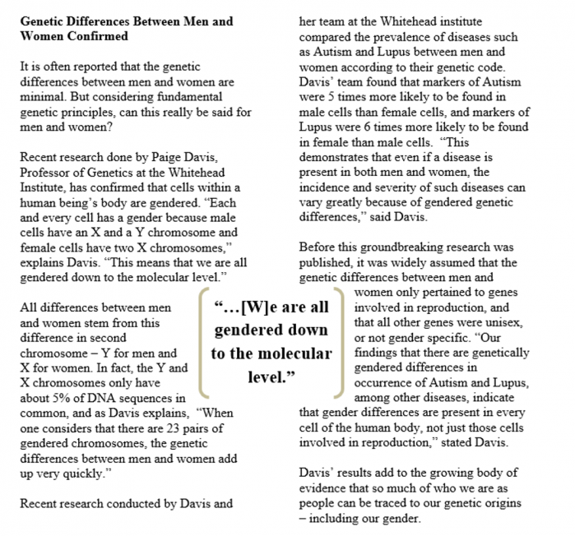

Anti-Essentialist Gender Condition.
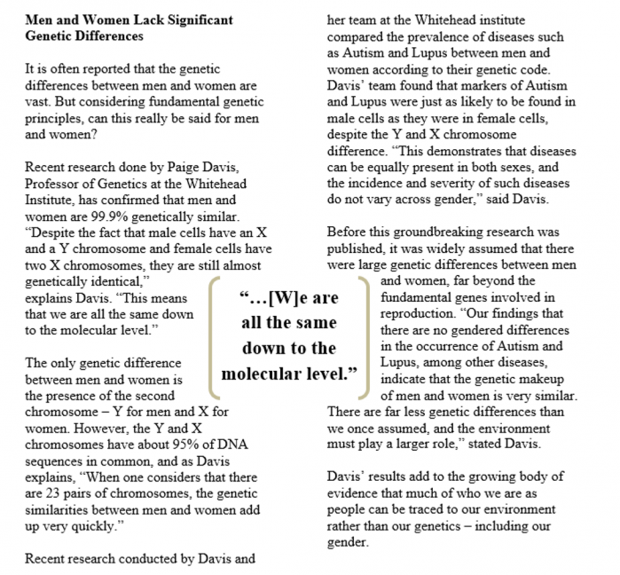

Manipulation checks for all studies. Participants who answered the question incorrectly one time were prompted to respond again. Participants who answered the question incorrectly two times were removed from analyses.

According to the article, which of the following statements is true:
- There is a greater genetic basis than environmental basis for human appearance, behavior, and preferences.
- There is a greater genetic basis than environmental basis for human appearance, behavior, and preferences.

