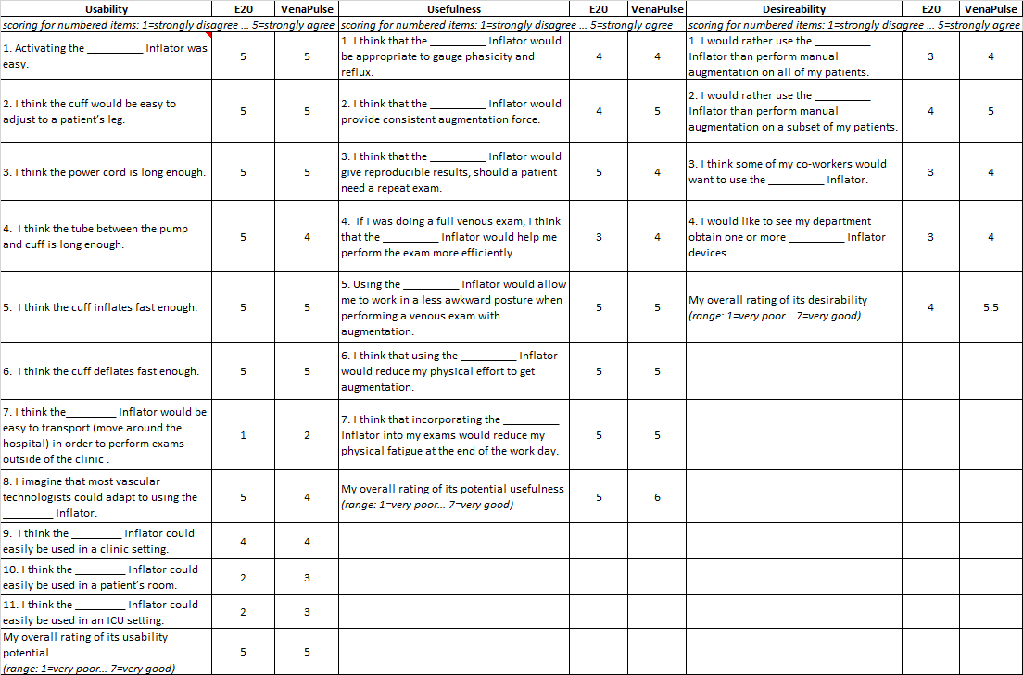
Appendix. Usability, usefulness, and desirability ratings for each item. On the evaluation form, the ________ was filled in with the name of the specific device that the VT were assessing.

