Supplement
Materials and Measures Study 1
Materials and Measures Study 2
Materials and Measures Study 3
Additional Information on Exclusions
Analyses with Full Samples
Supplementary Measures and Analyses
Additional Study

Materials and Measures
Experiment 1: Materials and Measures

In this study we are interested in the formation of perceptions and evaluations of companies.

We will give you information about a company called Livens and ask you questions about this company later.
You will not be provided with enough information to answer all of the questions, but it is crucial that you try to form a first impression about the company to provide best guesses/estimates later.

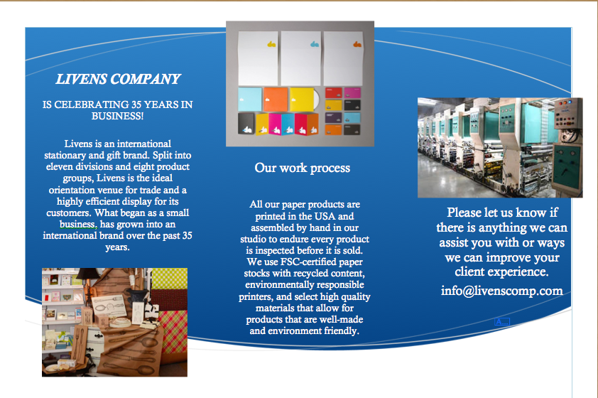
On the next page you will see the company's mission statement and see some company facts. Please read these well.

Experimental manipulations:

Value-in-homogeneity condition (discrimination): 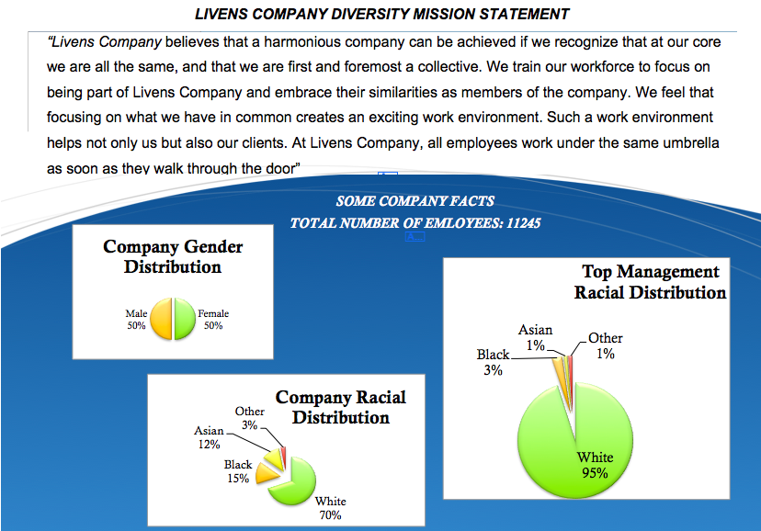

Value-in-homogeneity condition (no discrimination):
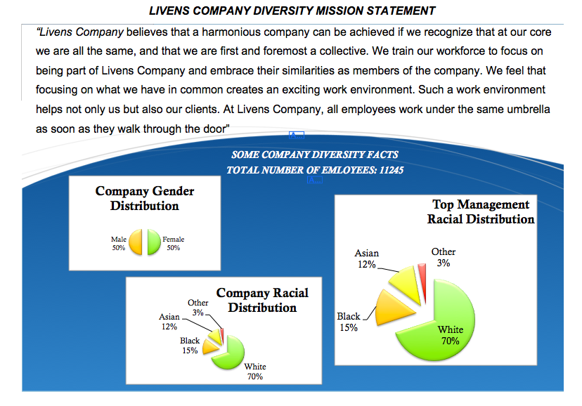

“Company diversity facts” were identical in the remaining two conditions. Diversity ideology manipulation texts were:
Value in Inter-individual Differences
“Livens Company believes that a harmonious company can be achieved if we recognize that at our core each of us is a unique individual, and that we are first and foremost a company of individuals. We train our workforce to focus on being individuals and embrace their individual characteristics. We feel that focusing on individual qualities creates an exciting work environment. Such a work environment helps not only us but also our clients. At Livens Company, each employee is a unique individual as soon as they walk through the door.”
Multiculturalism
Livens Company believes that a harmonious company can be achieved if we recognize that at our core we are a racially/culturally diverse group of people, and that we should first and foremost recognize and appreciate our diversity. We train our workforce to focus on embracing and celebrating their racial-ethnic diversity. We believe that appreciating and recognizing this diversity creates an exciting work environment. Such a work environment helps not only us but also our clients. At Livens Company, employees celebrate their racial ethnic diversity as soon as you walk through the door.

We will now ask you a number of questions about this company.
Remember: You do not have enough information to answer all of the questions, but it is crucial that you provide your best guesses/estimates.

Please indicate per statement to what extent you agree/disagree with Livens Company in mind. (1=completely disagree, 7=completely agree)

I think racial minorities are able to express their views and feelings about their treatment at Livens Company.
I think racial minorities have influence over the outcomes they receive at Livens Company.
I think Livens Company applies personnel procedures consistently across all employees, irrespective of race.
I think Livens Company values diverse opinions.
I think Livens Company treats racial minorities with respect.

Please indicate per statement to what extent you agree/disagree with Livens Company in mind. (1=completely disagree, 7=completely agree)

I think employees of different racial and cultural backgrounds have equal chances to reach higher positions at this company. (r)
I think employees of different racial and cultural backgrounds have equal opportunities at this company. (r)
I think employees of different racial and cultural backgrounds are proportionally represented in different hierarchical layers of this company. (r)
I think it is likely that racial groups get the salary they deserve at this company. (r)
I think it is likely that racial discrimination occurs at this company.

Please indicate which of the statements best represents the mission statement of Livens Company you read earlier.

Livens Company believes that one should focus on being part of the organization and similarities they have with other employees.
Livens Company believes that one should focus on their individual, unique characteristics and interpersonal differences.
Livens Company believes that one should acknowledge, value and celebrate racial and cultural diversity.

A couple of questions about yourself:

I am a (1) Man (2) Woman
How old are you? [open ended]
What is your ethnic/racial background?
- White/ Caucasian American
- Black/ African American
- Latin/ Hispanic American
- Asian American
- Native Hawaiian/Other Pacific Islander American
- Bi-racial
- Other American
- Other, please specify:…

Instructional manipulation check: Recent research on decision-making shows that choices are affected by context. Differences in how people feel, their previous knowledge and experience, and their environment can affect choices. To help us understand how people make decisions, we are interested in information about you.
Specifically, we are interested in whether you actually take the time to read the directions; if not, some results may not tell us very much about decision making in the real world. To show that you have read the instructions, please ignore the question below about how you are feeling and instead check only scared as your answer. Thank you very much.
QUESTION: Please check all words that describe how you are currently feeling.
Interested
Distressed
Excited
Upset
Strong
Guilty
Scared
Hostile
Enthusiastic
Proud
Irritable
Active
Afraid
Non of the above
Experiment 2: Materials and Measures

In this study we are interested in the formation of perceptions and evaluations of companies.

We will give you information about a company called Livens and ask you questions about this company later.
You will not be provided with enough information to answer all of the questions, but it is crucial that you try to form a first impression about the company to provide best guesses/estimates later.

On the next page you will see a segment from the company's annual HR-report.

Please read this information well. (Participants saw one of the two versions)

LIVENS COMPANY ANNUAL HR-REPORT
At Livens we follow all laws and in our employment decisions (such as recruiting, hiring, training, salary and promotion). We do not discriminate against individuals on the basis of race, color, gender, age, national origin, religion, sexual orientation, gender identity or expression, marital status, citizenship, disability, veteran status, HIV/AIDS status, or any other legally protected factor.
Our company has strong norms and beliefs around racial diversity and the racial-ethnic composition of our employees. These norms and beliefs are clearly stated in our company’s diversity mission statement stated below:
“Livens Company believes that a harmonious company can be achieved if we recognize that at our core we are all the same, and that we are first and foremost a collective. We train our workforce to focus on being part of Livens Company and embrace their similarities as members of the company. We feel that focusing on what we have in common creates an exciting work environment. Such a work environment helps not only us but also our clients.
All employees work under the umbrella of Livens Company soon as they walk through the door.”

LIVENS COMPANY ANNUAL HR-REPORT
At Livens we follow all laws and in our employment decisions (such as recruiting, hiring, training, salary and promotion) we do not discriminate against individuals on the basis of race, color, gender, age, national origin, religion, sexual orientation, gender identity or expression, marital status, citizenship, disability, veteran status, HIV/AIDS status, or any other legally protected factor.
Our company has strong norms and beliefs around racial diversity and the racial-ethnic composition of our employees. These norms and beliefs are clearly stated in our company’s diversity mission statement stated below:
“Livens Company believes that a harmonious company can be achieved if we appreciate our diversity, value and integrate the qualities of our employees with diverse racial-ethnic backgrounds in our organization. We train our workforce to focus on embracing and celebrating their racial-ethnic diversity. We believe that appreciating and recognizing this diversity creates an exciting work environment. Such a work environment helps not only us but also our clients.
At Livens Company, as soon as you walk through the door you’ll appreciate the strength that we derive from our racial-ethnic group diversity.”

Please indicate per statement to what extent you agree/disagree with Livens Company in mind. (1=completely disagree, 7=completely agree)

I think racial minorities are able to express their views and feelings about their treatment at Livens Company.
I think racial minorities have influence over the outcomes they receive at Livens Company.
I think Livens Company applies personnel procedures consistently across all employees, irrespective of race.
I think Livens Company values diverse opinions.
I think Livens Company treats racial minorities with respect.

Recently, a national newspaper published an article about Livens Company. Please read this article on the next page.

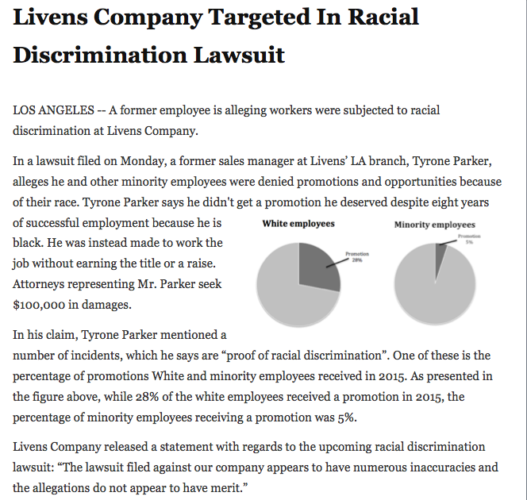

We will now ask you a number of questions about this company.
Remember: You do not have enough information to answer all of the questions, but it is crucial that you provide your best guesses/estimates.

Please answer the questions.

How legitimate is Tyrone Parker’s lawsuit against Livens Company? (1=not at all, 7 = very)
To what extent do you think that Tyrone Parker’s lawsuit is a result of real racial issues at this company? (1=not at all, 7 = very)
I don't see enough evidence for racial discrimination at Livens Company. (1=completely disagree, 7 = completely agree)
I believe that Livens Company has good intentions. (1=completely disagree, 7 = completely agree)

Please indicate which of the statements best represents the diversity mission statement of Livens Company you read earlier.

Livens Company believes that one should focus on being part of the organization and similarities they have with other employees.
Livens Company believes that one should acknowledge, value and celebrate racial and cultural diversity.

A couple of questions about yourself:
I am a (1) Man (2) Woman
How old are you? [Open-ended]
What is your ethnic/racial background? (part of the eligibility screening)
- White/ Caucasian American
- Black/ African American
- Latin/ Hispanic American
- Asian American
- Native Hawaiian/Other Pacific Islander American
- Bi-racial
- Other American
- Other, please specify:…

Instructional manipulation check: Recent research on decision-making shows that choices are affected by context. Differences in how people feel, their previous knowledge and experience, and their environment can affect choices. To help us understand how people make decisions, we are interested in information about you.
Specifically, we are interested in whether you actually take the time to read the directions; if not, some results may not tell us very much about decision making in the real world. To show that you have read the instructions, please ignore the question below about how you are feeling and instead check only scared as your answer. Thank you very much.
QUESTION: Please check all words that describe how you are currently feeling.
Interested
Distressed
Excited
Upset
Strong
Guilty
Scared
Hostile
Enthusiastic
Proud
Irritable
Active
Afraid
None of the above
Experiment 3: Materials and Measures

In this study we are interested in the formation of perceptions and evaluations of companies.
We will give you information about a company called Livens and ask you questions about this company later.
You will not be provided with enough information to answer all of the questions, but it is crucial that you try to form a first impression about the company to provide best guesses/estimates later.

Livens is an internationally operating, US-based consultancy firm with over 15,000 employees all over the US.

Recently, a national newspaper published an article about Livens Company. Please read this article on the next page

Please read this information well. (Participants saw one of the three versions)

Livens Company Targeted In Racial Discrimination Lawsuit

LOS ANGELES – Three former employees are alleging workers were subjected to racial discrimination at Livens Company. Here are some of the allegations in the complaint.

According to the former employees suing the company, Livens does not employ African-American consultants in many states. Black consultants at Livens allegedly have an extremely high attrition rate. In the years prior to the lawsuit, 75% of African-American trainee consultants left before the training period was over, the suit said. Black consultants said they received lower salaries than their White counterparts. The firm ranked its employees by putting them in five "quintiles" based on the amount of money they earned from commissions. Seventy percent of the firm's African-American consultants with at least 10 years of experience were in the bottom two quintiles, while white consultants were more evenly distributed.

A representative of Livens stated that the lawsuit did not have any legal or moral basis. According to the representative higher attrition rates did not mean there is discrimination. The representative also stated that the company had presented evidence to the court that the differences in salary and commissions were based on a variety of other factors including other employees’ education, previous work experience, and prior compensation.

Livens Company Targeted In Racial Discrimination Lawsuit

LOS ANGELES – Two former employees are alleging workers were subjected to racial discrimination at Livens Company. Here are some of the allegations in the complaint.

According to the former employees suing the company, Livens does not employ African-American consultants in many states. Black consultants at Livens allegedly have an extremely high attrition rate. In the years prior to the lawsuit, 75% of African-American trainee consultants left before the training period was over, the suit said. Black consultants said they received lower salaries than their White counterparts. The firm ranked its employees by putting them in five "quintiles" based on the amount of money they earned from commissions. Seventy percent of the firm's African-American consultants with at least 10 years of experience were in the bottom two quintiles, while white consultants were more evenly distributed.

A representative of Livens stated that the lawsuit did not have any legal or moral basis. According to the representative higher attrition rates did not mean there is discrimination. The representative also stated that the company had presented evidence to the court that the differences in salary and commissions were based on a variety of other factors including other employees’ education, previous work experience, and prior compensation.

The representative stated that Livens Company is highly committed to diversity. The company has a strong diversity policy as is stated in the company’s diversity mission statement:
“We believe that a harmonious company can be achieved if we value and integrate the qualities of our employees with diverse racial-ethnic backgrounds in our organization. We train our workforce to focus on embracing and celebrating their racial-ethnic diversity. A diverse workforce helps not only us but also our clients. At Livens Company, as soon as you walk through the door you’ll appreciate the strength that we derive from our racial-ethnic group diversity.”

Livens Company Targeted In Racial Discrimination Lawsuit

LOS ANGELES – Two former employees are alleging workers were subjected to racial discrimination at Livens Company. Here are some of the allegations in the complaint.

According to the former employees suing the company, Livens does not employ African-American consultants in many states. Black consultants at Livens allegedly have an extremely high attrition rate. In the years prior to the lawsuit, 75% of African-American trainee consultants left before the training period was over, the suit said. Black consultants said they received lower salaries than their White counterparts. The firm ranked its employees by putting them in five "quintiles" based on the amount of money they earned from commissions. Seventy percent of the firm's African-American consultants with at least 10 years of experience were in the bottom two quintiles, while white consultants were more evenly distributed.

A representative of Livens stated that the lawsuit did not have any legal or moral basis. According to the representative higher attrition rates did not mean there is discrimination. The representative also stated that the company had presented evidence to the court that the differences in salary and commissions were based on a variety of other factors including other employees’ education, previous work experience, and prior compensation.

The representative stated: “Livens has actually recently won the prestigious Diversity in Consultancy Award (DCA) for its commitment to racial diversity”. DCA is annually awarded to consultancy companies who score highly on multiple key areas of diversity management.

We will now ask you a number of questions about this company.
Remember: You do not have enough information to answer all of the questions, but it is crucial that you provide your best guesses/estimates.

Please indicate per statement to what extent you agree/disagree with Livens Company in mind. (1=completely disagree, 7=completely agree)

I think racial minorities are able to express their views and feelings about their treatment at Livens Company.
I think racial minorities have influence over the outcomes they receive at Livens Company.
I think Livens Company applies personnel procedures consistently across all employees, irrespective of race.
I think Livens Company values diverse opinions.
I think Livens Company treats racial minorities with respect.

Please answer the questions.

How legitimate is the former employees’ lawsuit against Livens Company? (1=not at all, 7=very)
To what extent do you think that the former employees’ lawsuit is a result of real racial issues at this company? (1=not at all, 7=very)
To what extent would you be willing to vote in favor of this racial discrimination claim against Livens Company? (1=not at all, 7=very)

Please indicate whether the following statement is true or false based on the information you received earlier about Livens [checks per condition]

Livens is sued for racial discrimination. The company rejects the claims in the lawsuit and states the claims have no basis.
Livens is sued for racial discrimination. The company rejects the claims in the lawsuit, states the claims have no basis and refers to company's strong pro-diversity policies and diversity mission statement.
Livens is sued for racial discrimination. The company rejects the claims in the lawsuit, states the claims have no basis and refers to company's award for its commitment to diversity.

A couple of questions about yourself:
I am a (1) Man (2) Woman
How old are you? [Open ended]
What is your ethnic/racial background?
- White/ Caucasian American
- Black/ African American
- Latin/ Hispanic American
- Asian American
- Native Hawaiian/Other Pacific Islander American
- Bi-racial
- Other American
- Other, please specify:…

Instructional manipulation check: Recent research on decision-making shows that choices are affected by context. Differences in how people feel, their previous knowledge and experience, and their environment can affect choices. To help us understand how people make decisions, we are interested in information about you.
Specifically, we are interested in whether you actually take the time to read the directions; if not, some results may not tell us very much about decision making in the real world. To show that you have read the instructions, please ignore the question below about how you are feeling and instead check only scared as your answer. Thank you very much.
QUESTION: Please check all words that describe how you are currently feeling.
Interested
Distressed
Excited
Upset
Strong
Guilty
Scared
Hostile
Enthusiastic
Proud
Irritable
Active
Afraid
None of the above
Additional Information on Exclusions
Study 1
In Study 1, individuals who were included versus excluded did not differ in terms of gender. 89 (out of 329) men and 76 (out of 275) women were excluded because they provided an incorrect answer to one of the checks, χ² (1, N=605)= 0.026, p=.872.
Individuals who were included (M=34.48, SD=11.14) versus excluded (M=35.18, SD=11.71) did not differ in terms of age, t(601)=-0.673, p=.501.
Eight (out of 191) participants in the value-in-homogeneity condition, 19 (out of 202) participants in the value-in-individual differences condition and 19 (out of 212) participants in the multiculturalism condition incorrectly answered the instructional check, χ² (2, N=605) = 4.662, p=.097. Moreover, 54 (out of 191) participants in the value-in-homogeneity condition 53 (out of 202) participants in the value-in-individual differences condition and 36 (out of 212) participants in the multiculturalism condition incorrectly answered the manipulation check, χ² (2, N=605) = 8.234, p=.016.
Study 2
In Study 2, individuals who were included versus excluded did not differ in terms of gender. 34 (out of 181) men and 31 (out of 237) women were excluded because they provided an incorrect answer to one of the checks, χ² (1, N=418) = 2.541, p=.111.
Individuals who were included (M=35.11, SD=9.95) versus excluded (M=31.31, SD=10.15) did not differ in terms of age, t(416)=1.338, p=.182.
14 (out of 207) participants in the value-in-homogeneity condition and 13 (out of 211) participants in the multiculturalism condition incorrectly answered the instructional check, χ² (1, N=418) = .063, p=.802. Moreover, 24 (out of 207) participants in the value-in-homogeneity condition and 20 (out of 211) participants in the multiculturalism condition incorrectly answered the manipulation check, χ² (1, N=418) = .497, p=.481.
Study 3
In Study 3, individuals who were included versus excluded did not differ in terms of gender. 12 (out of 285) men and 12 (out of 221) women were excluded because they provided an incorrect answer to one of the checks, χ² (1, N=418) = 0.410, p=.522.
Individuals who were included (M=35.48, SD=10.95) versus excluded (M=32.75, SD=10.55) did not differ in terms of age, t(504)=1.193, p=.234.
Seven (out of 163) participants in the control condition, 7 (out of 166) participants in the diversity mission statement condition, and 7 (out of 170) participants in the award condition incorrectly answered the instructional check, χ² (2, N=506) = 0.003, p=.999. Moreover, 1 (out of 163) participants in the control condition, 2 (out of 166) participants in the diversity mission statement condition, and 0 (out of 170) participants in the award condition incorrectly incorrectly answered the manipulation check, χ² (2, N=506) = 2.069, p=.355.

Analyses with the Full Samples
In all studies, we excluded participants before performing any analyses based on a priori determined exclusion criteria (1) An incorrect response to a forced choice manipulation check, and/or (2) An incorrect responses to an attention check (see Oppenheimer et al., 2009). We report below the results of the main analyses when we retain all participants.
Study 1
When we retain all participants, ideology still has a main effect on perceived fairness, F(2,599)=3.611, p=.028, η_{p}²=.012. Discrimination still has a main effect on perceived fairness, F(1,599)=38.512, p<.001, η_{p}²=.060. The two way interaction remains non-significant, F(2,599)=0.523, p=.593, η_{p}²=.002.
Study 2
When we retain all participants, ideology still has a main effect on perceived fairness, t(390.037)=-4.710, p<.001, d=.464. The non-significant direct effect of ideology on perceived legitimacy remains as well, t(416)=0.804, p=.422, d=.081.
Study 3
When we retain all participants, diversity structure manipulation still has a main effect on perceived fairness, F(2,503)=5.146, p=.006, η_{p}²=.020, on perceived legitimacy, F(2,503)=3.825, p=.022, η_{p}²=.015, and on the willingness to support the claim, F(2,503)=3.666, p=.026, η_{p}²=.014.

Supplementary Measures and Analyses
Study 1
In Study 1 we measured a number of additional dependent variables.
All participants read about an affirmative action policy at the company and rated their opposition to this policy through four items: “I do not think that this policy is needed at this company.”, “I feel like this policy is unfair towards White employees.”, “I think such policies should not focus on minorities but should include all employees.”, and “If a vote for this new policy was pending, I would vote against it.” (1=completely disagree, 7=completely agree; α=.88). Moreover, participants indicated how much money they would be willing to donate to this policy.
Participant answered two questions with regard to fair treatment by supervisors and co-workers: “How likely is it for employees of this company to be treated unfairly by bosses and supervisors because they belong to a racial minority group?” and “How likely is it for employees of this company to be treated unfairly by co-workers and colleagues because they belong to a racial minority group?” (1=not at all, 7=very; r=.79, p<.001).
Supplementary analyses. A 3 (ideology) by 2 (discrimination) ANOVA revealed a main effect of discrimination manipulation on opposition to affirmative action. Participants in the equal representation condition (M=4.74, SD=1.81) opposed affirmative action more than participants in the uneven representation condition (M=4.19, SD=1.74), F(1, 433)=10.694, p=.001, η_{p}²=.024. There was no main effect ideology on opposing affirmative action, F(2, 433)=2.017, p=.134, η_{p}²=.009. There was no interaction, F(2, 433)=0.101, p=.904, η_{p}²=.000.
A 3 (ideology) by 2 (discrimination) ANOVA shows no main effect of discrimination manipulation on the donations to affirmative action, F(2, 433)=0.060, p=.807, η_{p}²=.000. There was no main effect ideology, F(2, 433)=1.181, p=.308, η_{p}²=.005. There was no interaction, F(2, 433)=0.124, p=.884, η_{p}²=.001.
There was an indirect effect (ideologyfairnessopposition to affirmative action) for the dummy comparing value-in-homogeneity to multiculturalism, indirect effect = -.176, SE= .075, 95% CI [-0.347,-.052]. There was also an indirect effect (ideologyfairnessdonation for affirmative action) for the dummy comparing value-in-homogeneity to multiculturalism on donations, indirect effect = 2.245, SE=1.425, 95% CI [0.321, 6.237].
There was no an indirect effect (ideologyfairnessopposition to affirmative action) for the dummy comparing value-in-individual differences to multiculturalism, indirect effect = -.058, SE=.067, 95% CI [-0.203, 0.059]. There was also no an indirect effect (ideologyfairnessdonation for affirmative action) for the dummy comparing value-in-individual differences to multiculturalism on donations, indirect effect = .743, SE=.993, 95% CI [-0.504, 3.724].
Thus, although the diversity ideology manipulation did not have a direct impact on the opposition to affirmative action, indirect effects were consistent with our main findings.
A 3 (ideology) by 2 (discrimination) ANOVA shows a main effect of discrimination manipulation on unfair treatment by bosses and co-workers. Participants in the equal representation condition (M=2.99, SD=1.37) expected less unfair treatment than participants in the uneven representation condition (M=3.60, SD=1.51), F(1, 433)=19.864, p<.001, η_{p}²=.044. There was no main effect ideology on unfair treatment, F(2, 433)=1.997, p=.137, η_{p}²=.009. There was no interaction, F(2, 433)=0.388, p=.679, η_{p}²=.002.
There was an indirect effect (ideology fairness unfair treatment by bosses and coworkers) for the dummy comparing value-in-homogeneity to multiculturalism, indirect effect = .332, SE= .128, 95% CI [0.089,.594]. There was no an indirect effect (ideologyfairness unfair treatment by bosses and coworkers) for the dummy comparing value-in-individual differences to multiculturalism, indirect effect = .110, SE=.122, 95% CI [-0.121, 0.359].
Thus, although the diversity ideology had no direct impact on the anticipated unfair treatment by bosses/coworkers, indirect effects were consistent with our main findings. As participants inferred generalized fair treatment of minorities upon reading about a multicultural organization, they also expected racial minorities to be treated fairly on a day-to-day basis.
Study 3
In Study 3, we explored whether individual differences in the Motivation to Respond without Prejudice would influence how people reacted to racial discrimination claims. Plant and Devine (1998) identified two separate motivations to respond unprejudiced. Internally motivated individuals have genuine non-prejudiced attitudes, whereas externally motivated individuals merely obey to socially imposed norms. We conducted exploratory analyses on whether an internal and an external motivation to respond without prejudice would have direct effects or would moderate the effects of the diversity initiatives.
Participants completed the internal and external motivation to respond without prejudice scale (Plant & Devine, 1998). Each scale included three items. Items for the internal motivation to respond without prejudice were: “I am personally motivated by my beliefs to be non prejudiced toward racial minority groups”, “I attempt to act in non prejudiced ways toward racial minority groups because it is personally important to me.”, and “According to my personal values, using stereotypes about racial minority groups is OK.(-)” (α_{internal} = .77). Items for the external motivation were “Because of today’s PC (politically correct) standards I try to appear non prejudiced toward racial minority groups”, “If I acted prejudiced toward racial minority groups, I would be concerned that others would be angry with me.”, and “I attempt to appear non prejudiced toward racial minority groups in order to avoid disapproval from others.” (α_{external} = .86). Participants also indicated how much they thought the company should demand from the plaintiffs in a counter lawsuit.
Supplementary Analyses. We conducted exploratory analyses to uncover the possible moderating influence of White participants’ (n = 389) internal and external motivation to respond without prejudice on the relationships we studied. Prior to the analyses we established that neither internal, F (2, 479) = 2.017, p = .134, nor external, F (2, 479) = 0.305, p = .737, motivation was affected by the experimental manipulation. We used the dummy coded experimental conditions, mean-centered internal and external motivation scales and their interactions as predictors in multiple regression analyses.
Whites’ internal motivation to respond without prejudice increased their perceptions of legitimacy of the lawsuit (b = .339, SE = .101, p = .001), internal motivation did not interact with the experimental conditions (ps > .34). External motivation to respond without prejudice did not have a significant main effect or an interaction with the dummy comparing the award condition to the control condition (ps > .31), but it interacted with the ideology condition (b = .246, SE = .114, p = .032). Simple slopes analysis showed that when external motivation to respond without prejudice was low (1 SD below the mean), perceived legitimacy was lower in the multiculturalism condition (b = -.874, SE = .259, p = .001). When external motivation was average, perceived legitimacy was lower in the multiculturalism condition (b = -.453, SE = .197, p = .022). However, when external motivation was high (1 SD above the mean), the legitimacy gap between multiculturalism and control disappeared (b = -.032, SE = .258, p = .901).
Whites’ internal motivation to respond without prejudice increased their willingness to vote in favor of the lawsuit (b = .389, SE = .113, p = .001), internal motivation did not interact with the experimental conditions (ps > .24). External motivation to respond without prejudice did not have a significant main effect or an interaction with the dummy comparing the award condition to the control condition (ps > .24), but it interacted marginally with the ideology condition (b = .215, SE = .129, p = .098). Simple slopes analysis showed that when external motivation to respond without prejudice was low (1 SD below the mean), the willingness to support was lower in the multiculturalism condition (b = -.854, SE = .294, p = .004). When the external motivation was average, the willingness to support was lower in the multiculturalism condition (b = -.525, SE = .223, p = .019). However, when external motivation was high (1 SD above the mean), the difference in support between multiculturalism and control conditions disappeared (b = -.197, SE = .292, p = .501).
Whites’ internal motivation to respond without prejudice decreased their perceptions of fairness (b = -.289, SE = .096, p = .003), internal motivation did not interact with the experimental conditions (ps > .48). External motivation to respond without prejudice did not have main or interactive effects on perceived fairness (ps > .25).
Our exploratory analyses of the internal and external personal motivation to respond without prejudice offered some intriguing results. We found consistent main effects of the internal motivation; the fact that individuals with high levels of internal motivation are less suspicious of and more willing to support racial discrimination claims establish the impact of this motivation in an area that has not been previously explored. We also found some intriguing interactions between diversity ideologies and external motivation to respond without prejudice. Individuals with high levels of external motivation to respond without prejudice no longer saw racial discrimination claims as less legitimate in the multiculturalism condition.
After transforming the dependent variable (log-transformation + 1), an ANOVA revealed a non-significant main effect of initiative on the countersue amount, F(2, 433)=2.626, p=.073, η_{p}²=.011.

Additional Study
Following Study 1 in the main text, we conducted an additional study in order to test whether the strength of the discrimination context would moderate the impact of ideology on the dependent measures. Study 1 found that even when racial minorities were underrepresented at the organizational top, both minorities and Whites had a tendency to report less discrimination and to perceive more fairness when formal policies endorsed multiculturalism. However, the discrimination context in Study 1 was arguably ambiguous. This additional study was designed to replicate and extend Study 1 by manipulating ambiguous versus strong discrimination cues. Because multiculturalism and value-in-individual difference did not differ in Study 1, this study employed a simplified design, comparing multiculturalism to value-in-homogeneity.
Based on prior research, we determined the size per experimental cell as 37 (Kaiser et al., 2013), aiming at sample size around 148 for a 2 by 2 design. Keeping potential attrition in mind, we oversampled.
Method
Participants and design. We recruited 243 adults online (138 men, 187 White, 56 non-White [15 Black, 13 Hispanic, 22 Asian, 6 other]; M_{age}=34.37, SD_{age}=11.03).
The study had a 2 (diversity mission statement: multiculturalism versus value in homogeneity) by 2 (discrimination context: ambiguous versus explicit) between participants design.
Diversity mission statement manipulation. Participants read information about a company’s diversity mission statement which depending on the condition had a multicultural or a homogeneity valuing focus. We included a standard non-discrimination clause and an additional sentence, which mentioned the existence of strong organizational norms and values around racial diversity.
Discrimination manipulation. Participants read that a former employee sued the company for racial discrimination, claiming he did not receive the promotion he deserved because of his race. Participants saw pie charts depicting evidence that while 28% of the white employees received promotions in 2015, only 5% (strong discrimination)/ 20% (ambiguous discrimination) minority employees received promotions.
Dependent measures. Participants completed the same fairness toward minorities measure as in Study 1 (α = .93). They also indicated their perceived legitimacy of the discrimination claim by answering two questions (e.g., “How legitimate is [name employee]’s lawsuit against Livens Company?” and “To what extent do you think that [name employee]’s lawsuit is a result of real racial issues at this company?” ; 1=not at all, 7=very, r =.83, p <.001), and. Participants answered forced-choice manipulation, open-ended attention and instructional checks, and demographic questions.
Results
Manipulation and instructional checks. After excluding participants responding incorrectly to the checks, 192 participants (106 male) remained.
Perceived fairness toward minorities. We tested whether participant race (White vs. non-White) interacted with the manipulations to predict perceived fairness. Race did not have a main effect, F(1,184)=0.185, p=.668, η_{p}²=.001. There was no race by ideology interaction, F(1,184)=0.163, p=.686, η_{p}²=.001, no race by discrimination interaction, F(1,184)=1.387, p=.240, η_{p}²=.007, and no three way interaction, F(1,184)=0.901, p=.344, η_{p}²=.005, so we collapsed the data over this variable.
A 2 (diversity mission statement) by 2 (discrimination context) showed that participants perceived the multiculturalism-endorsing company (M=4.99, SD=1.37) to be more fair toward minorities than the value-in-homogeneity endorsing company (M=4.38, SD=1.63), F(1,188)=9.762, p = .002, η_{p}²= 049. They perceived higher fairness when discrimination context was ambiguous (M=5.13, SD=1.41), than when it was strong (M=4.29, SD=1.51), F(1, 188)=16.100, p<.001, η_{p}²=.079. There was an interaction, F(1,188)=4.510, p=.035, η_{p}²=.023: When organizations endorsed homogeneity, discrimination context did not impact perceived fairness, F(1,188)=1.59, p=.208, η_{p}²=.008. However, when organizations endorsed multiculturalism, they were perceived as more fair when discrimination was ambiguous (M=5.64, SD=1.10) rather than strong (M=4.37, SD=1.31) , F(1,188)=21.39, p<.001, η_{p}²=.102.
Perceived legitimacy of the claim. We tested whether participant race (White vs. non-White) interacted with the manipulations to predict perceived legitimacy of the claim. Race did not have a main effect, F(1,184)=0.259, p=.612, η_{p}²=.001. There was no race by ideology interaction, F(1,184)=0.774, p=.380, η_{p}²=.004, no race by discrimination interaction, F(1,184)=1.416, p=.236, η_{p}²=.008, and no three way interaction, F(1,184)=0.521, p=.471, η_{p}²=.003, so we collapsed the data over this variable.
A 2 (diversity mission statement) by 2 (discrimination context) ANOVA showed two main effects on perceived legitimacy. As predicted, participants perceived the claim to be less legitimate when the company endorsed multiculturalism (M=3.56, SD=1.58), rather than when it endorsed homogeneity (M=3.92, SD=1.66), F(1,188)= 4.113, p=.044, η_{p}²=.021. Participants perceived the claim to be less legitimate when 20% of minorities had a promotion (M=3.10, SD=1.49), than when 5% of minorities had a promotion (M= 4.39, SD=1.49), F(1,188)=35.577, p<.001, η_{p}²=.159. There was no interaction, F(1,188)=2.414, p=.122, η_{p}²=.013.
Indirect effects. We tested whether the effect of diversity ideology on perceived legitimacy was mediated by fairness perceptions. We performed conditional indirect effect analyses because the influence of ideology on the process variable (i.e., fairness perceptions) was moderated by discrimination strength (Hayes, 2013). The analyses demonstrated that multiculturalism increased perceived fairness toward minorities when discrimination was ambiguous, which in turn predicted decreased perceptions of the legitimacy of the employee’s claim, indirect effect=-.896, SE=.222, 95%CI [-1.332, -.456]. This indirect effect was not significant when discrimination was strong, 95%CI [-.717, .364].
Discussion
Replicating Study 1, multiculturalism-endorsing organizations are seen as more fair than homogeneity endorsing organizations and such fairness perceptions in turn are negative related with perceived legitimacy of employees’ racial discrimination claims. Moreover, these results suggest that fairness perceptions are, at least to some extent, affected by the strength of other, objective information with regards to discrimination (e.g., how equal are promotions distributed over minority versus white employees). As such, the indirect effect of multiculturalism on perceived legitimacy of racial discrimination claims through fairness is especially the case when there is some ambiguity present.

Pictures are covered due to copyright considerations.
We conducted these analyses for both the full sample and only for White participants, which revealed nearly identical results. However, we report the analyses for Whites only because the items used to measure these motivations were worded in a fashion (see Plant & Devine, 1998) that made them arguably more meaningful for White than minority participants.

