Appendix A.

Initial ALAAM Model

Table A1.
Initial ALAAM Model
Effects | Parameter | Stderr | t-ratio | SACF | Wald | signif.
Density | -7.80 | 4.38 | -0.02 | 0.029 | -1.78
SenderAttr | 2.35 | 0.95 | -0.03 | 0.018 | 2.48 | *
ReceiverAttr | 1.20 | 0.79 | -0.01 | 0.025 | 1.51
ReciprocityAttr | 1.05 | 0.87 | -0.02 | 0.039 | 1.21
ContagionArc | -0.53 | 0.46 | -0.03 | 0.042 | -1.15
Mixed2Star | -0.58 | 0.25 | -0.04 | 0.055 | -2.33 | *
Mixed2StarSource | -0.81 | 0.28 | -0.05 | 0.037 | -2.91 | *
Mixed2StarSink | -0.35 | 0.21 | -0.02 | 0.016 | -1.64
T1T | -0.48 | 0.47 | -0.03 | 0.044 | -1.03
T1C | 1.46 | 0.65 | -0.05 | 0.057 | 2.25 | *
chinese_oO | -2.78 | 1.65 | 0.00 | 0 | -1.69
L2C_oO | 1.47 | 0.91 | 0.01 | 0.027 | 1.61
Flow_oO | 1.05 | 0.33 | -0.03 | 0.018 | 3.17 | *
Langgrp_o<->Mismatch | 5.72 | 2.35 | -0.03 | 0.048 | 2.44 | *
class_o<->Mismatch | -5.01 | 1.81 | 0.04 | -0.009 | -2.76 | *

Goodness of fit was tested on all in-model and all available out-of-model effects (see Gallagher & Robins, 2015, appendix A, for an explanation). For all specified (in-model) effects, t-ratios were < 0.1, meaning that simulations adequately replicated the observed pattern of outcomes across the network structure, with excess or shortage of unspecified (available, but not-in-model) effects occurring either in excess, or in shortage.

Appendix B.

Causal Assumptions in Statistical Analysis of Social Networks: A Brief Primer.
A perennial issue in social science is disentangling cause and effect relations among variables. In cross-sectional research, any assertion about cause and effect should be made tentatively based on an assumption and prior theory, accompanied by appropriate caveats about alternative explanations. In longitudinal research, direction of causality can be tested more strongly (though not definitively proven). In social network research, the causal relation between ties and individual attributes take the following form:
- Social selection processes. Changeable or unchangeable individual variables (e.g., behaviour, sex, age) influence the formation, maintenance, or dissolution of social network ties. The exponential random graph modelling framework (ERGM) assumes that general social selection processes are in operation (Gallagher & Robins, 2015).
- Social influence processes. Network relationships shape and influence individual behaviour. The autologistic actor attribute modelling framework (ALAAM) assumes these processes are in operation.
- Co-evolution. Social selection and social influence operate simultaneously over time. Longitudinal statistical models for social network data, such as RSIENA, can test for both sets of processes simultaneously.
Social selection and social influence, however, are general categories of social processes, each of which may consist of more specific subprocesses, depending on the complexity of the social network position one is interested in. In figure B.1., we can observe a given outcome: a reciprocal network tie in association with an attribute (+). Note that this network position consists of three components: two directional ties, plus one individual-level outcome. If observed at only one time point, this configuration could be the result of any of the six three-step pathways shown. Each of these pathways represent different social processes. Pathways A and B are two different social influence processes, with the tie generally shaping the individual attribute. ALAAM assumes that these p[ro, but cannot say definitively. Pathways C and D are two different social selection processes, with the individual attribute generally shaping network ties. Finally, pathways E and F are two different co-evolution processes, consisting of a mix of selection and influence.

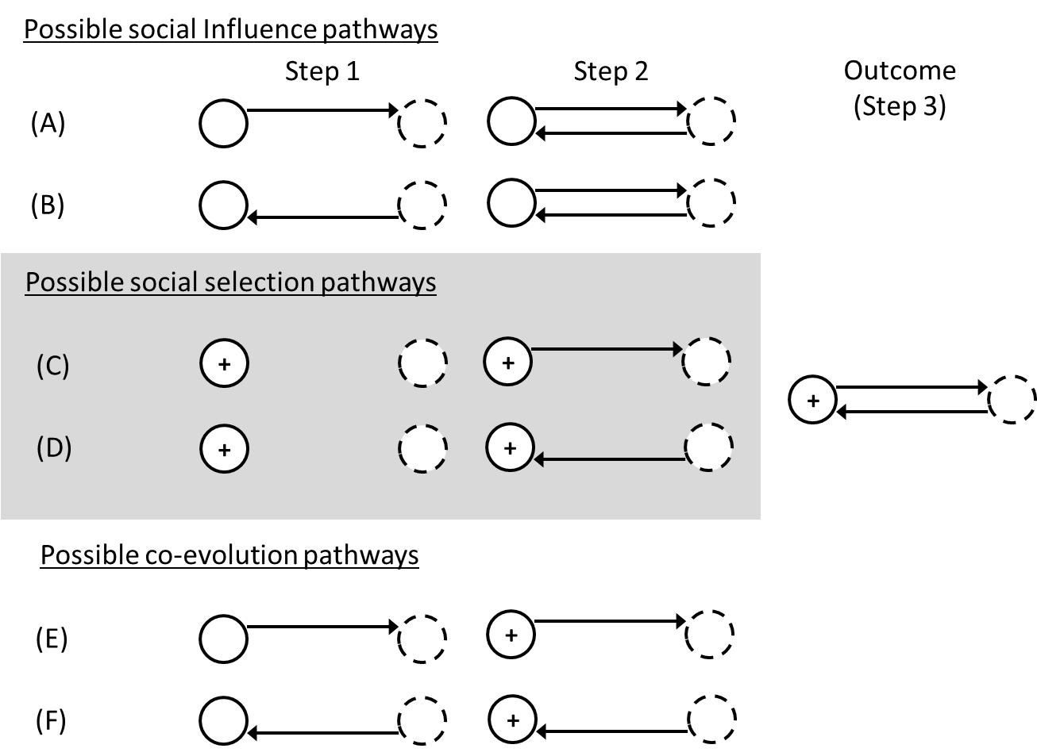
Figure 1. Possible social processes involving a (direct) reciprocal tie and an individual attribute.

Interpreting the Main Results
Given these various causal pathways, numerous possible interpretations exist for cross-sectional results from the main article. In figure B2, we see the main interpretations from the main text represented graphically. However additional interpretations are possible, with some suggested in figure B3. For instance, the finding that local brokers have lower WTC may indicate role stress (Krackhardt, 1999). Given their position between two or more disconnected groups, the broker may have to invest considerable energy and resources in balancing and resolving competing or conflicting demands from different groups of people.

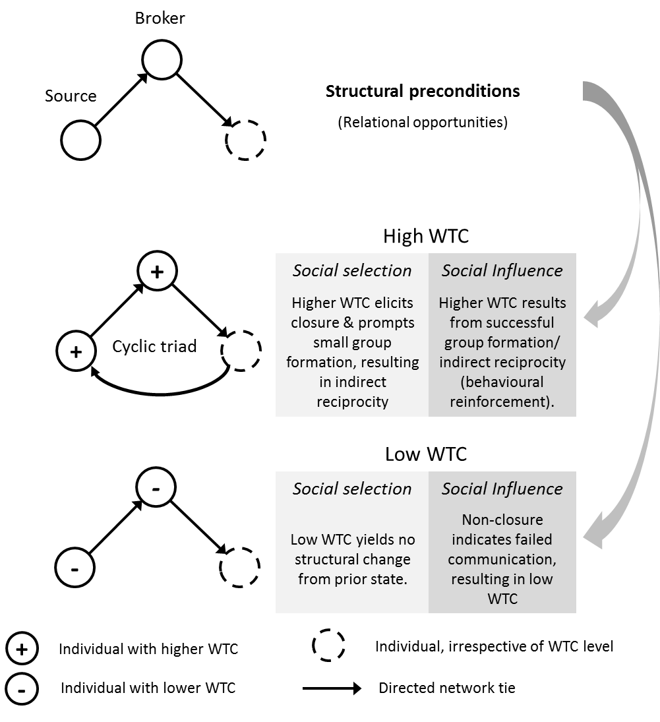
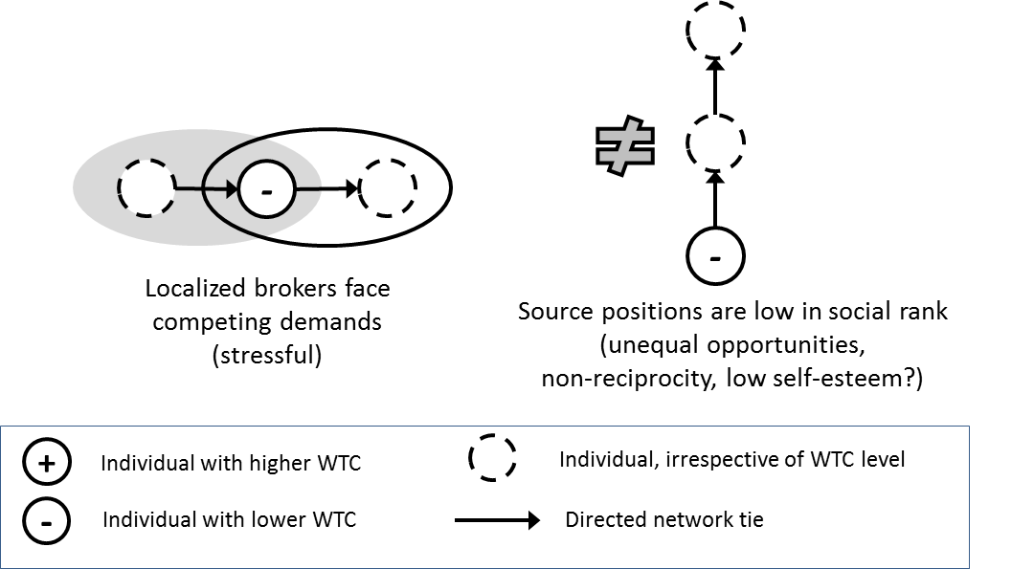
Figure 2. Main social selection and influence interpretations for brokerage and indirect reciprocity results, from main text.
Figure 3. Other social influence interpretations for brokerage results

Appendix C.

Willingness to Communicate Measure
Directions: Below are 20 situations in which a person might choose to communicate or not to communicate. Presume you have completely free choice. Indicate the percentage of times you would choose to communicate in each type of situation in English. Indicate in the space at the left of the item what percent of the time you would choose to communicate. (0 = Never to 100 = Always)

1. Talk with a service station attendant.
2. Talk with a physician.
3. Present a talk to a group of strangers.
4. Talk with an acquaintance while standing in line.
5. Talk with a salesperson in a store.
6. Talk in a large meeting of friends.
7. Talk with a police officer.
8. Talk in a small group of strangers.
9. Talk with a friend while standing in line.
10. Talk with a waiter/waitress in a restaurant.
11. Talk in a large meeting of acquaintances.
12. Talk with a stranger while standing in line.
13. Talk with a secretary.
14. Present a talk to a group of friends.
15. Talk in a small group of acquaintances.
16. Talk with a garbage collector.
17. Talk in a large meeting of strangers.
18. Talk with a spouse (or girl/boyfriend).
19. Talk in a small group of friends.
20. Present a talk to a group of acquaintances.

Context-type:

Group Discussion: items 8, 15, 19
Meetings: items 6, 11, 17
Interpersonal: items 4, 9, 12
Public Speaking: items 3, 14, 20

Receiver-type:

Stranger: items 3, 8, 12, 17
Acquaintance: items 4, 11, 15, 20
Friend: items 6, 9, 14, 19

Distractor (not counted in final score): 1, 2, 5, 7, 10, 13, 16, 18

Adapted from source: McCroskey, J. C. (n.d.). Willingness to communicate (WTC). Retrieved from http://www.jamescmccroskey.com/measures/WTC.htm

