Novel Bluetooth®-Enabled Tubeless Insulin Pump: A user experience design approach for a connected digital diabetes management platform
Sandhya S. Pillalamarri, BS, MHCI, ALM, Lauren M. Huyett, PhD, Aiman Abdel-Malek, PhD

Supplementary Data
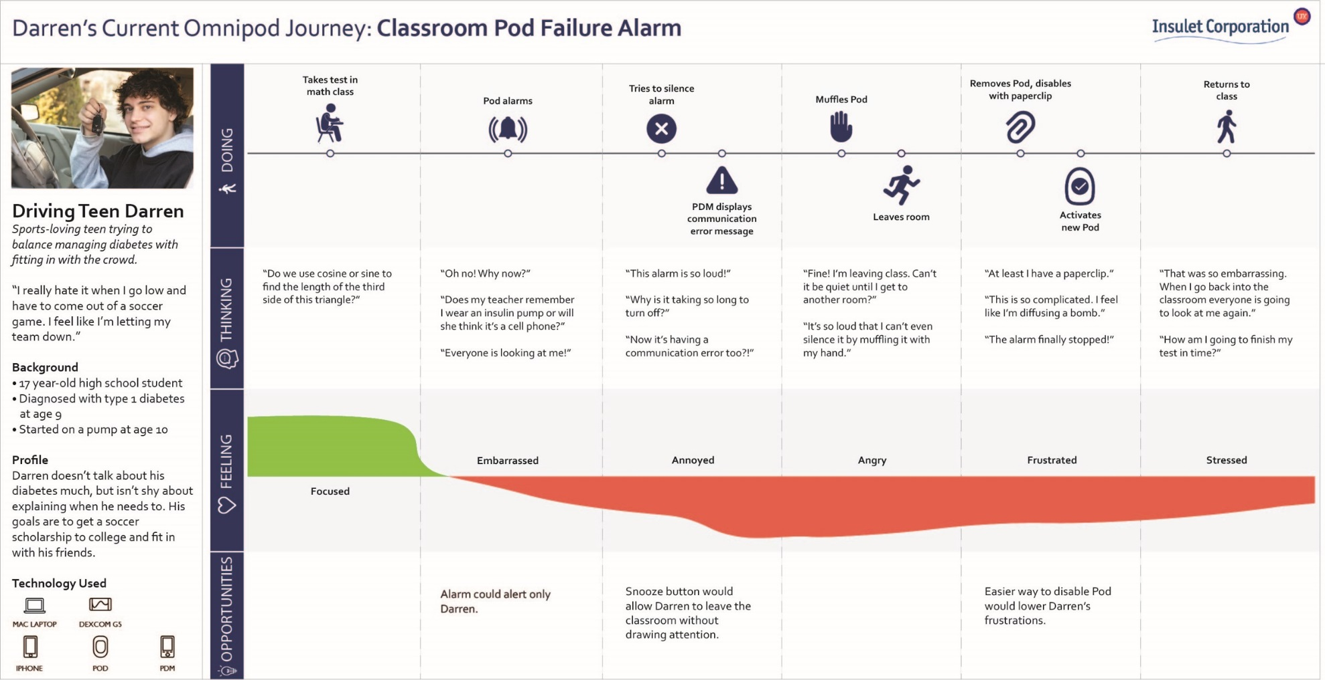 Figure S1. Example of a user journey for a specific persona and scenario with actions, thoughts, feelings, and opportunities for innovation. In this scenario, the team conducted contextual inquiries and home visits to better understand the journey and breakdowns of alarms and alerts experience per persona.

