Online Supplement for “Group Status Modulates the Associative Strength Between Status Quo Supporting Beliefs and Anti-Black Attitudes”:

Table of Contents
Meta-Analyses with only Independent Racial Attitude Scales 2
SDO Analyses with SDO-D and SDO-E 3
Meta-Analytic Forest Plots and Heterogeneity Statistics 6
Explicit Racial Preference – Explicit Scale Correlations 10
Analyses of White-Specific Attitudes 11
Comparison Between White and Black Attitude Measures in
Correlations with the IAT 13
Meta-Analyses with Only Independent Racial Attitude Scales

SDO. SDO was more strongly associated with anti-Black attitudes among White participants than among Black (Z = 4.27, p < .001) and Hispanic participants (Z = 2.32, p = .020). However, the SDO-racial attitude association did not differ between White and Asian participants (Z = 0.76, p = .447). Black participants did not differ in SDO-racial attitude associations compared to Asian (Z = -1.52, p = .129) or Hispanic participants (Z = -1.09, p = .276).
Conservatism. Conservatism was more strongly associated with anti-Black attitudes among White participants than among Black (Z = 7.12, p < .001), Asian (Z = 3.08, p = .002), and Hispanic participants (Z = 3.08, p = .002). Black participants also had lower conservatism-racial attitude associations compared to Asian (Z = -3.74, p < .001) and Hispanic participants (Z = -4.17, p < .001).

Analyses Using SDO-Dominance (SDO-D)

Implicit racial associations. We examined whether the relationship between SDO-D and implicit racial associations varied across racial groups. SDO-D was more strongly related to negative implicit racial associations toward Blacks among White participants than among Black participants (Fisher’s Z = 4.76, p < .001). However, Whites’ SDO-D/IAT correlation did not differ from the association among Asian (Fisher’s Z = 1.08, p = .280) and Hispanic participants (Fisher’s Z = 0.21, p = .834). Black participants’ SDO-D/IAT correlation was weaker than Hispanic participants (Fisher’s Z = -3.72, p < .001) but not Asian participants (Fisher’s Z = -1.64, p = .101). See Table S1 below for correlations between SDO-D and IAT D scores as well as the explicit preference item.
Explicit racial preferences. We next examined whether the relationship between SDO-D and explicit racial preferences varied across racial groups. SDO-D was more strongly associated with explicit anti-Black preferences for White participants than for Black (Fisher’s Z = 13.56, p < .001), Asian (Fisher’s Z = 4.29, p < .001), and Hispanic participants (Fisher’s Z = 8.43, p < .001). Black participants’ association between SDO-D and explicit racial preferences was weaker than that of Asian (Fisher’s Z = -3.56, p < .001) and Hispanic participants (Fisher’s Z = -5.02, p < .001), indicating that SDO-D was least strongly associated with explicit anti-Black preferences among Black participants.
Racial attitude scales. SDO-D was more strongly associated with anti-Black attitudes among White participants than among Black participants (Z = 3.94, p < .001). However, the SDO-D/racial attitude association did not differ between White and Asian participants (Z = 0.86, p = .390) or White and Hispanic participants (Z = 1.27, p = .204). Black participants did not differ in SDO-D/racial attitude associations compared to Asian participants (Z = -1.36, p = .174), but did differ compared to Hispanic participants (Z = -2.47, p = .014).
Table S1
Correlations (Pearson’s r) between SDO-D, explicit racial preferences, and IAT D scores
 | Participant Group
Variables | White | Black | Asian | Hispanic
SDO-D – Exp. Preference | .324 | .047 | .185 | .177
SDO-D – IAT D | .142 | .035* | .103 | .138
Note. Exp. Preference = Explicit racial preference item. SDO = Social dominance orientation. All correlations without a * are significant at p < .018.

Analyses Using SDO-Egalitarianism (SDO-E)

Implicit racial associations. We examined whether the relationship between SDO-E and implicit racial associations varied across racial groups. SDO-E was more strongly related to negative implicit racial associations toward Blacks among White participants than among Black participants (Fisher’s Z = 5.07, p < .001). However, Whites’ SDO-E/IAT correlation did not differ from the association among Asian (Fisher’s Z = 0.47, p = .638) and Hispanic participants (Fisher’s Z = 0.98, p = .327). Black participants’ SDO-E/IAT correlation was weaker than Asian (Fisher’s Z = -2.35, p = .019) and Hispanic participants (Fisher’s Z = -3.43, p < .001), indicating that SDO-E was least strongly related to implicit associations among Black participants. See Table S2 below for correlations between SDO-E and IAT D scores as well as the explicit preference item.
Explicit racial preferences. We next examined whether the relationship between SDO-E and explicit racial preferences varied across racial groups. SDO-E was more strongly associated with explicit anti-Black preferences for White participants than for Black (Fisher’s Z = 11.93, p < .001), Asian (Fisher’s Z = 2.15, p = .032) and Hispanic participants (Fisher’s Z = 7.89, p < .001). Black participants’ association between SDO-E and explicit racial preferences was weaker than that of Asian (Fisher’s Z = -4.56, p < .001) and Hispanic participants (Fisher’s Z = -4.08, p < .001), indicating that SDO-E was least strongly associated with explicit anti-Black preferences among Black participants.
Racial attitude scales. SDO-E was more strongly associated with anti-Black attitudes among White participants than among Black (Z = 3.62, p < .001) and Hispanic participants (Z = 4.08, p < .001). However, the SDO-E/racial attitude association did not differ between White and Asian participants (Z = 0.61, p = .542). Black participants did not differ in SDO-E/racial attitude associations compared to Asian (Z = -1.68, p = .093) or Hispanic participants (Z = -0.50, p = .617).
Table S2
Correlations (Pearson’s r) between SDO-E, explicit racial preferences, and IAT D scores
 | Participant Group
Variables | White | Black | Asian | Hispanic
SDO-E – Exp. Preference | .284 | .038* | .214 | .144
SDO-E – IAT D | .129 | .015* | .112 | .110
Note. Exp. Preference = Explicit racial preference item. SDO = Social dominance orientation. All correlations without a * are significant at p < .002.

Forest Plots for Meta-Analyses of Racial Attitude Scales
White Participants: SDO and Racial Attitudes
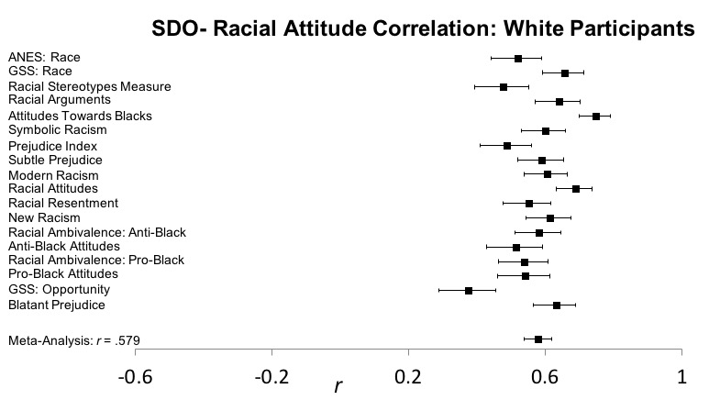
Test for heterogeneity: Q(17) = 118.67, p < .001
Black Participants: SDO and Racial Attitudes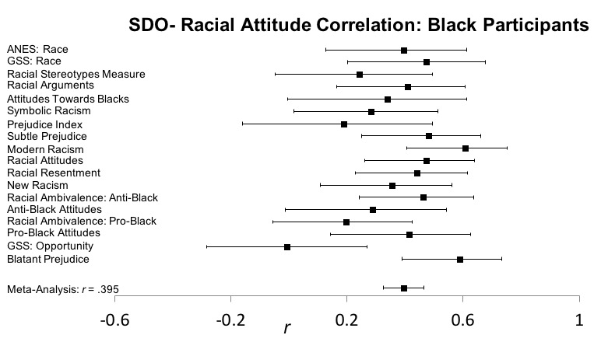
Test for heterogeneity: Q(17) = 28.05, p = .043

Asian Participants: SDO and Racial Attitudes
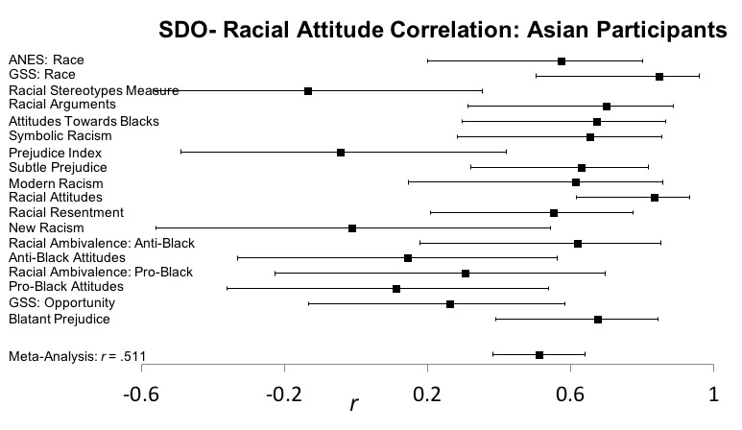
Test for heterogeneity: Q(17) = 54.00, p < .001
Hispanic Participants: SDO and Racial Attitudes
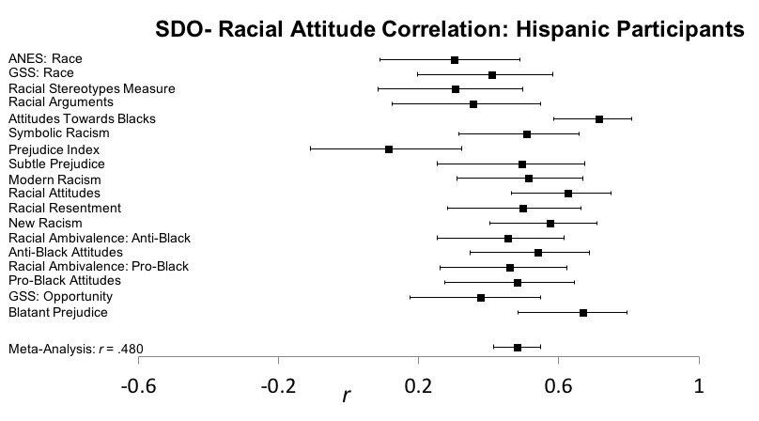
Test for heterogeneity: Q(17) = 48.15, p < .001

White Participants: Conservatism and Racial Attitudes
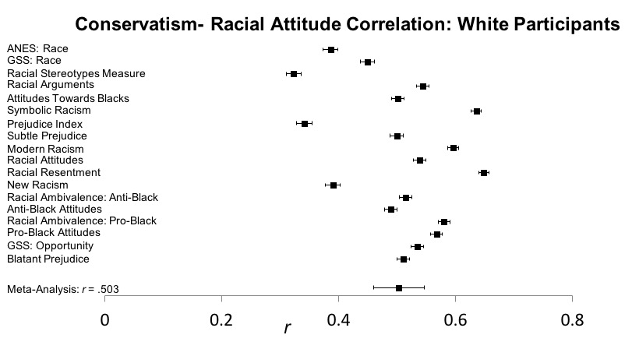
Test for heterogeneity: Q(17) = 4642.32, p < .001
Black Participants: Conservatism and Racial Attitudes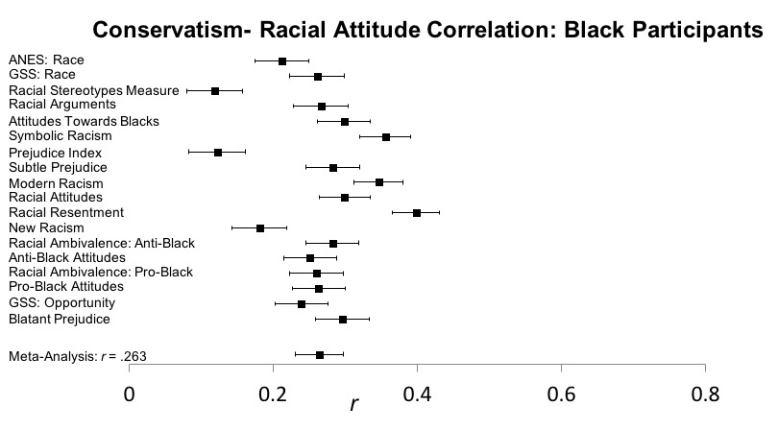
Test for heterogeneity: Q(17) = 258.09, p < .001

Asian Participants: Conservatism and Racial Attitudes
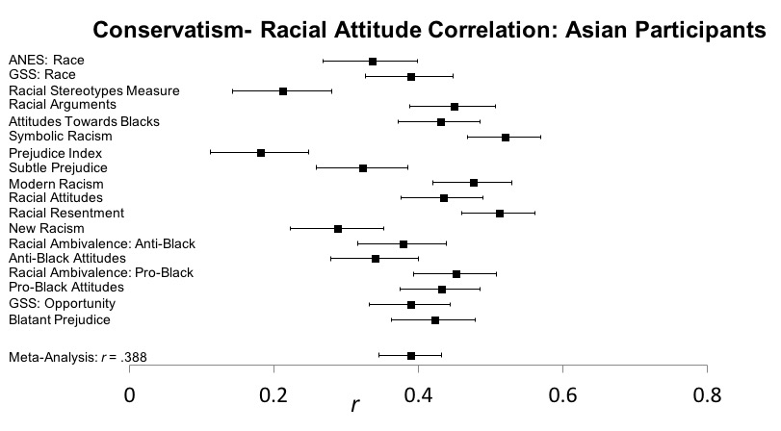
Test for heterogeneity: Q(17) = 151.91, p < .001
Hispanic Participants: Conservatism and Racial Attitudes
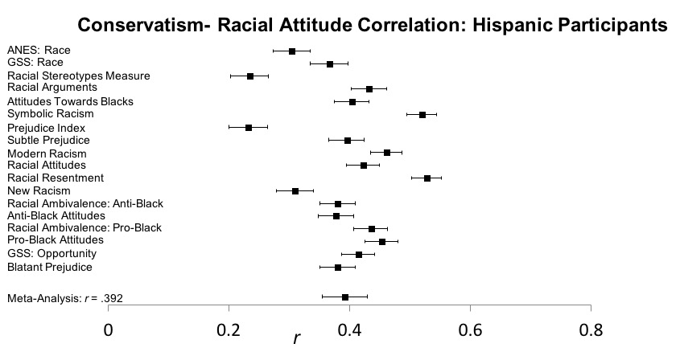
Test for heterogeneity: Q(17) = 534.83, p < .001

Correlation Between Explicit Racial Preference Item and each Racial Attitude Scale

ANES Race (ANES): r = .467
Anti-Black Attitudes (ABA): r = .329
Pro-Black Attitudes (PBA): r = .278
Attitudes Towards Blacks (ATB): r = .424
Blatant Prejudice (BP): r = .342
Subtle Prejudice (SP): r = .386
GSS: Perceptions of Opportunity (GSS: Opp): r = .228
GSS: Racial Attitudes (GSS: Race): r = .489
Modern Racism (MR): r = .349
New Racism (NR): r = .378
Prejudice Index (PI): r = .406
Racial Ambivalence: Anti-Black (RA-ABA): r = .340
Racial Ambivalence: Pro-Black (RA-PBA): r = .265
Racial Arguments (RaceArg): r = .334
Racial Attitudes (RA): r = .366
Racial Resentment (RR): r = .313
Racial Stereotypes Measure (RSM): r = .375
Symbolic Racism 2000 (SR2000): r = .341
Minimum r = .228; Median r = .346

Analyses of White-Specific Attitudes
Below, we recreate Tables 3 and 4 from the main text with measures that focused on attitudes toward Whites specifically. We used the Attitudes Towards Whites scale (ATW; Brigham, 1993) and the thermometer item assessing feelings towards White people (0 = Extremely cold, 10 = Extremely warm). Overall, SDO and conservatism were much more weakly related to attitudes toward White people than Black people, and the relationships of status quo supporting beliefs with attitudes toward White people generally varied in a very small magnitude across racial groups.

Table S3
Correlations (Pearson’s r) between SDO and conservatism with Attitudes Towards Whites and the White thermometer item
 | Participant Racial Group
Variables | White | Black | Asian | Hispanic
SDO – ATW | -.218* | -.216 | -.689* | -.245*
SDO – White Thermometer | -.063* | -.067* | -.086* | -.098*
Conservatism – ATW | -.018* | .028 | .001 | .033
Conservatism – White Thermometer | .011* | .035* | .015 | .028*
Note. SDO = Social dominance orientation. ATW = Attitudes towards Whites scale. All correlations with a * are significant at p < .033.
Table S4
Difference in correlation (Pearson’s r) and 95% confidence interval in comparisons among racial and ethnic groups.

 | Racial/Ethnic Group Contrast
Variables | White - Black | White - Asian | White - Hispanic | Black - Asian | Black - Hispanic
SDO – ATW | .002 [-.241, .266] | -.471 [-.695, -.044] | -.027 [-.252, .218] | -.473 [-.789, -.002] | -.029 [-.346, .286]
SDO – White Therm. | -.004 [-.045, .038] | -.023 [-.090, .044] | -.035 [-.071, .001] | -.019 [-.095, .057] | -.031 [-.082, .020]
Conservatism– ATW | -.010 [-.052, .032] | .017 [-.056, .090] | -.015 [-.051, .022] | .027 [-.054, .108] | -.005 [-.057, .047]
Conservatism – White Therm. | -.024 [-.033, -.015] | -.004 [-.019, .011] | -.017 [-.025, -.009] | .020 [.003, .037] | .007 [-.004, .018]
Note. SDO = Social dominance orientation. ATW = Attitudes towards Whites. White Therm. = White-specific thermometer. Positive values mean stronger (absolute) correlations among the group listed first in the comparison.
Comparison Between White and Black Attitude Measures in Correlations With the IAT
To examine whether IAT D scores were more indicative of anti-Black or pro-White associations, we compared the correlations between IAT D scores and (1) the thermometer items for Black versus White people and (2) responses on the Attitudes Towards Whites (ATW) versus Attitudes Towards Blacks scales (ATB; Brigham, 1993). The ATB and ATW scales have very similar items, and differences mostly consist of changing whether the items refer to Black versus White people. We compared the absolute value of these correlations because we were interested in associative strength.
Comparison between the two thermometer items used a Williams’ t test for dependent correlations, since all participants were assigned to complete both thermometer items. IAT D scores were more strongly associated with the thermometer item toward Black people, r(478,232) = .197, p < .001, than the thermometer item toward White people, r(478,232) = .011, p < .001, Williams’ t = 155.30, p < .001. We completed these same analyses for each racial group, and found the same pattern (White participants: Black thermometer r(349,667) = .134, White thermometer r(349,667) = .0004, Williams’ t = 103.80, p < .001; Black participants: Black thermometer r(47,861) = .132, White thermometer r(47,861) = .015, Williams’ t = 24.92, p < .001; Asian participants: Black thermometer r(15,673) = .171, White thermometer r(15,673) = .015, Williams’ t = 17.15, p < .001; Hispanic participants: Black thermometer r(65,031) = .176, White thermometer r(65,031) = .016, Williams’ t = 47.37, p < .001).
Comparison between the ATW and ATB scales used a Fisher’s Z test for independent correlations, since participants were assigned to complete two out of a possible 34 self-report scales that included the ATB and ATW measures. IAT D scores were more strongly associated with ATB scores, r(21,969) = .217, p < .001, than with ATW scores, r(21,485) = .088, p < .001, Fisher’s Z = 13.79, p < .001. We completed these same analyses for each racial group, and found the same pattern with the exception of Black participants (White participants: ATB r(16,158) = .214, ATW r(15,738) = .046, Fisher’s Z = 15.30, p < .001; Black participants: ATB r(2,200) = .054, ATW r(2,212) = .066, Fisher’s Z = -0.40, p = .689; Asian participants: ATB r(743) = .200, ATW r(708) = .006, Fisher’s Z = 3.74, p < .001; Hispanic participants: ATB r(3,089) = .175, ATW r(3,094) = .058, Fisher’s Z = 4.67, p < .001). Thus, IAT scores seem to more readily capture anti-Black associations than pro-White associations.

