**Online Appendices for the Article**

**“Computerized Adaptive Testing for Cognitively-Based Multiple-Choice Data”**

**Appendix A: Relationships between JSD and mutual information**

In the following, the equivalence between JSD and the mutual information index is discussed. We thank an anonymous reviewer for drawing our attention to this point.

Let two discrete random variable *X* and *Y* with a joint probability function and marginal probability functionsand, respectively. The mutual information was determined as the relative entropy between their joint distribution and product of their marginal distributions. That is,

 (A.1)

Moreover, the mutual information can be written in the Equation A.2:



 (A.2)

where the entropy, and conditional entropy are defined as:



and



With a symmetry property, the mutual information also follows that:



Let  and  , , be the elements of , then index in Equation 5 of the paper is:

 (A.3)

The first element on the right-hand side of the Equation A.3 can be written as:



 (A.4)

and the second element on the right-hand side of the Equation A.3 can be written as:



 (A.5)

Based on the Equation A.2, A.4 and A.5, Equation A.3 (i.e., Equation 5 in the paper) can be rewritten as in the following:



 (A.6)

which indicates that  can be considered as the mutual information between the distribution of  and .

**Appendix B: MC-DINA illustration**

For a three-attribute item with three coded options (i.e., two distractors and the correct response), the probability of success for examinees mastering all the required attributes was 0.75. Examinees who master two of the three required attributes chose the distractor most likely associated with their latent class with a probability of 0.70. Finally, examinees who master one of the three required attributes chose their corresponding distractor with a probability of 0.65. As indicated above, respondents that do not belong to any of these latent groups randomly chose one of the options with an equal probability. The last row of Table A.1 indicates ** and **. Considering the values included in Table A.1, one can observe that these values corresponds to a HD-HV condition given that **.

Table A.1

*Item Parameters for a Fictitious Item Measuring Three Attributes.*

|  |  |  |  |  |  |
| --- | --- | --- | --- | --- | --- |
| Q-Matrix Specification | | | | | |
| H | *α*1 | *α*2 | *α*3 | *α*4 | *α*5 |
| A | 0 | 0 | 0 | 0 | 0 |
| B | 0 | 0 | 0 | 0 | 0 |
| C | 1 | 0 | 0 | 0 | 0 |
| D | 1 | 1 | 0 | 0 | 0 |
| E = | 1 | 1 | 1 | 0 | 0 |
|  |  |  |  |  |  |
| Probability of Choosing each Response Option by Latent Group | | | | | |
|  | Response Option | | | | |
| Latent Groups | *A* | *B* | *C* | *D* | E = |
| *g* = 0 | 0.20 | 0.20 | 0.20 | 0.20 | 0.20 |
| {10000}, {10100}, {10010}, {10001},  {10110}, {10101}, {10011}, {10111} | 0.09 | 0.09 | 0.65 | 0.09 | 0.09 |
| {11000}, {11010}, {11001}, {11011} | 0.07 | 0.07 | 0.07 | 0.70 | 0.07 |
| *g* = | 0.06 | 0.06 | 0.06 | 0.06 | 0.75 |

*Note*. *g* = 0 indicates latent groups that do not match the requirements of any of the coded options, choices are made at random. *g* =  includes {11100}, {11110}, {11101}, {11111}.

**Appendix C: Overall item usage on attribute pattern α*l* = {11000}**

To obtain a deeper understanding of whether a specific pattern occurs as items are selected to be administered, the overall item usage on a specific attribute pattern (i.e.,) is depicted in Figure A.1. Due to the space constraints, the only analysis shown was on the test condition with 10-item test length and the best possible pool of items (i.e., HD-HV condition). In doing so, the items in the item bank were grouped together based on the attribute patterns in the correct options. From Figure A.1, it can be seen that both JSD and GDI most frequently used the items with the same q-vector as the true alpha pattern (i.e., ). With an in-depth look at the results, JSD frequently used items checking the third, fourth, or fifth attributes individually, while continuing to check the first and second attributes at the same time. For example, after the most frequently-used alpha pattern, JSD administered the items with the alpha patterns , , and  more. In contrast, GDI frequently used items checking the third, fourth, or fifth attributes individually while continuing to check only one of the first or second attributes, but not both (e.g., the alpha patterns: , , ). Moreover, GDI also used the items checking one attribute at a time, which seldom occurred with JSD.

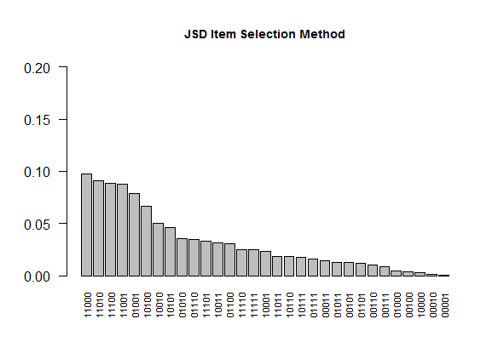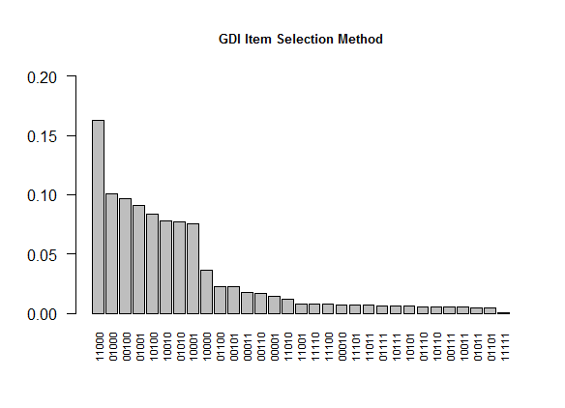

*Figure A.1.* Overall proportion of item usage of the latent class  for a 10-item CAT using high quality items. *Note*. JSD = Jensen-Shannon divergence; GDI= G-DINA model discrimination index.