Supplemental Material A: 5 Tables and 1 Figure

*Table S1. Study Characteristics*

|  |  |  |  |  |  |  |  |  |  |
| --- | --- | --- | --- | --- | --- | --- | --- | --- | --- |
|  | End of Day | | | | Momentary | | | | |
|  | NSDE | WFHS | ESCAPE | SAWM | SHADE | NTH | WDL | ESCAPE | SAWM |
| N |  |  |  |  |  |  |  |  |  |
| Participants | 845 | 313 | 240 | 170 | 117 | 300 | 115 | 241 | 172 |
| Possible Obs./Person | 8 | 8 | 14 | 10 | 7 | 2 | 3 | 14 | 10 |
| Average Obs./Person | 7.33 | 7.38 | 11.47 | 6.24 | 30.37 | 27.12 | 16.10 | 57.94 | 30.46 |
| Compliance rate | 91.7% | 92.3% | 81.9% | 89.2% | 86.8% | - | 89.5% | 82.8% | 87.0% |
| Grand mean |  |  |  |  |  |  |  |  |  |
| Negative Affect | 0.21 | 1.34 | 26.52 | 2.15 | 1.07 | 1.45 | 0.73 | 23.48 | 1.97 |
| Positive Affect | 2.74 | 2.87 | 60.83 | 4.40 | 2.80 | 4.60 | 4.35 | 60.42 | 4.33 |

*Note.* Summary of sample, design, and descriptive statistics across all studies. Obs.=Observations. The protocol in NTH involved different start times, wake and sleep times, and blood pressure functions, thus average compliance is not interpretable in the same way as the other studies.

*Table S2. Estimates for Between-Person (RBP) and Within-Person (RWP) Reliabilities for End of Day Assessments of Negative Affect.*

|  |  |  |  |  |  |  |  |  |  |  |
| --- | --- | --- | --- | --- | --- | --- | --- | --- | --- | --- |
|  | End of Day NA *RBP* Estimates | | | | | End of Day NA *RWP* Estimates | | | | |
|  | Study | | | | Median | Study | | | | Median |
| # Items | NSDE | WFHS | ESCAPE | SAWM | NSDE | WFHS | ESCAPE | SAWM |
| 2 | 0.85 | 0.85 | 0.98 | 0.97 | 0.91 | 0.32 | 0.35 | 0.69 | 0.74 | 0.52 |
| 3 | 0.88 | 0.89 | 0.99 | 0.97 | 0.93 | 0.41 | 0.45 | 0.77 | 0.81 | 0.61 |
| 4 | 0.90 | 0.91 | 0.99 | 0.98 | 0.94 | 0.48 | 0.52 | 0.82 | 0.85 | 0.67 |
| 5 | 0.92 | 0.92 | 0.99 | 0.98 | 0.95 | 0.54 | 0.58 | 0.85 | 0.88 | 0.71 |
| 6 | 0.93 | 0.93 | 0.99 | 0.98 | 0.96 | 0.58 | 0.62 | 0.87 | 0.89 | 0.74 |
| 7 | 0.94 | 0.94 | 0.99 | 0.99 | 0.96 | 0.62 | 0.66 | 0.89 | 0.91 | 0.77 |
| 8 | 0.94 | 0.95 | 0.99 | 0.99 | 0.97 | 0.65 | 0.68 | 0.90 | 0.92 | 0.79 |
| 9 | 0.95 | 0.95 | 0.99 | 0.99 | 0.97 | 0.68 | 0.71 | 0.91 | 0.93 | 0.81 |

*Note.* Estimates for reliability of between-person (*RBP*) and within-person (*RWP*) assessments of negative affect (NA) based on coordinated analyses of End of Day datasets. The *RWP* results are plotted in Figure 3.

*Table S3. Estimates for Between-Person (RBP) and Within-Person (RWP) for End of Day Assessments of Positive Affect.*

|  |  |  |  |  |  |  |  |  |  |  |
| --- | --- | --- | --- | --- | --- | --- | --- | --- | --- | --- |
|  | End of Day PA *RBP* Estimates | | | | | End of Day PA *RWP* Estimates | | | | |
|  | Study | | | | Median | Study | | | | Median |
| # Items | NSDE | WFHS | ESCAPE | SAWM | NSDE | WFHS | ESCAPE | SAWM |
| 2 | 0.96 | 0.94 | 0.99 | 0.97 | 0.96 | 0.49 | 0.45 | 0.81 | 0.69 | 0.59 |
| 3 | 0.97 | 0.95 | 0.99 | 0.98 | 0.97 | 0.59 | 0.55 | 0.86 | 0.77 | 0.68 |
| 4 | 0.98 | 0.96 | 0.99 | 0.98 | 0.98 | 0.66 | 0.62 | 0.89 | 0.82 | 0.74 |
| 5 | 0.98 | 0.97 | 1.00 | 0.98 | 0.98 | 0.71 | 0.67 | 0.91 | 0.85 | 0.78 |
| 6 | 0.99 | 0.97 | 1.00 | 0.99 | 0.99 | 0.74 | 0.71 | 0.93 | 0.87 | 0.81 |
| 7 | 0.99 | 0.98 | 1.00 | 0.99 | 0.99 | 0.77 | 0.74 | 0.94 | 0.89 | 0.83 |
| 8 | 0.99 | 0.98 | 1.00 | 0.99 | 0.99 | 0.79 | 0.77 | 0.94 | 0.90 | 0.85 |
| 9 | 0.99 | 0.98 | 1.00 | 0.99 | 0.99 | 0.81 | 0.79 | 0.95 | 0.91 | 0.86 |

*Note.* Estimates for reliability of between-person (*RBP*) and within-person (*RWP*) assessments of positive affect (PA) based on coordinated analyses of End of Day datasets. The *RWP* results are plotted in Figure 3.

*Table S4. Estimates for Between-Person (RBP) and Within-Person (RWP) Reliabilities for Momentary Assessments of Negative Affect.*

|  |  |  |  |  |  |  |  |  |  |  |
| --- | --- | --- | --- | --- | --- | --- | --- | --- | --- | --- |
|  | Momentary NA *RBP* Estimates | | | | | Momentary NA *RWP* Estimates | | | | |
|  | Study | | | | Median | Study | | | | Median |
| # Items | SHADE | NTH | ESCAPE | SAWM | SHADE | NTH | ESCAPE | SAWM |
| 2 | 0.99 | 0.98 | 1.00 | 0.99 | 0.99 | 0.69 | 0.54 | 0.65 | 0.73 | 0.67 |
| 3 | 0.99 | 0.99 | 1.00 | 0.99 | 0.99 | 0.77 | 0.64 | 0.74 | 0.80 | 0.75 |
| 4 | 0.99 | 0.99 | 1.00 | 0.99 | 0.99 | 0.82 | 0.70 | 0.79 | 0.84 | 0.80 |
| 5 | 0.99 | 0.99 | 1.00 | 1.00 | 0.99 | 0.85 | 0.74 | 0.82 | 0.87 | 0.84 |
| 6 | 0.99 | 0.99 | 1.00 | 1.00 | 1.00 | 0.87 | 0.78 | 0.85 | 0.89 | 0.86 |
| 7 | 1.00 | 0.99 | 1.00 | 1.00 | 1.00 | 0.89 | 0.80 | 0.87 | 0.90 | 0.88 |
| 8 | 1.00 | 0.99 | 1.00 | 1.00 | 1.00 | 0.90 | 0.82 | 0.88 | 0.91 | 0.89 |
| 9 | 1.00 | 0.99 | 1.00 | 1.00 | 1.00 | 0.91 | 0.84 | 0.89 | 0.92 | 0.90 |

*Note.* Estimates for reliability of between-person (*RBP*) and within-person (*RWP*) assessments of negative affect (NA) based on coordinated analyses of momentary datasets. The *RWP* results are plotted in Figure 3.

*Table S5. Estimates for Between-Person (RBP) and Within-Person (RWP) for Momentary Assessments of Positive Affect.*

|  |  |  |  |  |  |  |  |  |  |  |
| --- | --- | --- | --- | --- | --- | --- | --- | --- | --- | --- |
|  | Momentary PA *RBP* Estimates | | | | | Momentary PA *RWP* Estimates | | | | |
|  | Study | | | | Median | Study | | | | Median |
| # Items | SHADE | NTH | ESCAPE | SAWM | SHADE | NTH | ESCAPE | SAWM |
| 2 | 1.00 | 0.99 | 1.00 | 0.99 | 0.99 | 0.83 | 0.54 | 0.80 | 0.69 | 0.74 |
| 3 | 1.00 | 0.99 | 1.00 | 0.99 | 0.99 | 0.88 | 0.64 | 0.86 | 0.77 | 0.81 |
| 4 | 1.00 | 0.99 | 1.00 | 0.99 | 1.00 | 0.91 | 0.70 | 0.89 | 0.82 | 0.85 |
| 5 | 1.00 | 0.99 | 1.00 | 1.00 | 1.00 | 0.93 | 0.75 | 0.91 | 0.85 | 0.88 |
| 6 | 1.00 | 1.00 | 1.00 | 1.00 | 1.00 | 0.94 | 0.78 | 0.92 | 0.87 | 0.90 |
| 7 | 1.00 | 1.00 | 1.00 | 1.00 | 1.00 | 0.95 | 0.80 | 0.93 | 0.89 | 0.91 |
| 8 | 1.00 | 1.00 | 1.00 | 1.00 | 1.00 | 0.95 | 0.82 | 0.94 | 0.90 | 0.92 |
| 9 | 1.00 | 1.00 | 1.00 | 1.00 | 1.00 | 0.96 | 0.84 | 0.95 | 0.91 | 0.93 |

*Note.* Estimates for reliability of between-person (*RBP*) and within-person (*RWP*) assessments of positive affect (PA) based on coordinated analyses of momentary datasets. The *RWP* results are plotted in Figure 3.

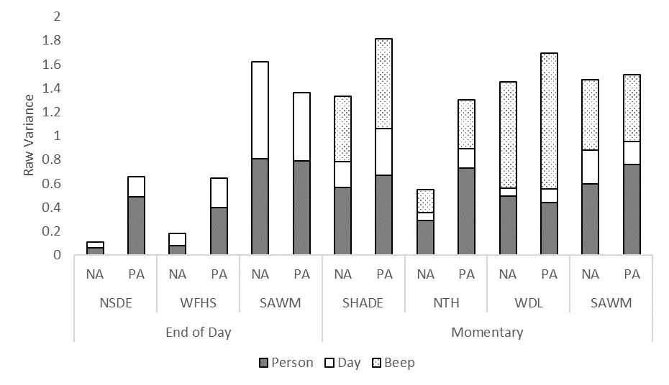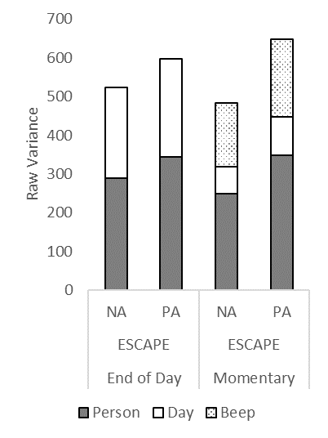

*Figure S1.* Raw Between- (Shaded) and Within- (Unshaded) Person Variance in Negative Affect (NA) and Positive Affect (PA) in End of Day (EOD) and Momentary (Ecological Momentary Assessment [EMA]) Reports. For each dataset, raw between-person variance is displayed in grey shaded portions of the bars and raw within-person variance is displayed in the unshaded portions. In momentary datasets, within-person variance can be decomposed into two sources, variation within-persons across days (the lower portion of the unshaded area) and variation within-persons within days (the upper portion of the unshaded area). ESCAPE and SAWM are hybrid designs containing both EOD and momentary reports, thus the EOD data from SAWM is presented with the diary studies and SAWM momentary data is presented with the EMA studies. ESCAPE EOD and momentary results are displayed in a separate panel because of differences in scale from the other datasets.