Online supplementary materials for:

Koch, A., Kervyn, N., Kervyn, M., & Imhoff, R. (2017). Studying the cognitive map of the U.S. states: Ideology and prosperity stereotypes predict interstate prejudice

Part 1
In Study 1, participants’ verbatim instructions were: “Dear participant, we are thankful that you participate in this study. We will show you a series of cards, each representing one state. What we need you to do is to classify these states based on your impression about them. States about which you have similar impressions will be classified together, whereas states about which you have different impressions will be placed on different piles. You can create as many piles as you want, but to keep it reasonable, we ask you to create at least 3 and at most 10 piles. Usually, most respondents create 4 to 7 piles. Take as much time as you want to do this task. At any time, you can also remove a state from a pile in which you had placed it and put it in another pile if you think that it is more similar to the states in that new pile. Please note that it is very important to understand that there is no right or wrong answer. We are interested in the way you think these states go together.”

Part 2

Note. Study 1: One of many possible setups for sorting the U.S. states into piles.

Note. Study 1: One of many possible solutions for sorting the U.S. states into piles.

Part 3
In Study 2, participants’ verbatim instructions were: "Dear participant, Your task is to position the 48 mainland states on the screen according to how similar or different you perceive them to be. The states will appear in the middle of the screen all at once [en bloc in six columns and eight rows], and you can drag and drop each of them at any time to move them to a different position. Please make use of the entire screen and position the states as follows: states that you think are more similar should be placed closer together, while states that you think are more different should be placed further apart. You must reposition each state at least once to complete this task.”

Part 4
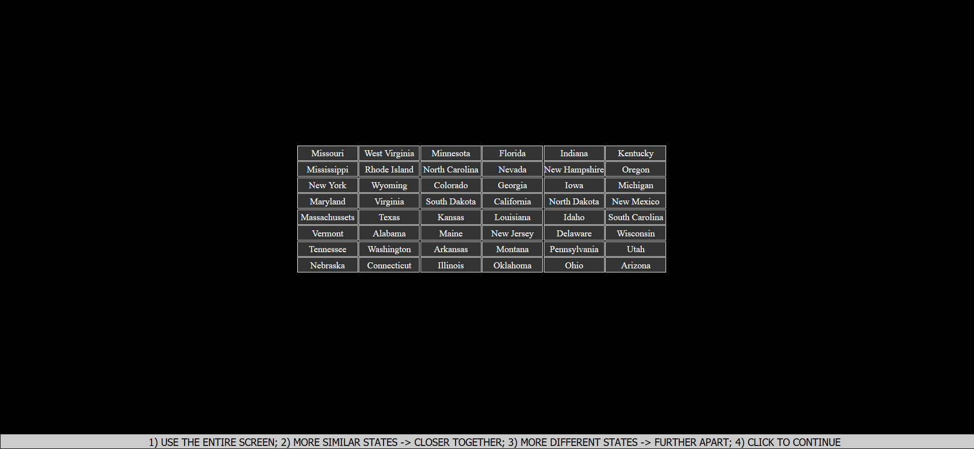
Note. Study 2: One of many possible setups for spatially arranging the U.S. states.
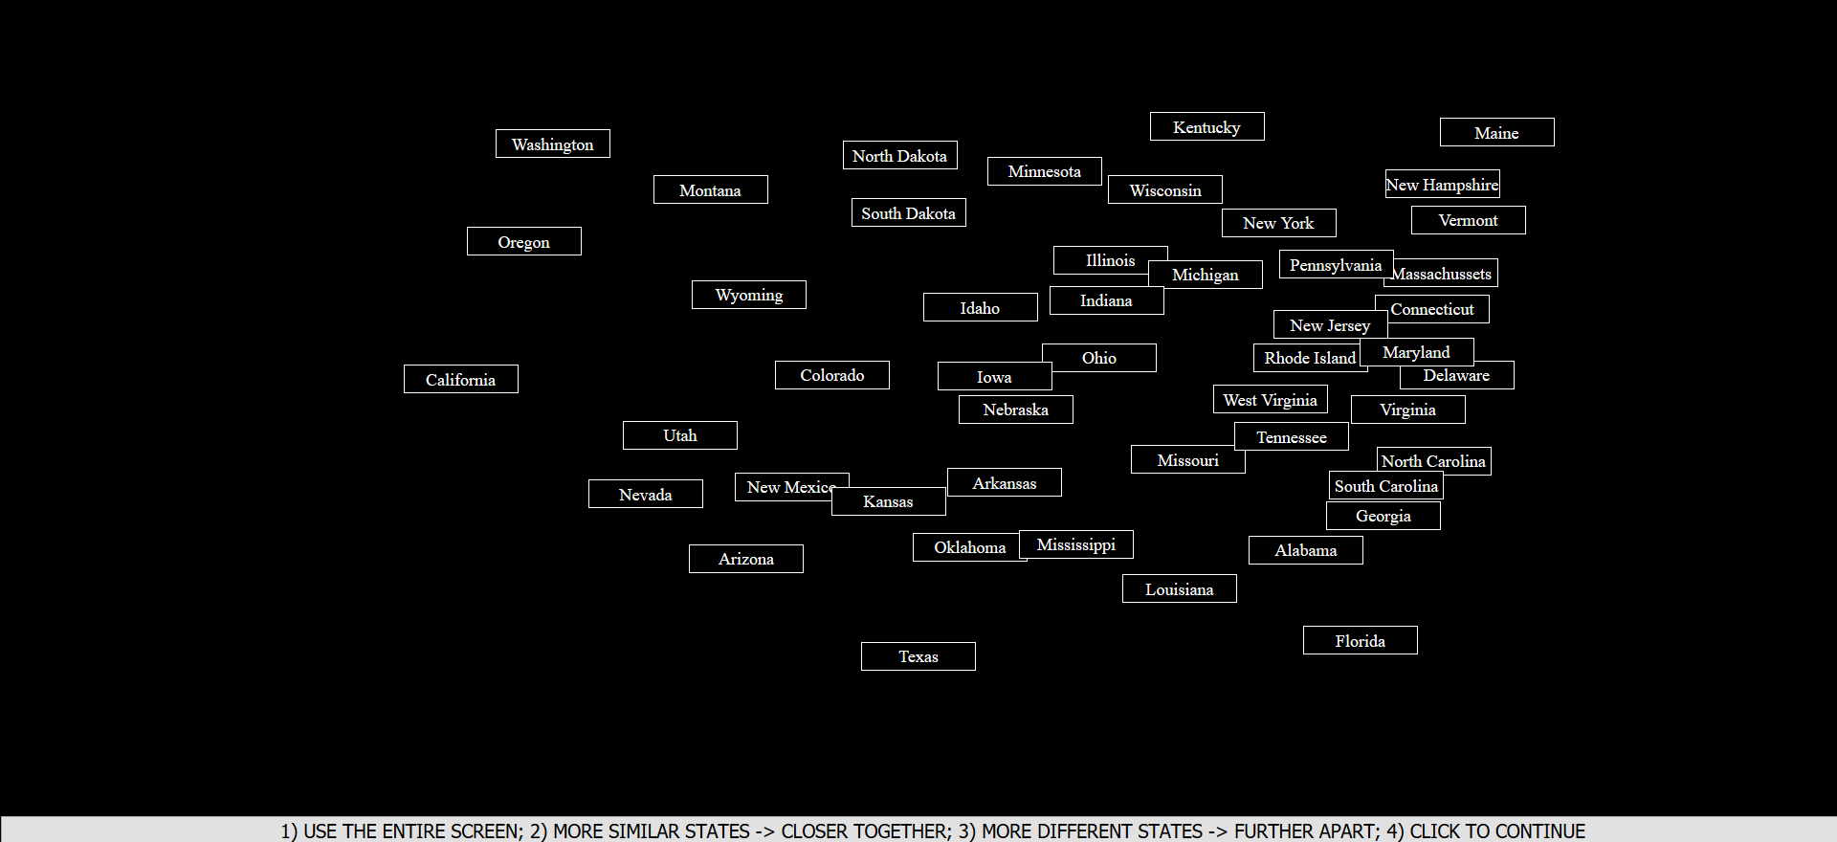
Note. Study 2: One of many possible solutions for spatially arranging the U.S. states. This solution is close to the states’ location on the U.S. geographic map.

Part 5
Multidimensional scaling (MDS; for an introduction, see Hout, Goldinger, & Papesh, 2012) analyses use similarity data as input and output coordinates for each stimulus of interest in a k-dimensional cognitive map. The output coordinates are estimated such that their proximities retain as much input similarity variance as possible. The more proximal the output coordinates of two stimuli, the higher their input similarity. In other words, MDS visualizes stimulus similarity in the form of stimulus proximity in a k-dimensional cognitive map. K is set by the researcher(s) striking a balance between explanatory depth and parsimony. If participants would rate the similarity of the U.S. states with respect to their longitude and latitude and k would be set to 2, MDS would visualize the states by x- and y-coordinates in a 2D cognitive map. The proximities between these output coordinates would retain the entire input similarity variance, and rotations of the output coordinates would correlate perfectly with the states’ longitude and latitude (i.e., a rotation of the 2D U.S. cognitive map would be identical to the U.S. geographic map). These perfect correlations would thus reveal that the states’ similarity was spontaneously rated with respect to their longitude and latitude.
However, if the states’ similarity was also rated with respect to their population, unless k would be set to >= 3 the proximities between the output coordinates would not retain the entire input similarity variance. Generally speaking, the higher k (i.e., the dimensionality of the cognitive map), the more input similarity variance is retained by the proximities between the output coordinates. However, the higher k, the more complex the resulting model of the dimensions that underlie the similarity data. Since researcher(s) aim for models as complex as necessary but also as simple as possible, they strike a balance between increasing retained input similarity variance and decreasing k. In this way, MDS is used to “systematize data in areas of research [here: spontaneous stereotypes about the U.S. states] where … underlying dimensions are not well-developed” (Schiffman, Reynolds, & Young, 1981).

Part 6
Note. U.S. geographical map.

Note. U.S. cognitive map computed based on pile sorting similarity ratings (Study 1).
Part 7
Note. U.S. geographical map.
Note. U.S. cognitive map computed based on spatial arrangement similarity ratings (Study 2).

Part 8
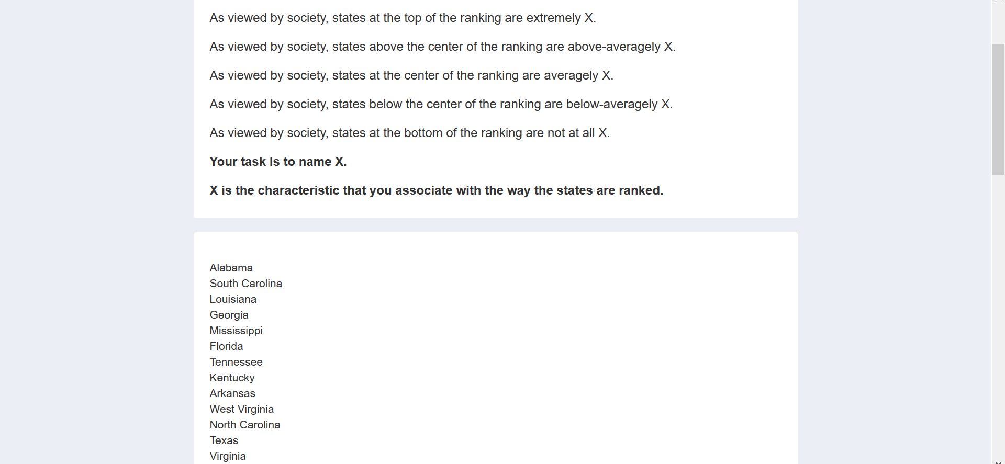
…
Note. Studies 1 and 2: Generating candidate dimensions.

Part 9
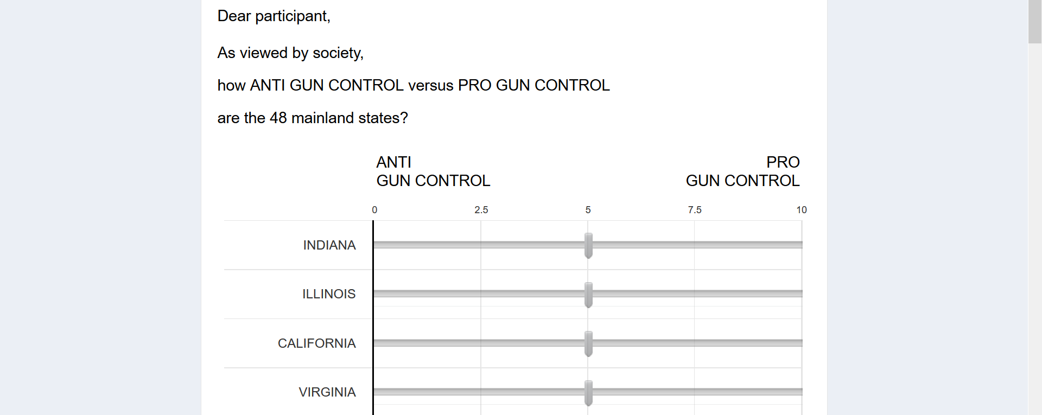
…
Note. Studies 1 and 2: Rating the states the candidate dimensions.

Part 10
Candidate dimension | Study 1  R² | Study 2  R² | Mean  R²
Western-Eastern | .81 | .96 | .89
Religious-Atheist | .78 | .91 | .85
Historic-New | .85 | .83 | .84
Conservative-Liberal | .76 | .91 | .84
North Western-South Eastern | .81 | .79 | .80
Uneducated-Educated | .67 | .85 | .76
Anti-Pro gun control | .63 | .81 | .71
Dry-Humid | .70 | .67 | .69
Southern-Northern | .60 | .73 | .67
North Eastern-South Western | .56 | .83 | .65
Poor-Wealthy | .60 | .69 | .65
Republican-Democrat | .53 | .71 | .62
Sparsely-Densely populated | .55 | .53 | .54
No-A lot of farming | .55 | .37 | .46
Desert-Jungle | .36 | .48 | .42
Flat-Mountainous | .30 | .30 | .30
Not-Mormon | .23 | .22 | .23
Cold-Hot | .13 | .27 | .20
Unpopulated-Populated | .16 | .11 | .14

Note. R² indicates the amount of state mean rating variance on the candidate dimensions
explained by the states’ coordinates in the pile sorting-based and spatial arrangement-based
2D cognitive maps. The higher R², the better the respective candidate dimension describes the
dimensions that participants spontaneously used to sort the states into piles (Study 1) or sort
more similar states closer together (Study 2).

Part 11

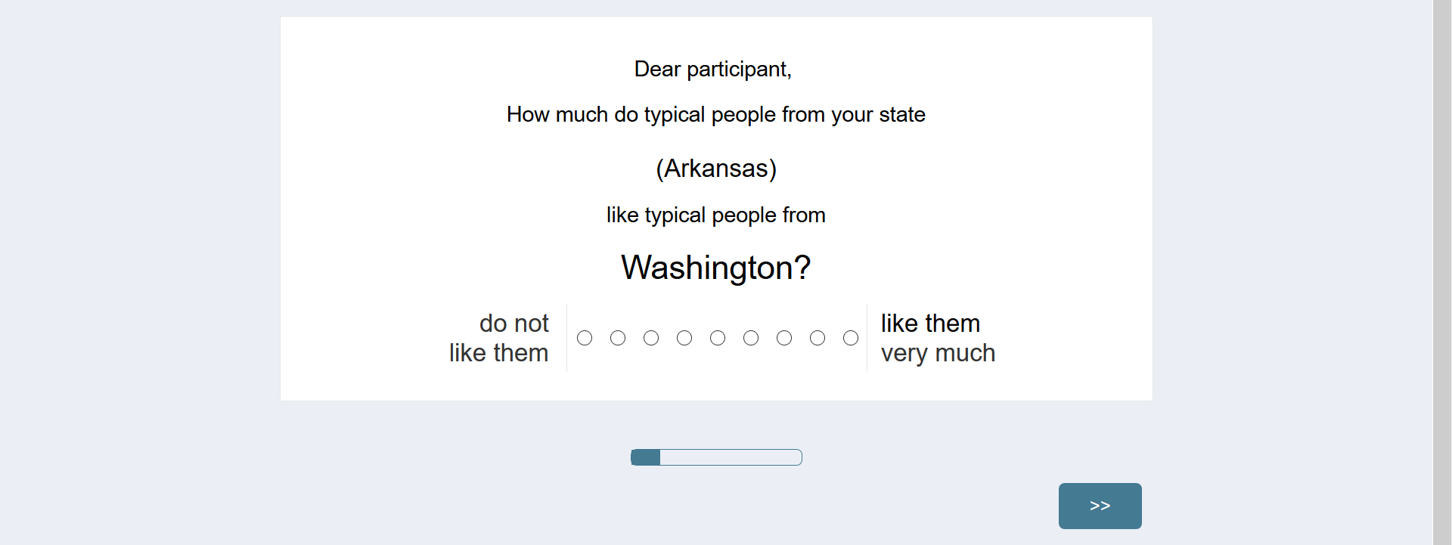

Note. Study 3: Measuring interstate liking.

Part 12
Note. Study 3: Curvilinear relation between the 48 U.S. mainland states’ likability averaged
across raters from all states (y-axis) and the states’ mean in stereotypic ideology and
prosperity (mean of the states’ rating on ideology stereotypes ‘Religious-Atheist’,
‘Conservative-Liberal’, ‘Republican-Democrat’, and ‘Anti …-pro gun control’, and the
prosperity stereotypes ‘Uneducated-Educated’ and ‘Poor-Wealthy’; x-axis).

