Supplemental Materials

Poisoned Praise:
Discounted Praise Backfires and Creates Negative Subordinate Impressions in the Minds of the Powerful

Jonathan W. Kunstman
Christina B. Fitzpatrick
Pamela K. Smith

Supplemental Measures and Results

I. In addition to the manuscript’s primary discounting and secondary person perception hypotheses, Experiments 1 and 2 also included exploratory measures of emotions, perceptions of feedback, and self-esteem that yielded inconsistent (e.g., emotions, self-esteem) or marginal effects (e.g., perceptions of feedback). To aid readers in comparing effects between experiments, these supplemental results are organized by DV: Emotions, perceptions of feedback, and self-esteem. Omnibus analyses are presented below each heading. Interested parties may also find complete data files and syntax at (OSF: https://osf.io/ukw2h/) or by contacting the lead author (jonathan.kunstman@miamioh.edu).

II. Below these summarized results, we present an alternate approach to analyzing the attribution data presented in Experiments 1 and 2 in which external and internal attributions are entered as independent factors in a mixed-model ANOVA (as opposed to computing the discounting difference score common to attributional ambiguity research; e.g., Major et al., 2002; 2003).

III. Finally, we include a list of survey items discussed in the manuscript and these supplemental analyses.

I. Analyses of Emotions, Perceptions of Feedback,
Emotions

Emotions were assessed with 18 items on 7-point scales (1=Does not apply at all, 7=Applies very much). Items were combined to form four different indices: two positive socially engaging emotions (sociable, respectful; Study 1: α=.73, Study 2: α=.71), three negative socially engaging emotions (ashamed, embarrassed, indebted; Study 1: α=.56; Study 2: α=.77), two positive socially disengaging emotions (proud, superior; Study 1: α=.57; Study 2: α=.58), and three negative socially disengaging emotions (irritated, frustrated, angry; Study 1: α=.88; Study 2: α=.89).

Study 1

We conducted a mixed-model ANOVA on participants’ ratings of emotions, with condition (high-/low-/equal-power) as a between-subjects factor and emotion valence (positive/negative) and sociality (socially engaging/socially disengaging) as within-subjects factors.

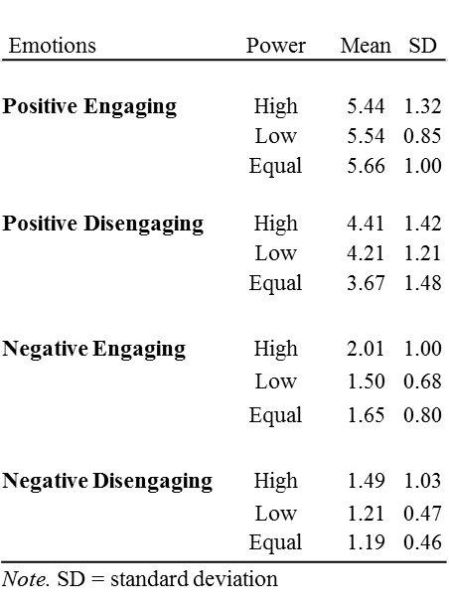
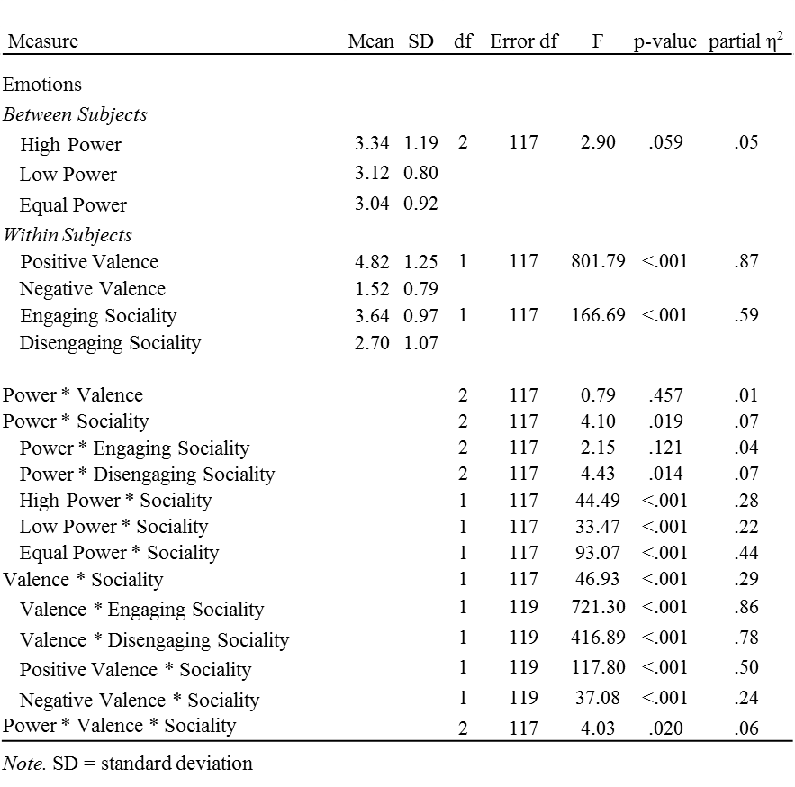
Study 2

We conducted a mixed-model ANOVA on participants’ ratings of emotions, with feedback type (positive, neutral) and power (high-/low-power) as between-subjects factors and emotion valence (positive/negative) and sociality (socially engaging/socially disengaging) as within-subjects factors.

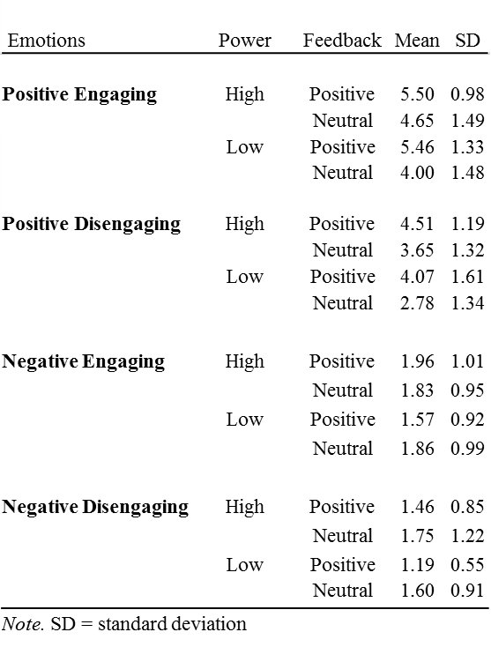

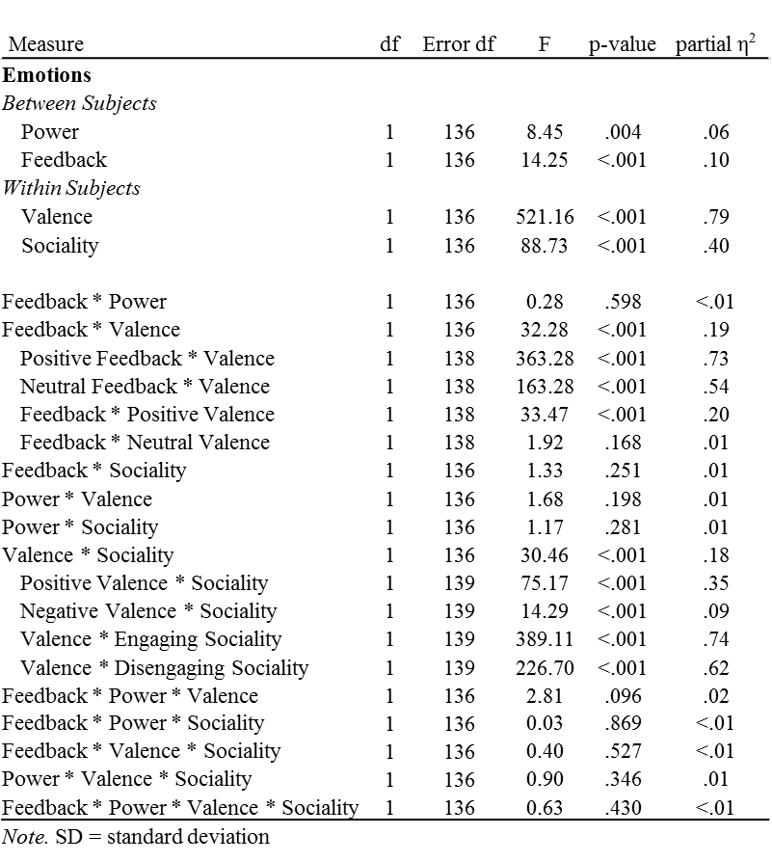

Perceptions of Partner Feedback

Participants reported whether they viewed their partner’s feedback as accurate, genuine, and valuable using 7-point scales (1=Not at All, 7=Very Much).

Study 1

To assess participants’ perceptions that their partners’ feedback was accurate, genuine, and valued, we conducted a multivariate analysis of variance (ANOVA) in which experimental condition was entered as a between-subjects factor.

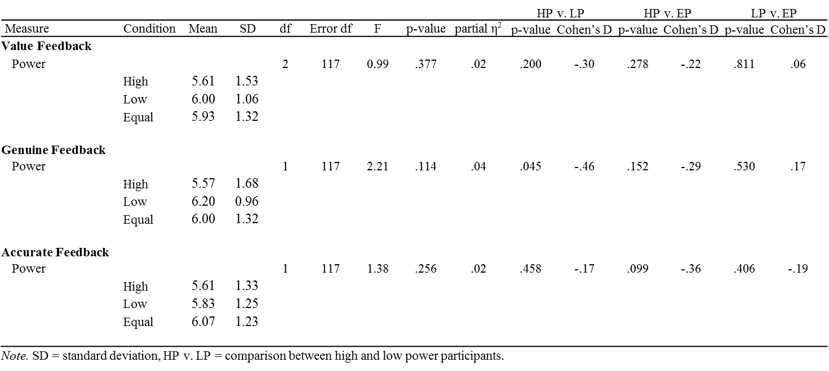

Study 2

To assess participants’ perceptions that their partners’ feedback was accurate, genuine, and valued, we conducted a multivariate analysis of variance (MANOVA) in which feedback and power conditions were entered as a between-subjects factors.

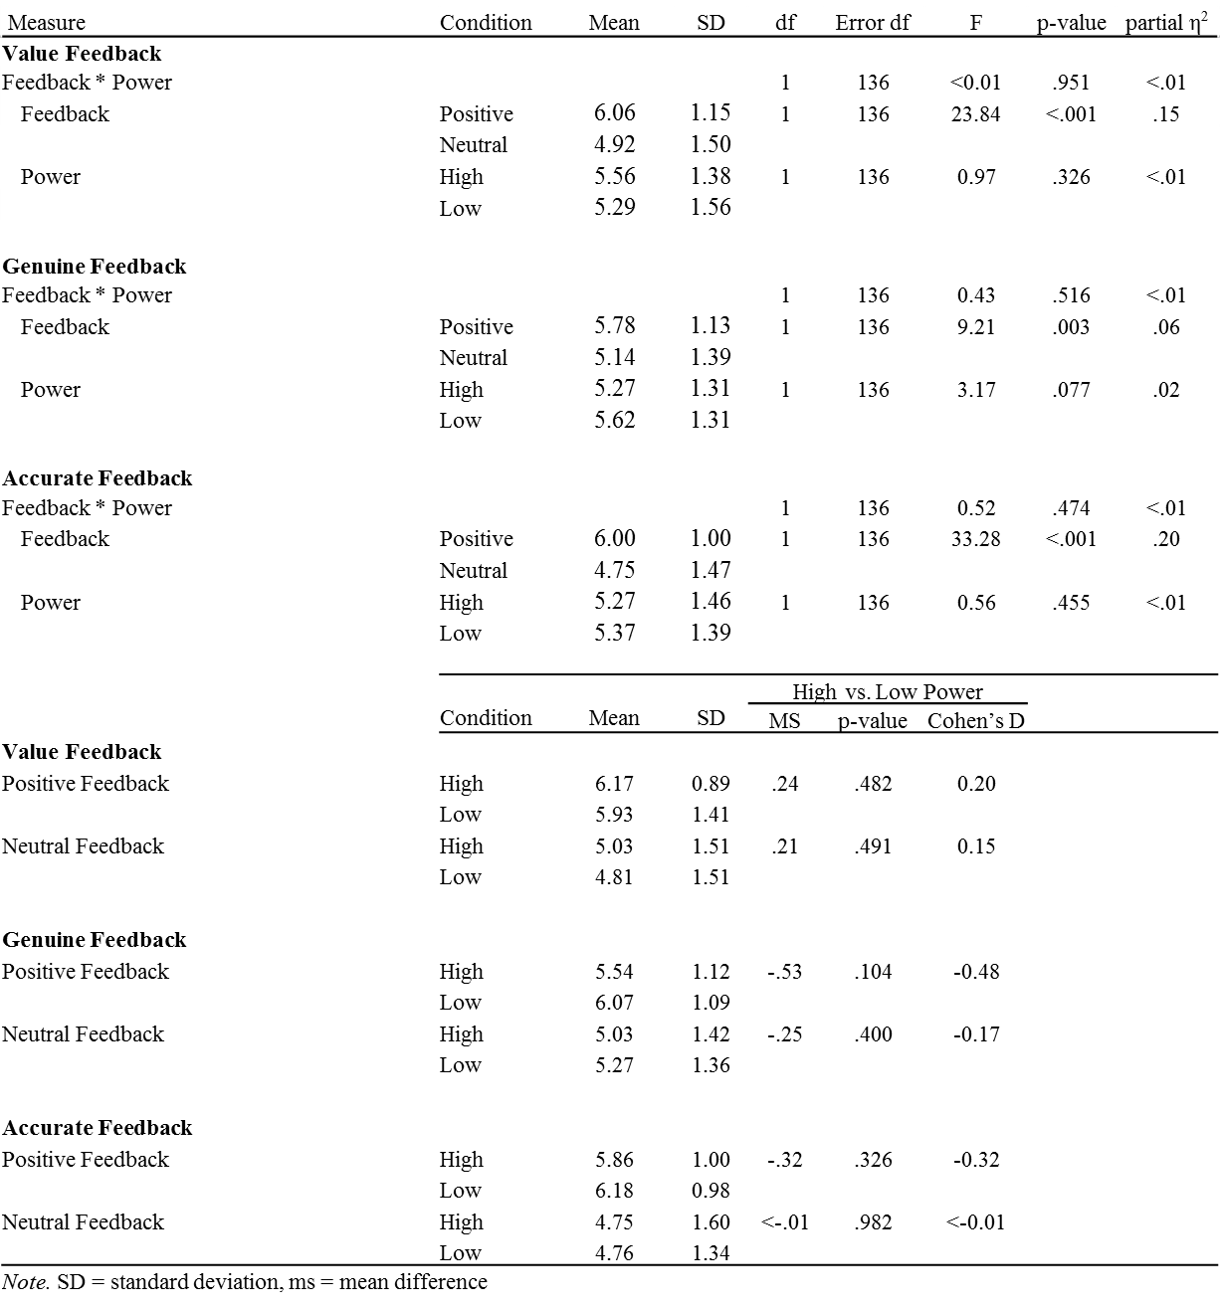

Self-Esteem

The 10-item Rosenberg Self-Esteem scale (Rosenberg, 1965; α=.89) was used to measure baseline self-esteem. Participants indicated their level of agreement on 4-point scales (1=Strongly Disagree, 4=Strongly Agree; e.g., “On the whole, I am satisfied with myself”). Post-feedback self-esteem was measured with Heatherton and Polivy’s (1991) index of state social self-esteem (e.g., “I am worried about what other people think of me”; α=.89) using 5-point scales (1=Not at All, 5=Extremely). Items were recoded such that higher scores reflected greater self-esteem.

Study 1

To test power’s effect on self-esteem, we conducted a simultaneous multiple regression analysis (following Aiken & West, 1991) with condition (dummy-coded to treat the high-power condition as the reference group) as a predictor of social self-esteem. Baseline self-esteem (mean-centered) was entered as a covariate.

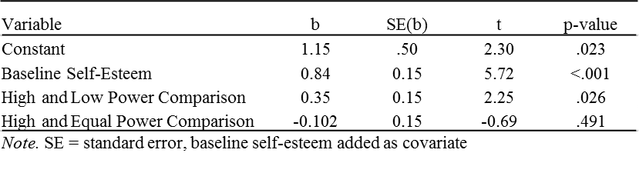

Study 2
To test the effect of power and feedback on self-esteem, we tested for an interaction between power and feedback as a predictor of social self-esteem. Baseline self-esteem (mean-centered) was entered as a covariate.

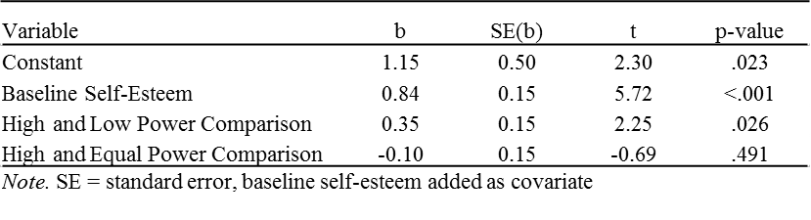

Mediation Analyses

To test whether discounting mediated positive feedback’s effect on feedback’s perceived genuineness and negative socially engaging and disengaging emotions we followed recommendations outlined by Hayes (2013).We establish that the discounting variable significantly predicted the outcome variable, while simultaneously reducing the magnitude of condition’s effect on the dependent variable. Second, we formally tested condition’s indirect effect with PROCESS (Hayes, 2012), a procedure that computes an asymmetric confidence interval around the point estimate of the indirect effect. Unstandardized regression coefficients for discounting, its resultant effect on outcome variables, changes in the effect of condition dummy codes, and associated confidence intervals (CI) can be found below. The above procedures provided evidence that discounted praise mediated power’s effect on feedback’s perceived genuineness (Figure 1) and negative socially engaging emotions (Figure 2).

Study 1
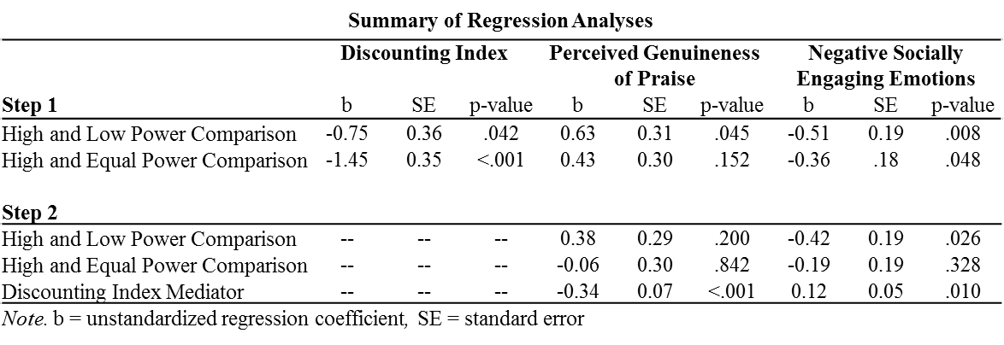

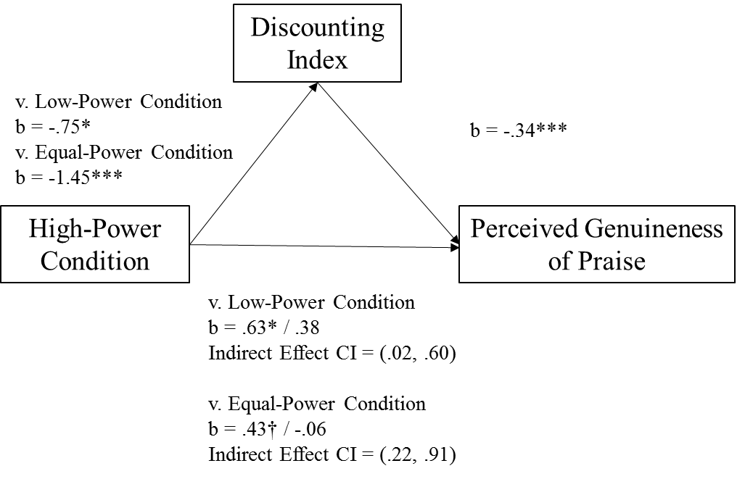

Figure 1. The discounting index mediated power’s negative effect on the perceived genuineness of praise. The more high-power participants discounted feedback, the less they believed praise was genuine. b=unstandardized regression coefficients, †=.152, *= p≤.05, **=p≤.010, ***=p≤.001

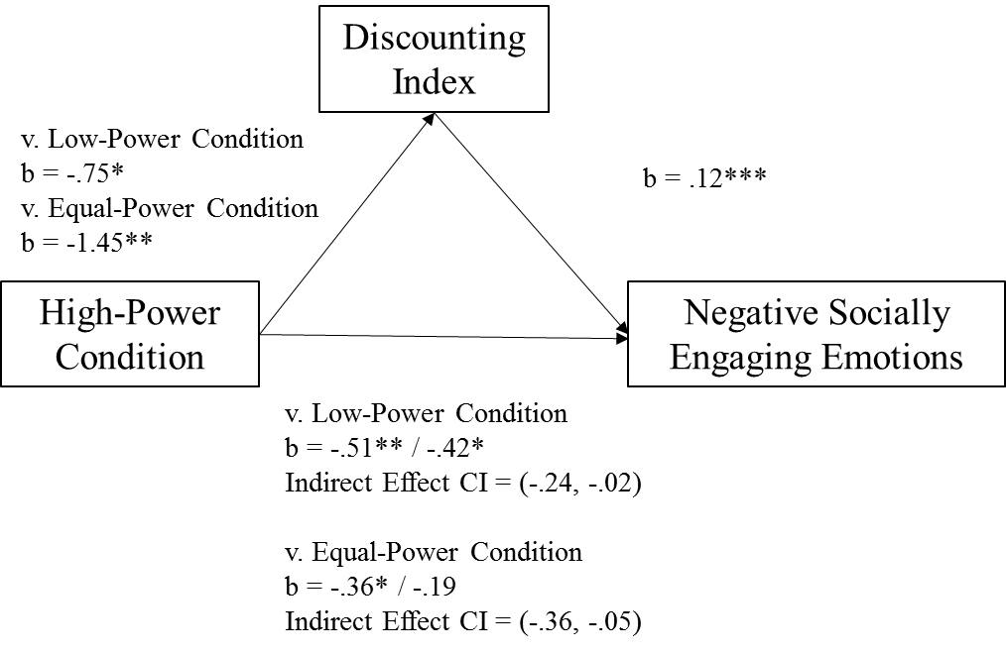

Figure 2. The discounting index mediated power’s effect on negative socially engaging emotions. The more high-power participants discounted feedback, the more negative socially engaging emotions they experienced. b=unstandardized regression coefficients, *= p≤.05, **=p≤.010, ***=p≤.001.

II. Attribution Analyses including External and Internal Attributions as Independent Factors
Study 1.
We also considered external and internal attributions simultaneously in a single analysis by conducting a mixed-model ANOVA with condition (high-/low-/equal-power) as a between-subjects factor and attribution type (external/internal) as a within-subjects factor. This analysis yielded main effects of condition F(2,117)=4.56, p=.013, =.072, and attribution type, F(1,117)=48.72, p<.001, =.29, qualified by a significant interaction F(2,117)=8.61, p<.001, =0.13. LSD comparisons indicated high-power participants made significantly stronger external attributions (M=4.47, SD=1.20) than equal-power participants (M=3.32, SD=1.18; p = .003) and trended toward making stronger external attributions for positive feedback than low-power participants (M=4.13, SD=0.96; p=.18). Low-power participants also made significantly stronger external attributions than equal-power participants (p=.010).

Study 2

Attributions could also be analyzed with a mixed-model ANOVA in which condition (high-power/low-power) and feedback type (positive/neutral) are entered as between-subjects factors and attribution type (external/internal) is entered as a within-subjects factor. This analysis yielded significant main effects of attribution, F(1, 136)=37.21, p<.001, =.22, and feedback condition F(1,136)=24.51, p<.001, =.15, a feedback by attribute interaction, F(1,136)=5.88, p=.017, =.041, and a power condition by attribute interaction, F(1,136)=7.53, p=.007, =.052. Most relevant to the current power results, follow-up contrasts revealed that high-power participants (M=4.23, SD=1.11) made marginally more external attributions than low-power participants (M=3.91, SD=1.28; p=.119), whereas high-power participants (M=4.64, SD=1.21) made significantly less internal attributions than low-power participants (M=4.99, SD=1.04; p=.033).

III. Survey Materials for Experiments 1 and 2

Attribution items (Internal – 1-3, External = 4-8)
We are interested in your current perception of your partner and what you believe motivated your partner’s feedback. Please respond to the following items with the scale below.

1 2 3 4 5 6 7
Not at All Very Much

To what extent do you believe the following factors influenced your partner’s feedback?

- My creative ability.
- My personality.
- My ideas and writing style.
- Her/his rank in the experiment.
- S/he wants the bonus rewards split fairly.
- S/he wants to get on my good side.
- S/he is afraid to miss out on the experiment’s bonuses.
- S/he wants me to like her(him).

Partner Perception Items (Positive Traits = 1-4, 6, 7, 9, 12; Negative Traits = 5, 8, 10, 11, 13-17).

People are surprising good at making first impressions of others. Based on what you know of your partner so far, what do you think s/he is like? Use the scale below to describe your partner’s traits.

1 2 3 4 5 6 7
Not at All Very Much

- Smart
- Competent
- Sociable
- Genuine
- Fake
- Caring
- Trustworthy
- Jealous
- Honest
- Dishonest
- Cold
- Warm
- Careless
- Superficial
- Manipulative
- Incompetent
- Status-seeking

Emotion Items

We are interested in how you felt when you got feedback from your partner. Please read each of the feeling words below and circle the number on the scale that indicates the extent to which each word applies to how you are feeling right now. Don't spend much time thinking about each word, just give a quick, gut-level response.

does not applies
apply at all very much

- Proud 1 2 3 4 5 6 7
- Superior 1 2 3 4 5 6 7
- Respected 1 2 3 4 5 6 7
- Embarrassed 1 2 3 4 5 6 7
- Ashamed 1 2 3 4 5 6 7
- Guilty 1 2 3 4 5 6 7
- Disgusted 1 2 3 4 5 6 7
- Angry 1 2 3 4 5 6 7
- Frustrated 1 2 3 4 5 6 7
- Sad 1 2 3 4 5 6 7
- Sociable 1 2 3 4 5 6 7
- Compassionate 1 2 3 4 5 6 7
- Empathic 1 2 3 4 5 6 7
- Indebted 1 2 3 4 5 6 7
- Independent 1 2 3 4 5 6 7
- Grateful 1 2 3 4 5 6 7
- Thankful 1 2 3 4 5 6 7
- Irritated 1 2 3 4 5 6 7

Perceptions of Feedback
We are interested in your current perception of your partner and what you believe motivated your partner’s feedback. Please respond to the following items with the scale below.

1 2 3 4 5 6 7
Not at All Very Much

- I believe my partner’s feedback was genuine.
- I believe my partner’s feedback was accurate.
- I valued my partner’s feedback.

Rosenberg Self Esteem Scale (1965): Baseline

Below is a list of statements dealing with your general feelings about yourself. Please indicate how strongly you agree or disagree using the scale below.

1 2 3 4
Strongly Disagree Disagree Agree Strongly Agree

- On the whole, I am satisfied with myself.
- At times I think I am no good at all.
- I feel that I have a number of good qualities.
- I am able to do things as well as most other people.
- I feel I do not have much to be proud of.
- I certainly feel useless at times.
- I feel that I’m a person of worth, at least on an equal plane with others.
- I wish I could have more respect for myself.
- All in all, I am inclined to feel that I am a failure.
- I take a positive attitude toward myself.

Heatherton and Polivy’s (1991) social self-esteem scale: Post-feedback Self-esteem

Please respond to the following items with the scale below.

1 2 3 4 5
Not at all a little bit Somewhat Very Much Extremely

- I am worried about whether I am regarded as a success or failure.
- I feel self-conscious.
- I feel displeased with myself.
- I am worried about what other people think of me.
- I feel inferior to others at this moment.
- I feel concerned about the impression I am making.
- I am worried about looking foolish.

