Gender Identity Question.
During a large prescreen prior to this study, participants reported gender identity as either “female,” “male,” “trans woman,” “trans man,” “gender queer,” or “other.” Participants who identified as “female” or “male” qualified. This question was employed in all studies.

Study 1 Exclusions.
This high exclusion rate was similar to other studies being conducted in the university’s online research pool at that time. Rates did not differ across participant gender, X²(1)=0.38, p=.54, race, X²(5)=5.60, p=.35, or condition, X²(1)= 3.11, p=.09. Retaining these participants does not significantly change findings (Table S2).

Control Company Critical Room:

Gender-Inclusive Critical Room:
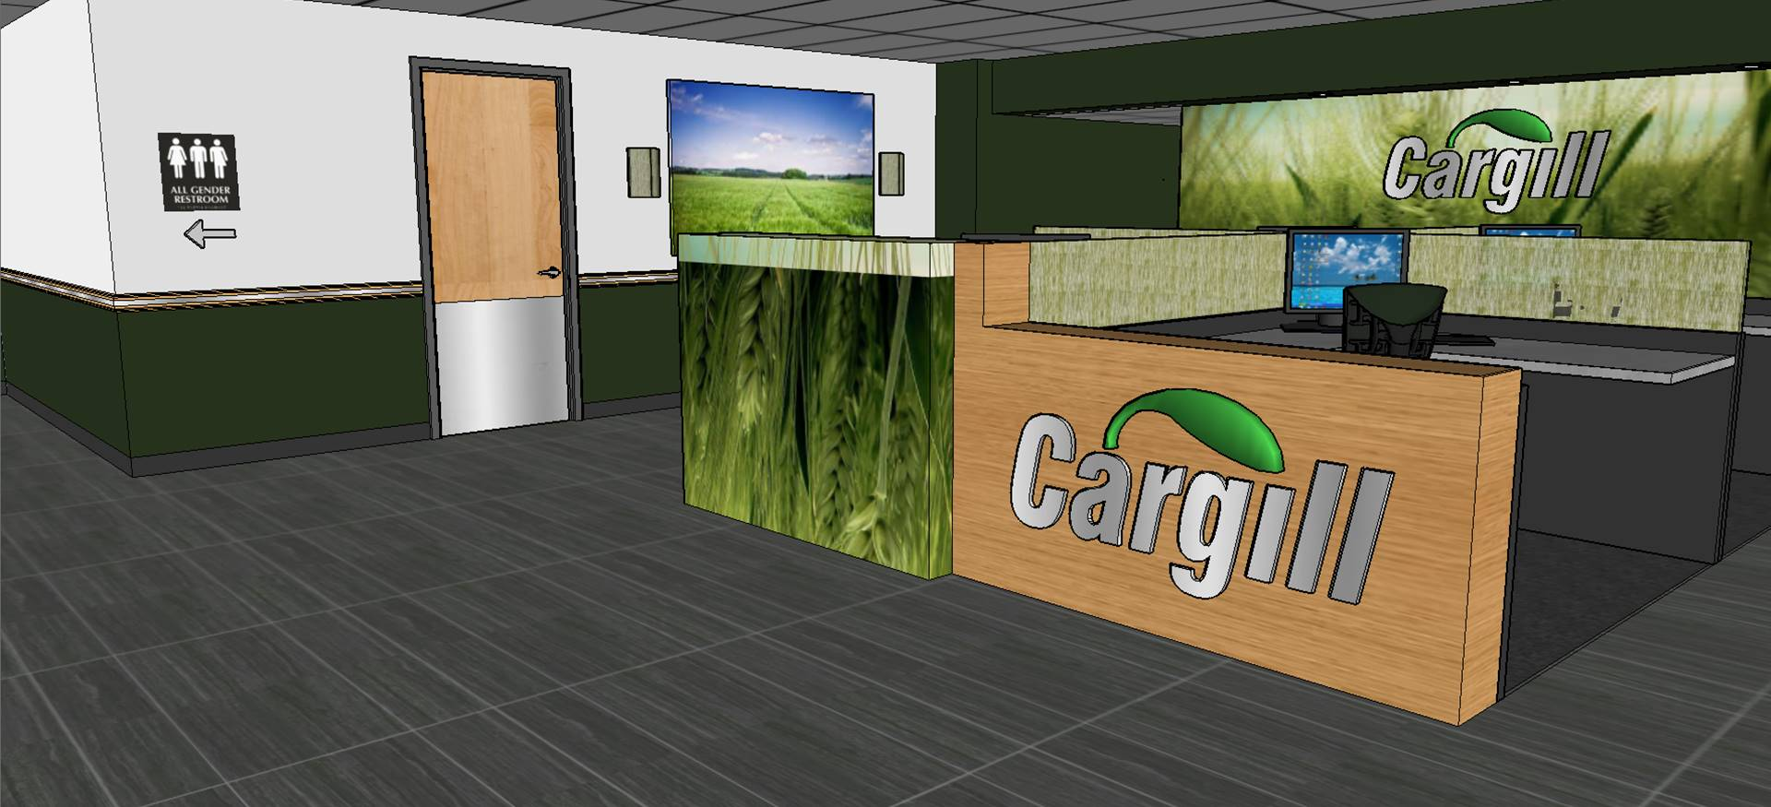
Company Information:
Neutral Room 1:
Neutral Room 2:
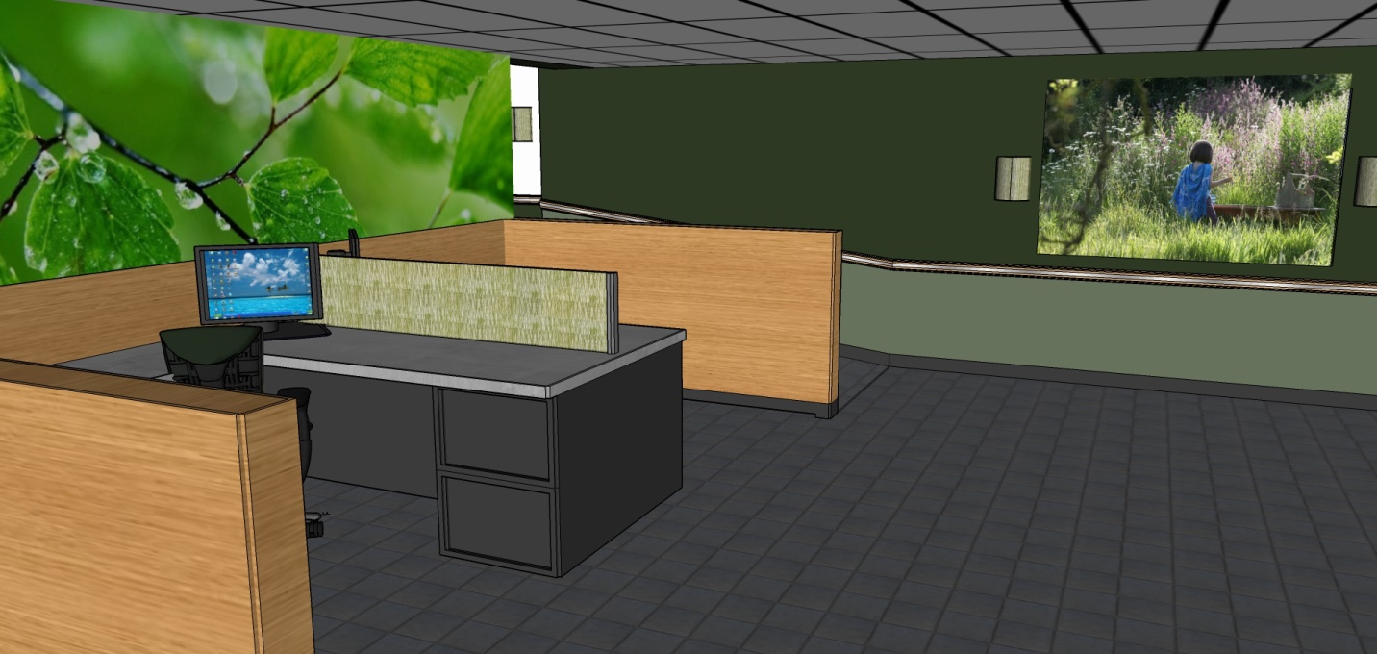

Study 1 Transgender Prejudice
A 2(Condition: gender-inclusive bathroom, control) x 2(Participant gender: male, female) ANOVA on participants’ transgender prejudice revealed a significant main effect of participant gender, F(1,166)=19.59, p<.001, d=0.70, 95% CI=[0.39, 1.01], and an unexpected significant main effect of condition, F(1,166)=4.20, p=.04, d=0.35, 95% CI=[0.01, 0.63].The interaction was not significant, F(1,166)=0.21, p=.58, d=0.09. Men were more prejudiced towards transgender individuals (M=2.50, SE=0.11) than women (M=1.80, SE=0.12), and participants in the control condition (M=2.31, SE=0.12) were more prejudiced towards transgender individuals than participants in the gender-inclusive condition (M=1.99, SE=0.11).

Study 2 Transgender Prejudice
Analyses on participants’ transgender prejudice (M=2.17, SE=0.09) revealed no main effect of participant race, F(1,127)=2.09, p=.15, d=0.26, 95% CI=[-0.13, 0.84], no effect of condition, F(1,127)= 0.95, p=.33, d=0.17, 95% CI=[-0.29, 0.83], nor an interaction, F(1,127)=0.26, p=.61, d= 0.09

Study 3 Transgender Prejudice
A 2x2 ANOVA on participants' transgender prejudice (M=2.40, SE=0.10) revealed no effect of condition, F(1,123)=0.62, p=.43, d=0.14, 95% CI=[-0.43, 0.75], participant race, F(1,123)=0.40, =.53, d=0.11, 95% CI=[-0.69, 0.43], nor a significant interaction, F(1,123)< .001, p=.99, d <0.01

Study 1 -3 Failure of Manipulation Check Question on 1st attempt
In Study 1, 61 participants in the gender-inclusive condition failed the manipulation check on the 1st time, compared to only 12 participants in the control condition, X²(1) = 47.11, p < .001. Excluding these participants depletes significantly and makes analyses too under powered (gender-inclusive condition: women, n = 18, men, n= 13) to draw conclusions from. However, chi-square tests revealed no participant gender effects in the gender-inclusive condition, X²(1) = 1.96, p = .16, nor in the control condition, X²(1) = 0.97, p = .33, indicating men and women were equally likely to fail the manipulation check the 1st time through.
In Study 2, 42 participants in the gender-inclusive condition failed the manipulation check on the 1st time, compared to only 10 participants on the control condition, X²(1) = 29.40, p < .001. Excluding these participants depletes the sample a great deal and makes analyses too under powered (gender-inclusive condition, White, n = 12, racial minority, n = 14) to draw conclusions from. However, chi-square tests revealed no participant race effects in the gender-inclusive condition, X²(1) = 0.14, p = .91, nor in the control condition, X²(1) = 0.42, p = .52, indicating Whites and racial minorities were equally likely to fail the manipulation check the 1st time through.
In Study 3, 33 participants in the gender-inclusive condition failed the manipulation check on the 1st time, compared to 23 participants in the control condition, X²(1) = 3.54, p = .06. Excluding these participants leaves a final n = 70, and makes the effects marginal (essentialism, p = .07, climate, p = .08, fairness, p = .16) or not significant (SDO, p = .67). The effect sizes in Study 3 are smaller than in Studies 1 & 2 overall, likely due to controlling for caring and transgender prejudice, and thus it is likely this depleted sample size is simply underpowered to detect these smaller effects.

Table 1
Study 1 Means by condition and participant gender, controlling for participants’ transgender prejudice and excluding non-heterosexual participants
 |  | Gender-Inclusive | Control
Perceived Gender Essentialism
 | Women | 3.85_{a} (0.26) | 5.29_{b} (0.27)
 | Men | 4.12_{a} (0.21) | 4.98_{b} (0.22)
Fairness for Women
 | Women | 5.72_{a} (0.23) | 4.56_{b} (0.24)
 | Men | 5.71_{a} (0.19) | 5.34_{a} (0.20)
Anticipated Gender Stigma
 | Women | 1.96_{a} (0.25) | 3.33_{b} (0.25)
 | Men | 1.92_{a} (0.20) | 2.08_{a} (0.21)
Female Friendly Climate
 | Women | 5.47_{a} (0.25) | 4.12_{b} (0.26)
 | Men | 5.42_{a} (0.21) | 4.69_{b} (0.21)
Note. Standard errors in parentheses. Means not sharing a subscript significantly differ at p < .05

Table 2
Study 1 Means by condition and participant gender, controlling for participants’ transgender prejudice and excluding no one
 |  | Gender-Inclusive | Control
Perceived Gender Essentialism
 | Women | 4.08_{a} (0.18) | 4.93_{b} (0.19)
 | Men | 4.27_{a} (0.16) | 5.00_{b} (0.16)
Fairness for Women
 | Women | 5.37_{a} (0.17) | 4.49_{b} (0.17)
 | Men | 5.23_{a} (0.15) | 4.98_{a} (0.15)
Anticipated Gender Stigma
 | Women | 2.53_{a} (0.19) | 3.49_{b} (0.20)
 | Men | 2.44_{a} (0.17) | 2.38_{a} (0.17)
Female Friendly Climate
 | Women | 5.01_{a} (0.18) | 4.08_{b} (0.19)
 | Men | 4.99_{a} (0.16) | 4.51_{b} (0.16)
Note. Standard errors in parentheses. Means not sharing a subscript significantly differ at p < .05

Table 3
Study 1 dependent variable correlations, presented with manuscript’s analytic sample
 | 1 | 2 | 3 | 4
1.Gender Essentialism
2. Fairness | -.22**
3. Gender Stigma | .17* | -.50**
4. Female Climate | -.31** | .63** | -.61*
5. Transgender Prejudice | .14 | -.06 | .12 | -.02

Table 4
Study 1 Means by condition and participant gender, not controlling for participants’ transgender prejudice
 |  | Gender-Inclusive | Control
Perceived Gender Essentialism
 | Women | 3.74_{a} (0.22) | 5.20_{b} (0.26)
 | Men | 4.13_{a} (0.21) | 5.05_{b} (0.21)
Fairness for Women
 | Women | 5.71_{a} (0.19) | 4.59_{b} (0.22)
 | Men | 5.72_{a} (0.18) | 5.34_{a} (0.19)
Anticipated Gender Stigma
 | Women | 2.15_{a} (0.21) | 3.39_{b} (0.25)
 | Men | 1.90_{a} (0.20) | 2.08_{a} (0.21)
Female Friendly Climate
 | Women | 5.33_{a} (0.21) | 4.05_{bc} (0.25)
 | Men | 5.45_{a} (0.20) | 4.74_{b} (0.21)
Note. Standard errors in parentheses. Means not sharing a subscript significantly differ at p < .05

Table 5
Study 1 Moderated Mediations controlling for Participants’ Transgender Prejudice
 |  |  |  |  | BC 95% Confidence Interval
 |  | β | SE | p | Lower | Upper
Procedural Fairness for Women
a1 (Conditionessentialism) |  | -0.36 *** | 0.07 | <.001 | -0.51 | -0.22
b1 (essentialism fairness) |  | -0.17 | 0.10 | .10 | -0.38 | 0.03
b2 (genderfairness) |  | -0.18 | 0.10 | .07 | -0.37 | 0.01
b3 (essentialism x gender fairness) |  | -0.21* | 0.10 | .04 | -0.41 | -0.01
c |  | 0.34*** | 0.10 | .001 | 0.15 | 0.54
c' |  | 0.27*** | 0.10 | .01 | 0.06 | 0.47
Indirect effect (women) |  | 0.14** | 0.07 |  | 0.02 | 0.30
Indirect effect (men) |  | -0.01 | 0.06 |  | -0.14 | 0.10
Anticipated Gender Stigma
a1 (Conditionessentialism) |  | -0.36 *** | 0.07 | <.001 | -0.51 | -0.22
b1 (essentialism stigma) |  | 0.18 | 0.11 | .13 | -0.05 | 0.40
b2 (genderstigma) |  | 0.35*** | 0.11 | .002 | 0.13 | 0.57
b3 (essentialism x gender stigma) |  | 0.31** | 0.11 | .004 | 0.10 | 0.52
c |  | -0.28** | 0.11 | .01 | -0.50 | -0.06
c' |  | -0.24* | 0.12 | .04 | -0.47 | -0.02
Indirect effect (women) |  | -0.18** | 0.09 |  | -0.38 | -0.04
Indirect effect (men) |  | 0.05 | 0.06 |  | -0.06 | 0.18
Female Friendly Climate
a1 (Conditionessentialism) |  | -0.36*** | 0.07 | <.001 | -0.51 | -0.22
b1 (essentialism climate) |  | -0.33** | 0.11 | .004 | -0.56 | -0.11
b2 (genderclimate) |  | -0.18 | 0.11 | .10 | -0.40 | 0.03
b3 (essentialism x gender climate) |  | -0.20 | 0.10 | .058 | -0.41 | 0.007
c |  | 0.47*** | 0.11 | <.001 | 0.26 | 0.68
c' |  | 0.36** | 0.11 | .002 | 0.14 | 0.58
Indirect effect (women) |  | 0.19** | 0.09 |  | 0.04 | 0.40
Indirect effect (men) |  | 0.05 | 0.06 |  | -0.06 | 0.17

Table 6
Study 2 Means by condition and race controlling for participants’ transgender prejudice and participant gender, and excluding non-heterosexual participants
 |  | Gender-Inclusive | Control
Perceived Gender Essentialism
 | Racial Minorities | 3.33_{a} (0.15) | 4.52_{b} (0.19)
 | Whites | 3.38_{a} (0.15) | 4.22_{b} (0.13)
Fairness for Racial Minorities
 | Racial Minorities | 5.31_{a} (0.22) | 4.13_{b} (0.27)
 | Whites | 5.64_{a} (0.23) | 4.99_{b} (0.19)
Anticipated Racial Stigma
 | Racial Minorities | 2.64_{a} (0.28) | 3.64_{b} (0.35)
 | Whites | 1.66_{cd} (0.21) | 2.09_{d} (0.17)
Racial Climate
 | Racial Minorities | 4.70_{a} (0.25) | 3.74_{b} (0.32)
 | Whites | 5.79_{c} (0.25) | 4.47_{ab} (0.21)
Comfort
 | Racial Minorities | 5.07_{ab} (0.24) | 4.11_{b} (0.30)
 | Whites | 5.34_{ac} (0.21) | 4.91_{c} (0.18)
Note. Standard errors in parentheses. Means not sharing a subscript significantly differ at p < .05

Table 7
Study 2 correlations, presented with analytic sample
 | 1 | 2 | 3 | 4 | 5
1.Gender Essentialism
2. Fairness | -.36**
3. Racial Stigma | .22* | -.49**
4. Racial Climate | -.37** | .68** | -.43*
5. Comfort | -.38** | .60** | -.46** | .64**
6. Transgender Prejudice | .20* | -.18* | .15 | -.08 | -.04

Table 8
Study 2 Means by condition and race not controlling for participants’ transgender prejudice and controlling for participant gender
 |  | Gender-Inclusive | Control
Perceived Gender Essentialism
 | Racial Minorities | 3.40_{a} (0.14) | 4.46_{b} (0.18)
 | Whites | 3.30_{a} (0.15) | 4.25_{b} (0.13)
Fairness for Racial Minorities
 | Racial Minorities | 5.38_{a} (0.27) | 4.35_{b} (0.27)
 | Whites | 5.59_{a} (0.19) | 4.89_{b} (0.19)
Anticipated Racial Stigma
 | Racial Minorities | 2.55_{a} (0.23) | 3.56_{b} (0.30)
 | Whites | 1.78_{cd} (0.24) | 2.16_{d} (0.20)
Racial Climate
 | Racial Minorities | 4.60_{a} (0.23) | 3.88_{b} (0.30)
 | Whites | 5.77_{c} (0.24) | 4.36_{ab} (0.21)
Comfort
 | Racial Minorities | 5.00_{ab} (0.20) | 4.21_{b} (0.27)
 | Whites | 5.31_{ac} (0.21) | 4.83_{c} (0.18)
Note. Standard errors in parentheses. Means not sharing a subscript significantly differ at p < .05

Table 9
Study 2 Moderated Mediations controlling for Participant Gender and Transgender Prejudice
 |  |  |  |  | BC 95% Confidence Interval
 |  | β | SE | p | Lower | Upper
Procedural Fairness for Racial Minorities
a1 (Conditionessentialism) |  | -0.49*** | 0.08 | <.001 | -0.64 |  | -0.34
b1 (essentialism fairness) |  | -0.34** | 0.12 | .01 | -0.58 |  | -0.10
b2 (racefairness) |  | -0.19 | 0.11 | .08 | -0.40 |  | 0.02
b3 (essentialism x race fairness) |  | -0.20 | 0.10 | .05 | -0.41 |  | -0.01
c |  | 0.38** | 0.11 | .001 | 0.17 |  | 0.60
c' |  | 0.23 | 0.12 | .06 | -0.01 |  | 0.47
Indirect effect (racial minorities) |  | 0.27** | 0.08 |  | 0.12 |  | 0.47
Indirect effect (White) |  | 0.07 | 0.08 |  | -0.06 |  | 0.26
Anticipated Racial Stigma
a1 (Conditionessentialism) |  | -0.49 *** | 0.08 | <.001 | -0.64 |  | -0.34
b1 (essentialism stigma) |  | 0.22 | 0.13 | .10 | -0.04 |  | 0.48
b2 (racestigma) |  | 0.57*** | 0.12 | <.001 | 0.34 |  | 0.80
b3 (essentialism x race stigma) |  | 0.31** | 0.11 | .01 | 0.09 |  | 0.54
c |  | -0.22 | 0.13 | .09 | -0.47 |  | 0.03
c' |  | -0.20 | 0.13 | .13 | -0.46 |  | 0.06
Indirect effect (racial minorities) |  | -0.26** | 0.09 |  | -0.46 |  | -0.10
Indirect effect (White) |  | 0.05 | 0.08 |  | -0.11 |  | 0.18
Racial Climate
a1 (Conditionessentialism) |  | -0.49 *** | 0.08 | <.001 | -0.64 |  | -0.34
b1 (essentialism climate) |  | -0.36** | 0.14 | .01 | -0.64 |  | -0.09
b2 (raceclimate) |  | -0.42*** | 0.12 | .001 | -0.67 |  | -0.18
b3 (essentialism x race climate) |  | -0.02 | 0.12 | .89 | -0.25 |  | 0.22
c |  | 0.48*** | 0.13 | <.001 | 0.23 |  | 0.73
c' |  | 0.36** | 0.14 | .01 | 0.09 |  | 0.64
Indirect effect (racial minorities) |  | 0.18** | 0.09 |  | 0.02 |  | 0.37
Indirect effect (White) |  | 0.19** | 0.09 |  | 0.01 |  | 0.38

Table 10
Study 3 correlations, presented with analytic sample
 | 1 | 2 | 3 | 4 | 5 | 6 | 7
1.Gender Essentialism
2. SDO | .22*
3. Fairness | -.10 | -.43**
4. Racial Stigma | .35** | .35** | -.45**
5. Racial Climate | -.41** | -.41** | .56** | -.37**
6. Comfort | -.02 | -.36** | .58** | -.40** | .50**
7. Transgender Prejudice | .15 | .15 | -.11 | .13 | -.04 | -.27**
8. Warmth | -.07 | -.38** | .58** | .58** | .58** | .74** | -.06

Table 11
Study 3 Means by condition, not controlling for participants’ transgender prejudice or organizational warmth
 | Gender-Inclusive | Control
Perceived Gender Essentialism | 4.01 (0.15)_{a} | 4.84 (0.15)_{b}
Perceived SDO | 2.67 (0.17) _{a} | 3.34 (0.17) _{b}
Fairness for Racial Minorities | 5.45 (0.15) _{a} | 4.79 (0.16) _{b}
Anticipated Racial Stigma | 2.47 (0.20) _{a} | 3.07 (0.21) _{b}
Racial Climate | 4.72 (0.19) _{a} | 3.89 (0.19) _{b}
Comfort | 5.16 (0.17) _{a} | 4.58 (0.17) _{b}
Note. Standard errors in parentheses. Means not sharing a subscript significantly differ at p < .05

Table 12
Study3 Serial Mediations, controlling for transgender prejudice and warmth
 |  |  |  |  | BC 95% Confidence Interval
 |  | β | SE | p | Lower | Upper
Procedural Fairness for Racial Minorities
a1 (Conditionessentialism) |  | -0.24* | 0.10 | .03 | -0.44 |  | -0.03
a2 (ConditionSDO) |  | -0.29* | 0.12 | .02 | -0.53 |  | -0.04
a3 (Essentialism SDO) |  | 0.21* | 0.10 | .05 | 0.003 |  | 0.41
b1 (Essentialism fairness) |  | 0.01 | 0.08 | .91 | -0.15 |  | 0.16
b2 (SDO fairness) |  | -0.19** | 0.07 | .008 | -0.33 |  | -0.05
c |  | 0.18* | 0.09 | .05 | 0.01 |  | 0.37
c' |  | 0.14 | 0.09 | .14 | -0.05 |  | 0.33
Indirect effect (a1a3b2) |  | 0.01 | 0.01 |  | 0.001 |  | 0.05
Anticipated Racial Stigma
a1 (Conditionessentialism) |  | -0.24* | 0.10 | .03 | -0.44 |  | -0.03
a2 (ConditionSDO) |  | -0.29* | 0.12 | .02 | -0.53 |  | -0.04
a3 (Essentialism SDO) |  | 0.21* | 0.10 | .05 | 0.003 |  | 0.41
b1 (Essentialism stigma) |  | 0.09 | 0.17 | .45 | -0.14 |  | 0.32
b2 (SDO stigma) |  | 0.24* | 0.11 | .03 | 0.03 |  | 0.44
c |  | -0.17 | 0.14 | .25 | -0.10 |  | 0.39
c' |  | -0.10 | 0.14 | .48 | -0.38 |  | 0.18
Indirect effect (a1a3b2) |  | -0.02 | 0.01 |  | -0.06 |  | -0.02
Racial Climate
a1 (Conditionessentialism) |  | -0.24* | 0.10 | .03 | -0.44 |  | -0.03
a2 (ConditionSDO) |  | -0.29* | 0.12 | .02 | -0.53 |  | -0.04
a3 (Essentialism SDO) |  | 0.21* | 0.10 | .05 | 0.003 |  | 0.41
b1 (Essentialism climate) |  | -0.05 | 0.10 | .57 | -0.25 |  | 0.14
b2 (SDO climate) |  | -0.22 | 0.09 | .01 | -0.40 |  | 0.05
c |  | 0.24* | 0.12 | .04 | 0.01 |  | 0.47
c' |  | 0.17 | 0.12 | .14 | -0.06 |  | 0.40
Indirect effect (a1a3b2) |  | 0.01 | 0.01 |  | 0.002 |  | 0.06

Table 13
Study 3 alternative serial mediation model indirect effects
 |  |  |  |  | BC 95% Confidence Interval
 |  |  | B | SE | Upper | Lower
Condition SDOEssentialismDV
 | Procedural Fairness for Racial Minorities |  | -0.001 | 0.01 | -0.01 | 0.007
 | Anticipated Racial Stigma |  | -0.005 | 0.01 | -0.03 | 0.004
 | Racial Climate |  | 0.003 | 0.01 | -0.01 | 0.03

