Harling et al. Supplementary Table 1: Descriptive statistics for HAALSI respondents

Sex
Respondents Number of alters
N % Mean 95% CI

Male 2345 46.4% 3.13 [3.06 - 3.20] Female 2714 53.6% 3.02 [2.96 - 3.09]

Age, years
40-49 918 18.1% 3.04 [2.94 - 3.15]
50-59 1410 27.9% 3.14 [3.05 - 3.23]
60-69 1304 25.8% 3.24 [3.14 - 3.33]
70-79 878 17.4% 2.99 [2.88 - 3.10]
80+ 549 10.9% 2.70 [2.56 - 2.85]
Education level
No formal education 2306 45.6% 2.93 [2.86 - 3.00] Some primary (1-7 years) 1614 31.9% 3.21 [3.13 - 3.29] Some secondary (8-11 years) 537 10.6% 3.18 [3.05 - 3.32] Secondary or more (12+ years) 585 11.6% 3.18 [3.05 - 3.31]
Country of origin
South Africa 3528 69.7% 3.10 [3.05 - 3.16] Mozambique/other 1526 30.2% 3.01 [2.92 - 3.09]
Marital status
Never married 290 5.7% 2.10 [1.92 - 2.28] Separated/divorced 650 12.8% 2.62 [2.50 - 2.73] Widowed 1540 30.4% 2.60 [2.52 - 2.68] Currently married/cohabiting 2575 50.9% 3.58 [3.52 - 3.64]
Household composition
Living alone 534 10.6% 2.40 [2.26 - 2.54] Living with 1 other person 538 10.6% 2.97 [2.83 - 3.11] Living in 3-6 person household 1549 30.6% 3.30 [3.21 - 3.38] Living in 7+ person household 2438 48.2% 3.10 [3.03 - 3.17]
Employment status
Employed (part or full time) 805 15.9% 3.15 [3.04 - 3.26] Not working 3719 73.5% 2.91 [2.86 - 2.96] Homemaker 521 10.3% 4.15 [3.99 - 4.30]
Household consumption per capita
Quintile 1 (lowest) 989 19.5% 3.16 [3.05 - 3.27] Quintile 2 1009 19.9% 3.15 [3.05 - 3.26] Quintile 3 973 19.2% 3.11 [3.00 - 3.22] Quintile 4 975 19.3% 3.10 [2.99 - 3.20] Quintile 5 (highest) 903 17.8% 2.91 [2.80 - 3.01]
Wealth index
Quintile 1 (lowest) 985 19.5% 2.67 [2.56 - 2.77] Quintile 2 995 19.7% 2.98 [2.88 - 3.08] Quintile 3 1024 20.2% 3.09 [2.99 - 3.19] Quintile 4 1002 19.8% 3.27 [3.16 - 3.38]
Quintile 5 (highest) 1053 20.8% 3.34 [3.23 - 3.44]

Based on Kruskall-Wallis tests, differences in the mean number of respondents reported were significant at p<0.01 for all variables except for sex (χ2=3.3, p=0.07). Missing values not shown in table: education level, n=17; country of origin, n=5; household composition, n=4; employment status, n=14; household consumption, n=210.

Supplementary Table 2: Full results of mixed effect Poisson regressions for number of alters elicited

13 months of interviews (n=5059) 11 months of interviews (n=4856)

Months

Model 1: Null model

Model 2:
add Months

Model 3:
add Villages
Model 4:
add Respondent characteristics
Model 5:
add Interviewer characteristics
Model 6: add Dyad characteristics
Model 7: Final model
Model 8: Random Intercepts
Model 9: Random slopes

November 2014 1.00 1.00 1.00 1.00 1.00 1.00
December 2014 0.94 [0.87 - 1.02] 1.00 [0.89 - 1.13] 0.96 [0.88 - 1.04] 0.96 [0.89 - 1.04] 0.96 [0.89 - 1.04] 0.96 [0.89 - 1.04] January 2015 0.84 [0.78 - 0.91] 0.91 [0.80 - 1.03] 0.83 [0.76 - 0.89] 0.83 [0.76 - 0.89] 0.83 [0.76 - 0.89] 0.83 [0.77 - 0.90] February 2015 0.77 [0.71 - 0.83] 0.82 [0.71 - 0.94] 0.75 [0.69 - 0.81] 0.75 [0.69 - 0.81] 0.75 [0.69 - 0.81] 0.75 [0.69 - 0.81] March 2015 0.66 [0.61 - 0.72] 0.69 [0.61 - 0.80] 0.65 [0.60 - 0.71] 0.65 [0.60 - 0.71] 0.65 [0.60 - 0.71] 0.65 [0.60 - 0.71] April 2015 0.66 [0.61 - 0.71] 0.68 [0.59 - 0.78] 0.66 [0.61 - 0.71] 0.65 [0.60 - 0.71] 0.65 [0.60 - 0.71] 0.65 [0.60 - 0.71] May 2015 0.64 [0.60 - 0.69] 0.68 [0.59 - 0.78] 0.64 [0.59 - 0.69] 0.64 [0.59 - 0.69] 0.64 [0.59 - 0.69] 0.64 [0.59 - 0.69] June 2015 0.55 [0.51 - 0.59] 0.58 [0.50 - 0.66] 0.54 [0.50 - 0.58] 0.54 [0.50 - 0.58] 0.54 [0.50 - 0.58] 0.54 [0.50 - 0.58] July 2015 0.52 [0.48 - 0.56] 0.54 [0.48 - 0.62] 0.50 [0.45 - 0.54] 0.50 [0.45 - 0.54] 0.50 [0.45 - 0.54] 0.50 [0.45 - 0.54] August 2015 0.53 [0.48 - 0.58] 0.56 [0.48 - 0.65] 0.49 [0.44 - 0.54] 0.49 [0.44 - 0.54] 0.49 [0.44 - 0.54] 0.49 [0.44 - 0.54] September 2015 0.41 [0.34 - 0.49] 0.44 [0.36 - 0.54] 0.39 [0.32 - 0.46] 0.39 [0.32 - 0.46] 0.39 [0.32 - 0.46] 0.39 [0.32 - 0.46] October 2015 0.78 [0.69 - 0.89] 0.87 [0.73 - 1.03] 0.71 [0.62 - 0.81] 0.71 [0.62 - 0.80] 0.71 [0.62 - 0.81] 0.71 [0.62 - 0.81] November 2015 0.69 [0.59 - 0.80] 0.74 [0.62 - 0.89] 0.65 [0.55 - 0.75] 0.65 [0.55 - 0.75] 0.65 [0.55 - 0.76] 0.65 [0.55 - 0.76]
Months, continuous 0.92 [0.91 - 0.92] 0.89 [0.86 - 0.93] Village 1 1.00
Village 2 0.84 [0.73 - 0.98] Village 3 0.86 [0.75 - 0.98] Village 4 0.90 [0.81 - 1.00] Village 5 1.21 [0.78 - 1.88] Village 6 0.87 [0.72 - 1.04] Village 7 0.91 [0.77 - 1.08] Village 8 0.93 [0.75 - 1.14] Village 9 0.82 [0.67 - 1.01] Village 10 0.91 [0.79 - 1.06] Village 11 1.00 [0.82 - 1.22] Village 12 0.97 [0.83 - 1.14] Village 13 0.83 [0.70 - 0.99] Village 14 0.88 [0.78 - 0.98] Village 15 0.90 [0.77 - 1.04] Village 16 0.87 [0.76 - 1.00] Village 17 0.87 [0.71 - 1.08] Village 18 0.87 [0.73 - 1.04] Village 19 0.91 [0.81 - 1.04] Village 20 1.03 [0.69 - 1.54] Village 21 0.89 [0.76 - 1.05] Village 22 0.87 [0.75 - 1.00] Village 23 0.88 [0.70 - 1.11] Village 24 0.78 [0.68 - 0.91] Village 25 0.88 [0.73 - 1.07] Village 26 0.87 [0.72 - 1.05] Village 27 0.94 [0.80 - 1.10]
Respondent
Male 40-49 | 1.00 |  | 1.00 |  | 1.00 |  | 1.00 |  | 1.00 |  | 1.00
Male 50-59 | 0.95 | [0.88 - 1.03] | 0.95 | [0.88 - 1.03] | 0.93 | [0.85 - 1.02] | 0.95 | [0.89 - 1.03] | 0.95 | [0.88 - 1.03] | 0.96 | [0.89 - 1.04]
Male 60-69 | 0.97 | [0.89 - 1.04] | 0.97 | [0.90 - 1.05] | 0.93 | [0.84 - 1.04] | 0.97 | [0.90 - 1.05] | 0.98 | [0.90 - 1.06] | 0.98 | [0.90 - 1.06]
Male 70-79 | 0.90 | [0.82 - 0.98] | 0.90 | [0.83 - 0.98] | 0.87 | [0.76 - 1.01] | 0.90 | [0.83 - 0.98] | 0.90 | [0.83 - 0.98] | 0.90 | [0.83 - 0.98]
Male ≥ 80 | 0.86 | [0.78 - 0.95] | 0.86 | [0.78 - 0.95] | 0.84 | [0.71 - 1.00] | 0.86 | [0.78 - 0.95] | 0.87 | [0.78 - 0.96] | 0.87 | [0.79 - 0.97]
Female 40-49 | 0.95 | [0.88 - 1.03] | 0.96 | [0.89 - 1.03] | 0.95 | [0.88 - 1.03] | 0.96 | [0.89 - 1.03] | 0.97 | [0.89 - 1.04] | 0.96 | [0.89 - 1.04]
Female 50-59 | 0.98 | [0.91 - 1.06] | 0.99 | [0.92 - 1.06] | 0.96 | [0.89 - 1.05] | 0.99 | [0.92 - 1.06] | 1.00 | [0.92 - 1.07] | 0.99 | [0.92 - 1.07]

13 months of interviews (n=5059) 11 months of interviews (n=4856)

Model 1: Null model

Model 2:
add Months

Model 3:
add Villages
Model 4:
add Respondent characteristics
Model 5:
add Interviewer characteristics
Model 6: add Dyad characteristics
Model 7: Final model
Model 8: Random Intercepts
Model 9: Random slopes

Female 60-69 0.98 [0.90 - 1.06] 0.99 [0.91 - 1.07] 0.94 [0.84 - 1.06] 0.99 [0.91 - 1.07] 0.99 [0.91 - 1.07] 0.99 [0.91 - 1.07] Female 70-79 0.94 [0.86 - 1.03] 0.94 [0.86 - 1.03] 0.91 [0.79 - 1.05] 0.94 [0.86 - 1.03] 0.95 [0.87 - 1.04] 0.95 [0.87 - 1.04] Female ≥ 80 0.86 [0.78 - 0.95] 0.87 [0.78 - 0.96] 0.84 [0.71 - 1.00] 0.87 [0.78 - 0.96] 0.87 [0.79 - 0.97] 0.88 [0.79 - 0.97]
Education
None 1.00 1.00 1.00 1.00 1.00 1.00
Some primary 1.04 [0.99 - 1.08] 1.04 [1.00 - 1.08] 1.04 [1.00 - 1.08] 1.04 [1.00 - 1.08] 1.04 [1.00 - 1.08] 1.05 [1.01 - 1.09] Some secondary 1.08 [1.02 - 1.15] 1.09 [1.03 - 1.15] 1.09 [1.03 - 1.16] 1.09 [1.03 - 1.16] 1.08 [1.02 - 1.15] 1.09 [1.03 - 1.16] Secondary or more 1.07 [1.01 - 1.14] 1.08 [1.02 - 1.15] 1.09 [1.02 - 1.15] 1.08 [1.02 - 1.15] 1.08 [1.02 - 1.15] 1.08 [1.02 - 1.15]
Foreign national vs South African 1.01 [0.97 - 1.05] Marital status
Never married 1.00 1.00 1.00 1.00 1.00 1.00
Separated/divorced 1.20 [1.09 - 1.32] 1.19 [1.09 - 1.31] 1.19 [1.08 - 1.31] 1.19 [1.08 - 1.31] 1.19 [1.08 - 1.31] 1.18 [1.07 - 1.30] Widowed 1.19 [1.08 - 1.30] 1.19 [1.09 - 1.31] 1.19 [1.09 - 1.30] 1.19 [1.09 - 1.30] 1.19 [1.09 - 1.31] 1.19 [1.09 - 1.31] Currently married 1.61 [1.48 - 1.75] 1.63 [1.50 - 1.78] 1.63 [1.49 - 1.77] 1.63 [1.50 - 1.77] 1.63 [1.49 - 1.78] 1.61 [1.48 - 1.76]
Household size
Living alone 1.00
Living with one other person 1.04 [0.96 - 1.12] Living in 3-6 person household 1.03 [0.97 - 1.10] Living in 7+ person household 1.05 [0.98 - 1.12]
Employment status
Employed 1.00 1.00 1.00 1.00 1.00 1.00
Not working 0.96 [0.91 - 1.00] 0.95 [0.91 - 1.00] 0.95 [0.91 - 1.00] 0.95 [0.91 - 1.00] 0.95 [0.91 - 1.01] 0.96 [0.91 - 1.01] Homemaker 1.09 [1.02 - 1.18] 1.09 [1.02 - 1.18] 1.10 [1.02 - 1.18] 1.10 [1.02 - 1.18] 1.09 [1.01 - 1.17] 1.08 [1.00 - 1.16]
Wealth index
Quintile 1 (lowest) 1.00
Quintile 2 1.05 [0.99 - 1.11] Quintile 3 1.03 [0.97 - 1.08] Quintile 4 1.05 [1.00 - 1.11] Quintile 5 (highest) 1.05 [0.99 - 1.12]
Interviewer
20-29 1.00
30-39 0.96 [0.78 - 1.19]
40-49 0.79 [0.58 - 1.07] Male 1.00
Female 1.05 [0.86 - 1.29]
Number of interviews 1.02 [0.92 - 1.13] Respondent-interviewer dyad
Same-sex interviewer 0.99 [0.96 - 1.02]
Age difference quintile 1 (smallest) 1.00
Age difference quintile 2 1.03 [0.96 - 1.10] Age difference quintile 3 1.04 [0.96 - 1.14] Age difference quintile 4 1.06 [0.94 - 1.18] Age difference quintile 5 (largest) 1.03 [0.89 - 1.20]

Akaike Information Criterion | 18,346.5 | 17,805.4 | 17,830.3 | 17,191.8 | 17,197.1 | 17,200.2 | 17,192.1 | 16,582.8 | 16,495.0
Interviewer variance (intercept) | 0.12 | 0.06 | 0.06 | 0.05 | 0.05 | 0.05 | 0.05 | 0.05 | 0.05
Interviewer variance (per month) | [0.05 - 0.18] | [0.03 - 0.10] | [0.03 - 0.10] | [0.02 - 0.08] | [0.02 - 0.08] | [0.02 - 0.08] | [0.02 - 0.09] | [0.02 - 0.08] | [0.02 - 0.08]  0.01
[0.00 - 0.02]

Regressions 1-7 are two-level hierarchical Poisson models, containing random intercepts at the interviewer level (n=27);
model 9 additionally contains random slopes for interviewers.

Supplementary Figure 1: Mean number of alters reported in each month by HAALSI respondents

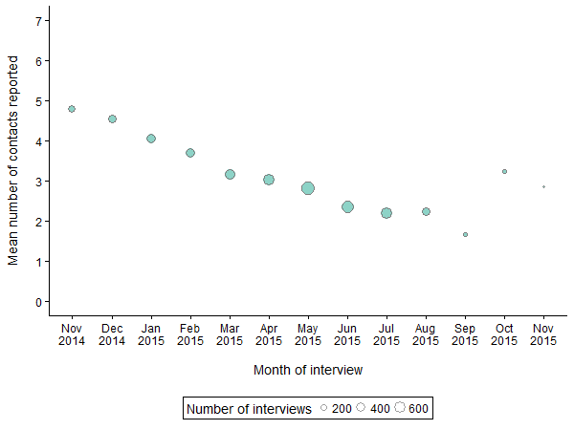

Each circle represents the number of interviews conducted by all interviewers in one month; the volume of each circle is proportional to the number of interviews conducted.

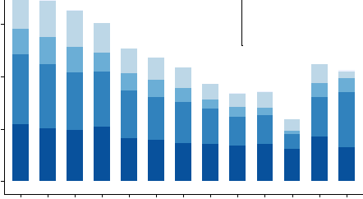Supplementary Figure 2: Location and relationship-type of alters reported in each month by HAALSI respondents

5

Q)
"
E 4
ecl:l
Relatives

5

Contact location
Other country
4
South Africa
Non-relatives

Contact location Other country South Africa

(/)
'-
=-
Q)
ell 3

0
'-
Q)
..c 2
E
:c:J:
c: ell Q)
2

0
IAgincourt Isame village ISame household

Nov Dec Jan Feb Mar Apr May Jun Jul Aug Sept Oct Nov
2014201420152015201520152015201520152015 201520152015

Month of interview
IAgincourt
Isame village
3
ISame household

2

0 IIIIII I
Nov Dec Jan Feb Mar Apr May Jun Jul Aug Sept Oct Nov
2014201420152015201520152015201520152015 201520152015

Month of interview

Supplementary Figure 3: Slope coefficients and intercepts for mean number of alters elicited over time by HAALSI
interviewers between November 2014 and September 2015

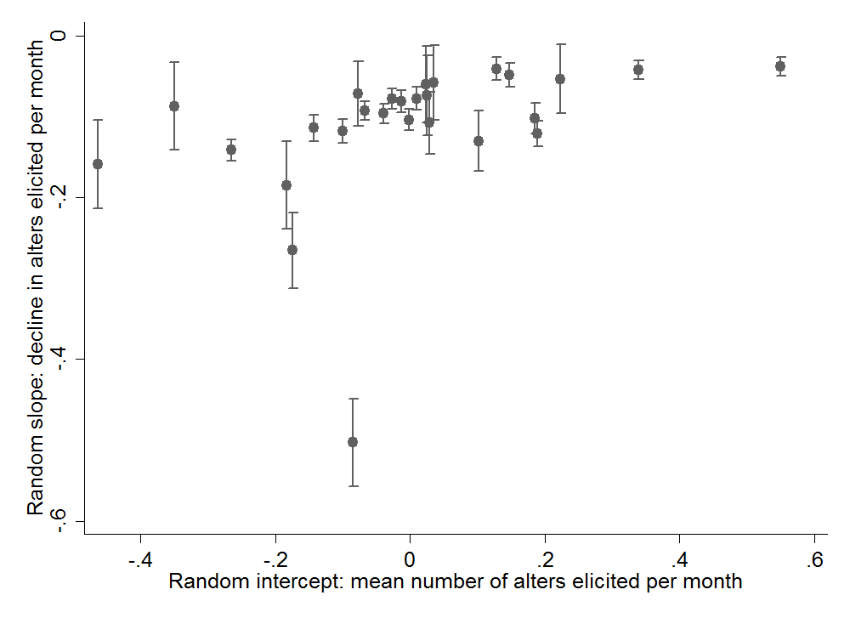

Coefficients taken from Model 9 in Table 2/Supplementary Table 2.

Supplementary Figure 4: Fitted incidence rate ratios for number of alters reported by HAALSI respondents in each survey month

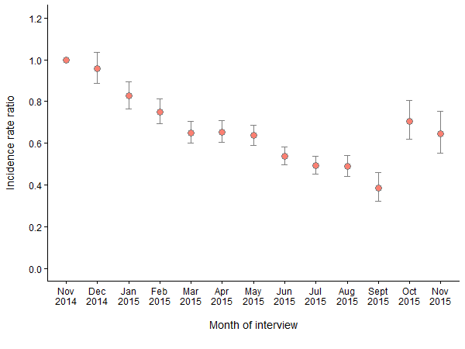

Coefficients (and 95% confidence intervals) are predicted values based on the Poisson two-level hierarchical Model 9 in Table
2 which includes all 13 months of data. All values are ratios relative to the number of alters reported in interviews in
November 2014.

Supplementary Figure 5: Communication frequency of alters reported in each month by HAALSI respondents

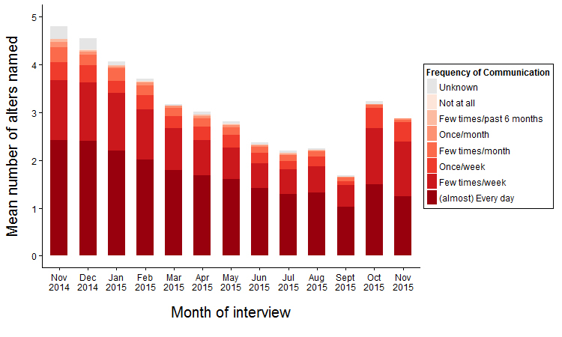

Values based on the more-frequent of in-person and telephone/electronic communication modes for each relationship

